CHAPTER-3 HEAT FROM EXTENDED SURFACES

Term extended surface is commonly used to depict an important special case involving heat transfer by conduction within a solid and heat transfer by convection (and/or radiation) from the boundaries of the solid.

Extended surfaces are used to increase heat transfer rate.

Here we have a plane wall:

at x=L ….……. conductive heat transfer = convective heat transfer

Ts q=h A [Ts-$T_{∞}$] = -k $A \frac{dT}{dx}$
x=L
air, $T_{∞}, h_{∞}$

x=0 x=L

q can be increased by the following strategies:

h can be increased by increasing the air (fluid) velocity
$T_{∞}$ can be reduced by using a coolant
A can be increased by employing extended surfaces on the plane wall.

So by attaching extended surfaces on the original surface, the area across which convection occurs can be increased. Extended surfaces are called FINS.

Below is a rectangular fin :

Ts

Tb

Tb is the base temperature

Ts is the tip temperature

conduction

convection

Ideally the fin material should have large k to maintain a uniform temperature along the finto minimize temperature variations from its base to its tip.

Heat transfer from the small side areas, in pink, are negligible.

For fins, heat transfer is considered for only upper and lower large surfaces.

Rectangular fin

w:width

t: thickness

Annular fin

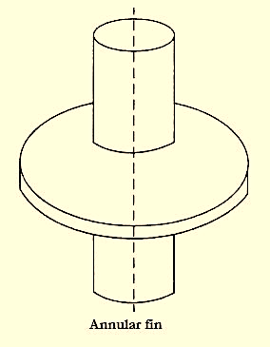

t:thickness

The general solution for a fin:
