2.Hafta 4-6
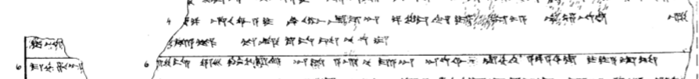
4 [(la-ah-ha-az KAS-az EG)]IR-pa hu-u-wa-a-i ^{LÚ}DUGUD-SU-ma-an UGULA LI-IM-ya le-e mu-un-na-an-zi
5 I-NA [(E.GAL^{LIM}-ya-an h)u-]u-da-a-ak te-ek-ku-us-sa-nu-ud-du
6 ma-ah-ha-an[-ma tu-uz-z]i-is ERINMES ANSE.KUR.RA^{HI.A} an-da a-ari nu ma-a-an ^{D}UTU^{SI} la-ah-hi a-pa-a-si-la i-ya-at-ta

