Mendelian Genetics
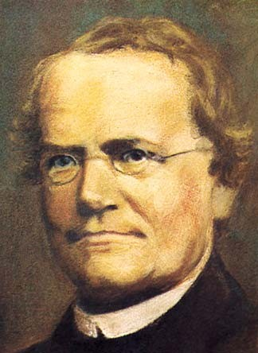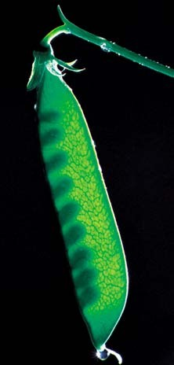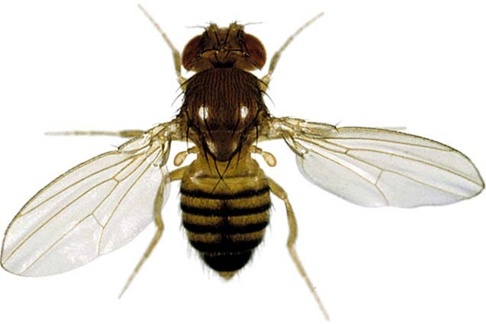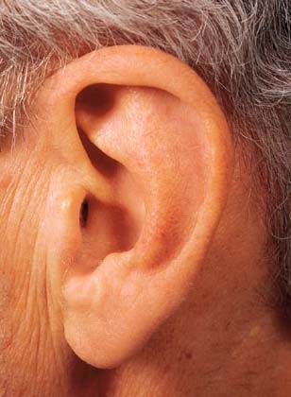
Living things tend to reproduce. They make more living
things similar to themselves. Genetics is the study of the rules of inheritance. 1

Although the tendency of offspring to resemble their parents has been generally recognized for thousands of years, the rules that govern the inheritance of characteristics were only first worked out about 150 years ago.

Gregor Mendel, and Austrian monk, worked out the basic rules of inheritance. Although many more principles have been discovered since Mendel’s work, our modern understanding of genetics can be traced back to Mendel.

Mendel worked on inheritance in the garden pea, in the 1850s and 1860s. His work was published but was largely unnoticed until the early 1900s, when a number of other biologists began to work on the same problem and rediscovered many of the things Mendel had 40 years earlier. Mendel is given credit for having discovered the basic rules of inheritance first.
2

Mendel was able to work out the rules of inheritance because he used a methodical approach, kept careful records of his results, and had good mathematical abilities. His math background gave him insight into what was happening during the production of gametes and during syngamy, even though he had never viewed cells in meiosis or fertilization.

Mendel’s goal was to discover how traits that are present in parents behave in subsequent generations.

To do this Mendel used varieties of the garden pea that differed in some distinct way. They had different states of the same character: pea shape: round vs. wrinkled, pod color: yellow vs. green, flower color: white vs. purple. He carefully crossed contrasting varieties and kept a record of the number and characteristics of the offspring they produced.
3

Mendel began his crosses with two true-breeding varieties of plants with a different state of the same characteristic such as white and purple flower color. The parents are the P1 - the parental generation.

P1: purple x white The offspring of the P1 are the F1
generation (first filial generation)

F1: purple

F1 x F1: purple x purple F2: ~3/4 purple:~1/4 white
Mendel found one of the parental states was expressed in the F1.
He then crossed the F1 among themselves or allowed them to self- fertilize.
In the F2 (second filial) generation Mendel found a ratio of approximately 3 to 1.
4

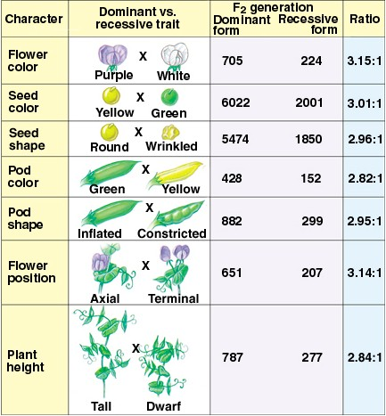
Mendel found the same pattern in all seven of the traits he studied.

5

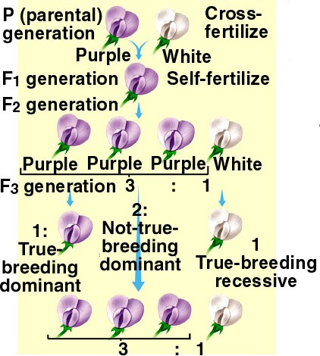
Mendel’s results raised two questions
- How can a trait be masked
in F1 generation and reappear in the F2?
- Why does the F2 generation consist of 3:1?

6

Mendel’s answers

- The factors (genes) that determine the characteristics of an organism occur in pairs, every individual possesses two factors and the factors come in alternative forms (alleles)

- The members of a factor pair are separated during gamete formation; gametes carry only one factor.
This is Mendel’s Law of Segregation

- When alternative forms of a factor (alleles) are combined, one form masks the expression of other members of a factor pair This is Mendel’s Law of Dominance

- During fertilization gametes combine randomly

7

P1: (purple) PP x pp (white)
p
P
F1: Pp (purple)
PP produces gametes that all carry the allele P. pp produce gametes that carry the allele p.
In the F1 P masks p. (P>p)

P
p

F1 x F1: (purple) Pp x Pp (purple)
P
PP | Pp
Pp | pp

1/4 (purple) PP
1/2 (purple) Pp
P
p
P
p
p

F2:

1/4 (white) pp
3/4 (purple) P-

8

Terminology
Genotype: the genetic constitution of an individual (PP, Pp, pp)
Phenotype: the outward appearance of an individual (purple, white)
Dominant phenotype: the phenotype seen when two alternative alleles are present together (Pp: purple)
Dominant allele: the form of the gene that is expressed when two alternative alleles are present together (P>p)
Recessive allele: the form of the gene that is not expressed when two alternative alleles are present together.
Recessive phenotype: the phenotype that is only seen when two identical alleles are found together (pp: white)
Homozygous: having two identical alleles (PP or pp)

Heterozygous: having two different alleles (Pp) 9

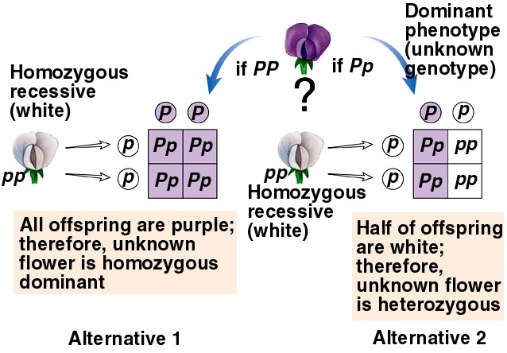
Mendel tested his explanation with more crosses. One cross that he used is a testcross: a cross of an individual with a dominant phenotype, but unknown genotype, to an individual with a recessive phenotype.
10

In Mendel’s original F2 generation, of 3/4 had the dominant phenotype and 1/4 had the recessive phenotype. Those with the dominant phenotype consisted of both PP and Pp in a ratio of 1:2. 1 of every 3 purple flowered plants in the F2 should be PP and 2 of every 3 F2 should be Pp.
Mendel crossed F2 purple with white
P- x pp

He found:
1/3 of the time all progeny were purple (when P- was PP)
2/3 of the time the progeny were 1/2 purple and 1/2 white (when P- was Pp)

11

Drosophila notation:
The most common form of the allele in natural populations is called the “wild-type” allele. The wild-type allele is always designated with a + superscript.
Any other form is called a “mutant”
Drosophila - the fruit fly

The gene is named with an abbreviation of the mutant name. If the mutant is recessive a lower case abbreviation is used and the wild-type allele is given a + superscript.
Example: vestigial wings is a recessive mutant. The mutant allele is vg. The wild-type allele is vg+ (vg+ >vg)
vg+vg+, and vg+vg are wild-type (normal wings)
vgvg has vestigial wings

12

If the mutant is dominant an uppercase abbreviation for the mutation is used. The wild-type allele gets a + superscript.
Example: Bar-eye is a dominant mutation (B>B+)
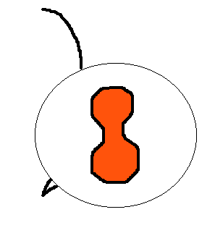
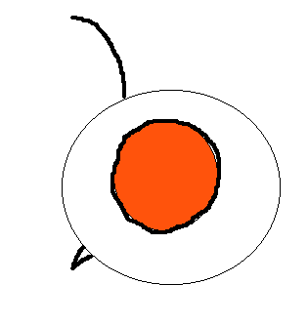
BB, and BB+ are Bar-eye B+B+ have normal eyes

13

Mendel also looked at the inheritance of two traits simultaneously and found that in the F2 there was always an approximate 9:3:3:1 ratio.

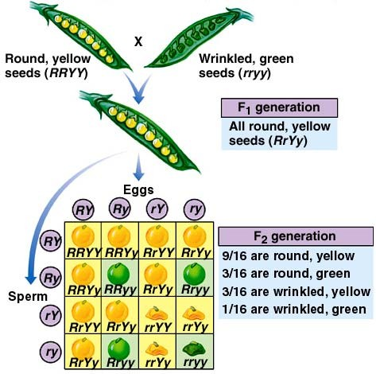
His explanation:

During gamete formation members of one gene pair segregate independently of members of other gene pairs

This is Mendel’s Law of Independent Assortment

14

If independent assortment occurs, the F1 individual (RrYy) produces 4 different gametes in equal frequencies

RY
Ry
rY
ry

This can be tested with a dihybrid testcross:
RrYy x rryy
ry

1/4 round yellow 1/4 round green
RY
Ry
rY
RrYy
Rryy
rrYy
rryy

1/4 wrinkled yellow

1/4 wrinkled green
ry
15

Rules of probability
  - If two events are independent (the outcome of one does not influence the likelihood of the other) then the probability that both events will occur together is the product of their individual probabilities.
Coin 1: pr(Heads) = 1/2, pr(Tails) = 1/2 Coin 2: pr(Heads) = 1/2, pr(Tails) = 1/2
Both coins: pr(Heads for #1) and pr(Heads for #2)= 1/2*1/2 = 1/4
  - If two events are mutually exclusive (the outcome of one excludes the possibility of the other) then the probability that one or the other will occur is the sum of their individual probabilities.
pr(Heads or Tails for #1) = 1/2 + 1/2 = 1

Probability can always be rephrased as “what proportion of ..” 16

Cross: RrYy x RrYy
among offspring: pr(R-) = 3/4, pr(rr) = 1/4 and pr(Y-)=3/4, pr(yy)=1/4
If the genes assort independently then we can ask what proportion of the offspring are expected to be R-Y-?
pr(R-Y-) = pr(R-) * pr(Y-) = 3/4 * 3/4 = 9/16 For all the other types seen from this cross:
pr(R-yy) = pr(R-) * pr(yy) = 3/4 * 1/4 = 3/16 pr(rrY-) = pr(rr) * pr(Y-) = 1/4 * 3/4 = 3/16 pr(rryy) = pr(rr) * pr(yy) = 1/4 * 1/4 = 1/16
The independent behavior of genes is the basis for the 9:3:3:1 ratio. 17

Independent assortment of genes can be extended to more than two genes:
Cross: AaBbCcDd x AaBbCcdd for each gene:
pr(A-) = 3/4, pr(aa) = 1/4, pr(AA)= 1/4, pr(Aa)=1/2 pr(B-) = 3/4, pr(bb) = 1/4, pr(BB)= 1/4, pr(Bb)=1/2 pr(C-) = 3/4, pr(cc) = 1/4, pr(CC)= 1/4, pr(Cc)=1/2 pr(D-) = 1/2, pr(dd) = 1/2, pr(Dd) = 1/2, pr(DD) = 0

If the genes assort independently, what proportion should be: A-B-C-? pr(A-) * pr(B-) * pr(C-) = 3/4 * 3/4 * 3/4 = 27/64 A-B-cc? pr(A-) * pr(B-) * pr(cc) = 3/4 * 3/4 * 1/4 = 9/64
A-B-C-dd? pr(A-) * pr(B-) * pr(C-) * pr(dd) = 3/4*3/4*3/4*1/2

18

From the cross: AaBb x AaBb
What proportion will have the dominant phenotype for at least one gene?
There are three mutually exclusive events that satisfy the condition: dominant for both (A-B-), dominant for the first and not the second (A-bb), dominant for the second and not the first (aaB-)
pr(A-B-) = 9/16
pr(A-bb) = 3/16 pr(aaB-) = 3/16
sum of all possibilities = 15/16

19

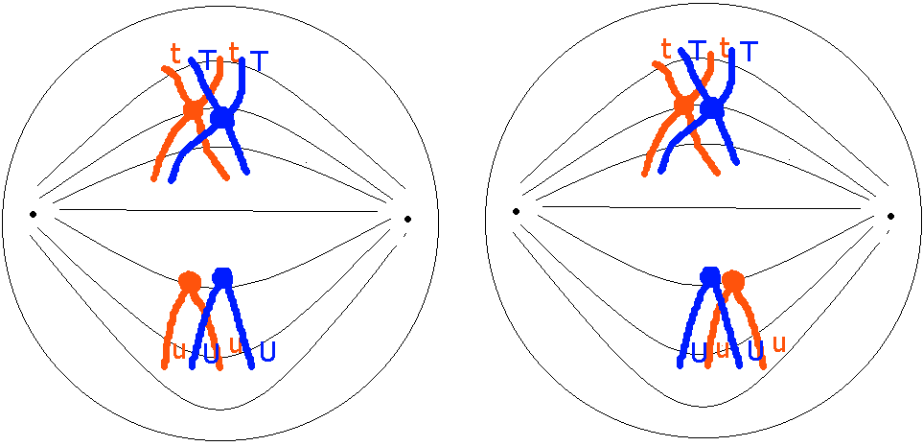
Even though Mendel had never viewed meiosis, he deduced what was happening during gamete formation.
    - The alleles of a gene are segregated during gamete formation.
    - During gamete formation members of the alleles of one gene segregate independently of alleles of other genes.
20

Mendel didn’t see evidence of genes that don’t assort independently, or if he did, he didn’t report it. Genes on the same chromosome can’t assort independently - they are called linked genes.
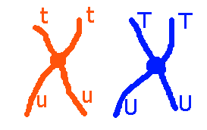
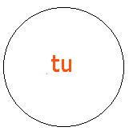
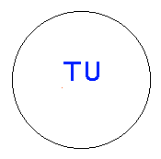
If crossing-over weren’t possible, heterozygotes for two linked genes could only produce two combinations of genes in their games, instead of four.

21

With crossing-over all four combinations of alleles of the two genes can be produced:
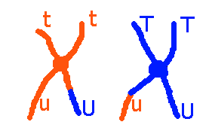

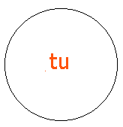
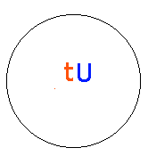
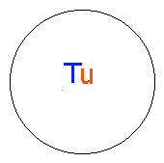
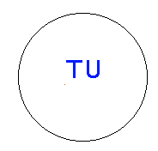
Two of the gametes have combinations that were not the product of crossing over (tu and TU) - these are called non-recombinant or parental type gametes
Two of the gametes have new combinations of genes (Tu, and
tU) - these are called recombinant gametes. 22

Linkage Mapping of Genes
If two genes are close together on the same chromosome, very few recombinant type gametes will be produced. Genes on the same chromosome can be identified by a low frequency of recombinant gametes or a low frequency of progeny produced from recombinant gametes.
A testcross of a dihybrid (double heterozygote) is used:
P1 TtUu x ttuu progeny 45 Ttuu

45 ttUu
5 TtUu
5 ttuu
90% non-recombinants (common)
10% recombinants (rare)

These genes must be on the same chromosome
23

The P1 dihybrid (TtUu) produced 4 gamete types
Tu
tU
TU
tu
The testcross parent (ttuu) produced only one gamete type
tu
When these were combined, they produced 4 offspring types, 2 of which were common and 2 were rare
progeny 45 Ttuu - this came from Tu and tu 45 ttUu - this came from tU and tu 5 TtUu - this came from TU and tu 5 ttuu - this came from tu and tu
Tu and tU are nonrecombinant gametes
TU and tu are recombinant gametes - they are the product of crossing over
24

Crossing-over is more common between distant genes. So the frequency of recombinant type gametes can be used as an estimate of the distance between the genes.
The percentage of recombinant gametes produced is the map distance between the genes: 10% recombination = 10 map units

A testcross of a dihybrid (double heterozygote) is used:
P1 TtUu x ttuu progeny 45 Ttuu

45 ttUu
5 TtUu
5 ttuu
90% non-recombinants (common)

10% recombinants (rare)

T and u allele are on one homologue. t and U are on the other homologue and the two genes are 10 map units apart. 25

When genes are far apart, double cross-overs become common. Double cross-overs recreate the original non-recombinant arrangement. Because of double cross-overs, when genes are far apart, the estimate of their distance is an underestimate. Mapping a series of genes gives a better estimate of the distance between
distant genes.

20

A D
5 10 15

A B C D 30

Estimate using only A & D

A better estimate using summed distances of intervening genes

26

Sex-linked, or X-linked, Genes
There is a special pattern of inheritance for genes on the sex chromosomes.
Mammals have chromosomal sex determination. Females have two homologous sex chromosomes (XX) and males have two nonhomologous sex chromosomes (XY).
Humans have 23 pairs of chromosomes, 22 pairs of autosomes, and 1 pair of sex chromosomes.
In humans the gene that allows individuals to distinguish between the colors of red and green is carried on the X chromosome.
There are two alleles: XC - the non-colorblind allele
Xc - the colorblind allele

The colorblind allele is recessive. 27

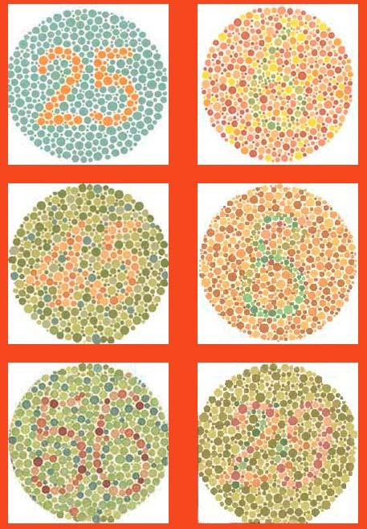
Females have 3 genotypes and 2 phenotypes:
XCXC - non-colorblind XCXc - non-colorblind XcXc - colorblind

Males have 2 genotypes and 2 phenotypes
XCY - non-colorblind XcY - colorblind

28

Sex-linked traits are detected with reciprocal crosses. If the trait is sex-linked, the progeny that result from the two crosses are different.

NCB ♂ x CB ♀
XCY x XcXc

female offspring: XCXc -NCB male offspring: XcY -CB
CB ♂ x NCB ♀
XcY x XCXC

female offspring: XCXc -NCB male offspring: XCY -NCB

29

The first sex-linked gene identified was the eye color gene in
Drosophila

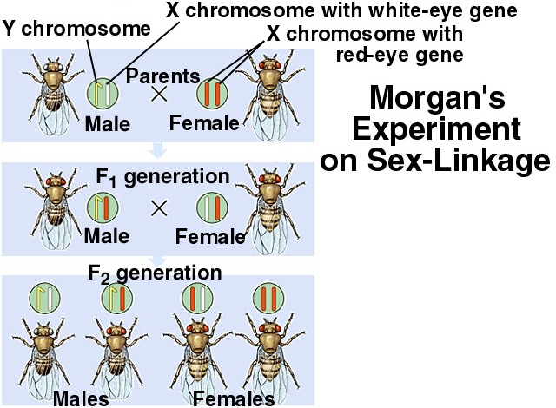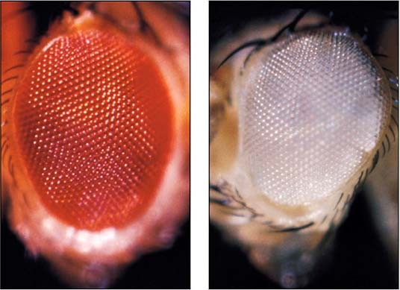

30

Why are some alleles dominant and others recessive?
A gene is a code for a protein. The code dictates the sequence of amino acids in the protein. Alleles are codes for proteins that have different amino acid sequences.
Proteins normally perform functions, but if their amino acid sequence is altered they may lose their ability to perform their normal function.
A commonly seen trait in many animals is albinism. It is due to the inability to produce the skin pigment melanin. For the albino/nonalbino system there are two alleles, A and a.
A is a code for an enzyme named tyrosinase. Tyrosinase converts the amino acid tyrosine to melanin.
a is a code for an altered tyrosinase, with an altered amino acid sequence, such that tyrosine can’t be converted to melanin.

31

AA, and Aa genotypes can make functional tyrosinase and thus melanin can be produced and deposited in skin and other structures.
aa genotypes can’t make functional tyrosinase and thus they can’t produce melanin.
a
Tyrosine X melanin
Most recessive alleles are the result of an altered gene code that results in a protein the does not perform the normal function of the protein.

32

Sometimes alleles are not fully dominant. The heterozygote can be distinguished from the homozygote and is intermediate in appearance between the two homozygotes. Such an interaction between alleles is called incomplete dominance or partial dominance.

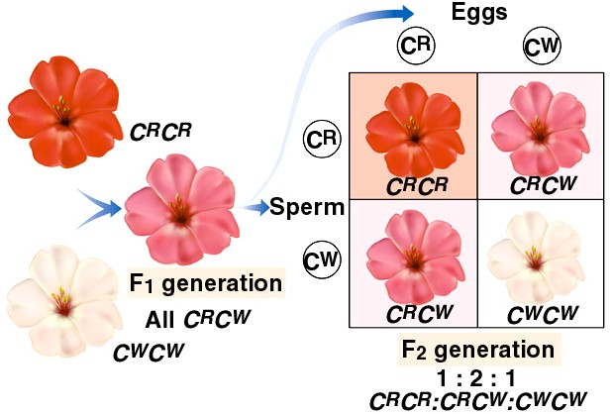
33

Some alleles have a codominant interaction in the heterozygote. A heterozygote for codominant alleles is different from, and not intermediate to, both homozygotes.
The best example of codominance is the ABO blood type system
In the human population there are 3 alleles for the ABO blood type system: IA, IB, i
IA and IB are codominant and both are dominant to i
IA codes for a protein that produces the A antigen on blood cells
IB codes for a protein that produces the B antigen on blood cells i codes for a protein that produces no antigen on blood cells

34
this produces 6 possible genotypes and 4 phenotypes
IA IA, and IAi - produce type A blood - with A antigen IB IB, and IBi - produce type B blood - with B antigen IAIB - produces type AB blood - with A and B antigens ii - produce type O blood - with no antigen

More than one gene can influence a characteristic. Sometimes they interact to produce unusual phenotypic ratios.
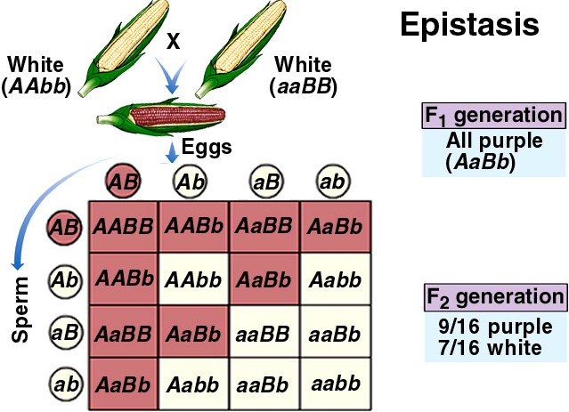
Epistasis - an interaction between genes - a specific combination of alleles at one gene influence the expression of certain allele combinations at another gene.

35

Epistatic interactions are often the result of two or more genes each affecting different steps of a biochemical pathway
starting substrate → intermediate substrate → final product (colorless) (colorless) (colored)

The A gene codes for a protein the catalyzes the first step. The B gene codes for a protein that catalyzes the second step. The
recessive alleles produce nonfunctional proteins. 36

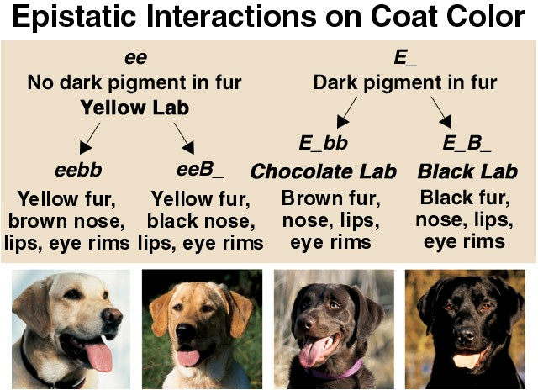

In general, the expression of one gene often depends on the alleles present at other genes.

37

Most traits are not due to the expression of a single gene. Many are due the expression of many genes that each have small effects on the phenotype. Such traits are said to have polygenic inheritance.
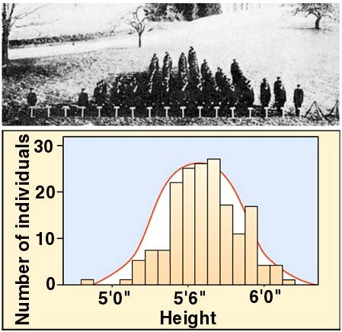
The simplest polygenic system is a system where each gene has additive allelic effects:
AABBCC - ++++++ AaBbCc - +++ Aabbcc - +
aabbcc -
Polygenic traits commonly show continuous variation

38

Human skin color variation is due to a polygenic system with at least 5 and as many as 8 genes that contribute to skin color

A single gene system would have 3 genotypes and 3 phenotypes AA - ++
Aa - +
aa -
A two gene system would have 9 genotypes and 5 phenotypes AABB - ++++
AaBB, AABb - +++
AaBb, AAbb, aaBB - ++ Aabb, aaBb - +
aabb -

39

A three gene system would have 27 genotypes and 7 phenotypes AABBCC - ++++++
AABBCc, AABbCC, AaBBCC - +++++
etc.

The human system with at least 5 genes would have at 243 genotypes and at least 11 phenotypic grades of skin color.

Most continuously varying traits - height, weight, shoe size, IQ, eyesight, athletic ability, etc. - are controlled by multiple genes each having small effects on the phenotype.

40

The environment in which an organism lives also influences its phenotype. Poor diet, regular physical exercise, exposure to sunlight, regular intellectual exercise, exposure to disease or toxins, all have phenotypic effects.
A measure of the influence of genes and the environment on the phenotype is heritability.
Heritability - the proportion of phenotypic variation in a population that is due to underlying genetic variation.
For example - skin color differences can be due to genetic differences and/or due to difference in exposure to sunlight in the recent past. If the differences among individuals in a population was due primarily to genetic differences then we could say the heritability of skin color is high. If the differences in skin color was primarily due to differences in exposure to sunlight then we
could say the heritability of skin color is low. 41

Heritability ranges in value from 0 to 1.
H = 0 means all of the phenotypic variation is due to environmental differences - e.g. language spoken
H = 1 means all of the phenotypic variation is due to genetic differences - e.g. tongue rolling
Many traits are due to a combination of genetic and environmental influences.
Normally heritability is measured as a statistic - a ratio of measures of variation.

42

Heritability can also be measured by raising a large number of pairs of identical twins in different environments.
If the twins, when raised apart, always exhibit the same trait, then the heritability is high (near 1).
If the twins almost always exhibit different traits, then the heritability is low (near 0).
Measuring heritability can be tricky because the measure always depends on the environment in which the measurement was made. For example, if all twins were raised in Norway then we might conclude that speaking Norwegian is a highly heritable genetic trait.
If all twins are raised in different countries with different languages then we would conclude the language has a low heritability.
43

Many human behavioral traits have been shown to have both a genetic and environmental component: introversion/extroversion, the tendency to smoke, the tendency to curse, sexual orientation, marital fidelity.
Heritability estimates: Height:
Weight:
Math aptitude: Science aptitude:

44

Human chromosomes and chromosomal abnormalities
It is important that the proper number of each chromosome be present in all cells. Additional chromosomes or missing chromosomes result in genetic imbalance. Some proteins are over-produced or under-produced if chromosome numbers are
not balanced.
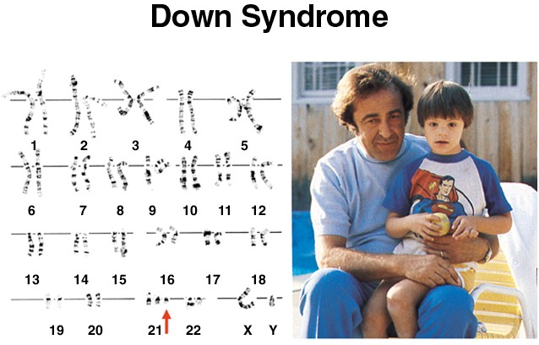
One case of genetic
imbalance is the condition known as Down Syndrome.
It is occurs when a human has 3 copies of chromosome 21 instead of the normal 2.

45

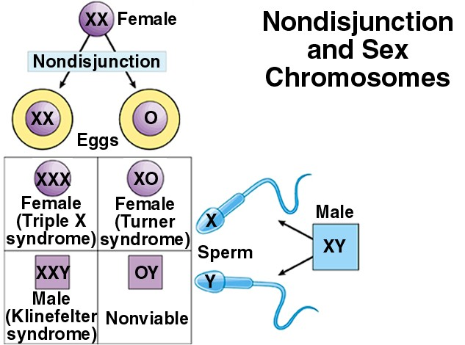
Errors in meiosis produce gametes that have extra copies of chromosomes or are missing chromosomes. Failure of the homologous chromosomes to separate properly during anaphase I or failure of the chromatids to separate at anaphase II is called chromosomal nondisjunction and results in gametes with extra chromosomes or gametes that lack a chromosome.

46

If genetic imbalance is such a problem, why don’t females who are XX and males who are XY not experience imbalance of the X chromosome?
Mammals compensate for the double X chromosome in females by turning off one of the X chromosomes in all the cells of the female body. This is called X-inactivation.
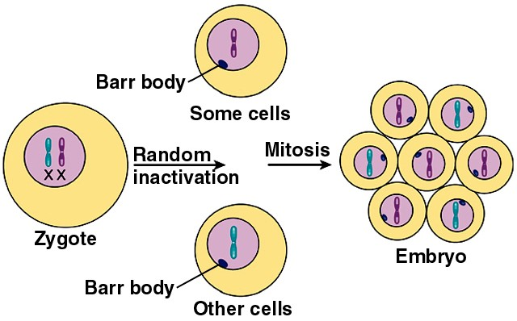
So, in effect, males and females only express genes on one of their X chromosomes in all their cells. The inactive X chromosome is highly condensed. It is called a Barr Body.

47

Which chromosome is inactivated is determined randomly during early development. This produces a mosaic pattern in the phenotype for any trait that is carried on the X chromosome.
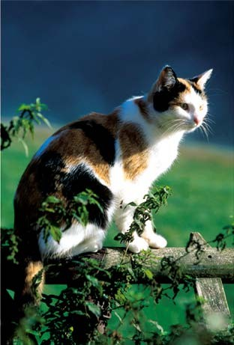
In cats, coat color is sex-linked. The X chromosome can carry a black allele (XB) (dominant) or a yellow allele (Xb) (recessive).
Males can be either black (XBY) or yellow (XbY).
Females can be black (XBXB), yellow (XbXb), or calico (XBXb).

48
Reference: https://www.nicholls.edu/biol-ds/biol155/Lectures/Mendelian%20Genetics.pdf

