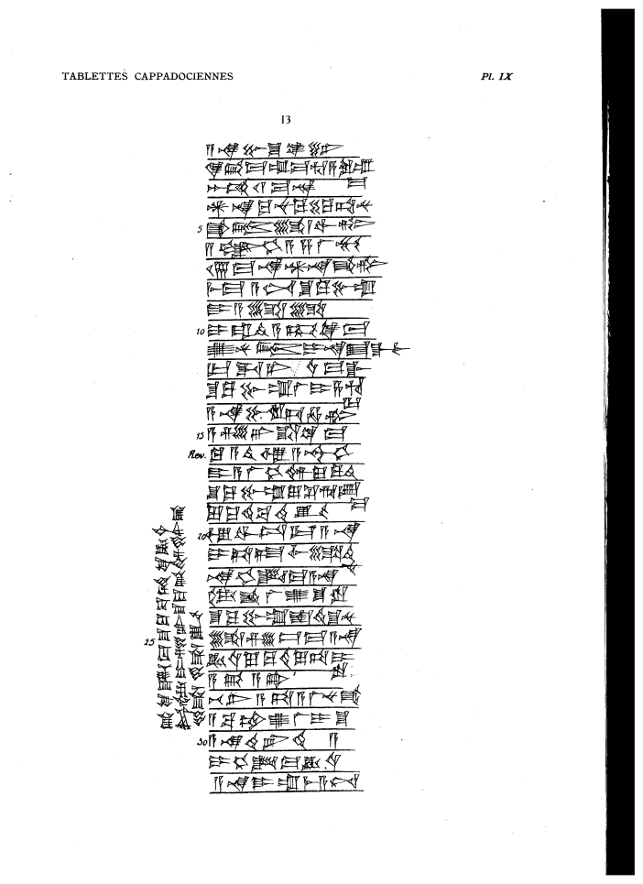

a-na Pu-s^u-ke-en6
qi2-bi-ma um-ma Hu-sa3-ru-um=ma
2 GU2 11 ma-na
AN.NA ku-nu-ku 40 ku-ta-nu
5 qa2-dum li-wi-tim
2 ANS^E.HI.A s,a-la2-mu
17 ma-na AN.NA qa2-tim
mi3-ma a-nim S^u-ku-bu-um
DUMU A-li-li
10 i-ra-di2-a-kum ki-ma
u2-nu-tum i-na E2.GAL.lim
ur-da-ni u4-ma-gal
S^u-Ku-bu-um la2 i-sa3-hu=ur
a-na Bu-ru-us^-ha-tim
15 a-s,e2-er s^a ki-ma
ku-a-ti2 u3 A-s^ur3-DU10
DUMU A-la2-hi-im lu-qu2-ti2
S^u-Ku-bu-um lu-s^e2-ri-ib=ma
lu-qu2-ti2 ba-ti2-iq
20 u3 wa-tu3-ur a-na
i-ta-at,-lim li-di2=nu
na-hi-id-ma a-na
DAM.QAR la2 u2-s^u-ru
S^u-Ku-bu-um is^-ti2-s^u-nu
25 li-zi-iz-ma a-na
KU3.BABBAR lu-qu2-ti lu-ta-i=ru
a-bi a-ta!
be-li2 a-ta a-la2-nu-ka3
a-ba-am u2-la2 i-s^u
30 a-na te2-er-ti2-a
i-hi-id-ma KU3.BABBAR
a-na DUMU um-mi3-a-nim
pi2-qi2-id-ma S^u-Ku-bu-am KI KU3.BABBAR
t,ur4-dam i-s,e2-er S^u-Ku-bi-im en6-ka3
li-li-ik

