T. S. Eliot Briefly
(1888-1965)

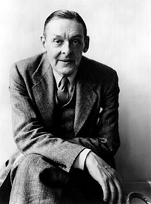

- Poet, critic and playwright. One of the most influential poets of the Twentieth Century.
- As a poet and critic he defined the standards of poetic taste. He is called “The Pope”.
- His poems expressed the disillusionment of the early twentieth century people with the Victorian values of the previous century.
- One of the fathers of modernism. Experimented with the form.
- He popularized the term “objective correlative”: “a set of objects, a situation, a chain of events which shall be the formula of that particular emotion” that the poet feels and hopes to evoke in the reader.”
- Consult https://www.poetryfoundation.org/poets/t-s-eliot for a larger biography.

