ADVANCED SPECTROMETER KIT (Thorlabs Inc.)

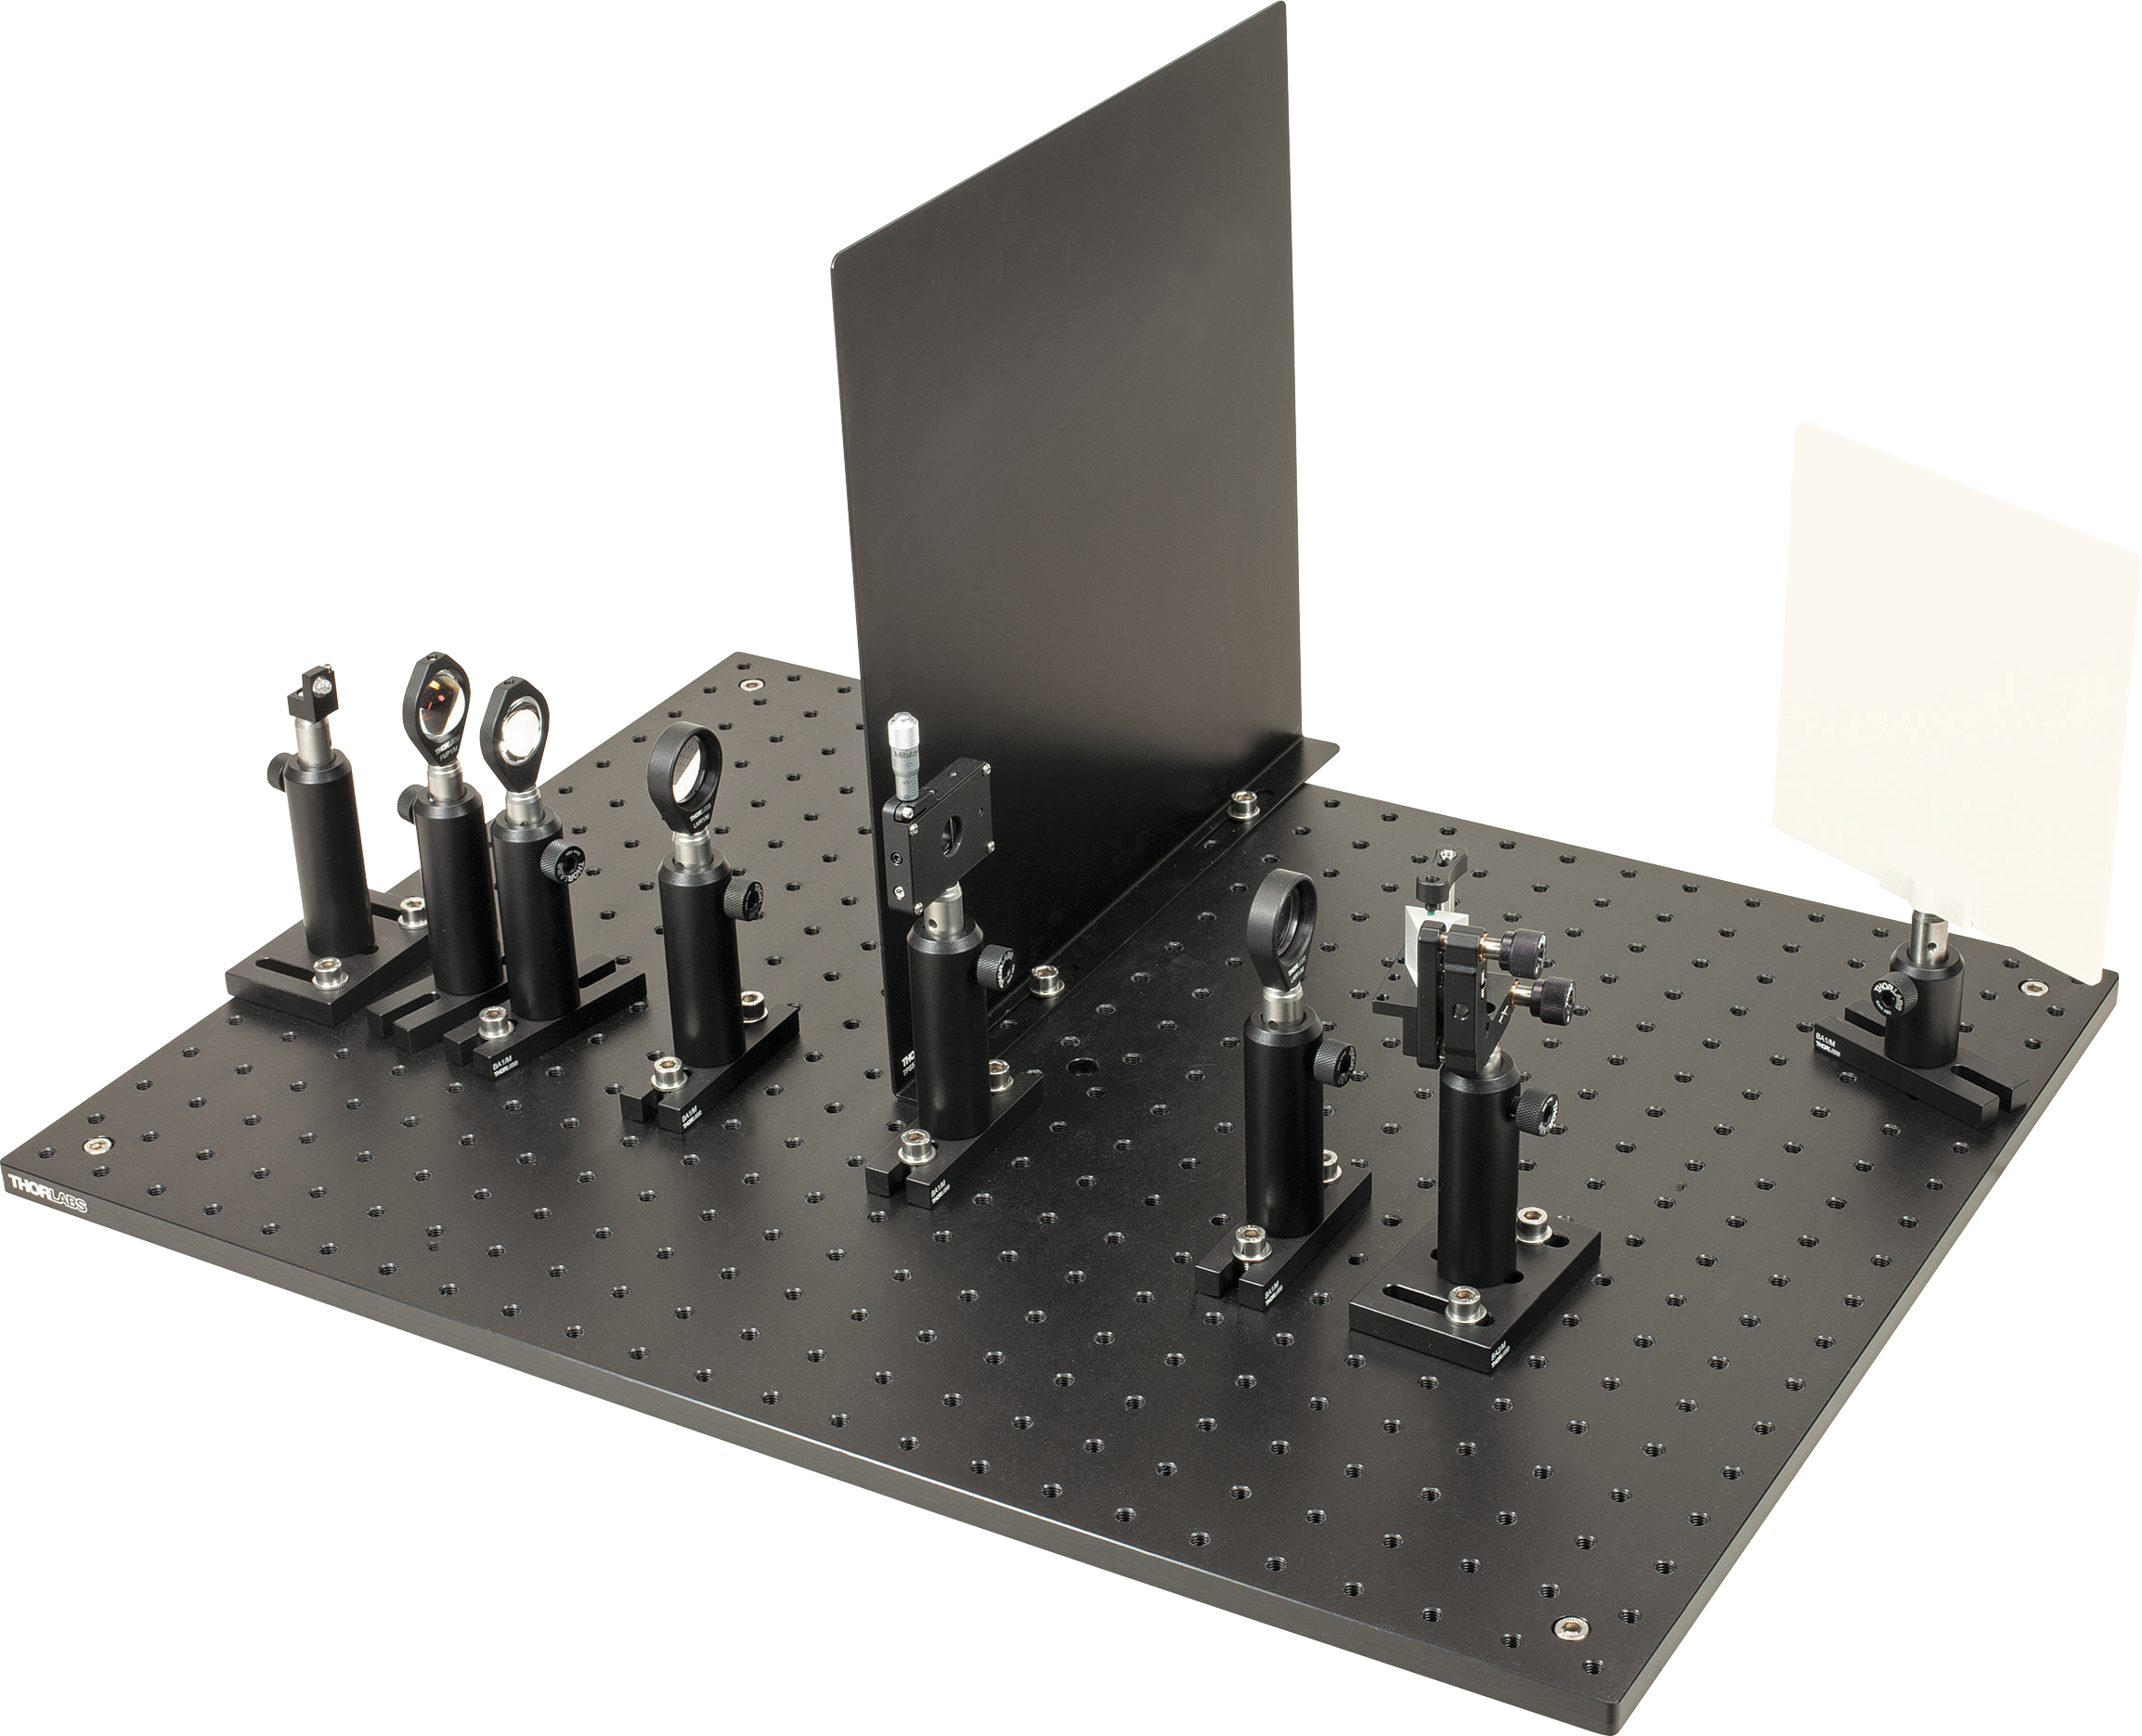

The following experiments are going to be performed with advanced spectrometer kit:

Experiment 1: Wavelength Measurement of Three Lines in the Mercury Spectrum

Experiment 2: Measuring the Index of Refraction of the Prism Using a Known Spectral Line

SETUP ADVANCED SPECTROMETER EXPERIMENTS

Introduction

This kit includes parts to build two types of spectrometers, and can be easily set up by students. These spectrometers can achieve very fine resolutions, allowing very close spectral lines to be resolved, such as the sodium-D lines (spectral distance of 0.6 nm). As the setup is very small, LEDs can also be analyzed, although so-called "superbright" LEDs, which have a higher intensity than normal LEDs, are recommended. The included LED bracket makes it very easy to install the LEDs in the setup. Other light sources, such as incandescent lamps, energy-saving lamps (compact fluorescent tubes), mercury vapor lamps, and lasers can also be analyzed by the spectrometer
The experiment package contains the following wavelength-dispersive elements:
- A reflective grating with 600 lines/mm.
- A reflective grating with 1200 lines/mm.
- An equilateral dispersing prism.
Setup

Components and Part List
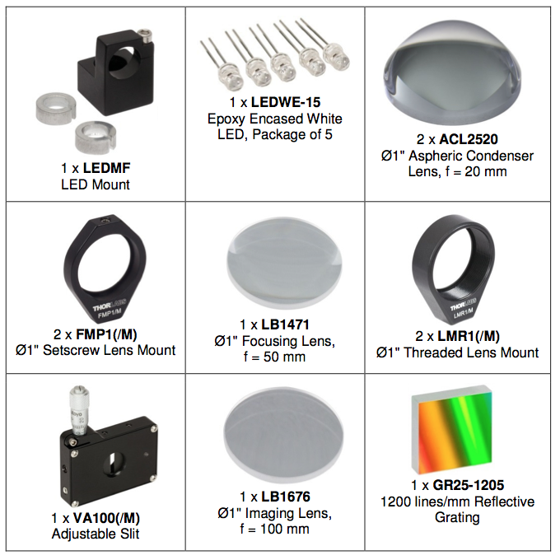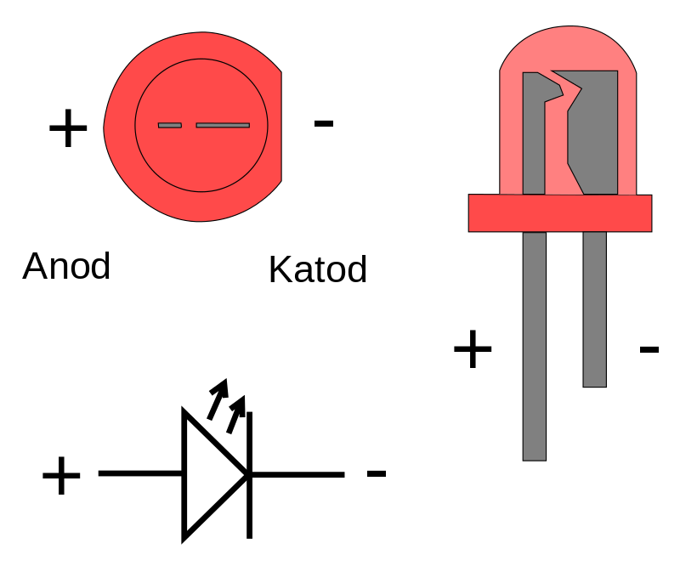

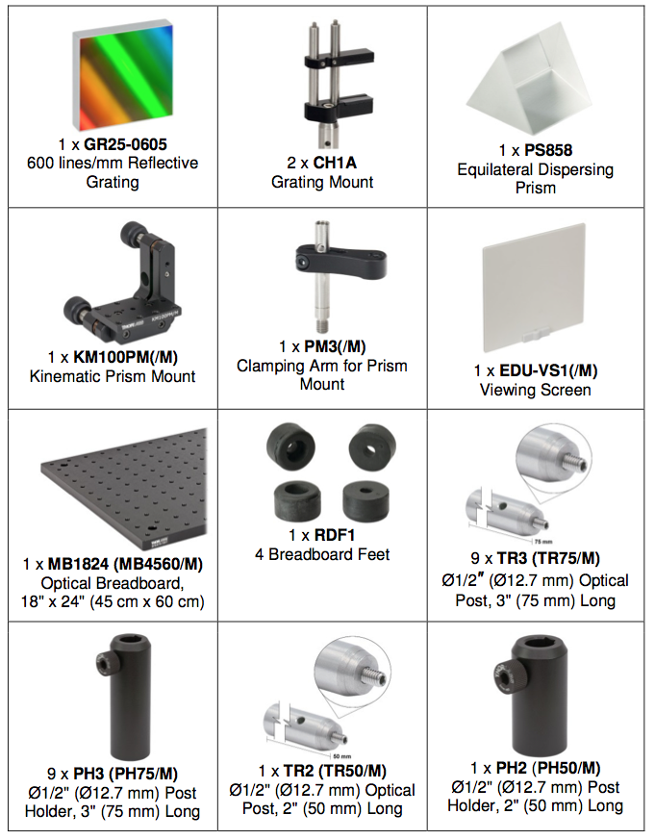
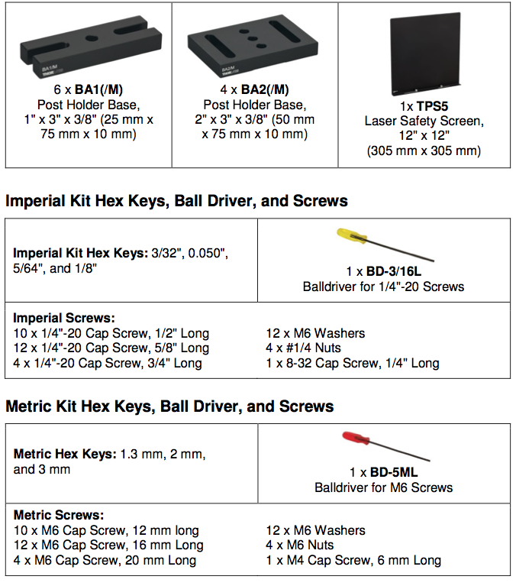

Setup and Adjustment

Light Source Setup

Take the two condenser lenses, the standard lens with focal length f = 50 mm, and the slit and assemble the components as shown in Figure 1.1, using 5/8" long 1/4"-20 (16 mm long M6) cap screws and M6 washers to attach components to the breadboard. Next, position your light source at the end of the breadboard. The goal is to focus as much light as possible from the light source on the slit. Depending upon the form and the size of your light source, the standard 50 mm focal length lens may be omitted.

Place the first condenser lens directly behind the light source. Place the second at a distance of about 40 mm behind the first (curvature facing inward). The function of these lenses is to “catch” as much light intensity as possible. The standard lens with f = 50 mm should now be positioned at a distance of 50 – 60 mm behind this. It will then focus the light on the slit. Place it in the beam path after approximately an additional 50 mm (focal length of the lens). As the light sources used usually are not ideal point light sources, you often see a small image of the light source in this focus point (e.g. coil filament, LED-chip, Hg-tubes). This can be useful for focusing.

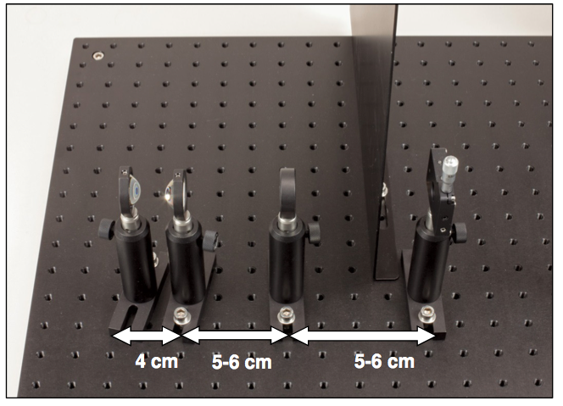
Figure 1.1: Beam Path from Light Source to Slit

Next, focus the image of the slit on the grating. For this, place the second standard lens (f = 100mm) in the beam path, as shown in figure 1.2. The distance from the slit should be 10-15 cm. Insert the dispersive element (grating, prism) after the lens after an additional 10-15 cm.

Place the TPS5 laser safety screen on the breadboard as shown in figure 1.1. This will shield the viewing screen from stray light emitted by the light source.

Prism Spectrometer Setup

When you place the prism into the beam path, ensure that you do not direct the beam through the matte side of the prism. Instead, this side of the prism should be facing between the black laser safety screen and the white viewing screen. Turn the prism until you see a sharp spectrum on the screen and make any necessary adjustments with the lenses and the distance of the screen. The slit, prism, lenses, and screen are shown in Figure 1.2, and the complete prism spectrometer setup is shown in Figure 1.3.

To obtain an optimum image, change the slit width. The further the slit is opened, the brighter/more intense the image becomes, and the tighter it is closed, the sharper the image becomes.
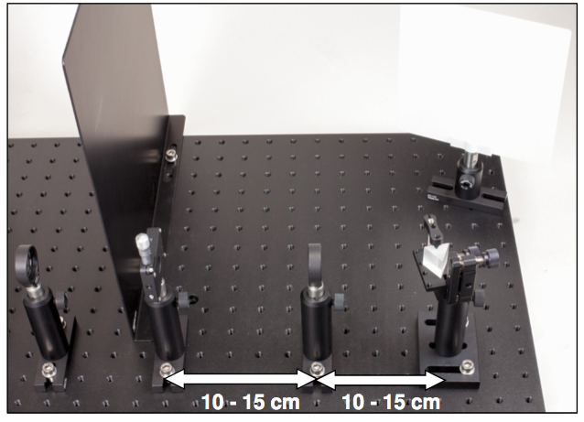
Figure 1.2: Beam Path from Slit to Prism to Screen

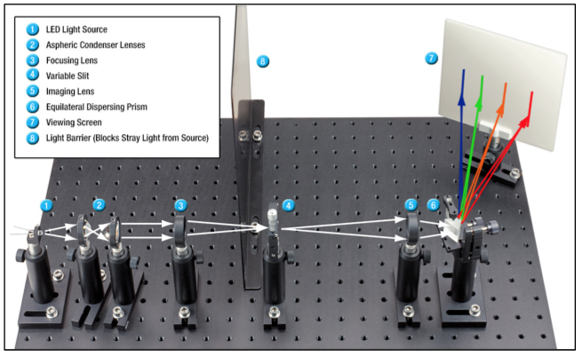
Figure 1.3: Prism-Based Spectrometer Complete Beam Path

Grating Spectrometer Setup

The grating-based spectrometer setup is the same up to the f = 100 mm lens (see setup and adjustment section, above). You must now focus the light on the grating. The complete grating-based spectrometer setup is shown in Figure 1.4. The illustration shows the first order to the right of the zeroth order of the 600 lines/mm grating.

Place the screen so that you can observe the spectrum. Once again, make fine adjustments to the lenses or screen for a sharp image.

Tip: Due to the sawtooth-like grating structure, the number of observable orders depends upon the direction the grating has been rotated in relation to the optical axis.

On one side of the zeroth order, you obtain a particularly intense image in the first order. This image is visible even with weak room lighting.

On the other side of the zeroth order, the spectra are less intense (similar to "normal" non-blazed gratings). In order to view this image, the room should be darkened. However, you can even observe the 5th order on this side with the grating with 600 lines/mm. Also note that the red/orange range of the 3rd order overlaps the blue/violet range of the 4th order.

Tip: If the grating or the screen is moved or rotated somewhat, the lens between the slit and the grating must also be adjusted accordingly. Move it back and forth somewhat in the beam path until a sharp image is obtained.

Tip: If you place a white sheet of paper on the screen (bleached), you can even observe UV lines (if present). This is due to the fact that the paper contains bleaches that fluoresce (absorb UV light and emit visible light) to make the paper look brighter under daylight.

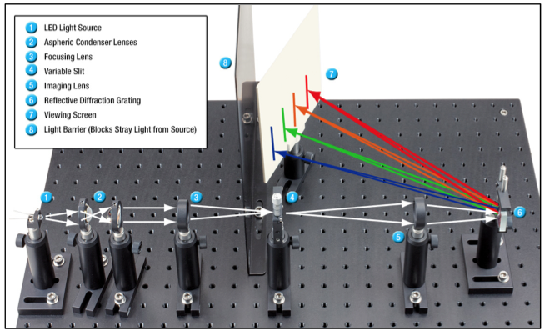

Figure 1.4: Grating-Based Spectrometer Complete Beam Path

Tip: If you place a white sheet of paper on the screen (bleached), you can even observe UV lines (if present). This is due to the fact that the paper contains bleaches that fluoresce (absorb UV light and emit visible light) to make the paper look brighter under daylight.

Spectrometer Theory

Introduction

A number of experiments can be conducted with this spectrometer kit. First, various types of light sources and spectra can be analyzed. Suitable light sources include:
- Incandescent Lamps
- Compact Fluorescent (Energy Saving) Lamps
- LEDs
- Gas Discharge Tubes Including Mercury or Sodium Vapor Lamps

The most important parameters or objects of study of the spectrometer are:

Qualitative:

- Relationship between slit width and spatial resolution.
- Relationship between slit width and intensity of the spectrum.
- Relationship between grating constant and spatial resolution.
- Observation of the differences between the diffraction orders.

Quantitative (listed here as an example):
- Calculation of the wavelengths of spectral lines by means of the grating
equation with the aid of a grating.
- Calculation of the refractive index of the prism glass with the prism.

Wave Interference with Double Slits and Gratings

Double slit

Consider a set of slits (double slit), as shown in Figure 1.5a and 1.5b. The dimensions of the slits should be smaller than the wavelength of the incoming light.

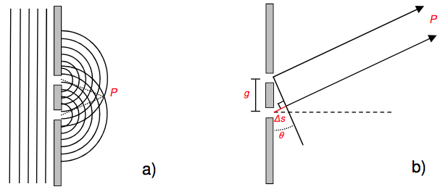

Figure 1.5: Double Slit Showing (a) Waves Emanating from the Two Point Sources and (b) Path Length Difference Between the two Slits

Light hits the double slit in the form of a planar wavefront (Figure 1.5a). In accordance with Huygens' principle, each slit is then the origin of an elementary spherical wave, also called an elementary wave for short. These two elementary waves spread out behind the slit and overlap. Areas of constructive and destructive interference are created, which result in bright and dark areas when an image is viewed on a screen. We consider any point P behind the slits, which is so far removed that we can observe the wave trains emanating from the slits as parallel (Figure 1.5b). The path difference ∆s between them is $∆S=g.sinθ$. With the aid of geometrical optics, we can then easily see that we obtain constructive interference for integral multiples of the wavelength and destructive interference for half-integral multiples.

Constractive interference: $∆S=g.sinθ_{n}=nλ, n=0,1,2…$
Destractive interference:$∆S=g.sinθ_{n}=\left(n+\frac{1}{2}\right)λ, n=0,1,2$...

This is also easy to understand intuitively, because at points of maximum intensity, "wave peak meets wave peak" if the phase difference of the wave trains is one wavelength and "wave peak meets wave trough" if it is one half wavelength.
Grating Interference

We can model a grating as a number of slits, N, as sketched in Figure 1.6.
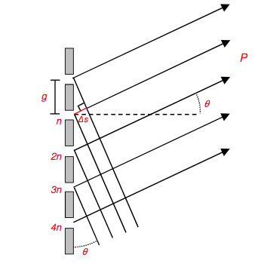

Figure 1.6: Path Length Differences Between Grating “Slits”

For the sake of clarity, we will refrain from a detailed, theoretical explanation of gratings, but can still make the following conclusions:

Intensity:
The intensity I₀ of the interference pattern becomes greater as more slits are illuminated: If the amplitudes of the individual wave trains overlap, the intensity is I = (N⋅A)², as the output amplitudes A₀ of the electrical field vectors add up. (Note that intensity results from the square of the field amplitudes.).

Interference:
As is the case with the double slit, the differences in pathways of the wave trains from the individual slits must also be an integral multiple of the wavelength of the incident light in the case of the grating in order to obtain constructive interference. For the maxima, the following grating equation is in effect:
$$sinθ_{n}=\frac{nλ}{g}, n=0,1,2$$
Here, g is the grating spacing, λ is the wavelength of the incident light, and n the diffraction order observed under the angle θ_{n}. In conclusion, the spectral separation at the grating results from the diffraction by the slits.

From this correlation, it is immediately obvious that the angle θ_{n} depends upon the wavelength of the incident light. If we examine light that is composed of many wavelengths, as is the case with our light sources to be examined, these wavelengths are spatially split, and we obtain a spectrum. These characteristics apply regardless of whether the grating works in transmission or reflection. In addition, it is apparent that larger wavelengths also result in a larger deflection angle (as opposed to a prism – here the behavior is reversed).

Resolution:
The spatial resolution A of a spectrometer can be derived as follows:

$$A=\frac{λ}{Δλ}=n.N$$

Once again here, n is the diffraction order, ∆λ is the smallest observable wavelength difference, and N is the number of illuminated slits. In order to determine ∆λ, one can observe in the present setup, for example, whether known spectral lines (such as the orange lines in the mercury spectrum) can be perceived separately.

The formula above immediately reveals that the resolution increases with increasing diffraction order and increasing number of illuminated slits. In addition, one can demonstrate that the resolution increases as the slit width of the illustrated slit becomes smaller. In accordance with the grating equation:

$$sinθ_{n}=\frac{nλ}{g}, n=0,1,2$$
It becomes clear that the angle widening of the image increases with increasing fineness of the grating (meaning decreasing the grating spacing g) and the resolution is therefore improved. It is therefore interesting to compare gratings with various grating constants (in this experiment kit, g = 1/(600 lines/mm) vs. g = 1/(1200 lines/mm)).

Dispersing Prisms

“Dispersion” in the context of a prism means that the angle of refraction of light is highly dependent on wavelength. This is the case in so-called dispersion prisms. Such prisms have an equilateral triangle as a cross-sectional area and consist of suitable glasses with high dispersion, e.g. crown glass. Light is directed at one side of the prism. It is refracted once upon entering the prism at the air/glass interface and finally once again upon exiting the glass/air interface.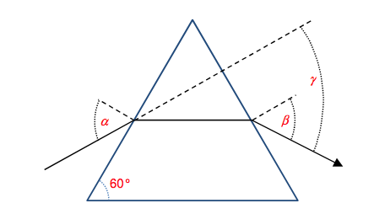
Figure 1.7: Angle of Minimum Deviation in an Equilateral Prism

The angle of minimum deviation γ (see Figure 1.7) with incident angle α and refractive angle β is obtained if α = β. Here, the beam within the prism runs parallel to the base of the prism. With the aid of geometry, one can derive the following:
$$γ=α+β-{60}^{°}=2α-{60}^{°}$$

In this case, the law of refraction can be written as:

$$n=\frac{sin⁡\left(\frac{γ+{60}^{°}}{2}\right)}{sin{ 30}^{°}}$$

Therefore, if one measures the minimal deflection angle, which can be sharply focused and thus determined well, one can determine the refractive index of the prism material at an observed wavelength.

Refraction in a Prism

The refractive index of the prism material depends upon the wavelength of the incident light. Since the deflection angle is ultimately determined by the refractive index, the various wavelengths can be separated spatially. This is a normal dispersion in the glass, meaning that the refractive index increases with reduced wavelength (blue light is refracted more than red). This is particularly interesting as the deflection in the grating behaves exactly in the opposite manner (smaller deflection angle for blue light). Figure 1.8 shows the index of refraction over the visible wavelengths for F2, the glass used to construct the prism.
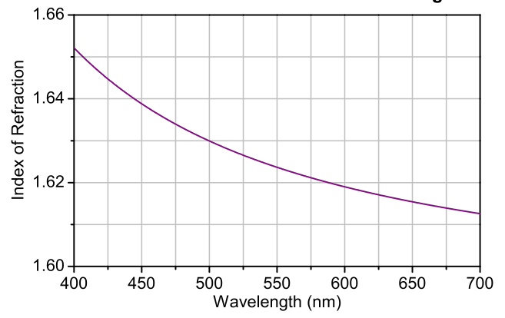

Figure 1.8: Index of refraction vs. wavelength for F2, the glass used in the PS868 prism

Resolution with the Prism Spectrometer

The spatial resolution A of a prism is defined as

$$A=\frac{∆λ}{λ}=b.\frac{dn}{dλ}$$

Here, b is the base length of the prism and $\frac{dn}{dλ}$is the relative dispersion.
For didactic purposes in the classroom, the most reasonable approach is certainly to estimate the possible resolution based only on the observation of certain spectral lines (e.g. orange lines in the mercury spectrum). You can also compare the resolution with that of the grating.

EXPERIMENT 1.1: WAVELENGTH MEASUREMENT OF THREE LINES IN THE MERCURY SPECTRUM

In order to make the calculations as simple as possible, we set up the experiment so that we can use the simple grating equation
$$sinθ_{n}=\frac{nλ}{g}, n=0,1,2$$

This is the case if the light from the slit hits the grating perpendicularly. We therefore orient the grating perpendicularly to the optical axis – we can guarantee perpendicular incidence if we position the grating so that the zeroth order hits the slit. In addition, the observation screen should be positioned so that it is in line with the slit, so that the angle between the grating, slit, and screen is 90°(see Figure 1.9).

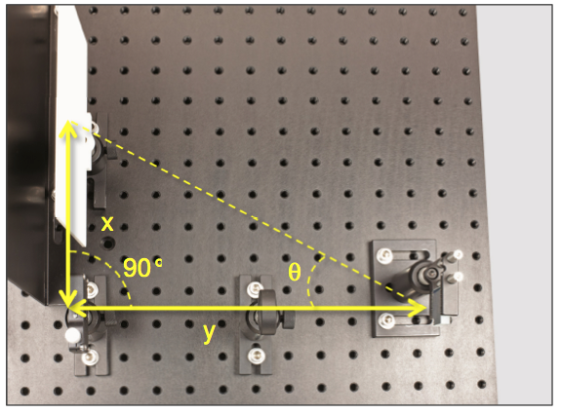

Figure 1.9: Measuring the angle at which light leaves the grating can be used to calculate wavelength

We want to use the wavelength based on the spectrum of the first order to the right of the zeroth order, as this is the most intense (this is in the nature of the blazed grating, see grating interference section above). We use the grating with 1200 lines/mm. Therefore, we already know n = 1 and g = 1/(1200 lines/mm). In order to determine the wavelength λ, we therefore still need the deflection angle θ, as shown in Figure 1.9. We thus determine x and y as designated in Figure 1.9 and obtain:
$$θ=arctan\frac{x}{y}$$

The following results come from a simple determination of x and y with a ruler during a student experiment. The three most intense lines of the mercury spectrum were measured:

x(cm) | y(cm) | λ_{exp} (nm) | λ_{reference} (nm)
 |  |  | 577 (orange)
 |  |  | 546 (green)
 |  |  | 436 (blue/violet)

If one compares the values of the wavelengths determined in this manner with the literature values, the error rate is under 2%.

EXPERIMENT 1.2: MEASURING THE INDEX OF REFRACTION OF THE PRISM USING A KNOWN SPECTRAL LINE

As shown above, we only need to measure the smallest deflection angle γ in the prism to determine refractive index.

In Figure 1.10, light hits the prism from the left and is refracted in the smallest deflectionangle γ as shown in the image. We can very easily determine this angle by measuring the drawn distances x and y. The following equation applies:

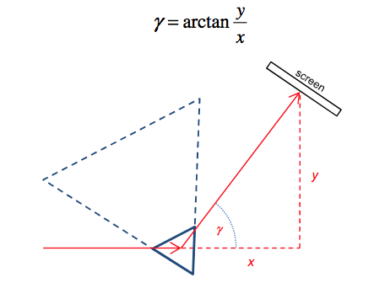
FİGURE 1.10: Measuring the Angle of Minimum Deviation in a Prism

Naturally, one can only roughly estimate the point that lies within the prism. But, the advantage of this method is that it is no longer necessary to determine the incident and refractive angles.

The setup shown in Figure 1.11 can be used to measure the angle of minimum deviation. When one turns the prism slightly in the beam, the position with the minimal deflection angle produces the most intense image. In order to obtain a sharp image, the position of the screen should also be moved back and forth somewhat until the optimum image is achieved. As the value of the refractive index of the prism glass is listed as 1.617 at 633 nm, we recommend measuring a red spectral line for ease of comparison. However, as a mercury vapor lamp is commonly available, we used an orange line of the mercury spectrum in the test example (Refer to Figure 1.11 for index of refraction data at other wavelengths.).

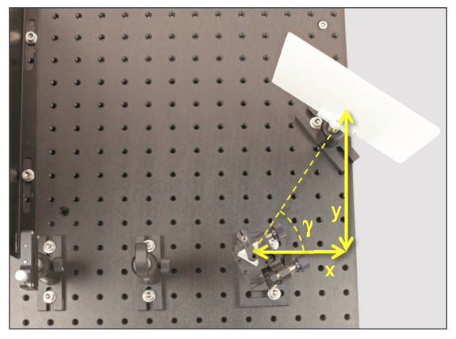
Figure 1.11: Measuring the Angle of Minimum Deviation

By measuring X and Y with a ruler, calculate the refractive index and compare your results with the reference values. Repear the measurements 3 times and use the mean values of X and Y to reduce the error on refractive index. Calculate the error percentage.

x(cm) | y(cm) | γ_{exp} (nm) | γ_{ref}(nm) | n_{exp} @ 579 nm | n_{ref} @633 nm
 |  |  |  |  | 1.62
 |  |  |  |  | 1.62
 |  |  |  |  | 1.62

