3.Hafta 7-9
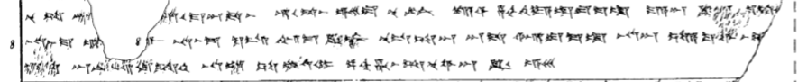
7 nu SA LÚ[^{MES} (a-pi-ya-ya)] hu-u-ma-an-da-as hu-u-da-as e-es-du nu ^{LÚ}KÚR kar-si za-ah-hi-ya-ad-du-ma-at ma-a-an KIN-[m]a ku-t-k[i]
8 na-as-ma u[-e-tum-m]ar na-as-ma ku-is im-ma KIN-az nu-us-sa-an an-da ar-du-ma-at na-an sa-a-ku-wa-as-s[a-ri-it]
9 ZI-[i]t an-ni-is-ki-it-ten na-at SA EGIR UD^{MI} pa-ah-ha-as-sa-nu-wa-an KIN e-es-[du]

