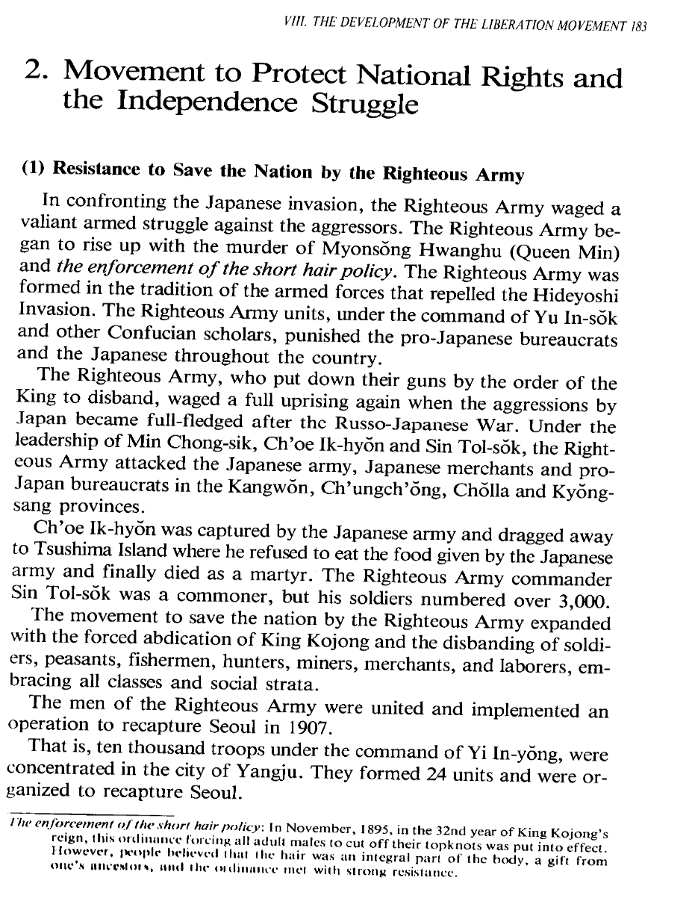
Resim 1 Radio Korea International Korean Broadcasting System. 1995. The History of Korea. Seoul
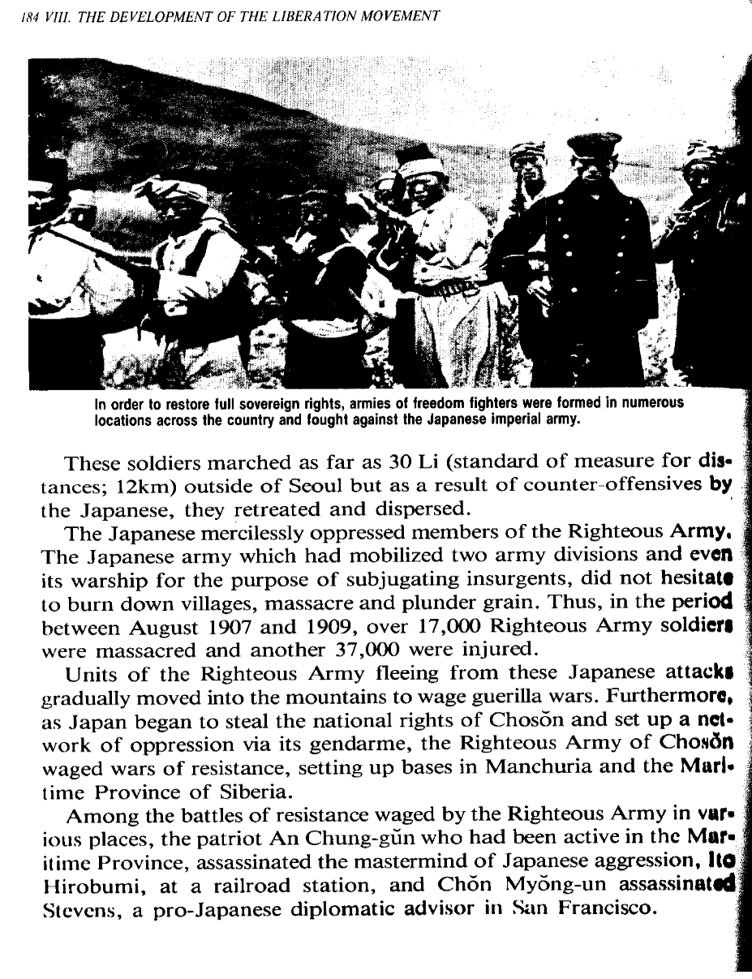
Resim 2 Radio Korea International Korean Broadcasting System. 1995. The History of Korea. Seoul
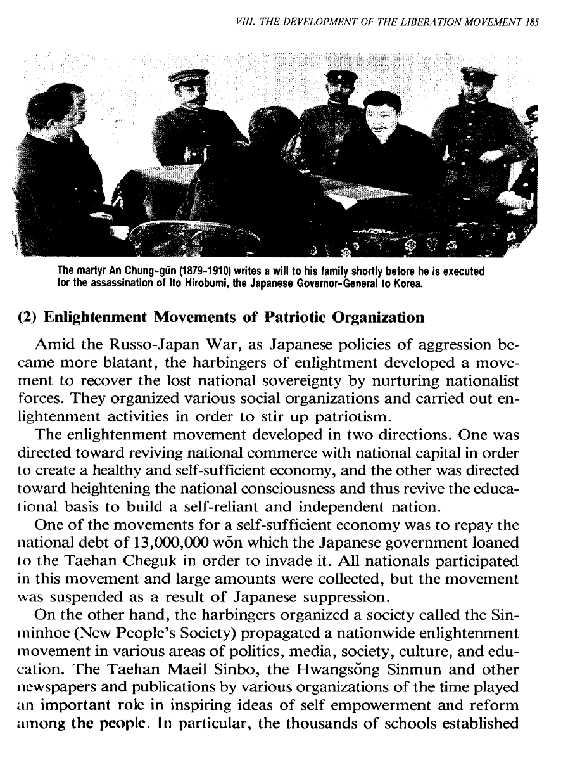
Resim 3 Radio Korea International Korean Broadcasting System. 1995. The History of Korea. Seoul
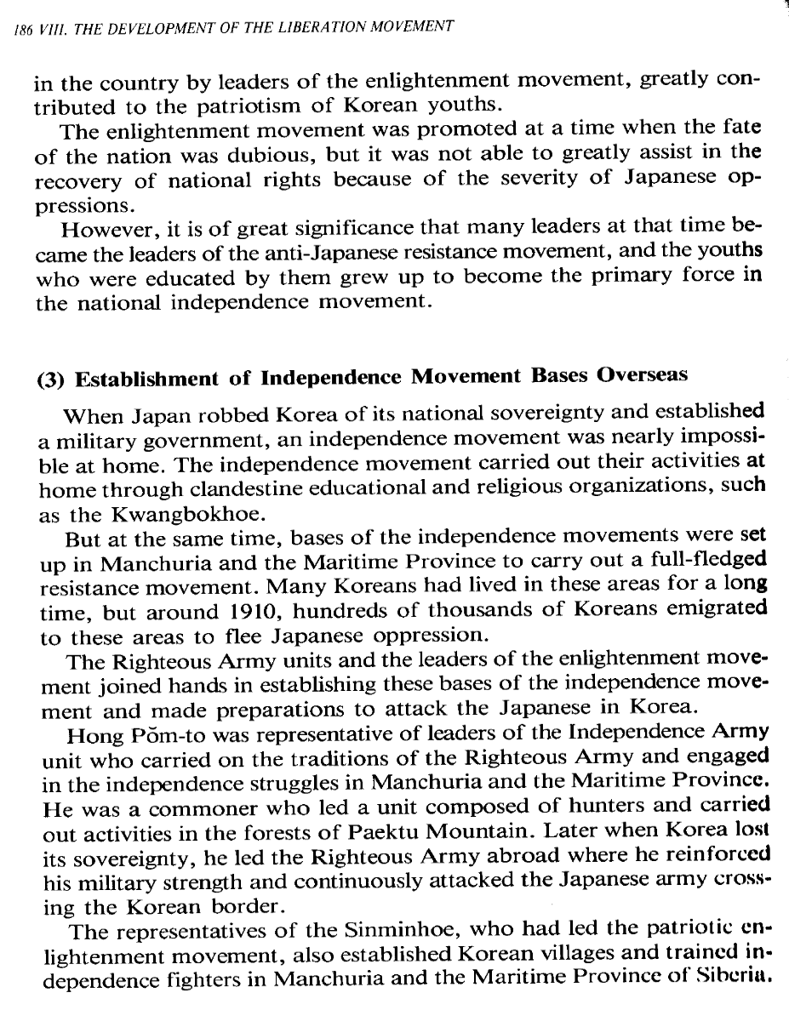
Resim 4 Radio Korea International Korean Broadcasting System. 1995. The History of Korea. Seoul
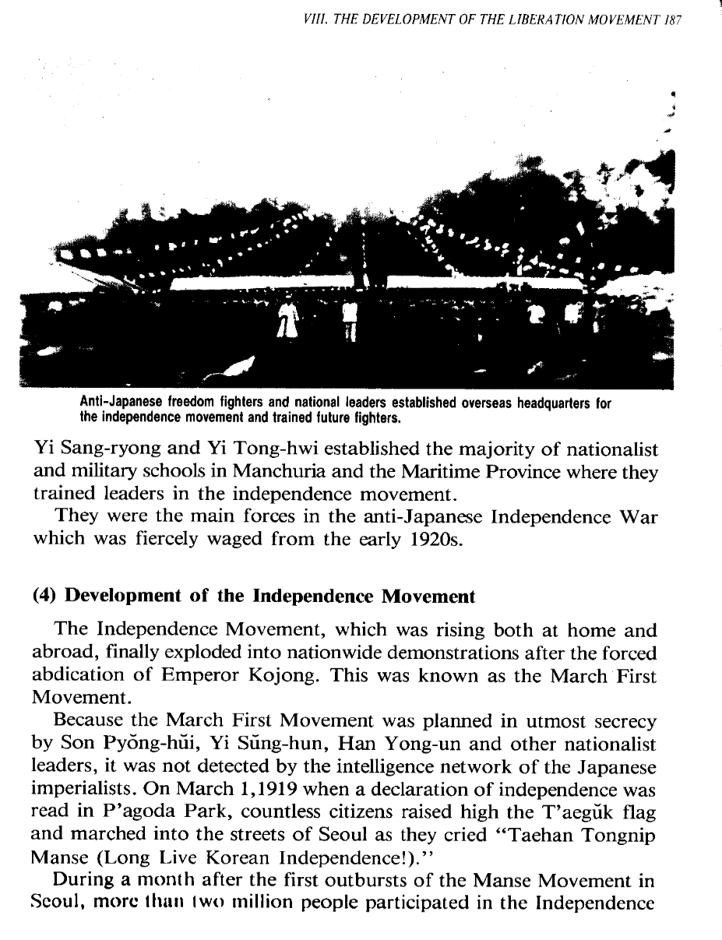
Resim 5 Radio Korea International Korean Broadcasting System. 1995. The History of Korea. Seoul
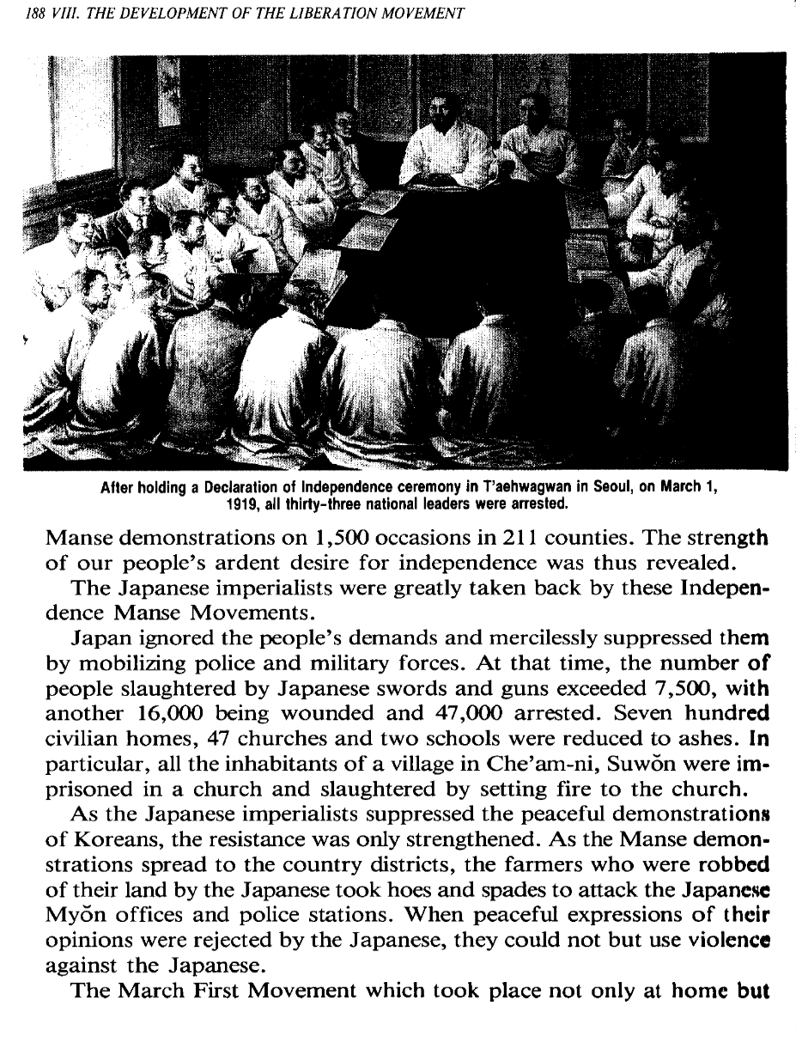
Resim 6 Radio Korea International Korean Broadcasting System. 1995. The History of Korea. Seoul
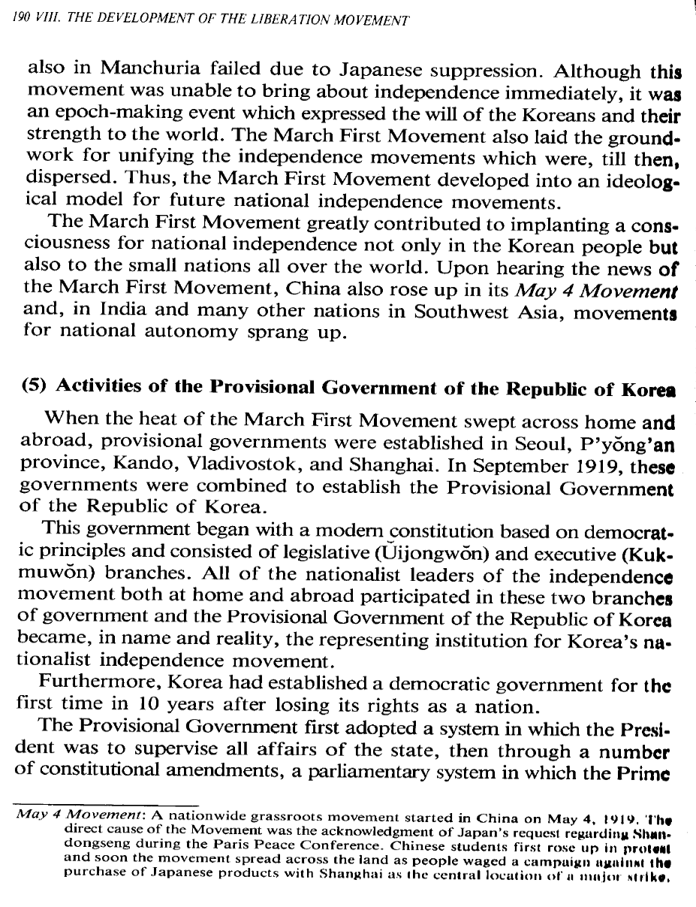
Resim 7 Radio Korea International Korean Broadcasting System. 1995. The History of Korea. Seoul
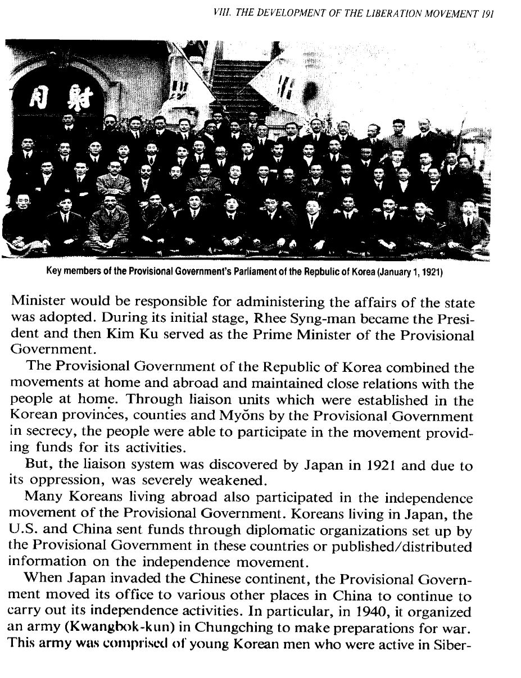
Resim 8 Radio Korea International Korean Broadcasting System. 1995. The History of Korea. Seoul
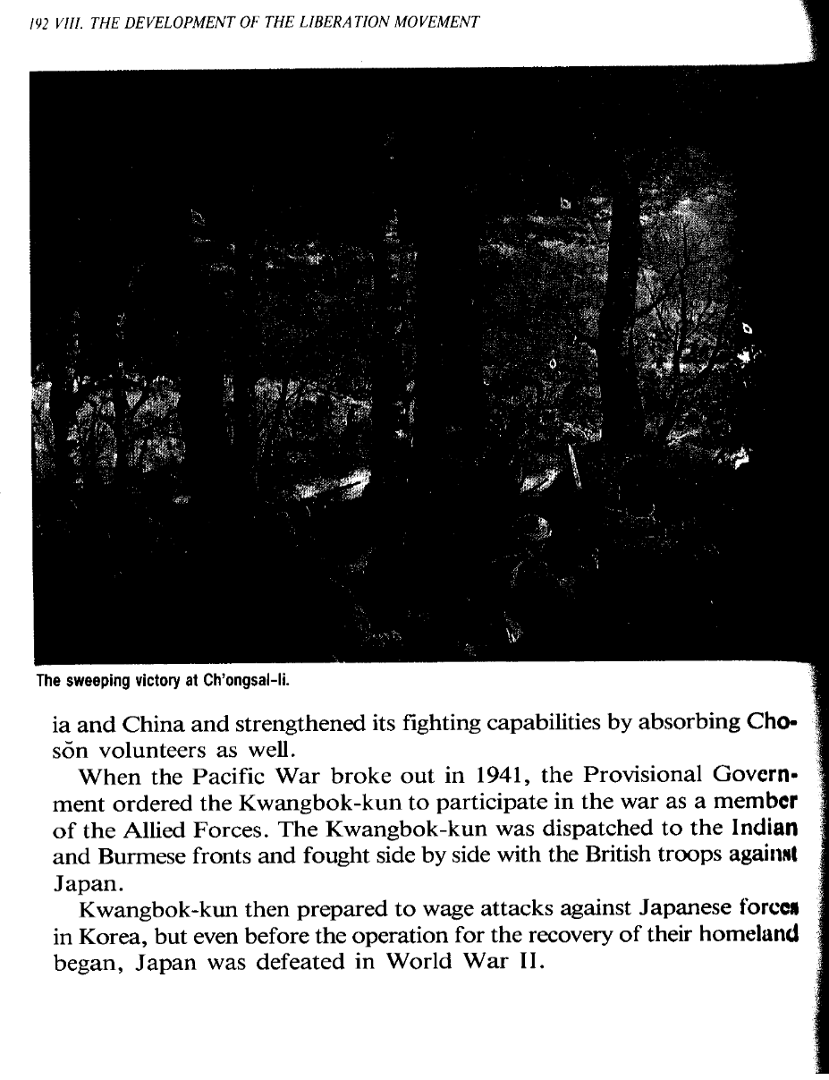
Resim 9 Radio Korea International Korean Broadcasting System. 1995. The History of Korea. Seoul
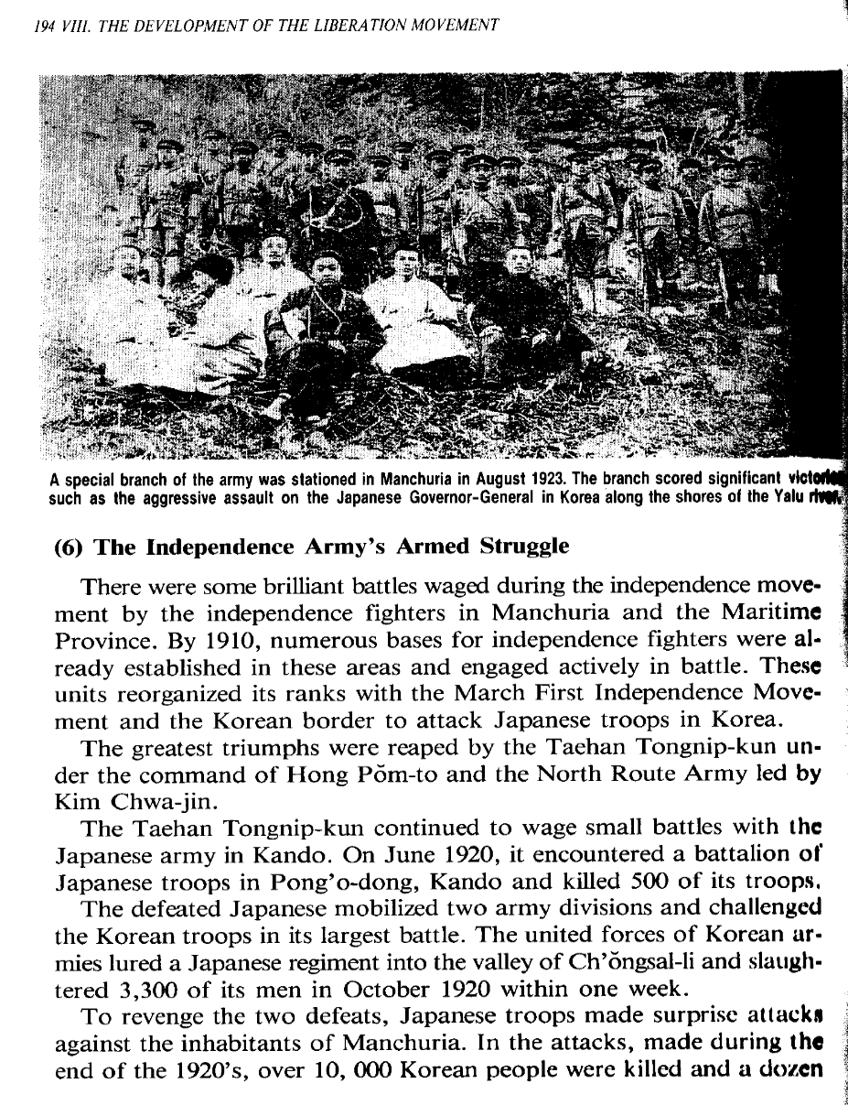
Resim 10 Radio Korea International Korean Broadcasting System. 1995. The History of Korea. Seoul
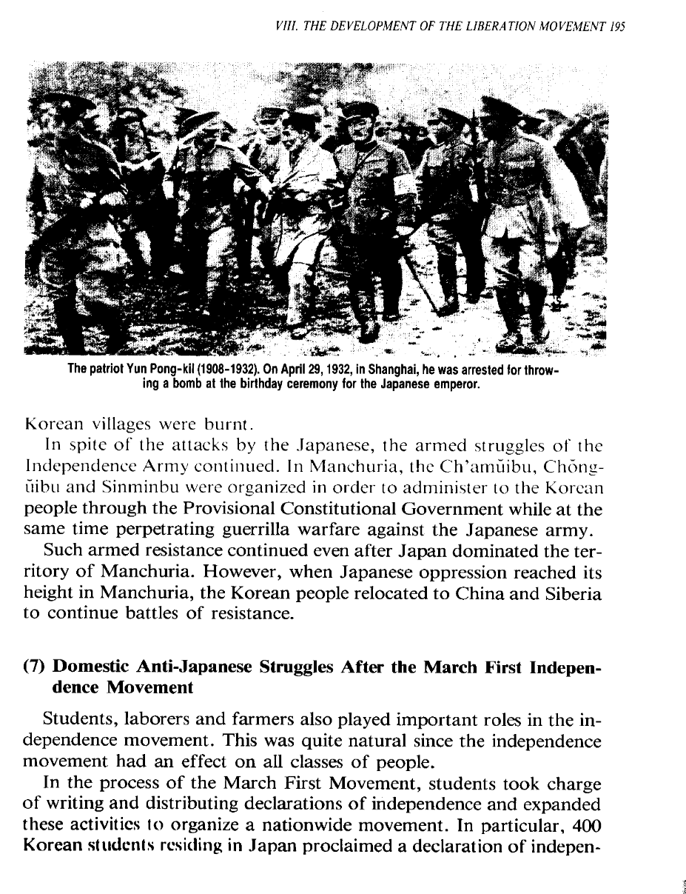
Resim 11 Radio Korea International Korean Broadcasting System. 1995. The History of Korea. Seoul
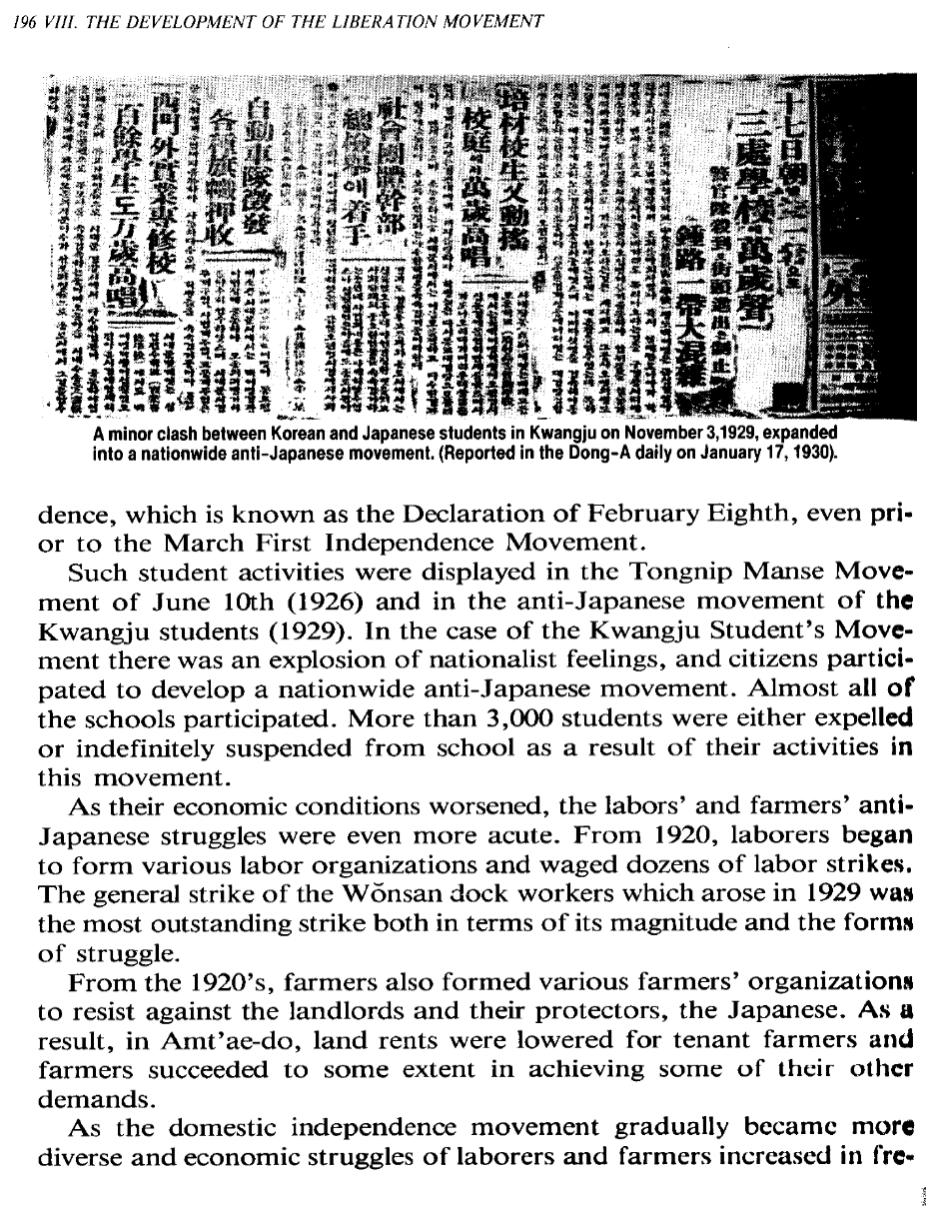
Resim 12 Radio Korea International Korean Broadcasting System. 1995. The History of Korea. Seoul

