5. Drying Technology
Drying is the oldest known food preservation technique. Fruits and vegetables in which this technique is widely applied are figs, apricots, grapes, bananas, cherries, pineapples, apples, onions, potatoes, carrots, peas and peppers. Drying process is also widely applied especially in cereals. Milk, fish, meat pasta, spices, coffee and tea are among the foods where this technique is widely applied^{[47]}.

With the drying process, the water in the food is removed and the moisture content of the food is reduced to a level where microorganisms cannot survive. As a result of drying, the water activity (a_{w}) value is reduced below 0.6.

Drying can be done sun-drying or in dryers. Other than sun-drying, the most expensive drying method is freeze drying, and the cheapest is tunnel drying. Whichever method is chosen, the basic principle is to reduce water activity. While the a_{w} value of water is 1.0, this value drops below 1.0 when there is a solute in water. The degree of degradation depends on the type and level of solute, the nature and physical character of the food^{[48]}.

During the drying process, the drying stops when the vapor pressure of the air equals the vapor pressure of the water on the surface of the food.

Different factors affect the drying rate. These can be summarized as follows^{[49]};
- The water between the cells is easily removed compared to the water inside the cell. If the cell is fragmented, removal is facilitated.
- As the particle size decreases, the drying speed increases.
- If the temperature of the air increases, drying accelerates.
- If the humidity of the air decreases, drying accelerates.
- As the air velocity increases, drying accelerates.
- If the stacking height of the food is reduced, drying accelerates.
- If vacuum is applied in drying, drying accelerates at first, then the effect of vacuum is less.

The relationship between the water content and the water activity of the food is shown by the sorption isotherms (Figure 7). Sorption isotherms can be generated from an adsorption process (starting from a dry system having zero water activity) or a desorption process (starting with a wet system having an a_{w} value of 1). The difference between these curves is defined as hysteresis. In other words, hysteresis is the situation in which the substance cannot fully regain the lost water. Hysteresis is observed in most hydroscopic foods. In the Figure 7, in region A, water is tightly bound. In region B, the water is less tightly held and usually present in small capillaries, and in region C, water is free or loosely held in large capillaries. Hysteresis is an indication that a thermodynamic equilibrium has not been reached^{[50-54]}.

Although the exact cause of hysteresis is not known, possible causes include^{[50]}:
- Due to the effect of capillary forces in the porous structure, the water content remains partially high (surface tension forces keep the water inside the pores during drying).
- Another reason may be the expansion and contractions that occur during water intake or quenching.

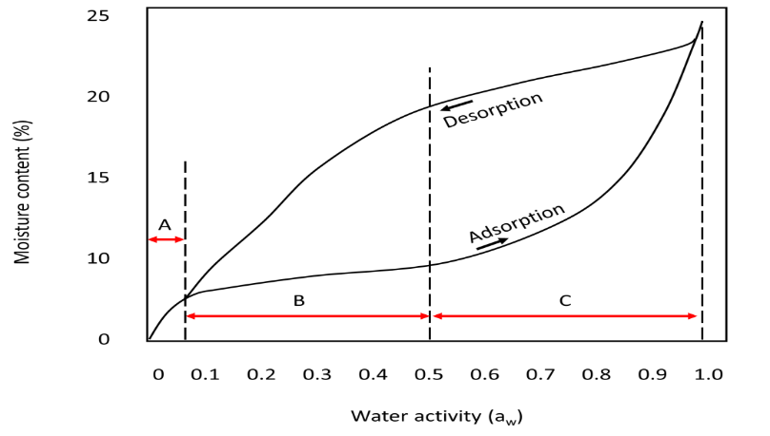
Figure 7 Sorption isotherm

Table: Relationship between water content and water activity
Food | Water (%) | Aw
Onions | 10 | 0,38
 | 20 | 0,73
 | 30 | 0,88
Potatoes | 5 | 0,12
 | 10 | 0,47
 | 15 | 0,69
Tomatoes | 10 | 0,44
 | 20 | 0,61
 | 30 | 0,69

The processes applied to fruits and vegetables after drying can be listed as follows^{[55]}:
- Moisture balancing: The moisture content of the dried product may not be the same. For this reason, the dried product is kept in airtight barrels or plastic bags for 1-2 days after cooling.
- Classification: Broken parts and foreign materials, if any, are separated. It should be done very quickly to prevent the product from absorbing moisture.
- Compression: Dried vegetables are in loose form and have large volume. This creates difficulties in terms of packaging and transportation. For this reason, some dried vegetables or fruits are compressed at 60-65°C, at a pressure of 20-80 kg-f/cm² (e.g. figs).
- Packaging: It is placed in plastic bags that are insulated against moisture and contain aluminum. These are also taken into corrugated cardboard boxes.
- Storage: The temperature should be around 20 °C (a little cooler is recommended as it is economical). The warehouse should be moisture-free, should not contain foreign odors, insects, etc.

Changes in the drying of fruits and vegetables^{[55-57]};
- During drying, soluble substances are carried to the surface along with water. As the water moves away, the dry matter level on the surface increases.
- It occurs as a result of incorrect selection of drying conditions. If high temperature is applied at the beginning of drying, the dry matter formed on the surface will shrink and pressurize the lower layers. The resulting crust causes the drying rate to decrease. It is more common in fruits, the outer part may become glassy.
- Mass density decreases.
- Rehydration ability differs depending on the success applied in drying.
- Color changes may occur with enzymatic or non-enzymatic processes. If vegetables are not blanched before drying, the temperature applied during drying is not enough to inactivate the enzymes and therefore enzymatic change occurs. The main problem is non-enzymatic change (Maillard reaction, ascorbic acid degradation, caramelization). Because in drying, the reaction is fast because both the temperature is high and the amount of reactant is high.
- In addition to color, sensory properties are also deteriorated. The nutritional value decreases. Caramelization occurs.
- Vitamin loss occurs before and after drying.

5.1. Drying Methods
There are many drying techniques. Selection of method depends on the food to be dried (liquid-solid-particle), the economy of the dryer and the investment cost. Dryers are generally classified in 3 groups as direct contact, infrared or dielectric and indirect dryers. Regardless of the type of dryer, it consists of 3 main parts. These are the energy source that will produce the thermal energy that will provide the phase change of the water in the food, the system that will move the food and the system that will remove the brude (exhaust steam) formed^{[15]}.

5.1.1. Sun Drying
Today, its use is gradually decreasing. It has been completely abandoned in developed countries.

5.1.2. Dryers Using Heated Air
Tray, tunnel or conveyor dryers are used^{[58]}.

In tray (or cabinet) dryers, perforated trays are placed in an insulated cabinet. Hot air is passed through the food at a height of 2-6 cm. These dryers are easy to install and operate, but have little capacity. The most important problem in these dryers is that homogeneous air circulation cannot always be achieved. The location of the trays may need to be changed from time to time.

Tunnel dryers are the most common type of dryer for drying fruits and vegetables. Similar to cabinet dryers, the trays are located on movable shelves. The process is semi-continuous. Raw material enters from one end and is taken from the other end after a certain time. The direction of the food and the direction of the air can be the same or opposite. In tunnel and tray (cab) dryers, the process is slow and the temperature must be kept low to avoid burning.

Conveyor (belt) dryers are very suitable for chopped fruits and vegetables. The food is placed on perforated metal or plastic belt. Generally, hot air is blown from the bottom. Air temperature, air circulation speed and direction, belt speed can be controlled separately. In foods with high humidity, the load height is low (5-6 cm) and the belt speed is high. In medium moisture foods, the height reaches 15-20 cm, the speed slows down. Towards the end of drying, the air direction is made from top to bottom. The humidity rate can be reduced from 80-90% to 5% in a single stage, or to 20% in a belt dryer and then to 5% in another dryer (e.g. tunnel dryer).

