4. Freezing Technology
Foods are complex substances and an important part of most food is water, whether or not the cellular structure is broken. The proportion of water reaches up to 95% in some vegetables. Water can be found inside and outside the cell. This water contains dissolved or suspended inorganic and organic salts, sugars, organic acids, proteins and sometimes gases. The presence of these water and other compounds means that the food is a good nutrient medium for microorganisms. With freezing, the water turns into the ice phase, that is, a state that microorganisms cannot use. In addition, microorganisms causing food poisoning and psychrophilic microorganisms can not function below -10°C. Freezing removes the latent heat of freezing (melting) of water (79.7 kcal/kg=335 kJ/kg). While the water molecules in the structure of the food freeze, small crystals are formed if the heat removal rate is high, and large crystals are formed if it is slow^{[7,25-27]}.

The freezing process is basically divided into three stages based on large temperature changes at a particular location in the product, as shown for pure water and food in Figure 5, respectively^{[27]}.

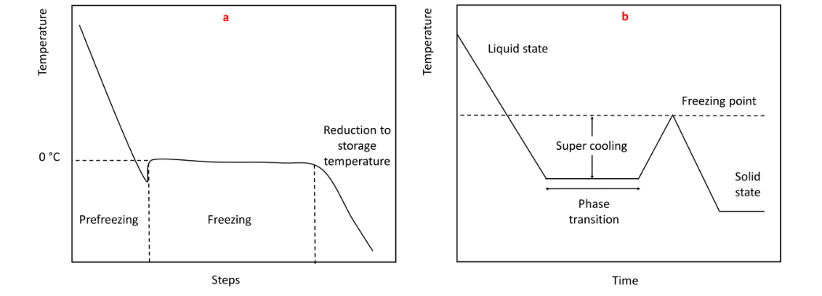
Figure 5 Graphical representation of the freezing process for pure water (a) and foods (b)

Starting from the pre-freezing stage, the food is frozen until the first ice crystal is formed. If it is pure water that is frozen, the freezing temperature is 0°C and it will be super cooled until this temperature, that is, until ice formation begins. At this stage, the temperature in foods drops below freezing and rises to freezing temperature with the formation of the first ice crystal. The second stage is the freezing stage, where a phase change occurs that turns water into ice. For pure water the temperature at this stage is constant, but decreases slightly in food due to the increased solute concentration in the unfrozen water portion. The final stage begins when the product temperature reaches the point at which the freezable water in the structure turns into maximum ice and ends when the temperature drops to the storage temperature^{[27]}.

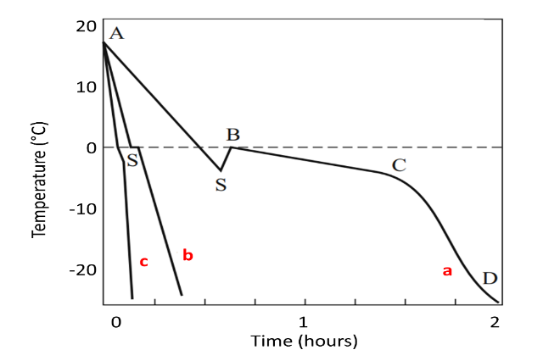
Figure 6 Freezing curves of foods at different temperatures; (a) very slow, (b) fast, (c) very fast.

Freezing time and freezing speed are the most important parameters in the design of freezing systems. While the quality of the frozen product is most affected by the freezing speed, the freezing time is calculated according to the freezing rate. Examining the temperature changes during freezing is very important to understand how products are processed. Typical freezing curves at different freezing rates are given in Figure 6^{[26]}. Here;
- When the product cools down to 0 °C, ice formation begins (A-S).
- Ice formation occurs when the product reaches a temperature below its freezing point (-5 °C to -9 °C). This process is known as subcooling (S).
- Due to the release of heat during initial ice formation, the temperature rises to the freezing point (B).
- Most tissue water freezes at a practically constant temperature (B-C), with a negative slope resulting from the drop in freezing point depending on the solute concentration.
- With a significant increase in solute concentration in the unfrozen part, the product is cooled to storage temperature (C-D)

Since it is more pure during freezing, the water in the intercellular space freezes first and the cells shrink as the water inside the cell moves to the ice mass. Therefore, the water inside and outside the cell must be turned into ice at the same time. The freezing process usually takes place between 0°C and -5°C. This zone, called the critical zone or the zone of maximum crystallization, must be passed quickly. In fact, the freezing point is not the only point. Because when the water in the food freezes, the amount of soluble matter in the remaining part increases and therefore the freezing point decreases. After a certain point the freezing point no longer falls, this is called the saturation point (last eutectic point, constant freezing temperature). The final eutectic point differs according to the food^{[15,28]}.

The freezing point of foods varies between -0.6 °C and -2.8 °C. It is free water that freezes during freezing. Food also contains water bound to ions and electrically charged particles. Bound water is not a solvent, it does not freeze at any temperature (also called non-freezing water). Approximately 8-10% of water in animal tissues and about 6% in fruits and vegetables is non-freezing water form^{[7]}.

In foods with intact cell structure, the following phenomena occur as a result of damage to the cell, that is, the mechanical effect of the ice outside the cell^{[29,30]}:
- Tissue loses its vitality. The molten tissue is mostly mushy.
- The cell loses its fluid (drip-loss).
- The cell loses its ability to swell or shrink in hypotonic or hypertonic solutions.
- Injury can also occur as a result of the cell protoplasm losing its water. In addition, some substances (e.g. ascorbic acid, copper) whose concentration increases in the cell cause adverse effects.

One of the most important points to be considered in the freezing process is that the food is frozen after it is made consumable, as in other food processing methods. All necessary pre-treatments are applied to fruits and vegetables before they are frozen^{[15]}.

4.1. Receiving of Fruits and Vegetables into Factory
Preservation of vegetables and fruits by freezing is a method in which they can be preserved as close to their fresh qualities. The use of quality raw materials in production is an important factor for a good quality frozen product. Vegetables to be used in freezing technology should be as tender as possible. Because vegetables are consumed after cooking. However, since the fruits are consumed without cooking, they must be fully ripe and in their natural softness^{[31,32]}.

If fruits and vegetables are not to be frozen immediately, they are placed in the cold room for short-term storage, and when processed, they are taken to the pre-processing line with transport systems.

4.2. Pre-treatments
The pre-treatments to be applied to the fruits and vegetables to be frozen include sorting, washing, separating the stem, end, peel and core and chopping.

4.3. Freezing Process
The freezing (shocking) process is defined as the phase change of the water inside and outside the cell from liquid state to ice state by transferring the heat energy contained in the structure of foodstuffs to a cooler.

The stages of the freezing process can be summarized as follows^{[33]}:
- Cooling the product temperature to freezing point.
- Freezing of the product forming ice crystals at the freezing point.
- Cooling the frozen product temperature to the desired storage temperature in the frozen structure.

In the freezing process, the water contained in the food is transformed into ice crystals, so that the microorganisms that cause deterioration cannot continue their vital activities and the chemical and biochemical changes are minimized, thus protecting the food in its most natural state.

The most important advantages of frozen foods are that they are processed products with the closest nutritional value to fresh because they are provided with the freezing method, which is a natural method, without the use of additives, they can be stored for a long time in suitable environments and they are practical foods because they are offered for consumption in a washed, sorted and ready-to-cook form^{[34]}.

The freezing rate also directly affects the formation of ice crystals. If the heat is removed slowly from the plant tissue, ice crystals form outside the cell and these crystals grow. Meanwhile, the osmotic pressure difference between the extracellular and the intracellular increases and water vapor transfer from the cell to the outside of the cell takes place. While this allows the extracellular crystals to grow further, ice crystals cannot form inside the cell. On the other hand, with fast freezing, ice crystals are again formed primarily outside the cell. However, this time, since the water inside the cell cannot be transferred to the outside of the cell at the same rate, the inside of the cell is also rapidly frozen. Fruits and vegetables are frozen quickly so that the ice crystals are small and homogeneous inside and outside the cell^{[32]}.

Factors affecting the freezing time of foods are^{[35]};
- The thermal conductivity coefficient and thickness of the food,
- Thermal conductivity coefficient and thickness of the packaging material,
- Surface area where heat transfer takes place,
- The temperature difference between the food and the environment.

In choosing the most suitable method for freezing fruits and vegetables, criteria such as the size of the food, physical qualities of the food, whether it is packaged, the desired freezing speed and production cost are important. The main purpose of freezing is to quickly pass the critical zone between 0°C and -5°C. Freezing can be done by different methods^{[36]}.

