The Origins of Life on Earth
Prebiotic/Biochemical Evolution

Biomolecules First Arose by Chemical Evolution
Apart from their occurrence in living organisms, organic compounds, including the basic biomolecules such as amino acids and carbohydrates, are found in only trace amounts in the earth’s crust, the sea, and the atmosphere. How did the first living organisms acquire their characteristic organic building blocks? In 1922, the biochemist Aleksandr I. Oparin proposed a theory for the origin of life early in the history of Earth, postulating that the atmosphere was very different from that of today. Rich in methane, ammonia, and water, and essentially devoid of oxygen, it was a reducing atmosphere, in contrast to the oxidizing environment of our era. In Oparin’s theory, electrical energy from lightning discharges or heat energy from volcanoes caused ammonia, methane, water vapor, and other components of the primitive atmosphere to react, forming simple organic compounds. These compounds then dissolved in the ancient seas, which over many millennia became enriched with a large variety of simple organic substances. In this warm solution (the “primordial soup”), some organic molecules had a greater tendency than others to associate into larger complexes. Over millions of years, these in turn assembled spontaneously to form membranes and catalysts (enzymes), which came together to become precursors of the earliest cells. Oparin’s views remained speculative for many years and appeared untestable—until a surprising experiment was conducted using simple equipment on a desktop.

Chemical Evolution Can Be Simulated in the Laboratory
The classic experiment on the abiotic (nonbiological) origin of organic biomolecules was carried out in 1953 by Stanley Miller in the laboratory of Harold Urey. Miller subjected gaseous mixtures of NH3, CH4, H2O, and H2 to electrical sparks produced across a pair of electrodes (to simulate lightning) for periods of a week or more, then analyzed the contents of the closed reaction vessel (Fig. 1). The gas phase of the resulting mixture contained CO and CO2, as well as the starting materials. The water phase contained a variety of organic compounds, including some amino acids, hydroxy acids, aldehydes, and hydrogen cyanide (HCN). This experiment established the possibility of abiotic production of biomolecules in relatively short times under relatively mild conditions. More refined laboratory experiments have provided good evidence that many of the chemical components of living cells, including polypeptides and RNA-like molecules, can form under these conditions. Polymers of RNA can act as catalysts in biologically significant reactions, and RNA probably played a crucial role in prebiotic evolution, both as catalyst and as information repository.
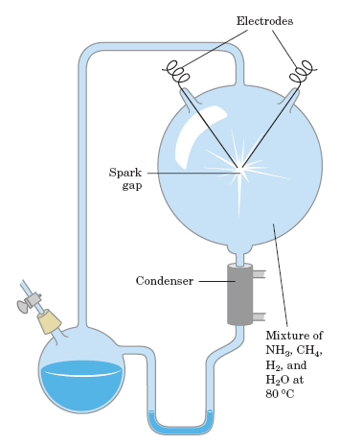
Figure 1: Abiotic production of biomolecules. Spark-discharge apparatus of the type used by Miller and Urey in experiments demonstrating abiotic formation of organic compounds under primitive atmospheric conditions. After subjection of the gaseous contents of the system to electrical sparks, products were collected by condensation. Biomolecules such as amino acids were among the products.

RNA or Related Precursors May Have Been the First Genes and Catalysts
In modern organisms, nucleic acids encode the genetic information that specifies the structure of enzymes, and enzymes catalyze the replication and repair of nucleic acids. The mutual dependence of these two classes of biomolecules brings up the perplexing question: which came first, DNA or protein? The answer may be: neither. The discovery that RNA molecules can act as catalysts in their own formation suggests that RNA or a similar molecule may have been the first gene and the first catalyst. According to this scenario (Fig. 2), one of the earliest stages of biological evolution was the chance formation, in the primordial soup, of an RNA molecule that could catalyze the formation of other RNA molecules of the same sequence—a self-replicating, self-perpetuating RNA. The concentration of a self-replicating RNA molecule would increase exponentially, as one molecule formed two, two formed four, and so on. The fidelity of self-replication was presumably less than perfect, so the process would generate variants of the RNA, some of which might be even better able to self-replicate. In the competition for nucleotides, the most efficient of the self-replicating sequences would win, and less efficient replicators would fade from the population. The division of function between DNA (genetic information storage) and protein (catalysis) was, according to the “RNA world” hypothesis, a later development. New variants of self-replicating RNA molecules developed, with the additional ability to catalyze the condensation of amino acids into peptides. Occasionally, the peptide(s) thus formed would reinforce the self-replicating ability of the RNA, and the pair—RNA molecule and helping peptide—could undergo further modifications in sequence, generating even more efficient self-replicating systems. The recent, remarkable discovery that, in the protein-synthesizing machinery of modern cells (ribosomes), RNA molecules, not proteins, catalyze the formation of peptide bonds is certainly consistent with the RNA world hypothesis. Some time after the evolution of this primitive protein-synthesizing system, there was a further development: DNA molecules with sequences complementary to the self-replicating RNA molecules took over the function of conserving the “genetic” information, and RNA molecules evolved to play roles in protein synthesis. The simplest explanation for this take over is that DNA is a more stable molecule than RNA and thus a better repository of inheritable information. Proteins proved to be versatile catalysts and, over time, took over that function. Lipid-like compounds in the primordial soup formed relatively impermeable layers around self-replicating collections of molecules. The concentration of proteins and nucleic acids within these lipid enclosures favored the molecular interactions required in self-replication.
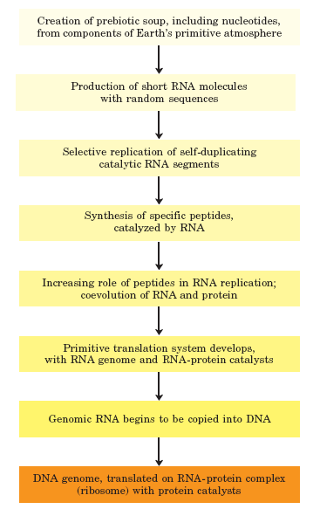
Figure 2: A possible “RNA world” scenario.

Biological Evolution Began More Than Three and a Half Billion Years Ago
Earth was formed about 4.5 billion years ago, and the first evidence of life dates to more than 3.5 billion years ago. In 1996, scientists working in Greenland found not fossil remains but chemical evidence of life from as far back as 3.85 billion years ago, forms of carbon embedded in rock that appear to have a distinctly biological origin. Somewhere on Earth during its first billion years there arose the first simple organism, capable of replicating its own structure from a template (RNA?) that was the first genetic material. Because the terrestrial atmosphere at the dawn of life was nearly devoid of oxygen, and because there were few microorganisms to scavenge organic compounds formed by natural processes, these compounds were relatively stable. Given this stability and eons of time, the improbable became inevitable: the organic compounds were incorporated into evolving cells to produce increasingly effective self-reproducing catalysts. The process of biological evolution had begun.

The First Cell Was Probably a Chemoheterotroph
The earliest cells that arose in the rich mixture of organic compounds, the primordial soup of prebiotic times, were almost certainly chemoheterotrophs. The organic compounds they required were originally synthesized from components of the early atmosphere— CO, CO2, N2, CH4, and such—by the nonbiological actions of volcanic heat and lightning. Early heterotrophs gradually acquired the ability to derive energy from compounds in their environment and to use that energy to synthesize more of their own precursor molecules, thereby becoming less dependent on outside sources. A very significant evolutionary event was the development of pigments capable of capturing the energy of light from the sun, which could be used to reduce, or “fix,” CO2 to form more complex, organic compounds. The original electron donor for these photosynthetic processes was probably H2S, yielding elemental sulfur or sulfate (SO4 2) as the by-product, but later cells developed the enzymatic capacity to use H2O as the electron donor in photosynthetic reactions, eliminating O2 as waste. Cyanobacteria are the modern descendants of these early photosynthetic oxygen-producers. Because the atmosphere of Earth in the earliest stages of biological evolution was nearly devoid of oxygen, the earliest cells were anaerobic. Under these conditions, chemoheterotrophs could oxidize organic compounds to CO2 by passing electrons not to O2 but to acceptors such as SO4 2, yielding H2S as the product. With the rise of O2-producing photosynthetic bacteria, the atmosphere became progressively richer in oxygen—a powerful oxidant and deadly poison to anaerobes. Responding to the evolutionary pressure of the “oxygen holocaust,” some lineages of microorganisms gave rise to aerobes that obtained energy by passing electrons from fuel molecules to oxygen. Because the transfer of electrons from organic molecules to O2 releases a great deal of energy, aerobic organisms had an energetic advantage over their anaerobic counterparts when both competed in an environment containing oxygen. This advantage translated into the predominance of aerobic organisms in O2-rich environments. Modern bacteria inhabit almost every ecological niche in the biosphere, and there are bacteria capable of using virtually every type of organic compound as a source of carbon and energy. Photosynthetic bacteria in both fresh and marine waters trap solar energy and use it to generate carbohydrates and all other cell constituents, which are in turn used as food by other forms of life. The process of evolution continues—and in rapidly reproducing bacterial cells, on a time scale that allows us to witness it in the laboratory.

Eukaryotic Cells Evolved from Prokaryotes in Several Stages
Starting about 1.5 billion years ago, the fossil record begins to show evidence of larger and more complex organisms, probably the earliest eukaryotic cells (Fig. 3).
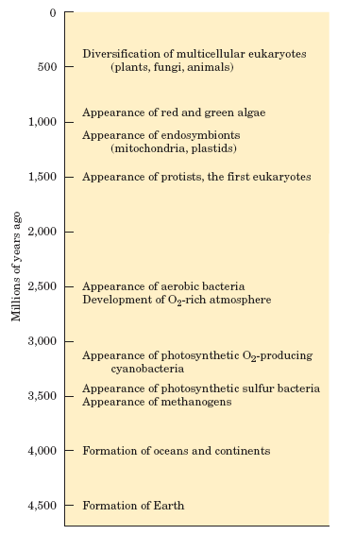
Figure 3: Landmarks in the evolution of life on Earth.
Details of the evolutionary path from prokaryotes to eukaryotes cannot be deduced from the fossil record alone, but morphological and biochemical comparisons of modern organisms have suggested a sequence of events consistent with the fossil evidence. Three major changes must have occurred as prokaryotes gave rise to eukaryotes. First, as cells acquired more DNA, the mechanisms required to fold it compactly into discrete complexes with specific proteins and to divide it equally between daughter cells at cell division became more elaborate. For this, specialized proteins were required to stabilize folded DNA and to pull the resulting DNA-protein complexes (chromosomes) apart during cell division. Second, as cells became larger, a system of intracellular membranes developed, including a double membrane surrounding the DNA. This membrane segregated the nuclear process of RNA synthesis on a DNA template from the cytoplasmic process of protein synthesis on ribosomes. Finally, early eukaryotic cells, which were incapable of photosynthesis or aerobic metabolism, enveloped aerobic bacteria or photosynthetic bacteria to form endosymbiotic associations that became permanent (Fig. 4). Some aerobic bacteria evolved into the mitochondria of modern eukaryotes, and some photosynthetic cyanobacteria became the plastids, such as the chloroplasts of green algae, the likely ancestors of modern plant cells. At some later stage of evolution, unicellular organisms found it advantageous to cluster together, thereby acquiring greater motility, efficiency, or reproductive success than their free-living single-celled competitors. Further evolution of such clustered organisms led to permanent associations among individual cells and eventually to specialization within the colony—to cellular differentiation. The advantages of cellular specialization led to the evolution of ever more complex and highly differentiated organisms, in which some cells carried out the sensory functions, others the digestive, photosynthetic, or reproductive functions, and so forth. Many modern multicellular organisms contain hundreds of different cell types, each specialized for some function that supports the entire organism. Fundamental mechanisms that evolved early have been further refined and embellished through evolution. The same basic structures and mechanisms that underlie the beating motion of cilia in Paramecium and of flagella in Chlamydomonas are employed by the highly differentiated vertebrate sperm cell.
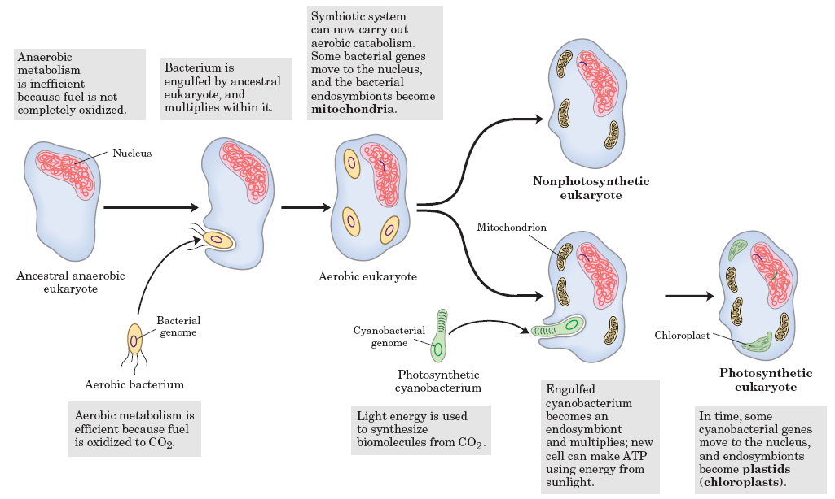
Figure 4: Evolution of eukaryotes through endosymbiosis. The earliest eukaryote, an anaerobe, acquired endosymbiotic purple bacteria (yellow), which carried with them their capacity for aerobic catabolism and became, over time, mitochondria. When photosynthetic cyanobacteria (green) subsequently became endosymbionts of some aerobic eukaryotes, these cells became the photosynthetic precursors of modern green algae and plants.

Reference:

Lehninger-Principles of Biochemistry
Author(s): Albert Lehninger, David L. Nelson, Michael M. Cox
Publisher: W. H. Freeman, Year: 2008
ISBN: 9781429224161,1429224169

