3.Hafta

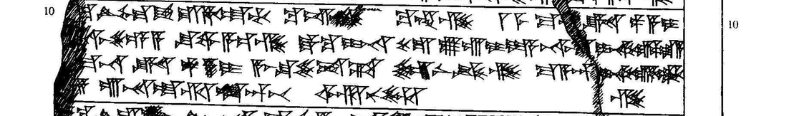

10 [(ták)]-ku ^{LÚ}DAM.GÀR ^{URU}Ha-at-ti ku-iš-ki ku-en-zi 1 ME MA.N[(A)] KÙ.BABBAR pa-a-i
11 [(pár-n)]a-aš-še-e-a šu-wa-a-ez-zi ták-ku I-NA KUR ^{URU}Lu-ú-i-ya na-aš[(-m)]a I-NA KUR ^{URU}Pa-la-a
12 [(I ME)] MA.NA KÙ.BABBAR pa-a-i a-aš-šu-še-et-ta šar-ni-ik-zi ma-a-an I-NA KUR ^{URU}Ha-at-ti
13 [(nu-)]za ú-na-at-tal-la-an-pát ar-nu-uz-zi

