MATERIAL INFORMATION

2.INTERNAL STRUCTURE OF MATERIALS

The raw materials found in nature are in various components and their mixtures. Raw materials are first separated into compounds by physical methods, and these are separated into elements by chemical methods. The elements consist of atoms with the same atomic numbers. Atoms form the cornerstone of materials.

2.1.Structure of the atom

An atom is defined as the smallest unit in which an element can be divided without losing its chemical properties. Each atom consists of a nucleus and the surrounding electrons. Since the number of electrons and protons in the atom is equal, the entire atom is electrically neutral. When electron and proton numbers are different, it's called ion. The nucleus forms an important part of the mass of the atom. The mass of each proton and neutron is approximately 9.11 x 10⁻²⁸ g. Atomic mass, on the other hand, equals the average number of protons and neutrons in an atom and meets the mass of the atom as much as the number of Avogadros. Therefore, a gram of neutrons or protons contains as many as 6.02 x 10²³ particles. The atomic number of an element is equal to the number of protons or electrons in each atom and determines its location in the periodic chart. Electrons determine the atomic bond character of an atom. With their energies, electrons make rotational movements in orbits called energy shells around the nucleus. Electrons in each shell have different energy levels.

2.1.1.Electricals and features

The energy levels of electrons rise as they move away from the nucleus. The energy levels of free electrons are indicated as zero. An atom has up to two electrons at the same energy level. These electrons spin in the opposite direction (rotating around their axis). With their energy, electrons make rotational movements around the nucleus in orbits called energy shells. The number of electrons in the energy shells of atoms follows therule^{2 n 2.} In this representation, n is the shell number.
Electrons in the outer exopliation of an atom are called valans electrons. Valans electrons are poorly connected to the nucleus and determine the properties of the elements to which they belong. The elements are included in 8 groups in the periodic schedule according to the number of valence electrons with a maximum of 8 pieces. The elements in the group with a number of valans electrons are stable, which does not interact with the outside. Elements with a different number of valans electrons than 8 enter the electron exchange with the outside. In the periodic schedule, the atoms of elements (ametals) with more than 3 valans electrons take electrons from the outside and become negative (-) charged ions. Elements (metals) with less than 3 valans electrons give electrons to the outside, making them positive (+) loaded ions. Thus, interatomic bonds are formed between negative and positive ions on the basis of Coulomb tensile force.

2.2.Interatomic Bonds

The interconnecting of atoms is formed by the common use or transfer of valence electrons. The bonds that occur in this way (ionic and coony bonds) are quite strong. On the other hand, without the common use or transfer of electrons, there are also weak gravitational forces (Van der Waals bonds) between atoms or molecules.

Materials with strong atomic bond strength have high formatting resistance and melting temperature, and low thermal expansion.

Ion Bond: It is found in the majority of non-metal inorganic substances. Valans occurs when electrons are displaced and the opposite charges of atoms that become ions attract each other. In this bond formed by electron transfer, the atom that gives electrons is loaded positively (+) and becomes cation, while the atom that receives electrons becomes negative (-) charged and anionized. Thus, the opposite charged ions attract each other and an ionic bond is formed between them. While materials with ionic bonds do not have electrical conductivity in solid form, they gain electrolyte properties due to the mobility of ions in liquid solutions. In the NaCl molecule, the transfer of an electron from the Na atom to the Cl atom consists of the Na cation and cl ion. NaCl or food salt occurs when these two opposite loads attract each other Figure 2.1).

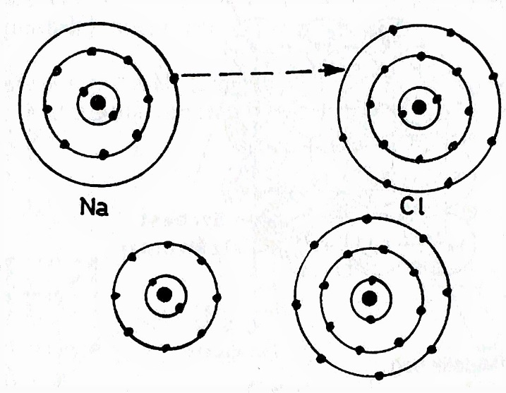
Figure 2.1. Ion bond

Valans Bond – Covariant Bond: Some atoms jointly use valans electrons by sharing them with another or more atoms. Thus, with the help of bridges consisting of two electrons, they stabilize their external orbits. A valans bond is formed between shared (-) charged electrons (+) and loaded atomic nuclei. Examples of hydrogen and methane molecules can be given in this bond (Figure 2.2). It has a diamond valans bond.

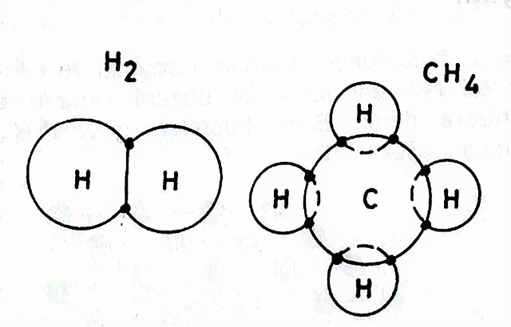

Figure 2.2. Valans bond

Metallic Bond : In metals with a maximum of three waltz electrons, electrons are easily separated from the nucleus because they are poorly connected to the nucleus. Because the electric cloud (-) is loaded and the nuclei (+) are loaded, the atoms are strongly connected to each other. Metals transmit electricity and heat well due to these free electrons Figure 2.3).

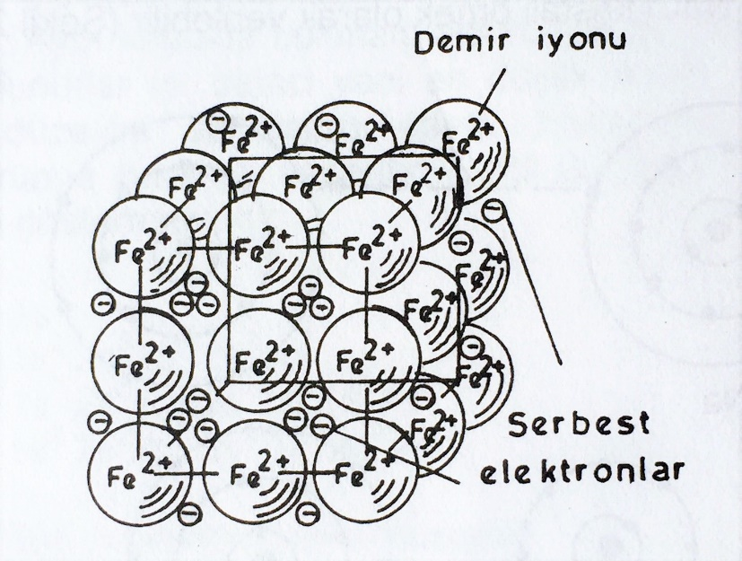
Figure 2.3. Metallic bond

Van der Waals bond or secondary bond

Van der Waals bonds are seen in the bonding of groups of molecules or atoms with weak electrostatic shots. The atoms in these molecules are connected to each other by ionic or cod bond. For example, if the water is heated to the boiling point, the Van der Waals bonds will break and become water spring. But higher temperatures are needed to break the cod bond between hydrogen and oxygen atoms. Therefore, the Van derr Waals bond is defined as a secondary bond.

2.3. Sequence of Atoms

Atomic sequenching is very important in determining the properties and behavior patterns of the material.

According to the formation of atoms, 3 different structures appear: crystal, molecular and amorphous.

2.3.1.Crystal structure

In one part of solid materials, atoms have a 3D and repeated sequence. It's called a crystal structure. All metals, most ceramics and some plastics are crystal lattice structure.

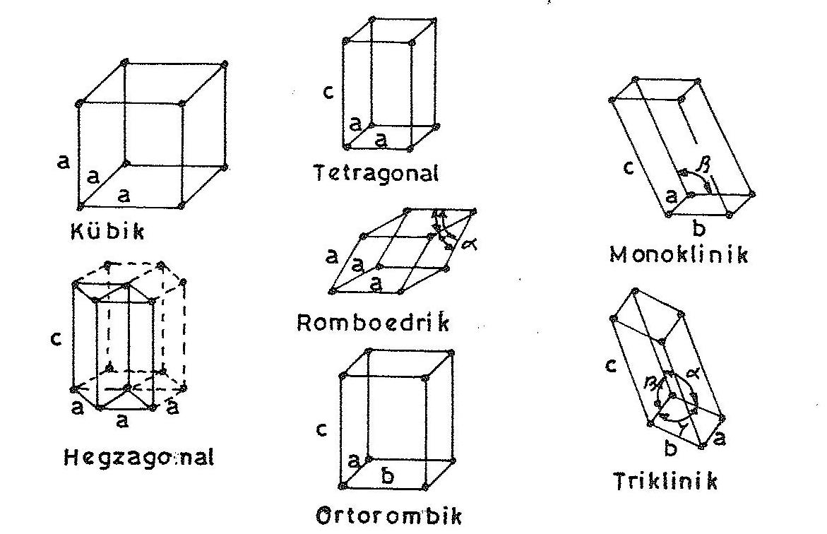

Figure 2.4. Main types of crystals

All crystal mesh consists of 14 different types. The main types of these are 7; cubic, hexagonal, orthomic, romboedric, tetragonal, monoclinic and tricyclic Figure 2.4).

The smallest volumetric unit of crystalline structures, which is repeated continuously, is called 'unit cell'. The difference of crystal structures consists of the dimensions of the unit cell edges and the angles between the edges (Table 2.1).

