RATE LAWS
The homogeneous reaction involves only one phase. The heterogeneous reaction includes more than one phase, and the reaction usually takes place at the interface between the heterogeneous phases.
The irreversible reaction occurs only in one direction and continues in that direction until all reactants are consumed. Different from the irreversible reaction, the reversible reaction can occur in either direction, depending on the concentrations of reactants and products relative to the corresponding equilibrium concentrations.
The molecularity of any kind of reactions is the number of atoms, ions or molecule colliding in a given reaction.
The notation unimolecular refers to reactions containing one atom (or molecule) decomposing in any one reaction step. The notation bimolecular refer to reactions containing two atoms (or molecules) colliding in any one reaction step. The notation termolecular refer to reactions containing three atoms (or molecules) colliding in any one reaction step.
The most known example of a unimolecular reaction is radioactive decay of uranium as shown below:
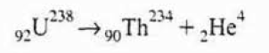
The disappearance or decomposition rate of uranium (U) can be illustrated by the following rate law:
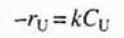
As an example for the bimolecular reaction can shown below:
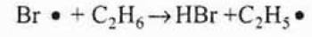
The disappearance rate of bromine (Br) can be illustrated by the following rate law:
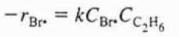
The probability of a termolecular reaction taking place is almost low, and Most of time, the reaction pathway foIlows a series of bimolecular reactions as shown below:
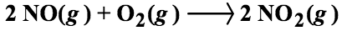
The rate law for the given reaction is illustrated below:
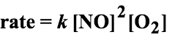
The reaction pathway for the given reaction is quite complex. The proposed reaction pathway for the given reaction is
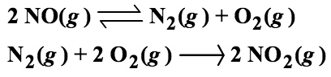
Relative Rates of Reaction
The relative rates of reaction of the various species involved in a given reaction can
be determined from the ratio of stoichiometric coefficients:
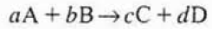
The relationship can be obtained directly from the given stoichiometry of any kind of reaction as followings:
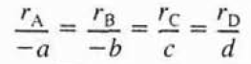
The relationship for the following reacion can be obtained directly from the given stoichiometry:
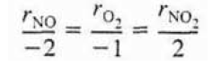
The Reaction Order and the Rate Law
In the chemical reactions, the limiting reactant is usually chosen as the basis for reaction calculations. The disappearance rate of the reacant “A”, -rA,, depends on temperature and composition of the reactant within the reactor.
For most of the times. it can be written as the product of a reaction rate constant “k”, which is direct function of temperature, and the concentrations of the various species of in the reaction:
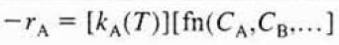

Power Law Models And Elementary Rate Laws
The rate law is the product of concentration of the individual reacting species, each of which is raised to a power as shown below:
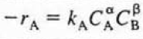
The exponents of the concentrations of the reacting species in the given equation lead to the concept of reaction order. The order of any kinds of reaction refers to the powers to which the concentrations are raised in the kinetic rate law.
In the given equation, the reaction is α order with respect to reactant A and β order with respect to the reactant B. The overall order of the given reaction is:
N = α + β
The rate law corresponding to a zero order reaction, together with typical unit for the corresponding rate constants “k”:
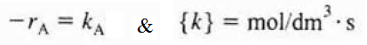
The rate law corresponding to a first order reaction, together with typical unit for the corresponding rate constants “k”:
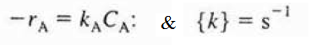
The rate law corresponding to a second order reaction, together with typical unit for the corresponding rate constants “k”:
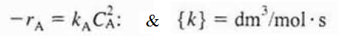
The rate law corresponding to a third order reaction, together with typical unit for the corresponding rate constants “k”:

References:
- H. Scott Fogler, “Elements of Chemical Reaction Engineering”, Prentice Hall Professional Technical Reference, Fourth Edition.

