Life Cycle and Lactation Cycle of Dairy Cows
Life Cycle of Typical Milk Producing Dairy Cow

Birth – 0 DAYS OLD
When a calf is born it is taken away from the dam after only a few hours of life. This is done to ensure that the mother and calf do not become too attached to each other, as this will make the weaning process and the separation process much more stressful for both the animals and the stock keeper. If calves were left with their mother, they would suckle from her for several months, sometimes even up to a year.
If the calf is male there are several possible options for its future: it can be castrated and raised as a steer; kept entire and used for future breeding (only healthy, well-bred calves are used for this); or used for as a source of semen for Artificial Insemination (AI) programmes (only the a small percentage of the best, usually pure bred, bull calves are used for this process).
In the case of a female calf, the calf can either be raised as a replacement milker for the main milking herd or raised on behalf of a buyer who will buy the calf when it is of correct age and weight.

Post-Birth Period to Weaning 1 DAY – 6/8 WEEKS OLD
(In the case of a female calf) After being removed from the dam, a calf will be fed milk or milk replacer until 6-8 weeks of age. This age is known as the weaning age, at which the calf will be transferred onto a milk-free diet, consisting of high-energy and concentrated nutritional feed as well as forages found on pasture, in order to tone the physiology of the calf into a milk-producing vessel. From around one week of age, calves should be offered starter feed which will prepare it for weaning from milk.
Prior to weaning, calves are vaccinated, dehorned, have extra teats removed and some male calves are castrated.

Breeding Period – 15 MONTHS OLD
The calf, which is known as known as a heifer (a female cow before it has calved, usually less than 2 years of age) is raised until it reaches appropriate breeding age which is around 15 months of age. If the calf has not reached a target weight, it will be left to grow a little longer, in some cases the calf reaches target weight earlier and so is put into calf slightly earlier.
It is necessary to mate a heifer with a bull (mature male cow) in order for her to become pregnant and consequently start producing milk. A female cow must calve once a year in order to maintain maximum milk production.
At approximately 15 months of age the heifer (which has never calved or produced milk before) is mated with the bull, or artificially inseminated with bull semen in order for her to conceive/become pregnant.

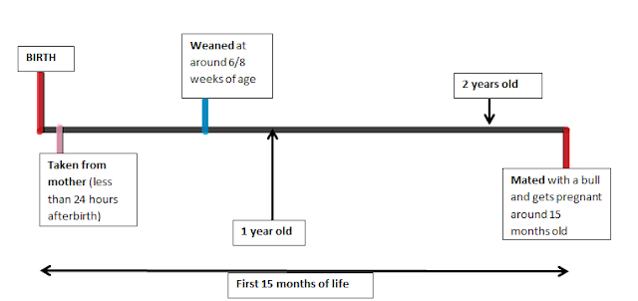

Gestation and Parturition – 24 MONTHS OLD
If the heifer was put in calf at 15 months of age, she should calf at around 24 months of age. Therefore the period of gestation (pregnancy) lasts around 9 months. Throughout this period the heifer will continue to grow and develop, however will not reach full size until around 4 years of age.
When the heifer has delivered her calf, her milk production will have started in order to provide colostrum (first milk/yellow milk/boystins) in order to maintain the health of her calf. At this point, her calf is taken away and she is milked to maximum capacity.

Milking Cow – 24 MONTHS OLD
The heifer (which is now known as a cow, because it has calved) will now start her period of milk production (lactation) which she would naturally do in order to feed her calf. This period lasts from the time of calving to the time of drying off; naturally, without human intervention, it would last around 10-12 months but is usually forcibly stopped at around 10 months of lactation in order for the cow to go into a dry period before her next calving.
A cow can be ready to calve again around 3 weeks after giving birth and at every 3 weeks after this point (as this is when the cow is ‘in heat’). Generally it is aimed for cows to calve 12 months after from their parturition. If a cow is put back into calf at the earliest opportunity (approx. 1 month after a calf) then she will be dried off after only 7 months of the lactation period (which can last up to 12 months) meaning that production of milk is prematurely halted. To increase the milk yield duration of the cow, the cow can be put into calf at around 2/3 months (around 50 days) after her previous calving date, which will extend the amount of time she can be milked for while she is still lactating.
I.e. 3 months after her calving, becomes pregnant again which will last 9 months. 3 months of being milked + 9 months of gestation while being milked would give 12 months of possible milk yield duration, but the drying period must be taken into account, which is 2 months before calving … therefore 10 months of milking can be achieved.
A dry period is when the cow is not milked and stops producing milk in order to give the cow’s body a rest and a chance to regenerate rebuild and resynthesize in the milk producing machinery (udder and teat). It lasts for around 60 days and is very beneficial to the cow.
Following this dry period of 60 days, the cow will calve again and the lactation cycle will begin again.
For cows, the period of 60 days prior to calving and 40 days after calving, this is known as the transition period. They make a transition between not being milked, to producing very high volumes of milk and to a high energy ration.

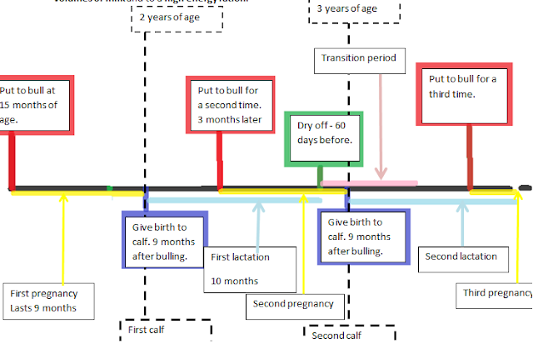

Summary:
· At 15 months of age, a heifer (young female cow) is ready to breed and has never produced milk before.
· A young female cow (heifer) has her first calf at about 2 years of age. After calving she is known as a cow.
· Once she has calved she starts her lactation cycle, which can last up to 12 months, but production of milk declines after around 10 months of lactation.
· Throughout the lactation cycle she is milked and during this period is also mated with a bull.
· 7 after months after mating, at around 60 days before calving (for the second time) she is put onto a dry period, at which time her lactation cycle ends and she is no longer being milked.

· After her calf is delivered, the lactation cycle begins again and the whole process is repeated.

