Biological Membranes
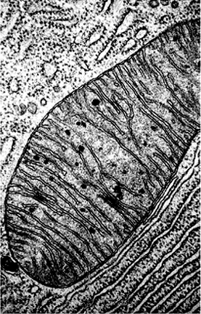
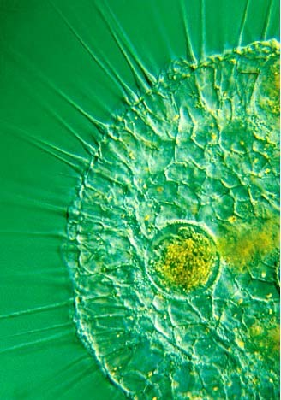
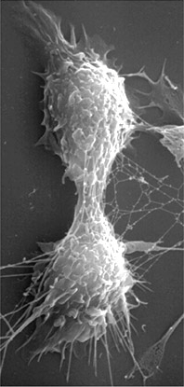

The organization of cells is made possible by membranes. Membranes isolate, partition, and compartmentalize cells.
1

Membranes
- isolate the inside of the cell from the outside - maintains the order of the cell
- regulate the movement of materials into and out of the cell
- compartmentalize the interior of cells and allows the creation of specialized regions within the cell
- provide a site for many chemical reactions - on or within membranes
- serve as the site of many chemical receptors - provide information about the outside environment
- serve as the site for many chemical identifiers - provide information about the cell to other cells

2

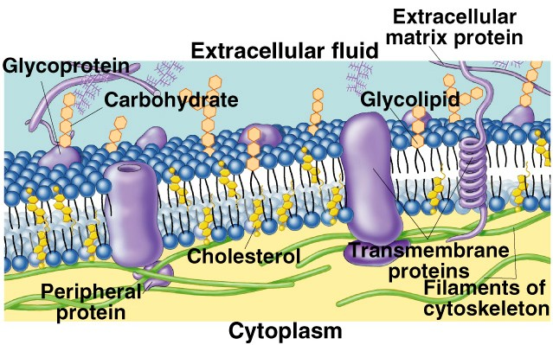
Cell and plasma membranes have a "fluid-mosaic” structure It has nonrigid arrangement of mobile lipids and proteins.
3

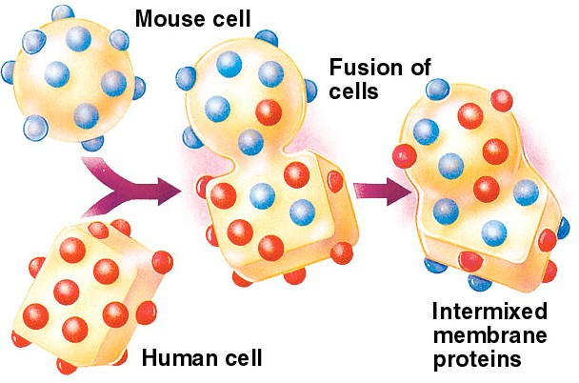
Human-Mouse Cell-Hybridization provides evidence for the fluid nature of membranes.

4

The basis of the behavior of cell membrane is largely due to the behavior of phospholipids in water.

Phospholipids are called amphipathic molecules - they have both polar and nonpolar regions within the same molecule.

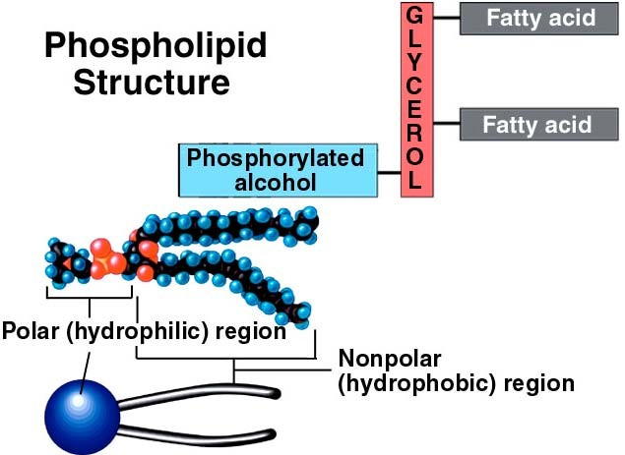
Polar head - charged - hydrophilic - hydrogen bonds with water

Nonpolar tail - no charge - hydrophobic - does not hydrogen bond with water

5

Phospholipids in water display much of the behavior of cell membranes - they form lipid bilayers

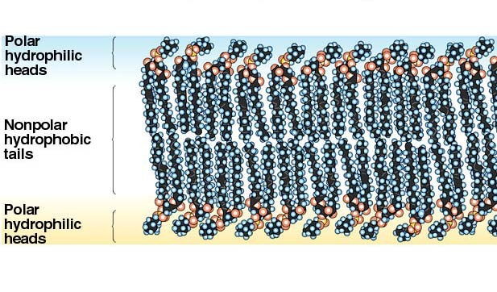
Water

Water

6

Within the phospholipid bilayer are other molecules. Cholesterol helps to stabilize membrane structure and restrict movement of water soluble substances through the membrane.
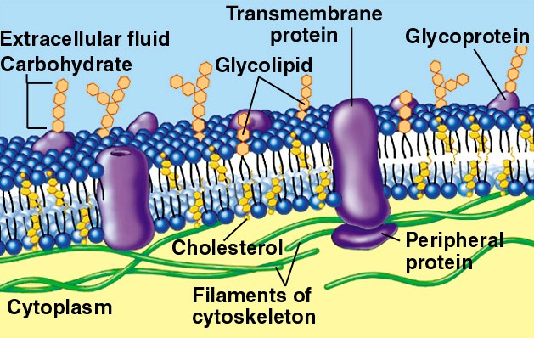 7

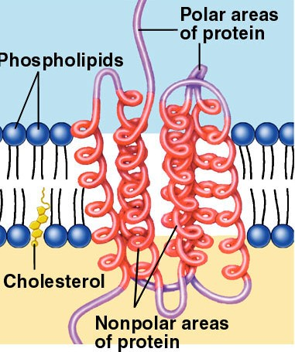
Proteins with nonpolar and polar domains fit within the membrane and associate with phospholipids tails in the membrane and water on either side of the membrane

8

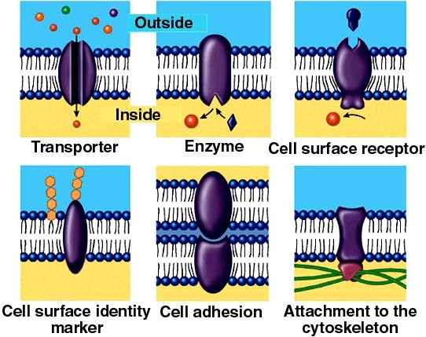
Imbedded (Integral) proteins in the plasma membrane have many functions. Imbedded proteins found in internal membranes have similar functions
9

A primary function of cell membranes is to restrict or facilitate movement of materials into or out of the cell. Movement of materials across membranes occurs in several ways.

Simple diffusion
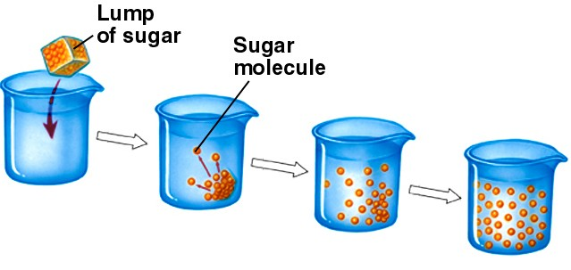
Random movement of molecules in solution ultimately results in an even distribution of molecules. The net result is that molecules move from areas of higher concentration to areas of lower concentration.

10

Diffusion occurs through cell membranes. Substances that are more concentrated on the outside of the cell than inside the cell tend to move into the cell and vice versa.

Some substances move through cell membranes more readily than others. Very small molecules move readily. Nonpolar molecules move more readily than polar molecules.

Diffusion of substances into or out of cells is passive - it requires no energy use by the cell to make it happen.

11

Facilitated diffusion
Proteins can aid the passage of molecules across the cell membrane.
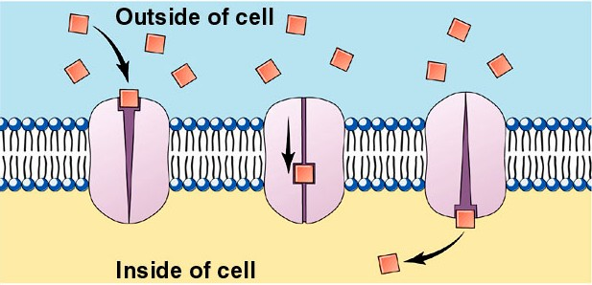
Membrane proteins may serve as pores or channels for the movement of specific chemicals.

Facilitated diffusion requires no direct energy input, but it does require the synthesis of proteins.
12

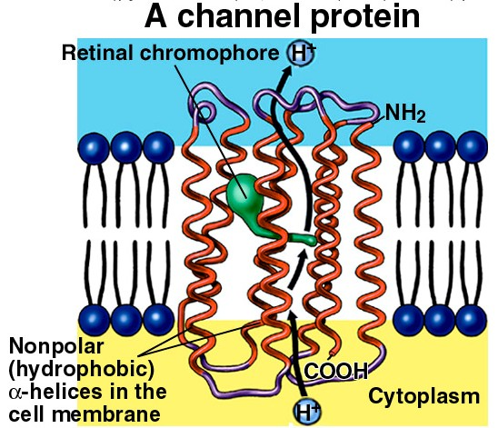
Channel proteins allow specific chemicals to move in response to specific conditions. The chemicals are often ions: H+, Cl-, Na+, Ca++ etc.

13

Some large molecules (such as sugars and amino acids) that do not diffuse readily through cell membranes can move through pores in the cell membrane made of protein.
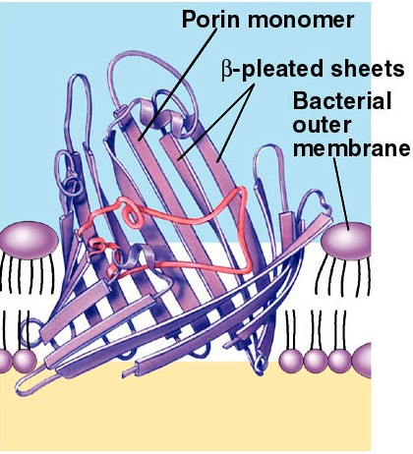
Pores and channels can be specific for only a single molecule, or for a very narrow class of molecules.

Cells produce membrane proteins for some chemicals that they need to have enter or exit the cell more quickly than they
would otherwise. 14

Because facilitated diffusion is mediated by a limited number of membrane proteins, the proteins can be saturated.
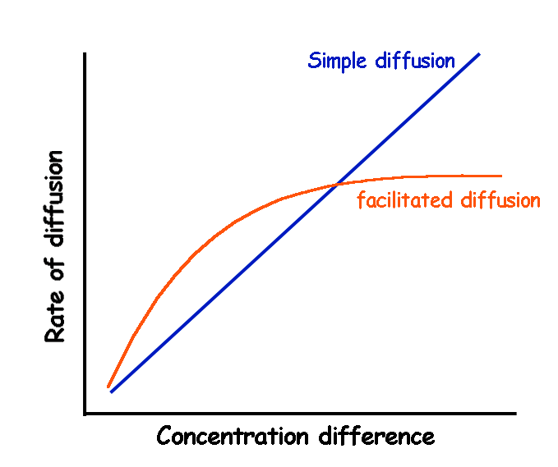
The rate of movement reaches a maximum when all of the proteins are being used at their maximum capacity.
Simple diffusion is does not exhibit saturation. Greater concentration differences result in faster diffusion.
15

Bulk Transport of materials through the formation of vesicles
Endocytosis - intake by vesicle formation
pinocytosis - intake of fluids by vesicle formation (e.g. yolk)
phagocytosis - intake of solids by vesicle formation

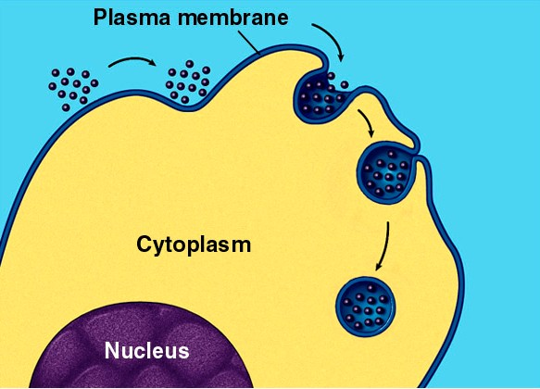
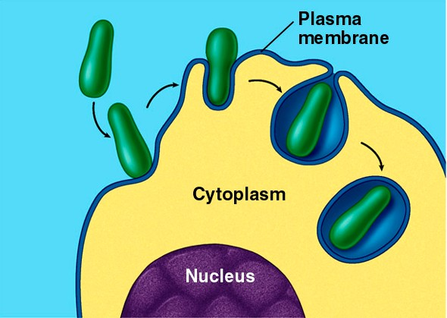

16

receptor mediated endocytosis
specific receptors line pits in cell membrane,
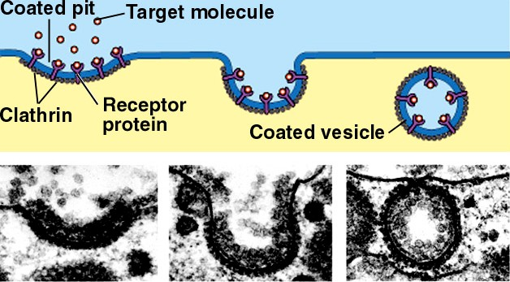
when many molecules of the substance attach to the receptor, a vesicle is formed (e.g. cholesterol)
17

Exocytosis - the expulsion of the contents of a vesicle - the reverse of endocytosis (e.g. digestive proteins, mucus)

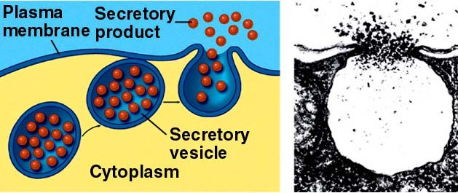

Endocytosis and exocytosis are active processes. Energy is required for the formation and movement of vesicles.

18

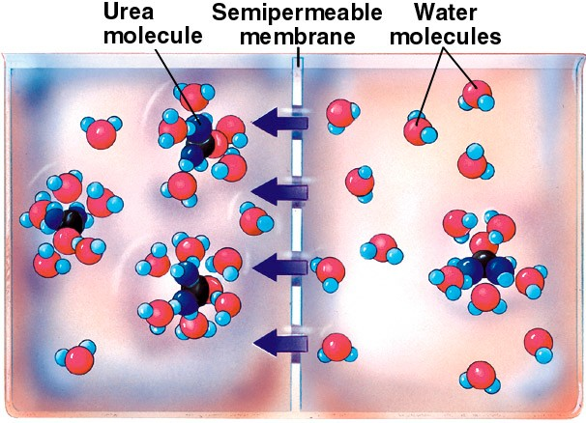
Osmosis - the passage of water through a selectively permeable membrane. Water moves from solution with a lower solute concentration to the solution with a higher solute concentration. Cell membranes are selectively permeable membranes. They allow only some chemicals to move through them

19

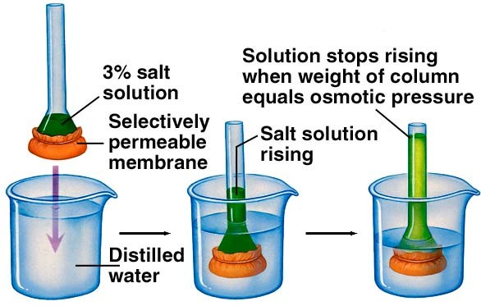
The force of water moving through a membrane can result in an increase in pressure, or water moving can oppose other forces that would move the water, like gravity. Solute differences on either side of a semipermeable membrane creates “osmotic pressure.”

20

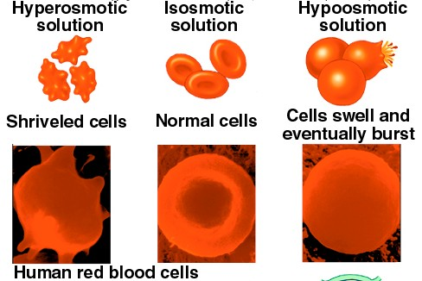
Osmosis is an important phenomenon in cells. Water will move into cells if the surrounding solution is hypoosmotic or hypotonic. This will inflate the cell. Animal cells can be over inflated and can burst. Water will leave cells if the surrounding solution is hyperosmotic or hypertonic. Cells collapse and become flaccid.

21

Plant cells also inflate in hypoosmotic solutions, but they don’t burst because they are contained within cell walls. In a leafy plant, turgid cells make leaves stand out straight. Plant cells deflate in hyperosmotic solutions. In leafy plants, deflation of cells results in “wilting.”

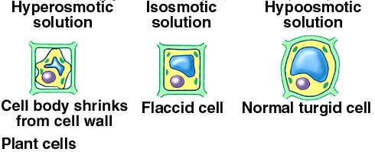

22

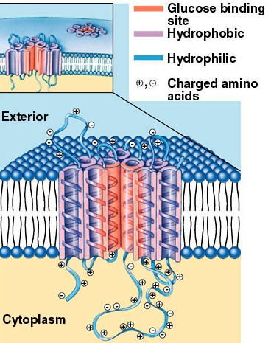
Active transport - the movement of substances through a membrane against the concentration gradient - from low to high concentration
- not passive - requires a membrane protein and energy in the form of ATP.

Active transport proteins are very specific for certain compounds and will move them into or out of the cell when chemical energy is available.
23

Active transport is very important for maintaining the concentration of certain solutes inside cells and in the extracellular environment - especially Na+ and K+.
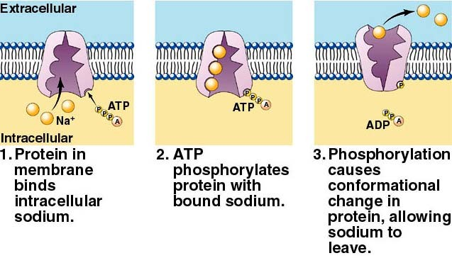
Most cells maintain the cytoplasm with a relatively high concentration of K+ and low concentration of Na+ relative to the the external medium - they do this with the use of a protein called the Na/K pump.

24

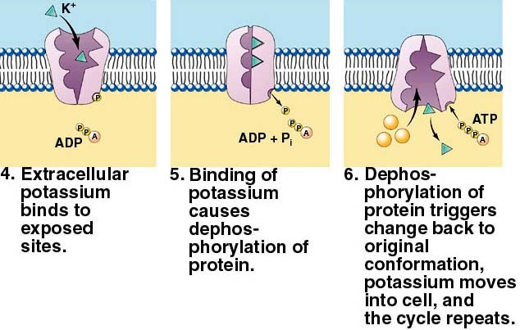
One pump can cycle over 300 times per second.

The difference in concentration of Na+ and K+ between the inside and outside is involved with many cellular phenomena
  - the conduction of nervous impulses
  - the sensitivity of sense organs
  - the response of many cells to cues in their environment Stimuli trigger opening of gated channels for Na+ and K+ which triggers further cellular change. 25

Active transport can be coupled to the transport of other substances.
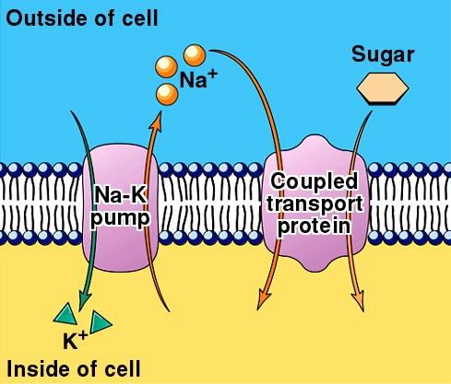
A large concentration of Na+ on the outside of cells can be used to carry other substances into or out of the cell.

Cotransport or symport is coupled transport in the same direction (both in or both out).

Countertransport is coupled transport in opposite directions (one in the other out).

26

One very important example of the use of a concentration gradient is found in mitochondria. During the breakdown of foodstuffs, H+ ions are pumped out of the mitochondrion using energy extracted from REDOX reactions.
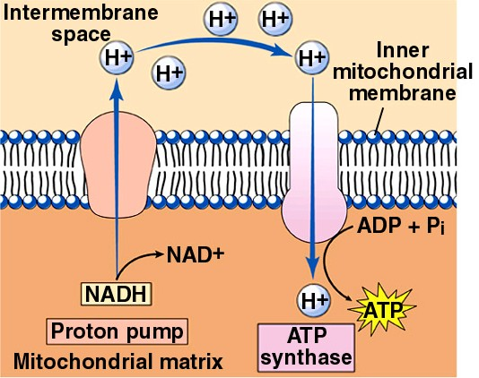
This creates a large concentration gradient, with more H+ outside the matrix than in. The H+ gradient is used to drive the production of ATP. This idea is called the Theory of Chemiosmosis.

27

Reference: https://www.nicholls.edu/biol-ds/biol155/Lectures/Membranes.pdf

