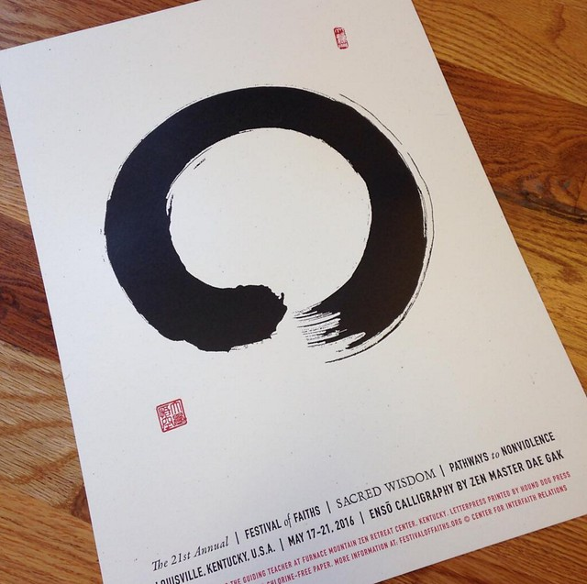
The zen circle: Enso. This means emptiness and universe. In order to understand the universe people must empty their minds.

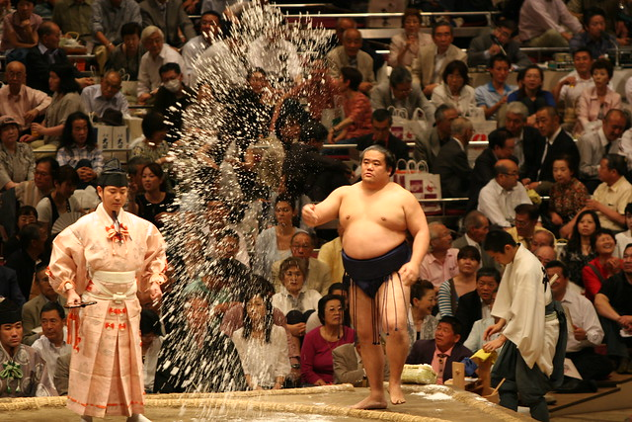
Salt : Salt means purification. Sumo wrestlers throw salt to clean the stage. Restaurants put salt next to the entrance to protect from evil spirits.
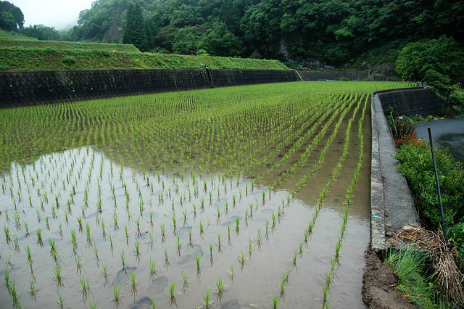
Rice : Rice is the symbol of the shinto religion. Rice is given to shinto gods. The Japanese emperor grows rice every year symbolically.

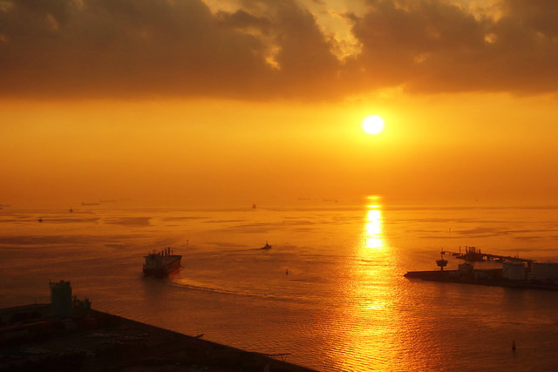
Sun: Sun is the most important god. The first Japanese emperor was the grandson of the Sun-God.

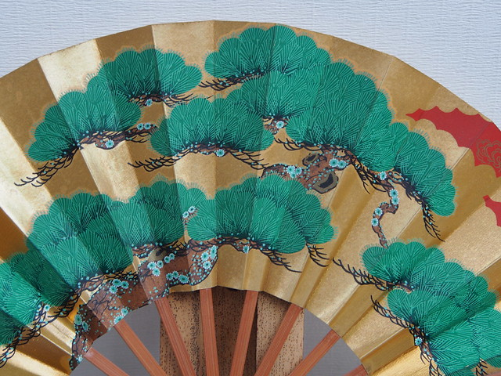

Folding fan: In the past, all Japanese people carried fans. It means prosperity and the blooming flower. In tea ceremony, the folding fan is the border of each participant.

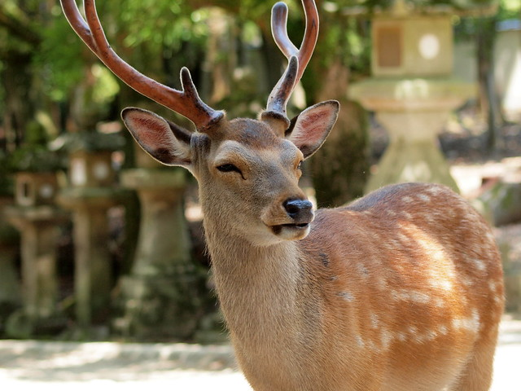
Deers : Deers are the messengers of god. They should not be hunted. That is why there are so many deers in Nara.
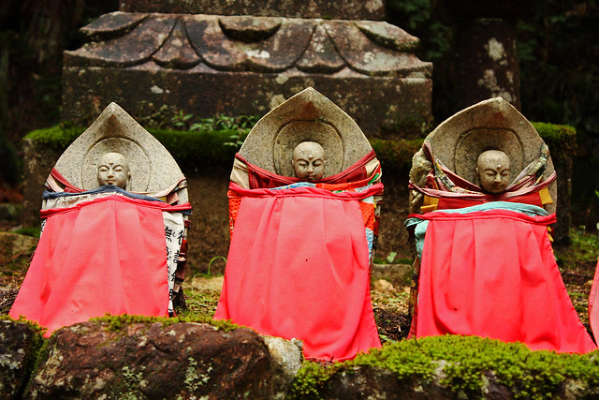
Statues with red bib: In the past parents put the red bib on the Buddhist statues to protect kids who died before their parents. “Jizo”is the protector of children and protector of travelers.
Red color: Red is the color of purification. Red color keeps the devils away.

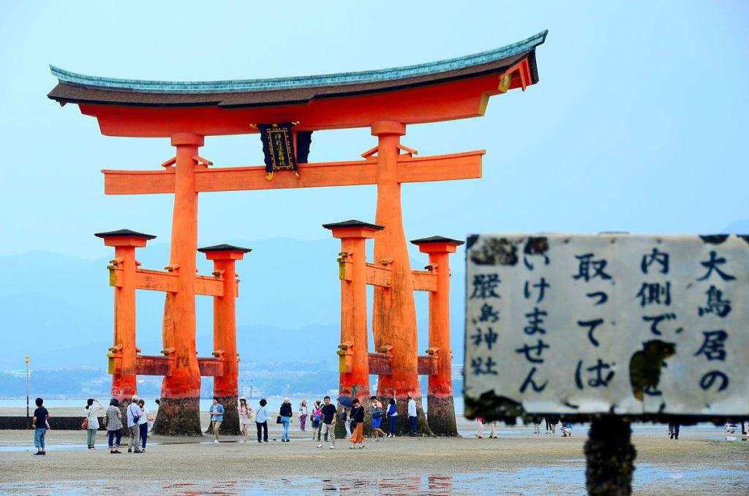
Red/orange Gate: This is called “tori” in Japanese. The gate symbolizes the separation between real life and spiritual life. You should not walk in the middle (middle way is reserved for the gods).
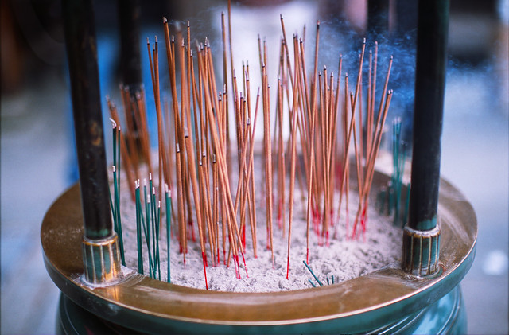
Incense burners / candle : The smoke from the candle heals your body. In Japanese they are called “koro.”

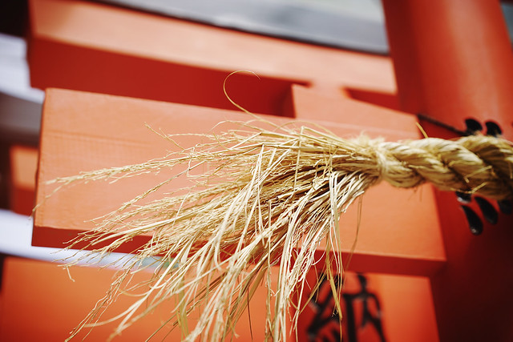
Rice straws: They protect from evil spirits. The rice straws are put at the gate of the shrines and around rocks and around trees (things that may contain spirits inside). Sumo champions also wear it because they also carry a special spirit inside. In Japanese this is called “shimenawa.”
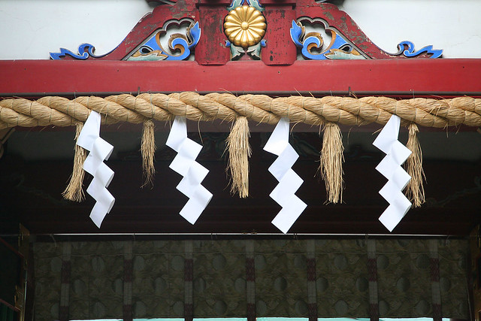
White zigzag papers: The paper represents the lightning wand. Shinto priests use it for purification. In Japanese it is called “shide.”
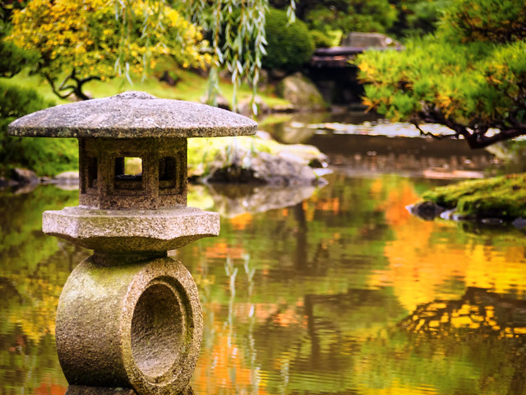
Stone lanterns : They are a present to buddha. They are also used for decoration in gardens. Most of the time they are empty. In Japanese they are called “doro.”
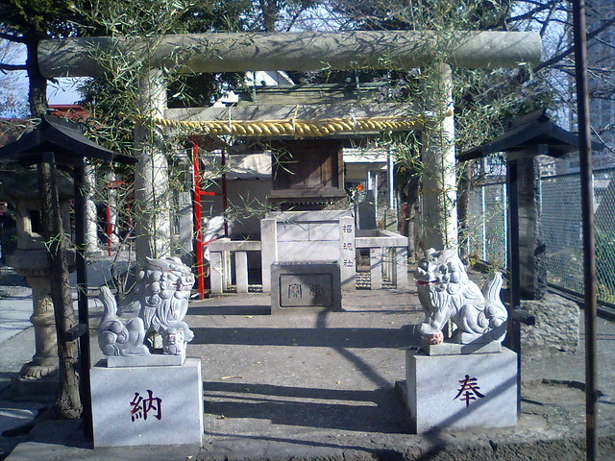
Dog statues: In front of Shinto shrines there are always dog statues. These dogs protect the shrine. The open mouth means beginning. The closed mouth means ending. In Japanese they are called “komainu.”

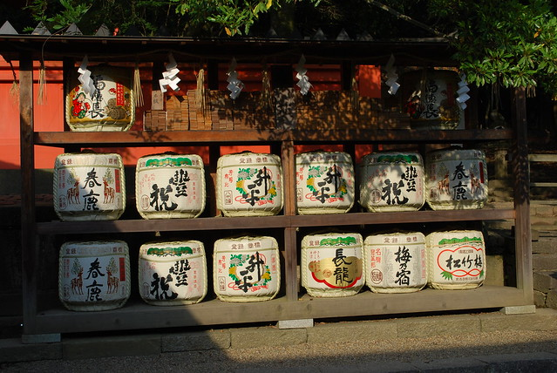
Sake Barrels : These barrels are donated to shinto shrines by sake breweries. Sake is a tool to unite people and the gods. One barrel equals to 72 liters. In Japanese it is called “karadaru.”
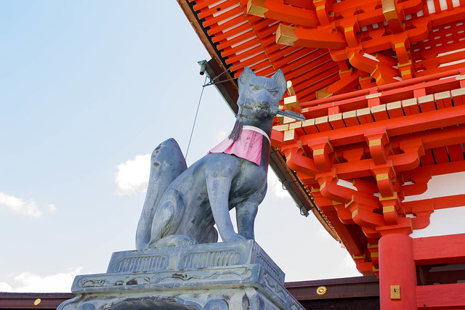
Fox: Represents the God of rice and fertility. It can be male or female. Some say foxes are not the gods, just the representative of the god. In Japanese it is called “Inari.”

Colorful flags in Buddhist Temples: Colorful flag (Gree, yellow, red, white, blue) represents the 5 Dhyani type of Buddhas. The flag is also shown on the birthday celebrations of Buddha (Hanamatsuri).
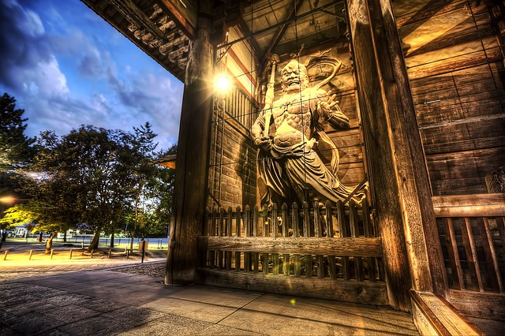
Agyo and Ugyo: Statues of devils at the gates of Buddhist temples. They protect the temple from evil spirits. They also represent the birth and death.

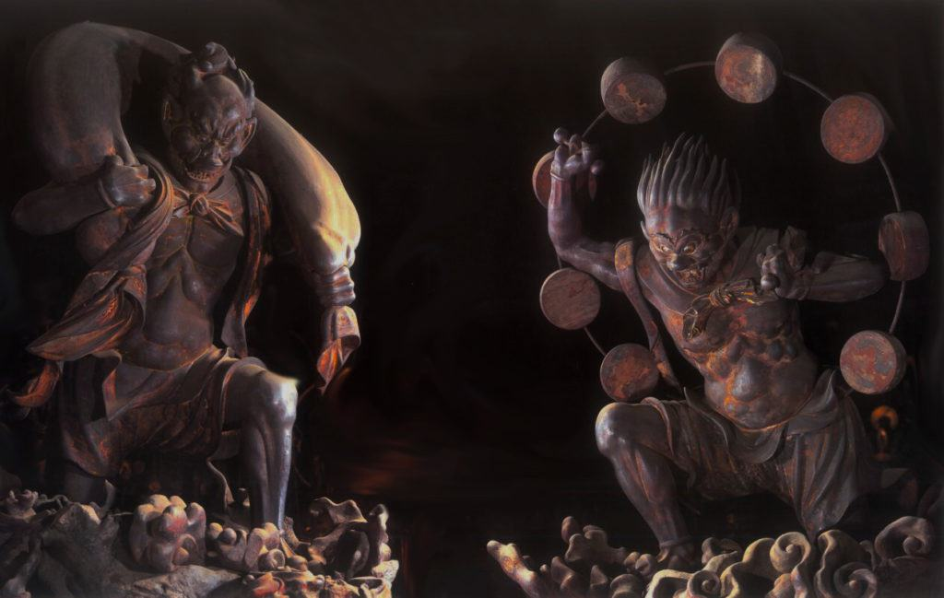
Raijin and Fujin: The god of thunder and the god of wind. These are shinto gods. Similar to the Greek mythology.
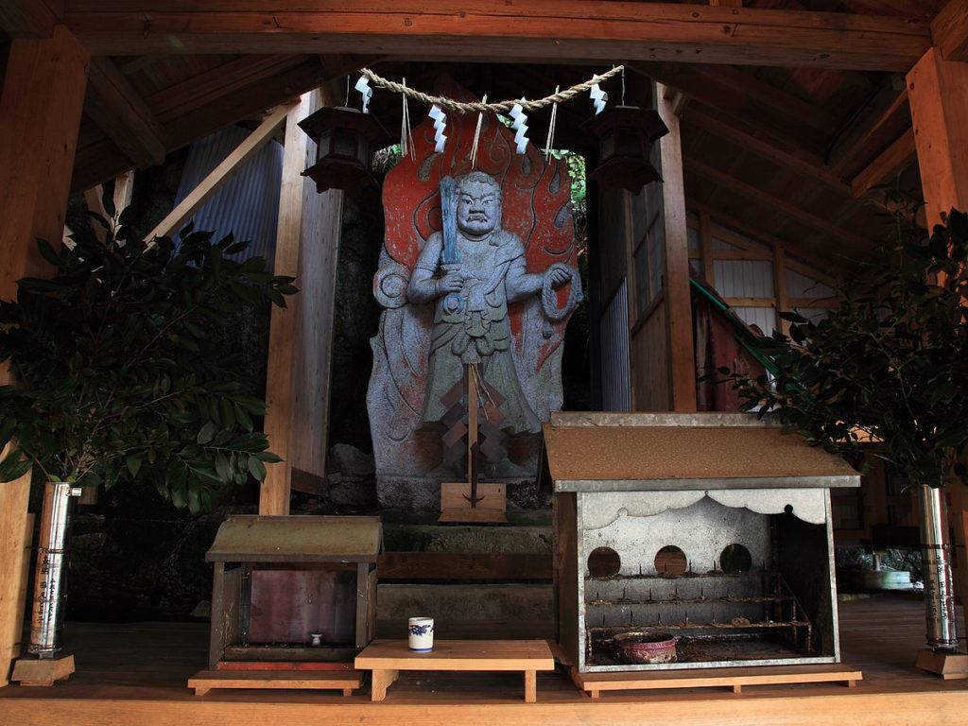
Fudou Myoo: The wisdom king. Also known as “Acala.” The sword represents wisdom that cuts ignorance. His rope binds up demons.

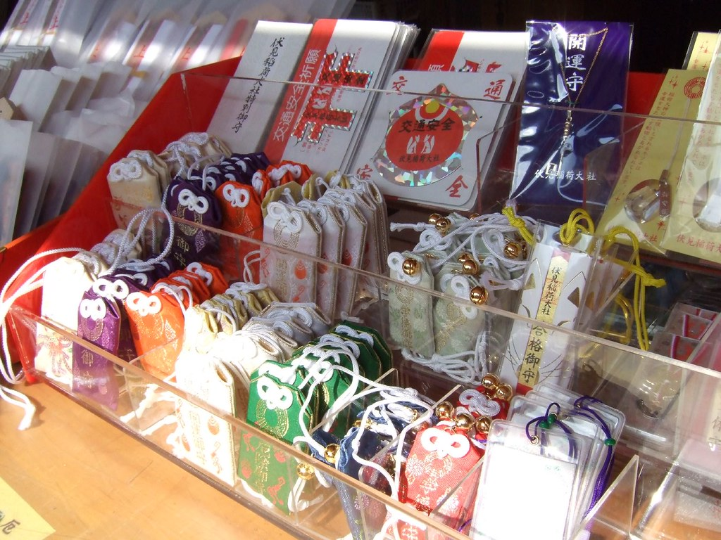
Omamori amulets: These amulets are sold at shrines. They protect from bad luck.
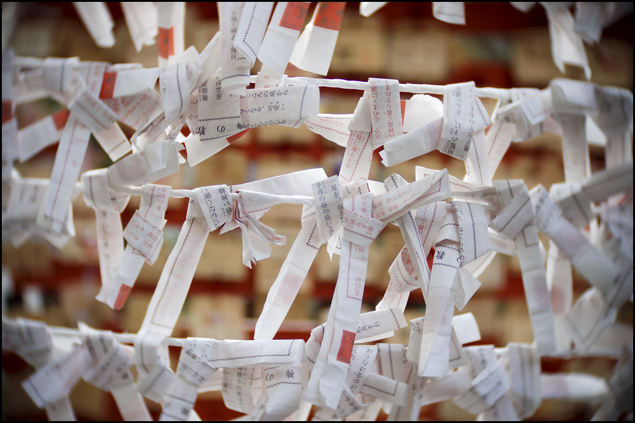
Omikuji papers: In shrines people can buy these papers for 5 yen. When people open the paper they can see good fortune or bad fortune. It must be tied to the tree or the wires if it has bad fortune. Paper knots.

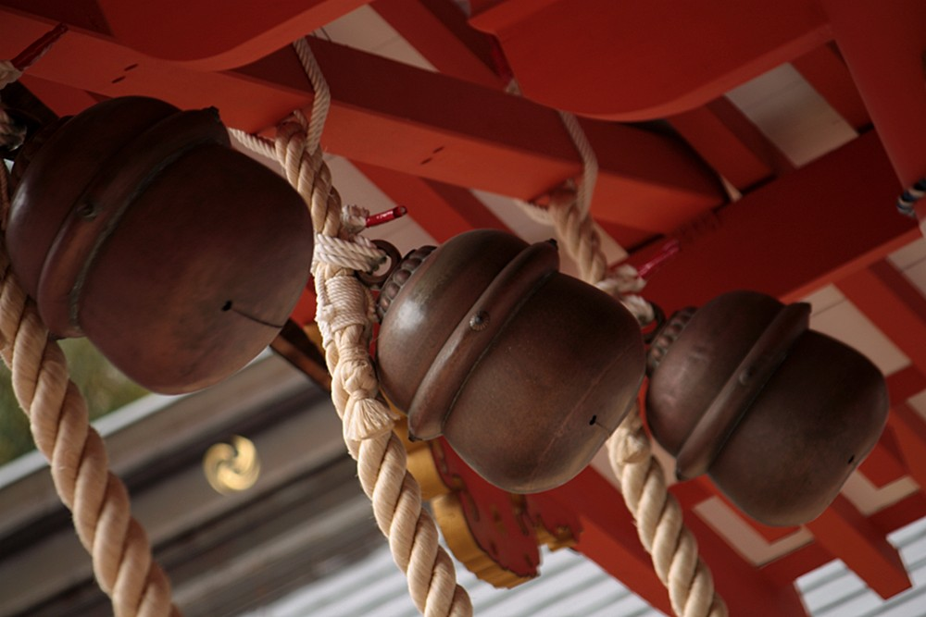
Ringing the bell and clapping hands: People ring the bell and clap hands to call attention of the gods.
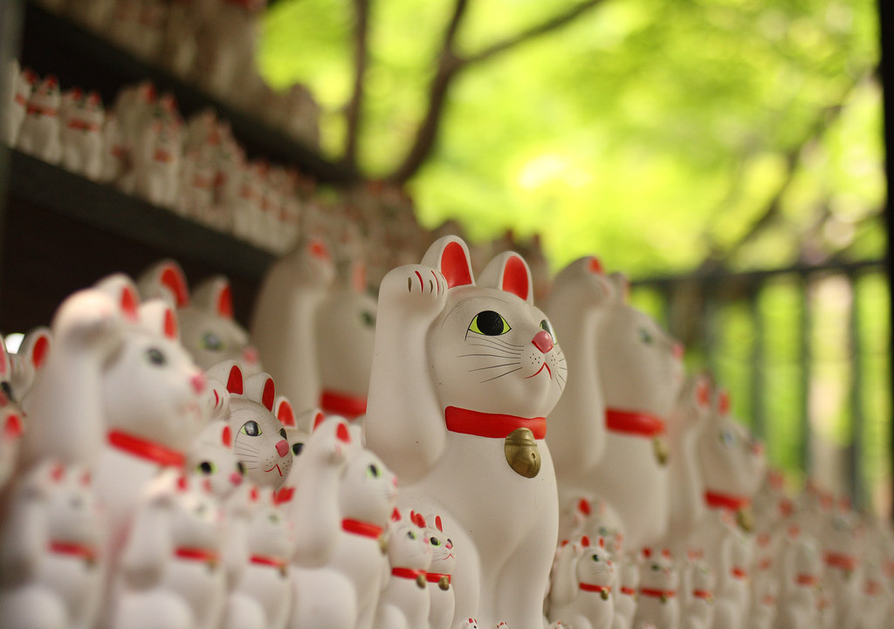
The cat: Maneki Neko. that brings luck. White cat brings health, black cat protects from evil spirits. The gold-color cat brings money.

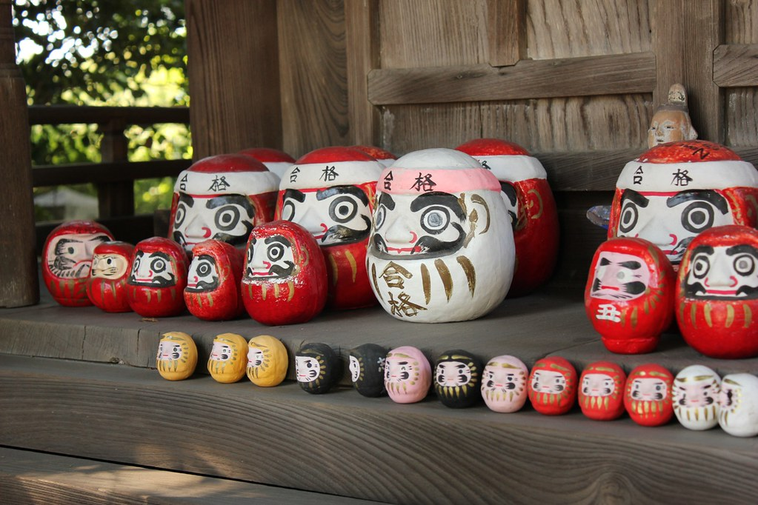
Lucky Daruma Doll: Represents Bodidaruma (the founder of zen buddhism). People paint the right eye before making a wish. When the wish comes true, people paint the left eye. It brings luck.
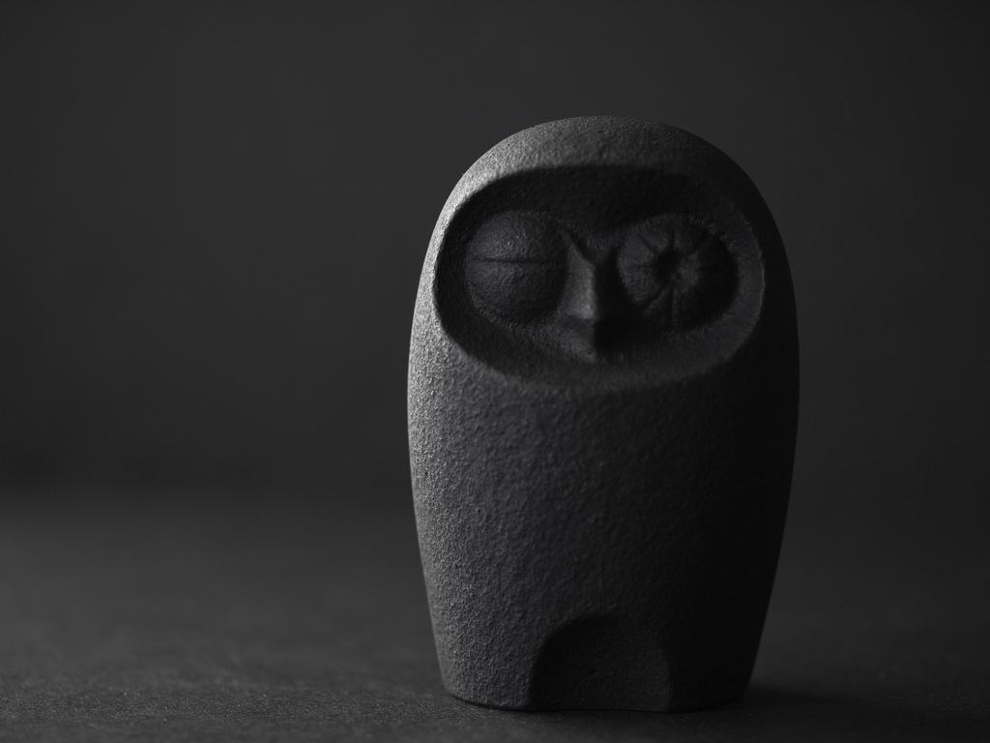
Owl figure: Fukuro フクロウ (梟), is written as luck (福 fuku, luck; 来ku, to come). It
protects from hardship (不 fu, no, 苦労 kurou suffering/hardship).

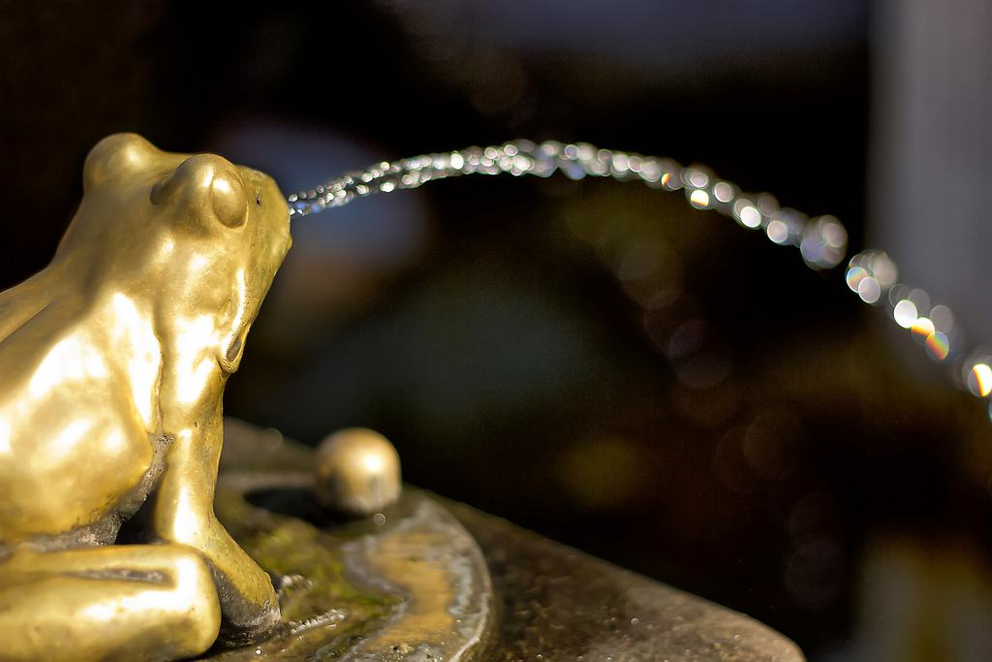
Frog figure: Kaeru. In Japanese the word for frog is “kaeru” (return). People who travel, carry a frog charm to safely return back home.
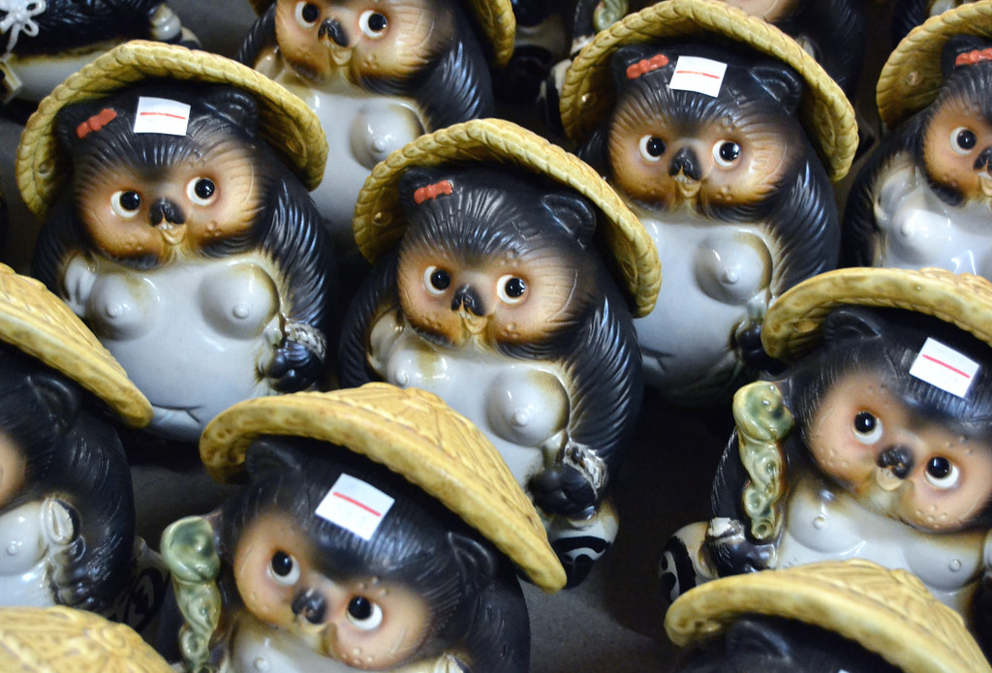
Tanuki statue: Racoon dog. They bring good luck, the sake bottle they carry has the good luck symbol (八). They carry papers that show they don’t pay their debt.

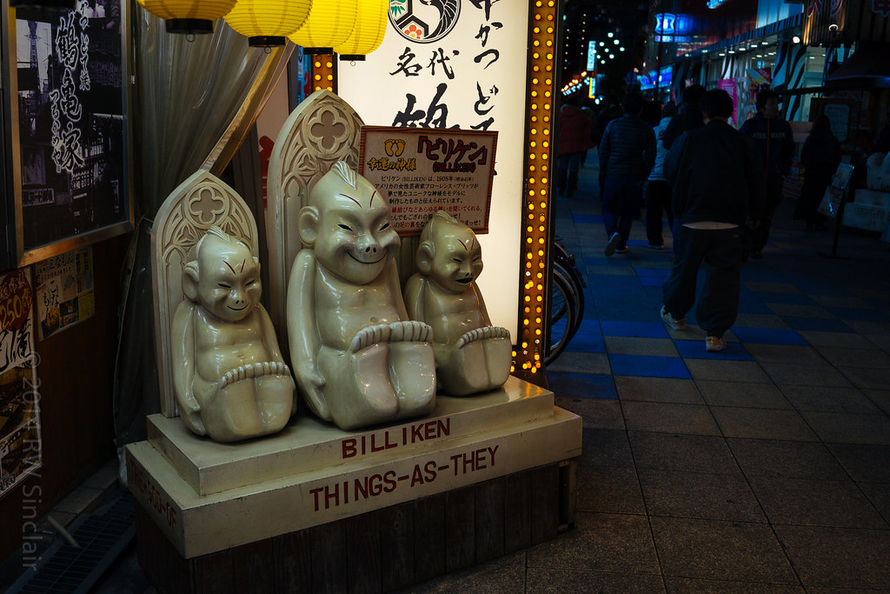
Biliken: a charm doll created by an American art teacher and illustrator, Florence Pretz of Kansas City. In 1912, Biliken was displayed in Shinsekai Lunapark as a symbol from the US.
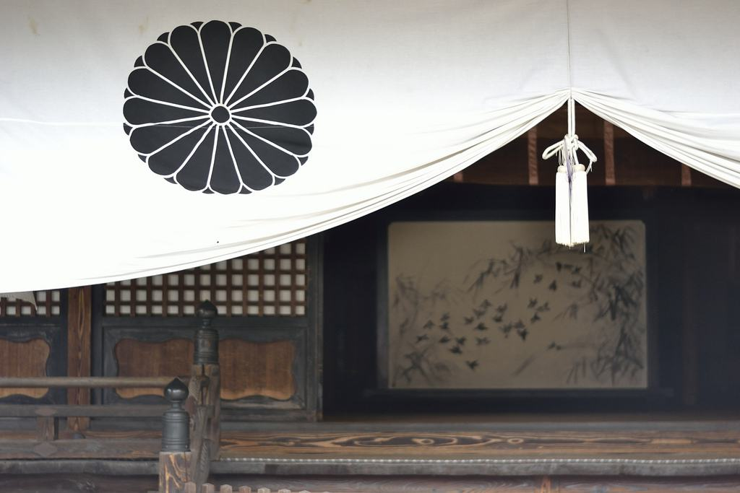
Chrysanthemum flower: This means endurance.Chrysanthemum is the symbol of the Imperial family. It has 16 petals. The Japanese parliament also uses this emblem.

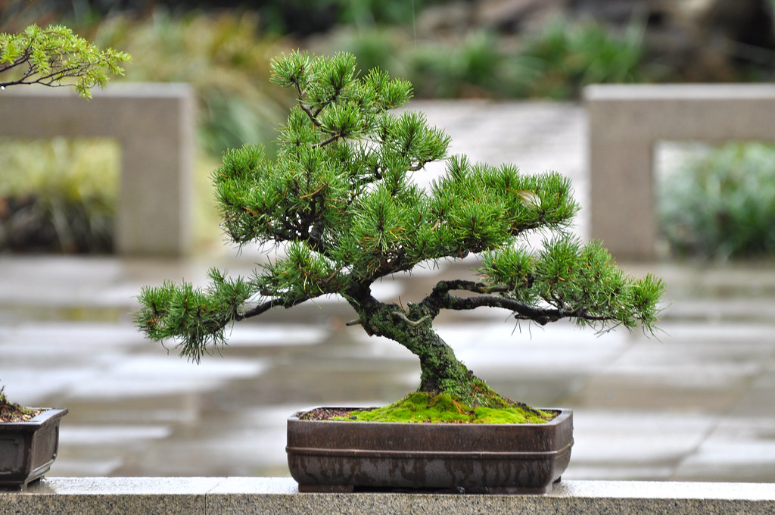
Bonsai: Bonsai means plant in a box. It symbolizes harmony and balance.
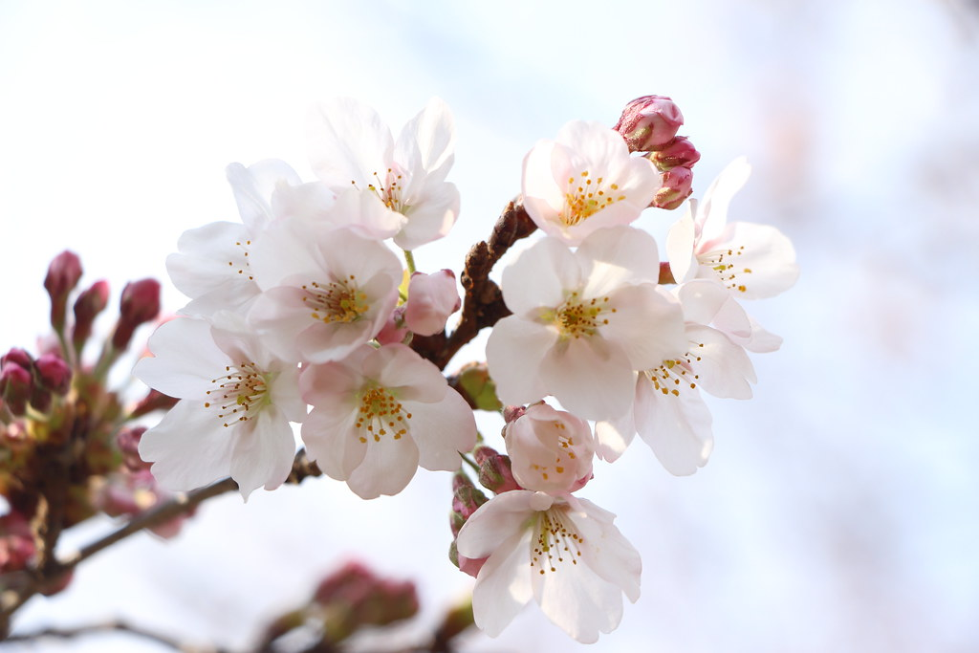
Sakura flower: This means, all the beautiful things in life are temporary (mono no aware).

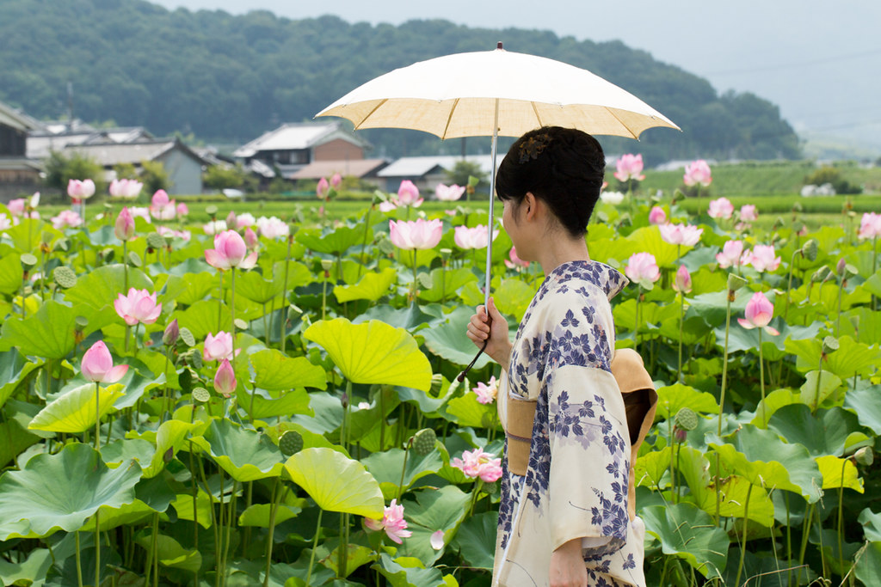
Lotus flower: The is the symbol of purity. The buddha sits in the shape of the lotus flower . This is related to Buddhism.
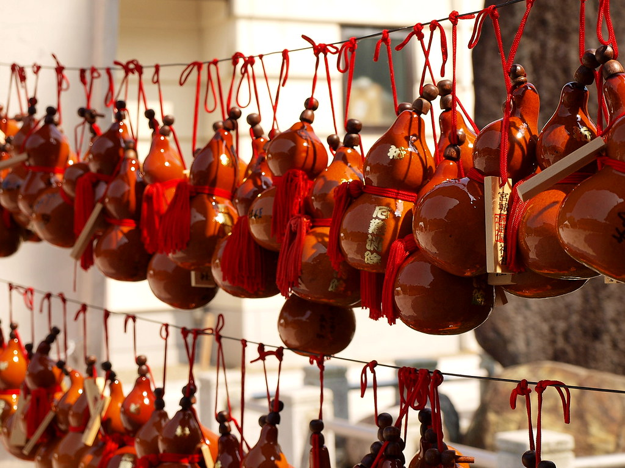
Gourd: Good luck and good health. This meaning comes from the Tao belief.

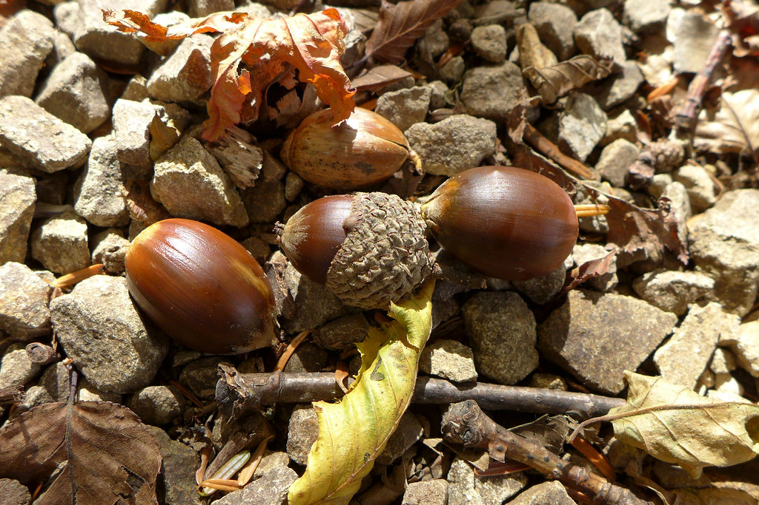
Acorn: Good luck.
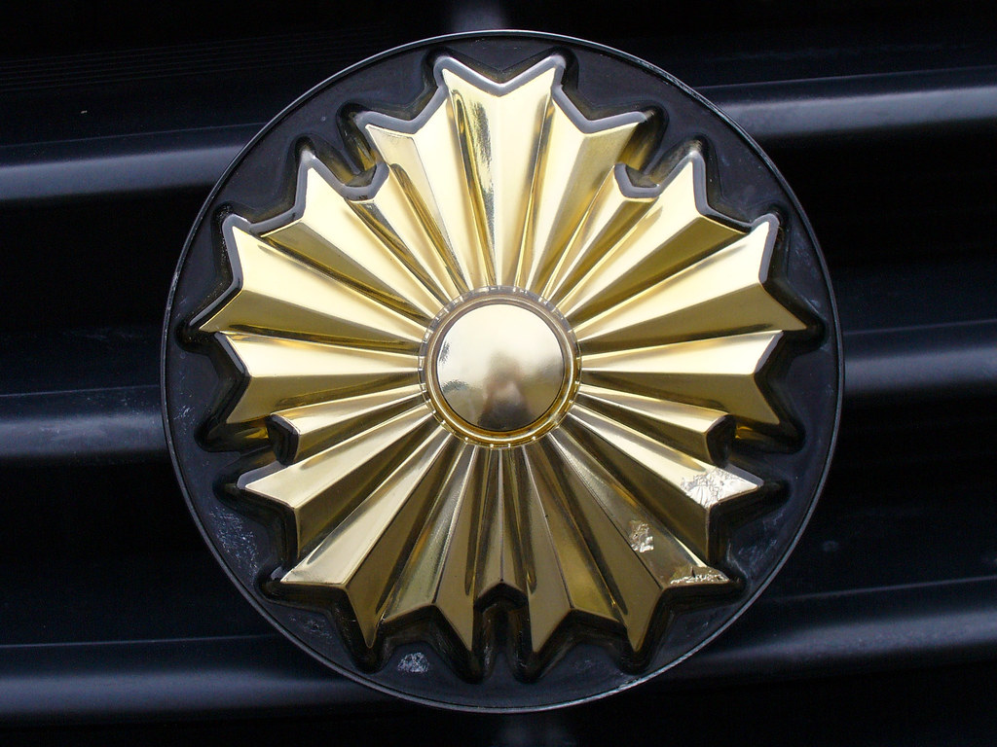
Police symbol: The pentagon shaped star represents the police force in Japan.

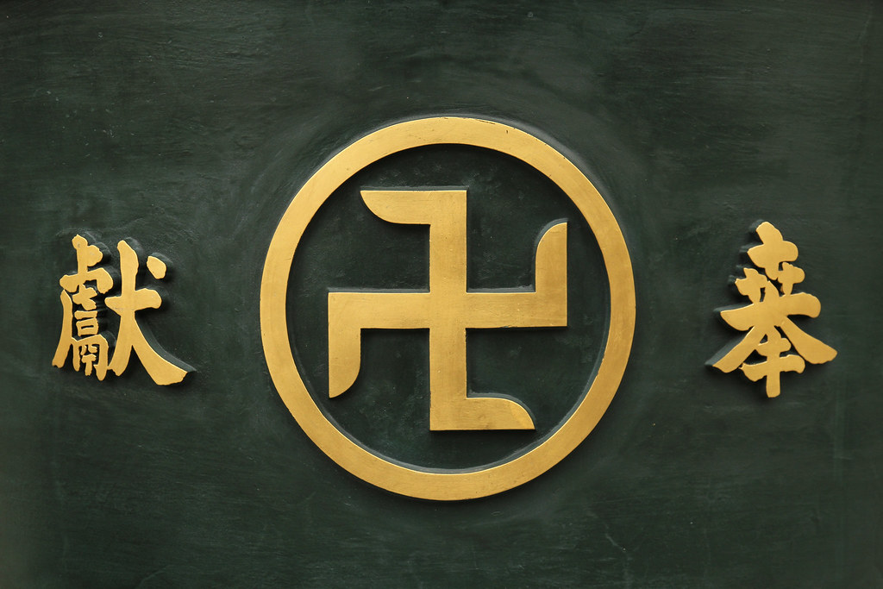
Manji: This shapes looks like swastika but it is not (The direction is different). It means good luck and good health. On the maps they represent a Buddhist temple.
Tomoe: 3 commas. The sign of Shinto. The commas represent earth, sky and human. It can be found in Buddhist temples too. Until the Meiji period, Buddhist temples and Shinto shrines were built together.

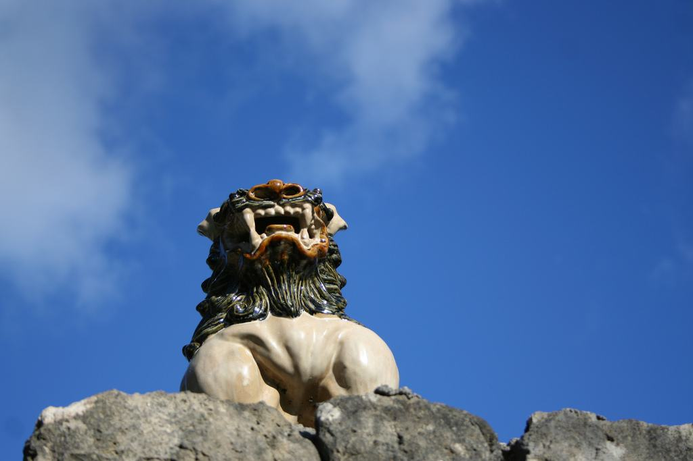
Lion on the roof. Shisa. These lions protect the houses from evil spirits. It is more common in the okinawa island.
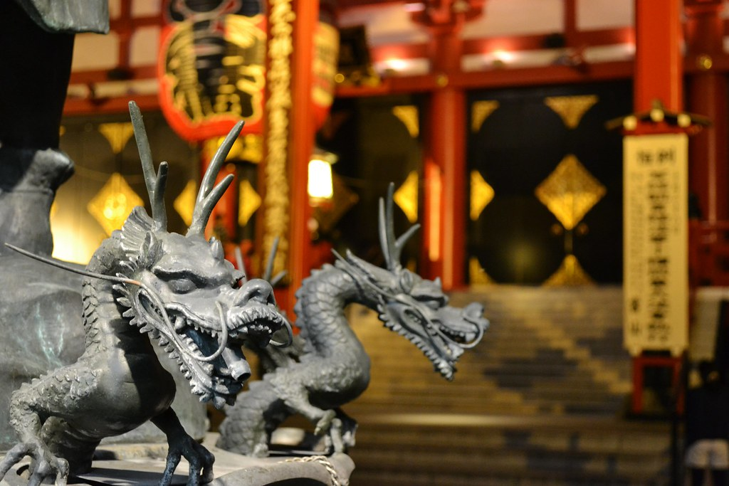
Dragon: Is the water deity. Dragon means strength and wisdom. Japanese dragons have 3 toes, Chinese dragons have 4 toes.
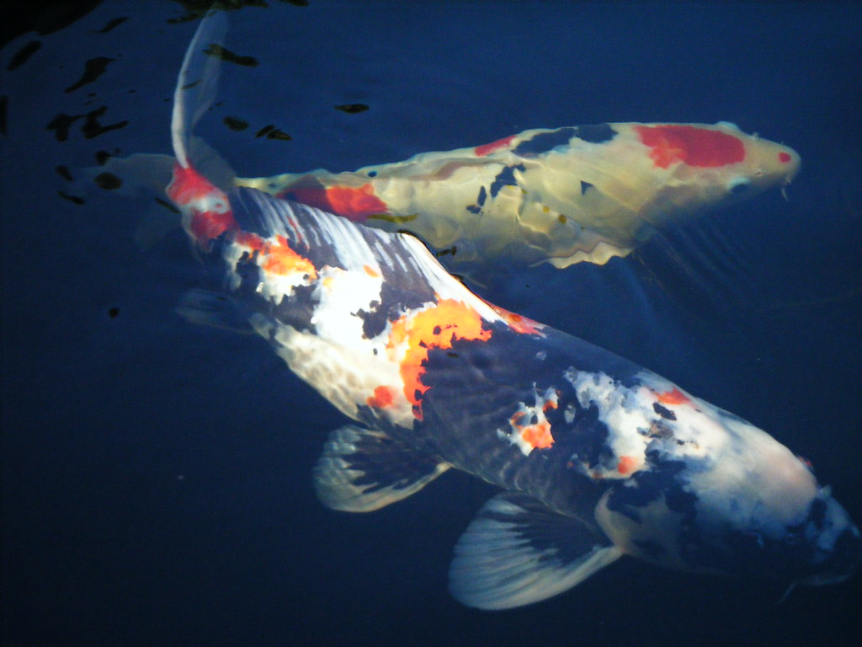
Koi fish : Perseverance. According to a Chinese tale, the koi fish becomes a dragon when it reaches on the top of the river.
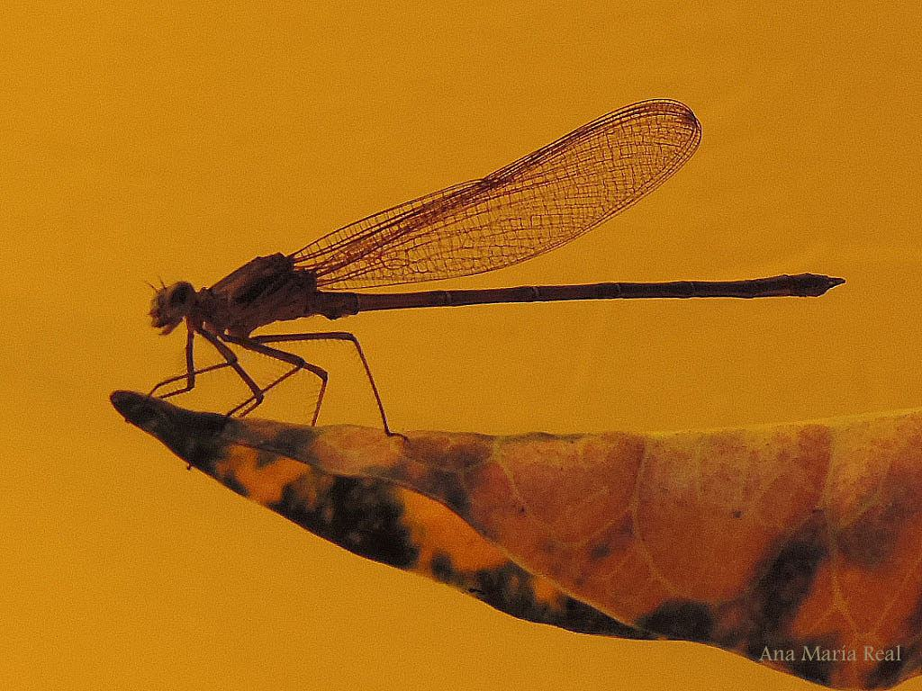
Dragonfly: Persistence. Dragonflies always fly forward, they never fly backward. The samurai put the dragonfly symbol on the samurai helmets.

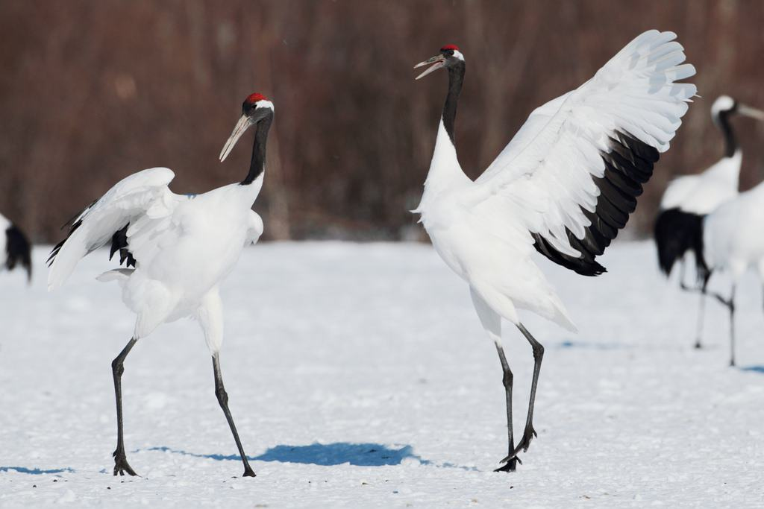
Crane: The symbol of longevity and good fortune. Cranes are monogamous. Japanese use cranes on bridals.
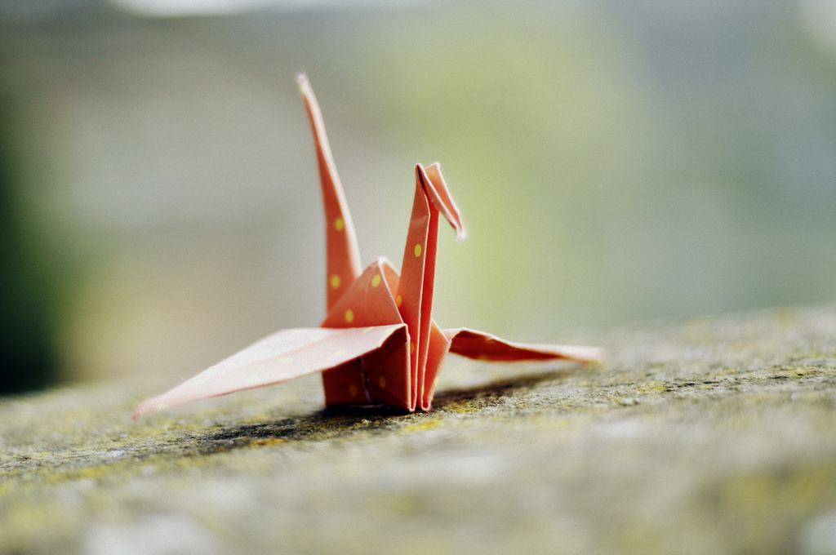
Paper crane: The symbol of peace.

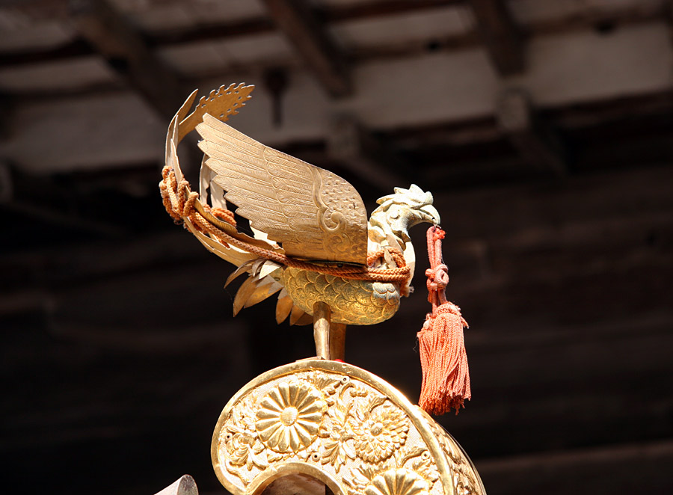
Phoenix: Phoenix is the symbol of the royal family. Both in China and Japan, phoenix used to
represent the imperial family.
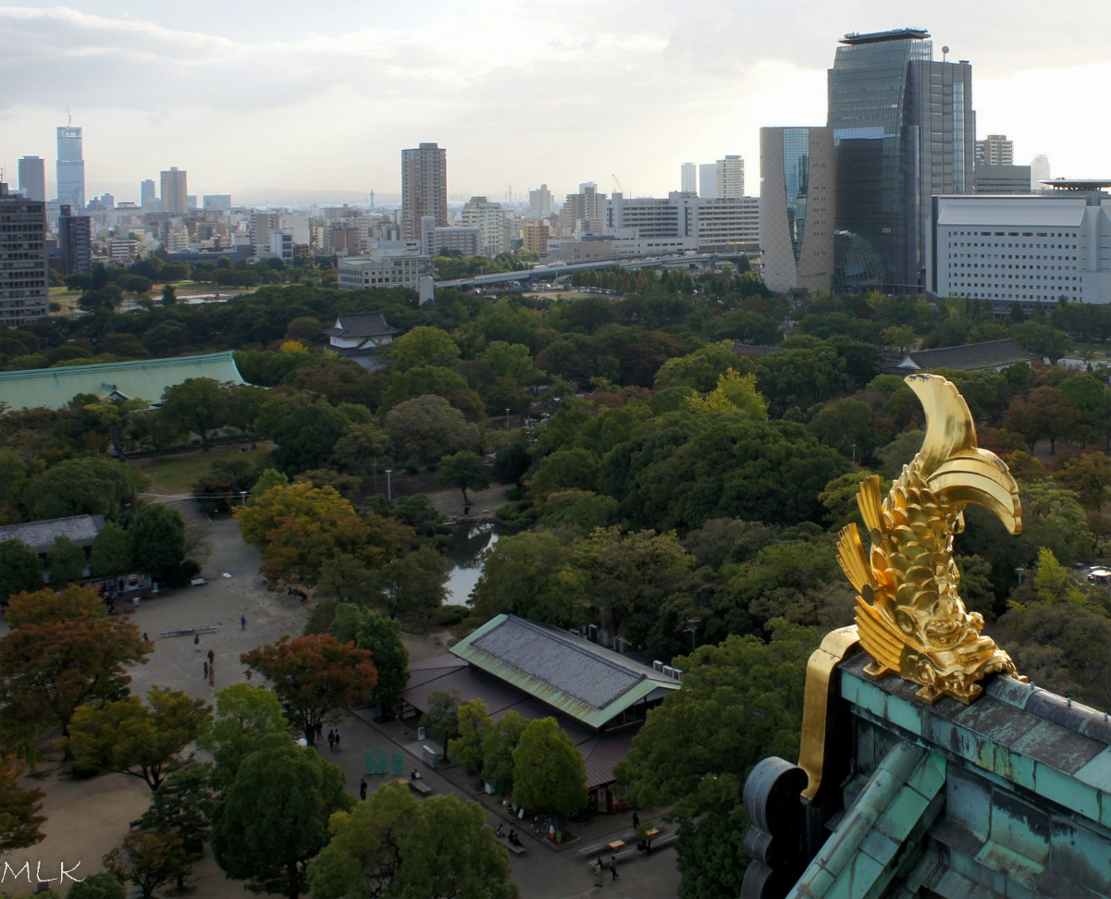
Monster fish on the castle roof: Shachihoko. These monsters bring the rain.They protect castles from fire.

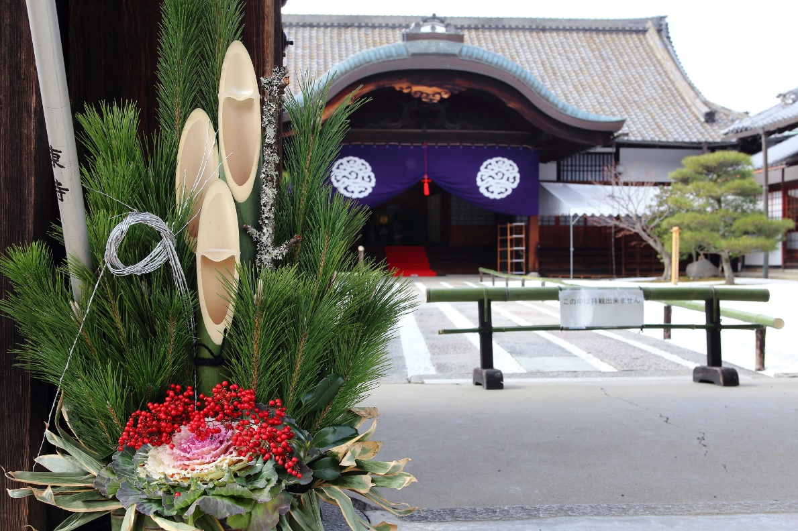
3 bamboos (new year): New year decorations have 3 bamboo pieces. These bamboos are cut in the middle. Bamboos always grow straightforward in difficult conditions. In Japanese this decoration is called kadomatsu. During the new year, the deitities only visit the houses if there is a special decoration.
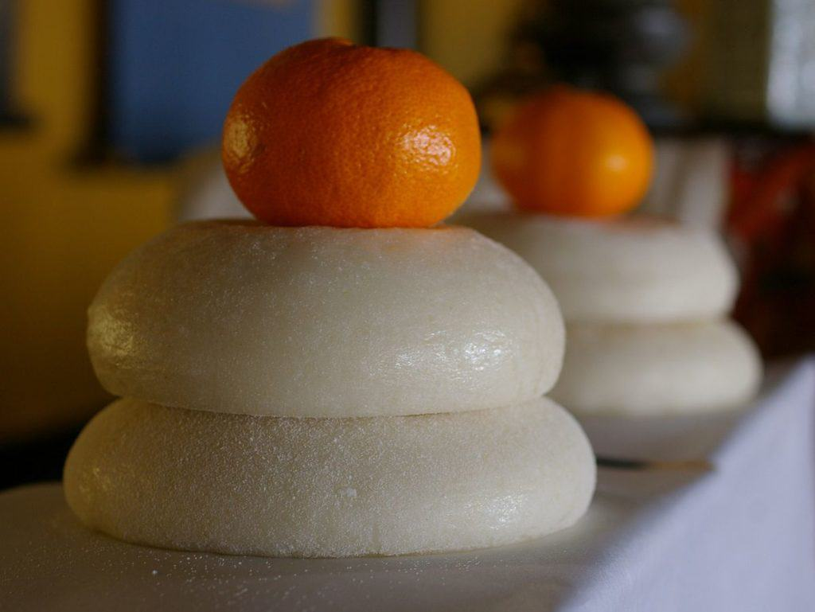
2 rice cakes and tangerine: In Japanese this is called “kagami mochi.”It means a) old generation and new generation b) the new year and the old year. People boil it and eat it on January 11th. In Japanese, kagami means mirror.

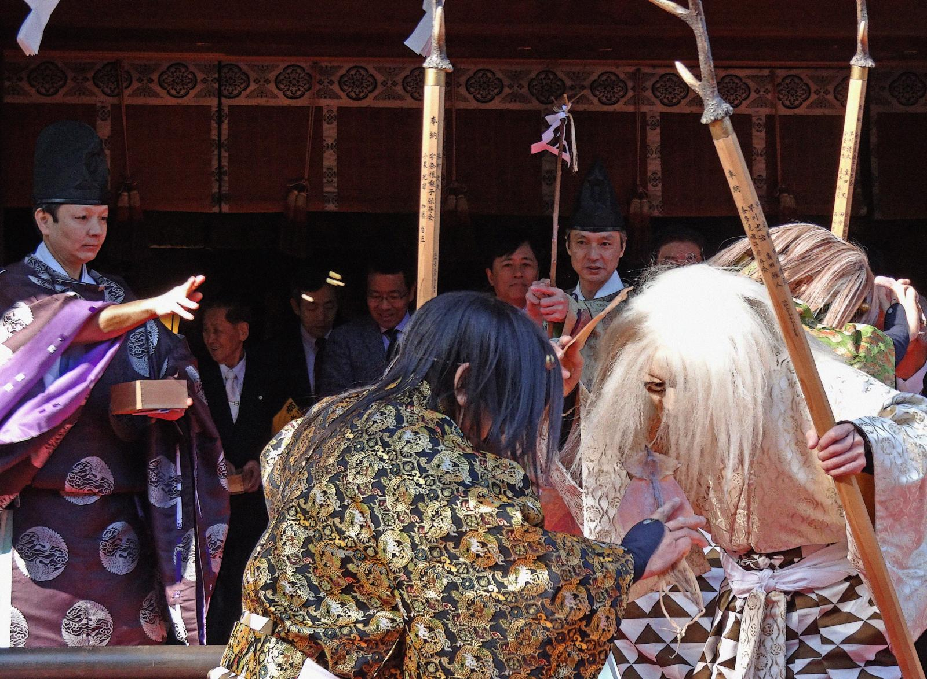
Bean throwing day: Setsubun. One day before the beginning of the Spring. People throw beans at the demon. People yell “demons go outside, luck come inside.”
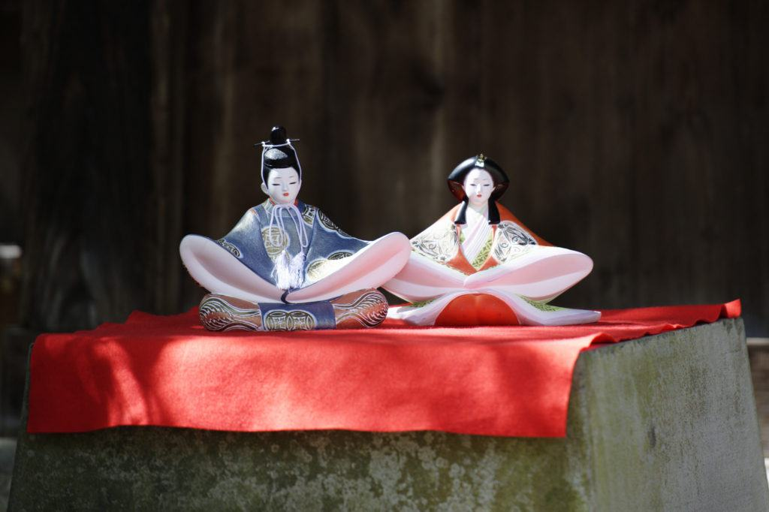
Hina dolls : 7 layers of dolls that represent the imperial family from the Heian Period. These
dolls are displayed in March to celebrate the girls’ day.

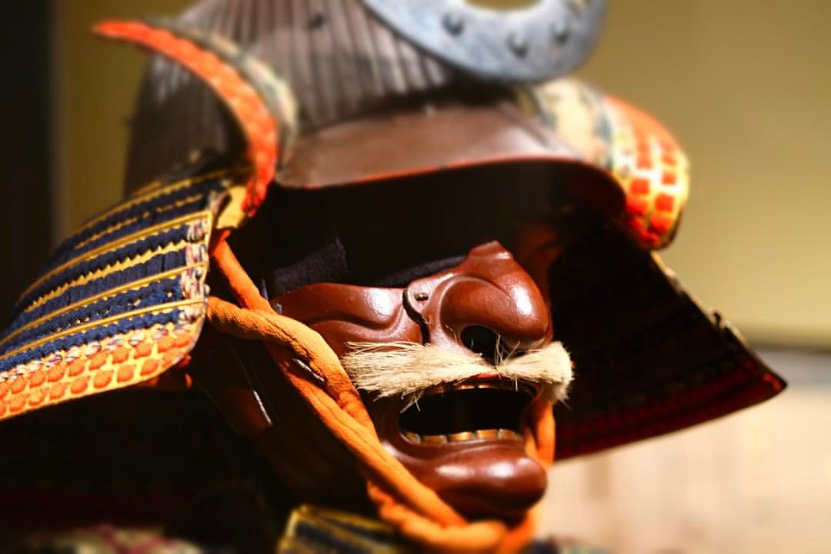
Samurai helmets: Samurai helmets and samurai statues are displayed to celebrate the boys’ day. In Japanese “kabuto.”
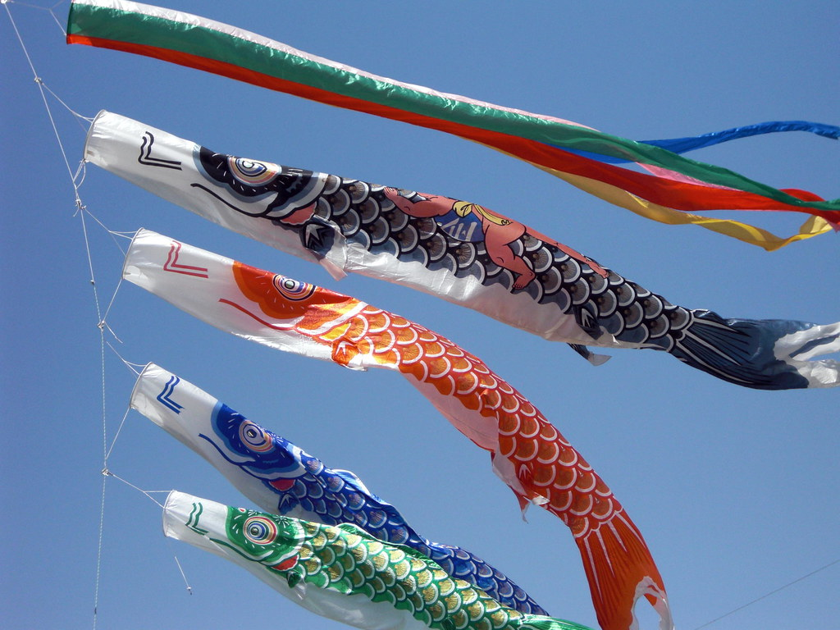
Flying fish on the roof: It is to celebrate the boys’ day in May. In Japanese it is called koi-nobori.

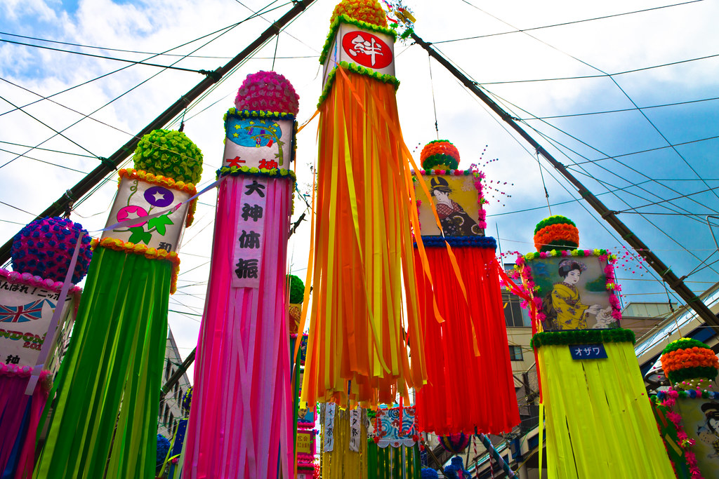
Colorful papers on bamboo tree. To celebrate the stars’ festival. Two stars (Vega Star and Altair Star) meet in the sky on the 7th day of the 7th month. People write their wish on these colorful papers. In Japanese it is called Tanabata.”
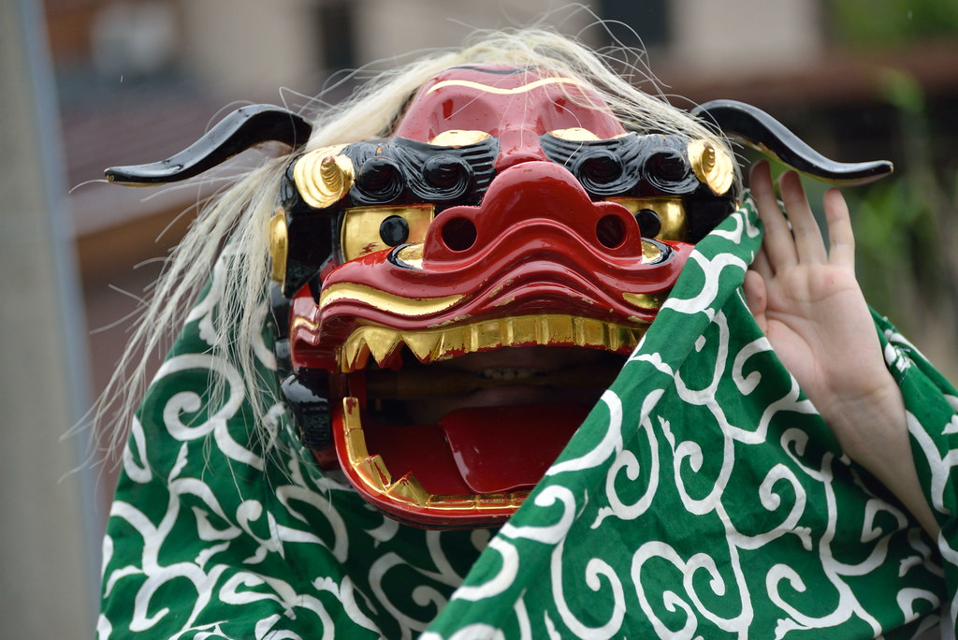
Red monster with green scarf. Lion heads. People wear these masks when they pray for the good harvest season. In Japanese they are called “shishimai.”

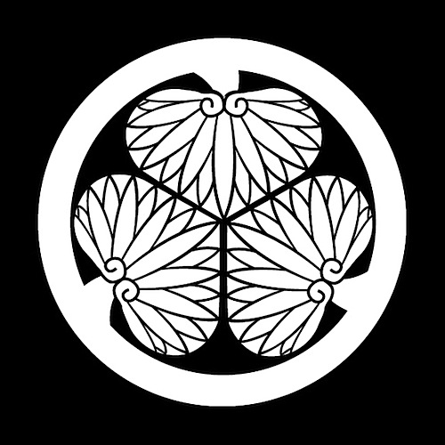
3 clovers : The symbol of the Tokugawa shogun.

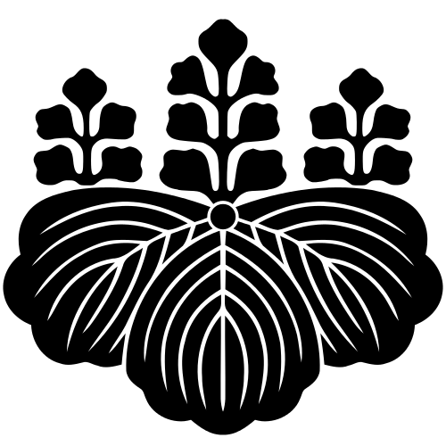
3 leaves and 3 roots: The symbol of the Toyotomi clan. This is also the same with government seal of Japan.

1 line and 3 dots: The symbol of the Mori clan.
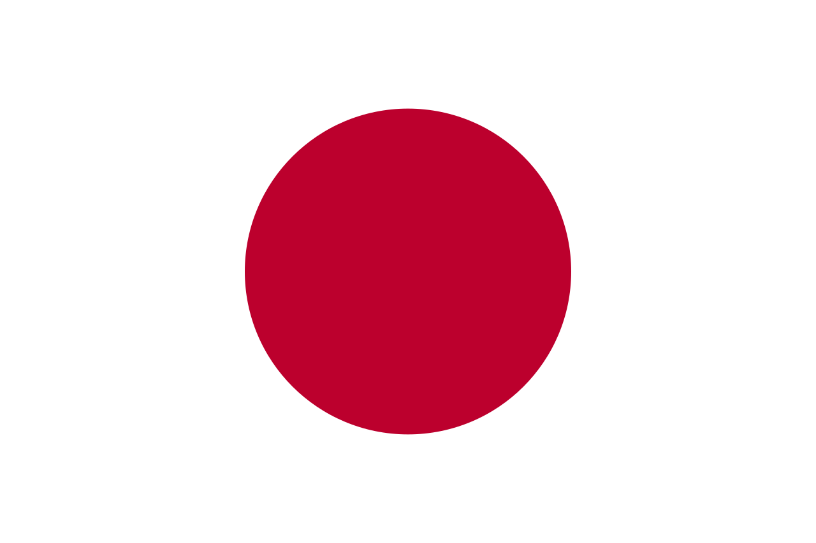
Rising sun in the flag: Japan is known as the land of the rising sun. The red circle in the flag represents the sun. The sun is the most important Shinto God (Amaterasu). In Japanese it is called “hinomaru.”
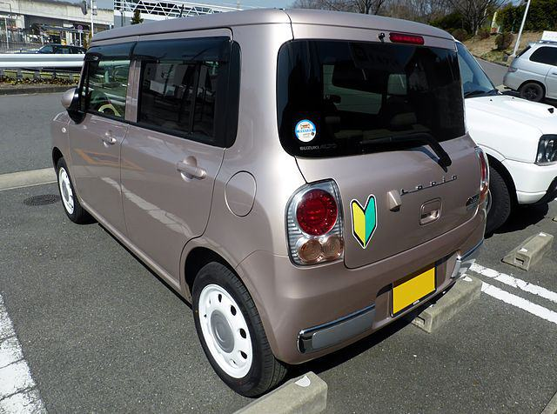
V-Shaped symbol with yellow and green: In japan this means the person is the beginner. It is commonly found in new drivers’ cars.
T-shape with a line. 〒 . This is the sign for the Japanese post office. This also means the zip code.

Masks

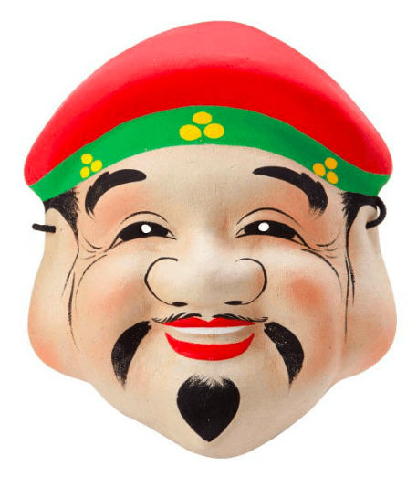
Daikoku: The god of good fortune and wealth. One of the 7 lucky gods.
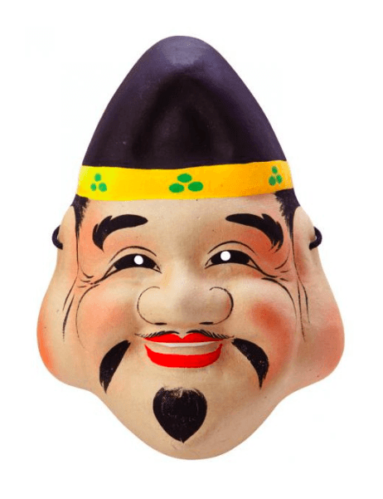
Ebisu: The god of fishermen and workers. One of the 7 lucky gods.
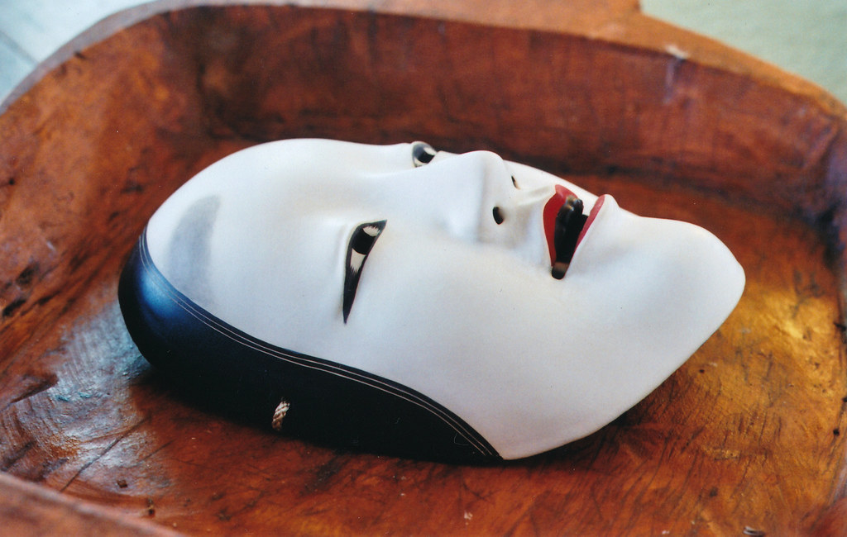
Ko-omote: The noh-theater mask. It represents a young woman. Many different emotions (joy, anger, happiness) can be seen on the face. The right half and the left half of the nose are asymmetrical.

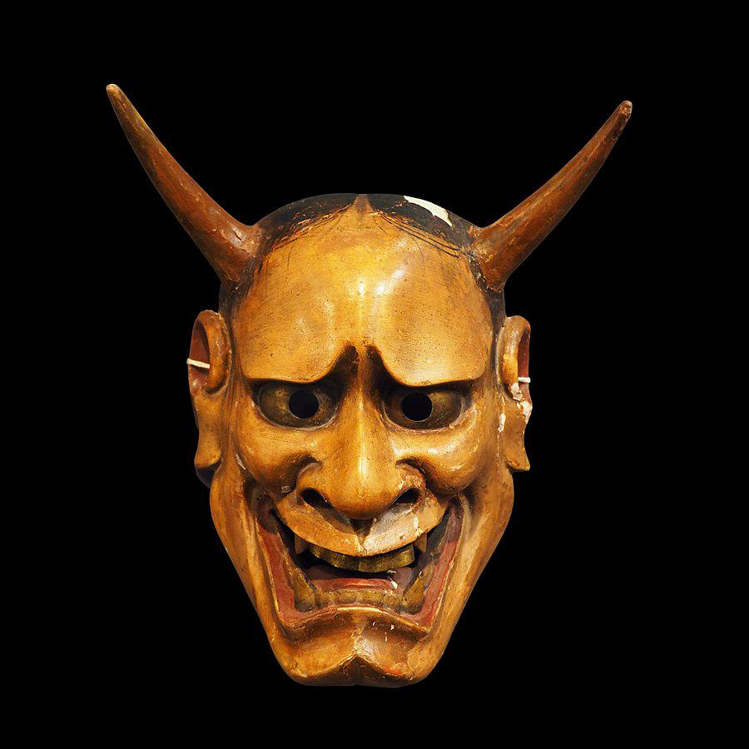
Hannya: The evil woman who became a demon because of jealousy.
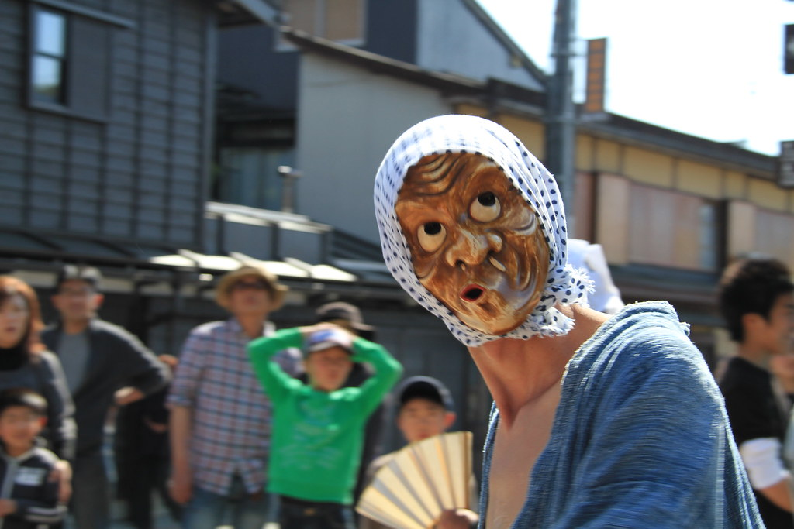
Hoyottoko: A comical character whose mouth is skewed.

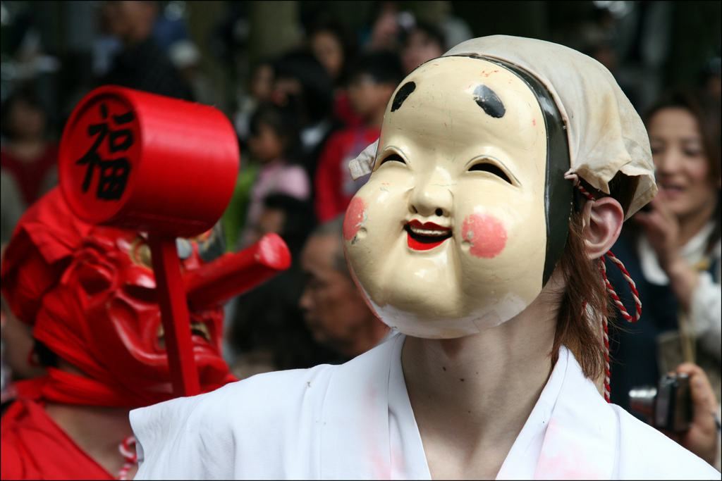
Okame: A smiling Japanese woman that brings happiness and wealth to the person she marries.

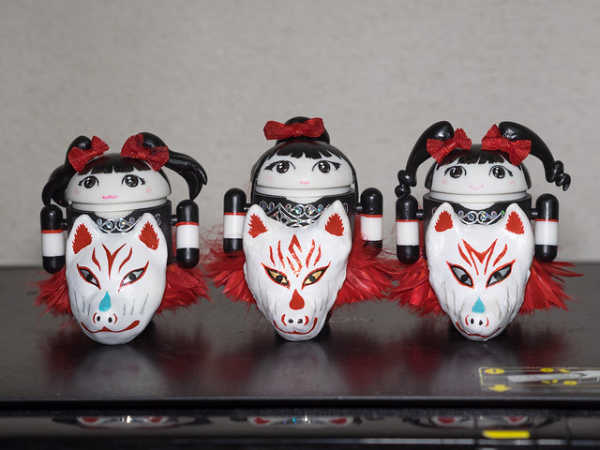
Kitsune: Fox. Foxes are the messengers of the God Inari. They maybe evil or benign depending on the situation.

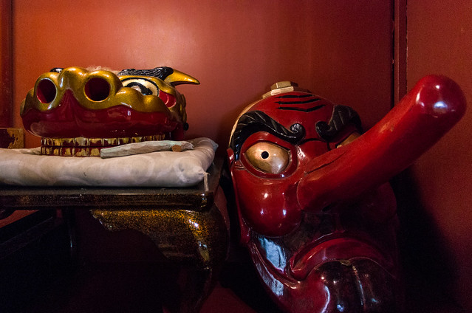
Tengu: It has a long nose. They are a combination of a bird and a human. They protect buddhist temples.
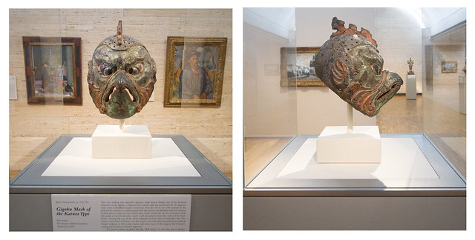
Karura: Has a human body and bird face also known as Garuda in Sanskrit.

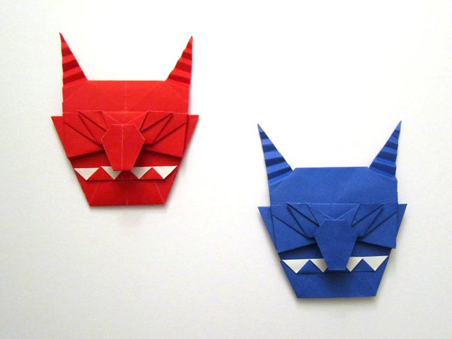
Red devil and blue devil. Oni. In Japan the image of the ogre is a red devil or blue devil. In children’s stories, the hero usually fight against these devils.

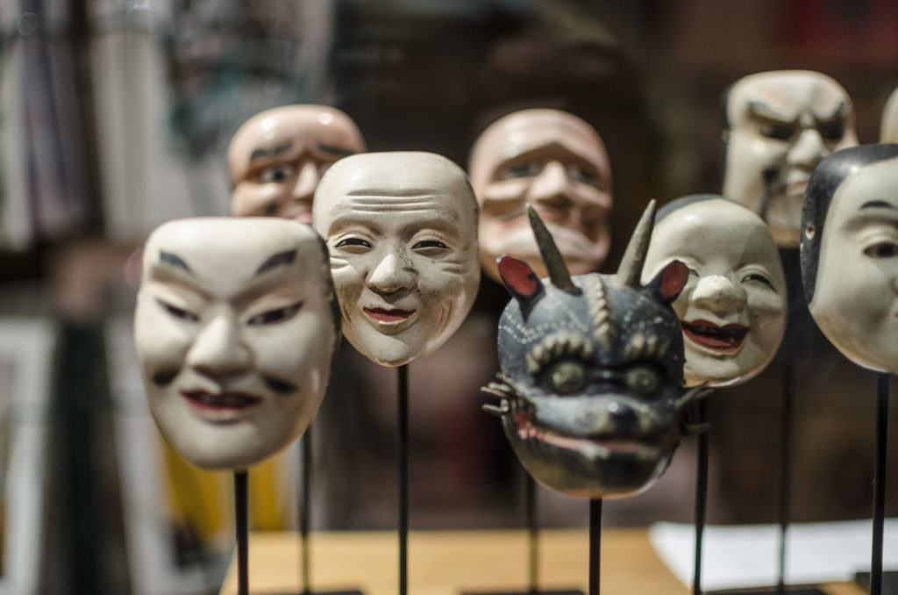
Kabuki masks: Red colors are used more for heroes and black colors are used more for evil characters.

