Steady-State Nonisothermal Reactor Design
The heat of reaction at any temperature T can be expressed in terms of the enthalpy of each
species at that temperature T as following
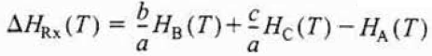
The enthalpy of each species can be also expressed as:
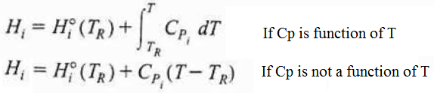
If the enthalpy of each species is inserted into the heat of reaction expression at T:
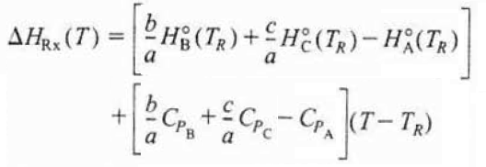
The first term of the given equation can be expressed as the heat of reaction at the reference temperature as following:
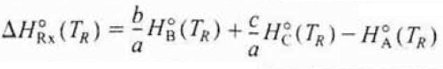
The second term of the given equation can be expressed as the overall change in the heat capacity per mole of A:
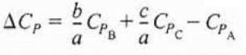
The heat of reaction at any temperature T can be expressed by using the given expressions above:
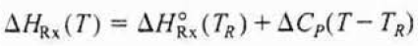
The general energy balance expression in terms of constant heat capacities can be expressed as following:
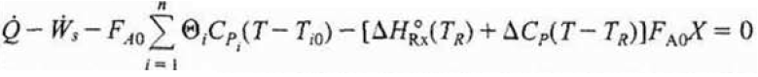
In most systems, the work term, “W” can be neglected. If the system is also adiabatic, the given general energy balance expression can be shown as following:
If we rearrange the give expression in terms of conversion “X”:
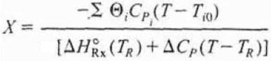
Sometimes, the last term of the denominator term can be neglected with respect to the heat of reaction at T. Hence, the conversion will be the linear function of the temperature as following:
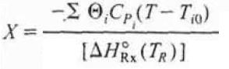
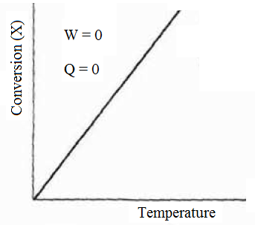
Figure 1. Adiabatic temperature-conversion relation for any type of reactors
If we consider a tubular reactor (PFR) where heat “Q” is either added or removed through the cylindrical walls of the tubular reactor (Figure 2).
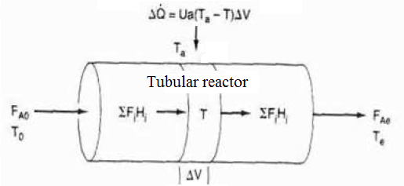
Figure 2. Tubular reactor energy balance diagram
If we make an energy balance on the specified volume ΔV on the tubular reactor with the work term, equal to zero.
where a is the heat exchange area per unit volume of the tubular reactor. For the tubular reactor, the term “a” can be expressed as:
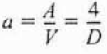
In which the term “D” is the tubular reactor diameter. This form of the energy balance will be expressed as shown below:
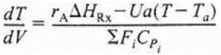
The highest conversion “X”, which can be obtained in reversible reactions, is the equilibrium conversion. For endothermic reactions, the equilibrium conversion rises with a parallel increase in temperature up to a maximum point of 1. In contrast to the endothermic reactions, the equilibrium conversion goes down with an increase in temperature.
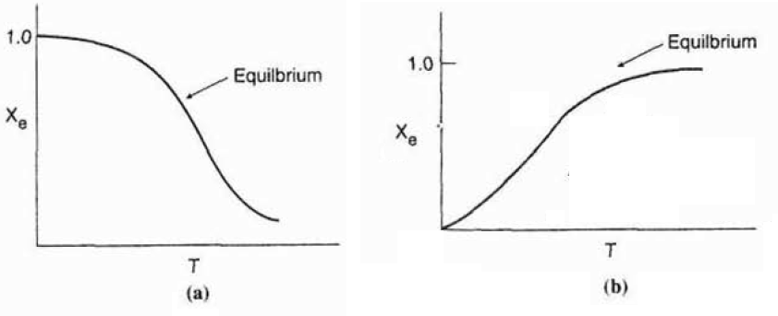
Figure 3. Temperature-conversion relation of (a) the exothermic reaction and (b) the endothermic reaction
For a first-order reaction, the equilibrium conversion “X” can be determined by using the following expression:
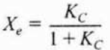
where K_{C} is the equilibrium reaction constant and X_{e} is the equilibrium conversion value.

References:
- H. Scott Fogler, “Elements of Chemical Reaction Engineering”, Prentice Hall Professional Technical Reference, Fourth Edition.

