Evaluation of Transfer Coefficients: Engineering Correlations
Heat Transfer Correlations
If a spherical object is immersed in an infinite stagnant fluid, the analytical solution for the steady-state conduction can be expressed in the following form:
Nu=2
If there is a fluid flow, contribution of the convective mechanism needs to be included in the total heat transfer. Correlation, which includies the convective heat transfer, is as followings:
Physical properties except the viscosity at the wall should be evaluated at the bulk temperature. The given expression is valid for the following conditions:
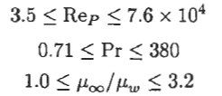
After the average heat transfer coefficient is calculated, the rate of heat transfer can be calculated as followings:
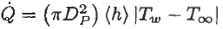

Mass Transfer Correlations
If a spherical object is immersed in an infinite stagnant fluid, the analytical solution for the steady-state diffusion can be expressed in the following form:
Sh=2
If there is a fluid flow, contribution of the convective mechanism needs to be included in the total mass transfer. Correlation, which includies the convective mass transfer, is as followings:
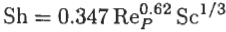
Steinberger and Treybal at 1960 proposed the given correlation, which includes a correction term for natural convection. The given expression is valid for the following conditions:
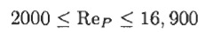
After the average mass transfer coefficient is calculated, the rate of mass transfer can be calculated as followings:

Example: A spherical object made of benzoic acid with a desity of 1267 kg/m³ and with a diameter of 12 mm is dropped in a long cylindrical vessel filled with pure water at 25°C. If the height of the vessel is 3 m, determine the amount of benzoic acid dissolved from the spherical object when it reaches the bottom of the vessel. The solubility value of benzoic acid in water is 3.412 kg/m³.
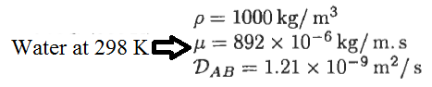
Solution:
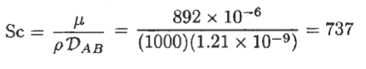
Assumptions:
- The spherical object reaches its terminal velocity instantaneously.
- The diameter of the spherical object does not change along the vessel, which means that the Reynolds number and the terminal velocity remain constant along the vessel.
- Steady-state condition
- The physical properties of fluid phase “water” do not change as a result of mass transfer

In order to determine the terminal velocity of the spherical object made of benzoic acid, the Archimedes number needs to be used:
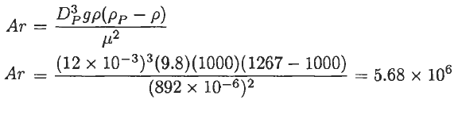
The Reynolds number is calculated from the given correlation below:
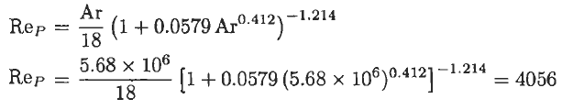
The terminal velocity can be can be calculated using the Reynolds number:
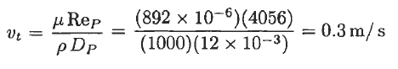
Since the spherical object made of benzoic acid falls the distance of 3 m with a velocity of 0.3 m/s then the falling time can be calculated as followings:
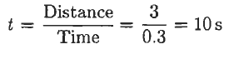
The Sherwood number can be calculated from the following correlation:
The average mass transfer coefficient can be calculated using the following correlation:
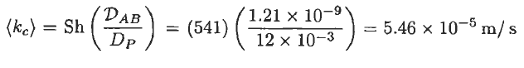
The rate of mass transfer of benzoic acid into the fluid phase “water” ca be calculated by using the following equation:
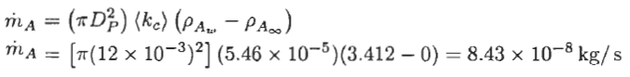
The amount of benzoic acid transferred from the spherical object made of benzoic acid ca be calculated as followings:

References:
İ. Tosun, “MODELLING IN TRANSPORT PHENOMENA A Conceptual Approach”, Elsevier, 2002.

