

d-Aldose sugars: (a) d-pentose and (b) d-hexose.



d-Ketose sugars: (a) pentulose and (b) hexulose.

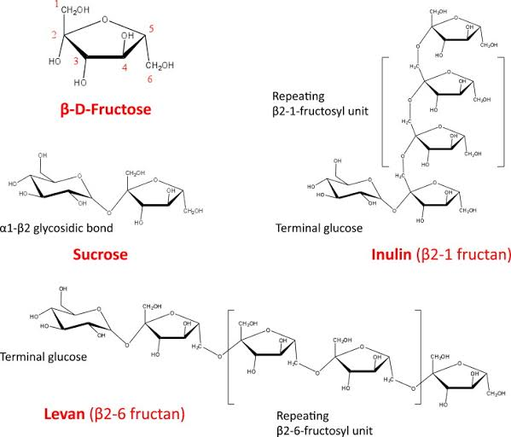

Fructans (Inulin and levan)