Vitamins and coenzymes

Water soluble vitamins:

The “B”-vitamins and Ascorbic acid (Vitamin C)  
  
Fat solubles:  
A, D,E,K  
  
Sources of vitamins  
1. Herbal (vegetable) source

2. Animal source

A well-balanced diet from a variety of food sources except some specific conditions, usually provides all these vitamins.

Recomendad daily allowance (RDA) synonym for [recommended dietary allowance](http://medical-dictionary.thefreedictionary.com/Recommended+Dietary+Allowance) : the amount of vitamin intake per day considered necessary for maintenance of good health, calculated for males and females of various ages

Vitamins are not structural elements they have catalytic functions.   
Some enzymes require chemical groups other than amino acid residues for their enzymatic activity.   
Some enzymes require one or more inorganic ions as Fe2+ , Mn2 + , Mg2 + and Zn2 + for their activity named as cofactors or require organic or metalloorganic components called coenzymes.

Coenzymes

are the intermediate carriers of;

-Functional groups

- specific atoms

- electrons that are transferred  
Most of the coenzymes are the modified structures of vitamins



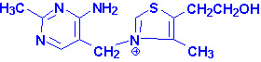  
Thiamine is also known as vitamin B1.

**Thiamin Pyrophosphate (TPP) or cocarboxilase (biologically active form of B**1**);** Coenzyme that is derived from B1 (antiberiberi factor, thiamine)

* It plays a coenzyme role in energy metabolism especially carbohydrate metabolism.
* 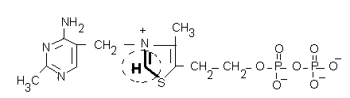
*    
   Reactive reagen of coenzyme; substrates bind to this region and transformations occur.

TPP plays a role in major carbohydrate pathway and in branched chain amino acid metabolism

TPP is found in central nervous system more localised in the membranes and functions in impuls tranmission.

TPP is a coenzyme of three multi enzyme complex that take in charge in oxidative decarboxylation of α-keto acids in mammalian mitocondria;

* + pyruvate dehydrogenase (see carbohydrate metabolism)
  + α-keto glutarate dehydrogenase (see TCA, citric acid cycle)
  + Branched chain keto acid dehydrogenase  
      
    It also serves as a coenzyme for the transketolase, phosphoketolase catalysed reactions of the pentose phosphate pathway.

Daily requirement  
0.5 mg/1000 cal.

RDA:1-1.5 mg/day   
  
Causes serious peripheral neuropathy.

Beriberi occurs if the vitamine is consumed less than 0.4 mg / day for a long time

**Wernicke-Korsakoff syndrome**Lack of vitamin B1 is common especially in people with [alcoholism](https://www.nlm.nih.gov/medlineplus/ency/article/000944.htm) in advanced countries and in narcotic addicts.

Due to B1 deficiency that affecting mostly the brain, encephalopathy does exist.   


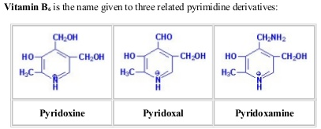

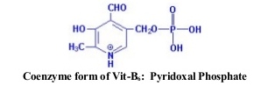  
The reactions involve the schiff base formation of the coenzyme either with the enzyme or the substrate

Pyridoxal phosphate (PLP) functions as a coenzyme for transaminstion reactions and some other of amino acids

Transamination:

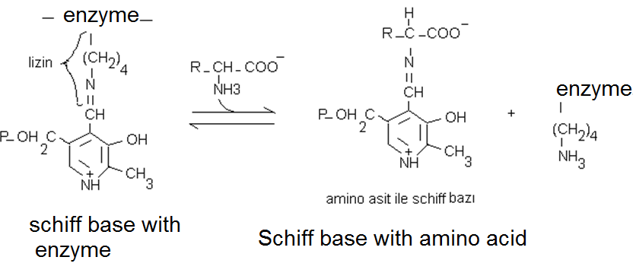

During the transamination reactions a new schiff base linkage take place by addition of pyridoxal phospate   
  
 α- amino group of amino acid that will be transaminated, take place the lysin’s ε- amino group that is present at the active site of the enzyme transaminase.  
  
  
  
Other reactions that PLP take place as a coenzyme:

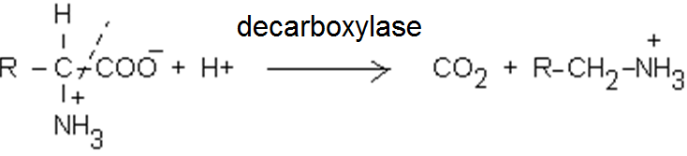

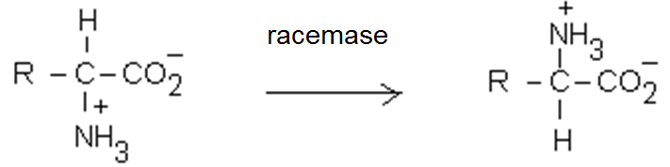

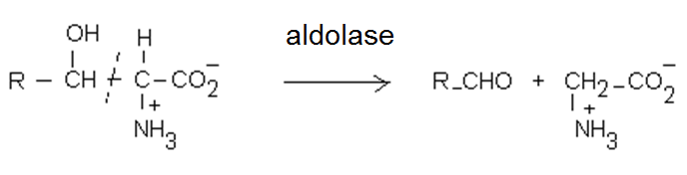 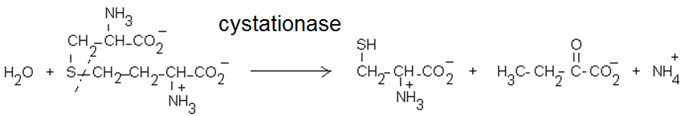

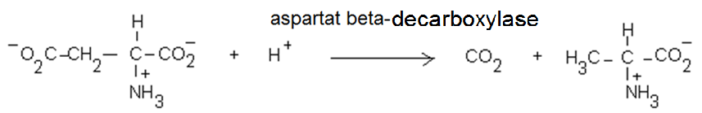

it is synthesized by plants and bacteria

Requirement: 2- 2.2 mg/day

**Functions:** Required for the formation of red blood cells and various neurotransmitters,

Deficiency of B6

* Taking izoniazid pills causes deficiency symptoms like microsytic hypochromic anemia and convulsions in children

The neurological symptoms occur in B6 deficiency is due to low GABA (gamma -amino butyric acid) synthesis.

Excitability increase in GABA deficiency.

Nicotin Amid (nikotinemayd) (B3 ) Coenzymes  
(pyridin coenzymes = pyridine nucleotides)

Niacin (nicotinic acid, nicotinamide,B3)  
 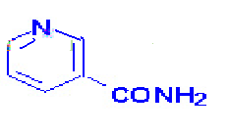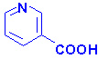Nicotinamide Nicotinic acid  
  
Nicotinic acid is the carboxylated derivative of pyridine

Vitamin B3 is the precursor of NAD and NADP  
Nicotinamid adenin dinucleotide (NAD+ or diphospho pyridin nucleotide DPN+)

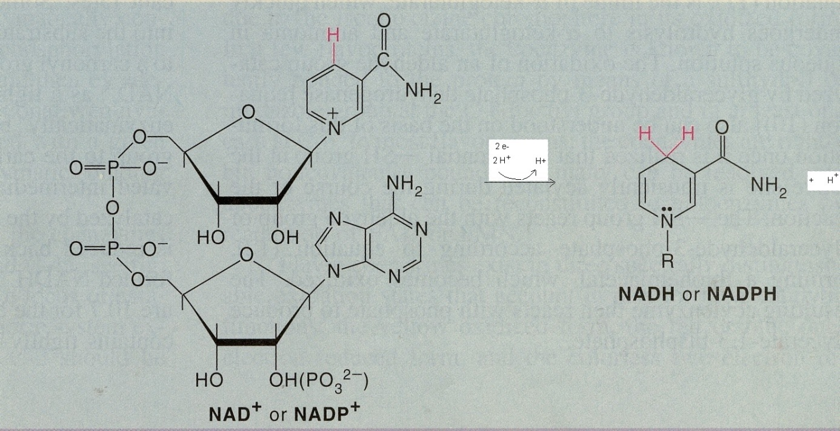

* NADH is used to synthesize ATP. NAD is used in catabolic reactions and NADPH *is used* as a reducing agent in anabolism

Reactions that NAD and NADP take part:

NAD and NADP are coenzymes of a lot of oxidoreductase enzymes.  
They are the key components of most metabolic pathways that influence  
carbohydrate, lipid and amino acid metabolism.

These enzymes are called as dehydrogenases (dh.) bound to pyridine

Niacin requirement: some of it is synthesized in our body. RDA: 13-19 mg niacin equivalent

1 niacin equivalent is equvalent to 1 mg free niacin

Niacin deficiency

Niacin and triptophan deficient diet cause niacin deficiency. Pellagra is the disease state that occurs as a result of severe niacin deficiency. B6 deficiency can cause niacin deficiency due to the fact that Pyridoxal phosphate serves as a coenzyme in NAD synthesis.

* it is known to occur with alcoholism,
* with isoniazid drug, in malign carsinoid syndrom
* in Hartnup disease

Symptoms include skin problems, dermatitis, diarheae and dementia.

*Vitamin B2 (riboflavin, lactoflavin)*

*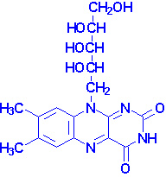  
It’s derivatives found as a prostethic group in most enzymes as flavin mononucleotide (FMN) and flavin adenin dinucleotide (FAD). They are called flavin enzymes.*

* *They play role in a variety of oxidation and reduction reactions. They can be a substrate for the enzymes as well.  
  FMN has a phosphate group attached to the hydroxyl of ribitol.*

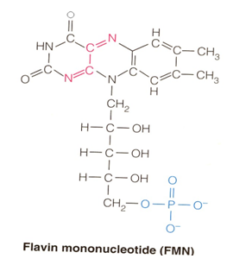

* FAD has ADP at the same position

