The flavin coenzymes can exist in an oxidized form (FMN and FAD),and a two-electron reduced form (FMNH2 and FADH2). Sometimes they also can accept 1 e-

Enzymes that utilize flavin coenzymes (often called flavoproteins) include dehydrogenases, oxidases and oxygenases. They are prostethic groups closely bound to the enzyme.

These enzymes play a role in oxidative degredation of amino acids, carbohydrates, pyruvate, fatty acids and also in e- transport. These reactions are essential for energy production and cellular respiration.  
  
FADH2 and FMNH2 bound to dehydrogenases; can not be reoxidised by O2. They transfer their electrons to ubiquinone (Coenzyme Q) in e- transport chain. Transport chain are localised in mitochondria. These are:

* NADH dehydrogenase (dh.), succinate dh., dihydrolipoyl dh., α-ketoglutarate dh., acyl CoA dh.

An example for flavin-bind dh

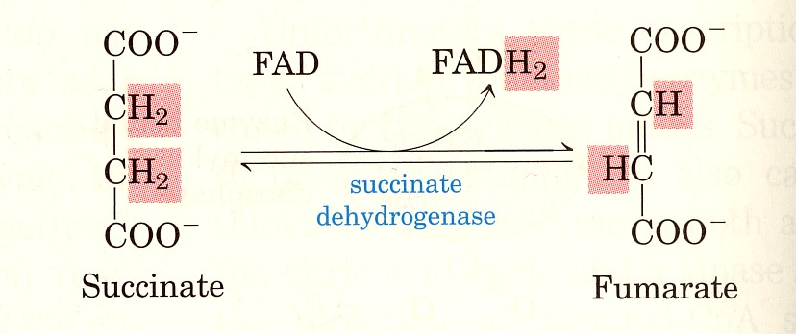

In the other flavin enzymes molecular O2 is an e- acceptor for both oxygenases and oxidases.

Reduced flavin oxidase and oxigenase can be reoxidized by molecular O2.

* Mol O2 is an oxidising agent for oxidase enzymes.
* It is different with oxigenases. One or more oxygen atom is incorporated to the oxidised product.

the reaction of L amino acid oxidase:

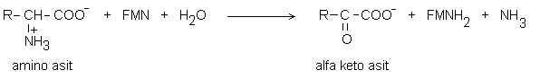



B2 requirement

The recommended riboflavin intake is,

RDA: 1.4-1.6 mg/day for the normal adults  
The requirement depends on the calorie;  
appr. 0.3 mg / kal

Deficiency has been known to occur with alcoholism, malignancy, malnutrition, chronic diarrheae, starvation and in the elderly. Symptoms of deficiency include photophobia, ocular disorders, cracks at the corners of the mouth (chelosis), dermatitis on nose and lips, light sensitivity.

Phenothiazine, oral contraseptives, tricyclic antidepressants antagonise the effect or the metabolism of B2.

*Vitamin B5 (pantothenic acid)*

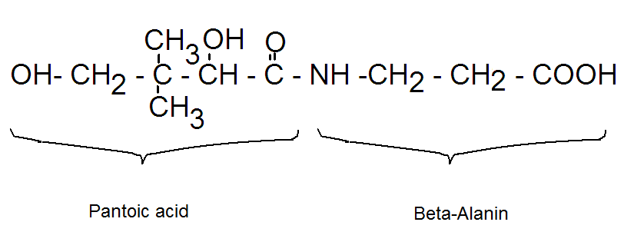

Pantothenic acid – also known as vitamin B5 – is a water-soluble [vitamin](http://lpi.oregonstate.edu/mic/glossary) that is a [precursor](http://lpi.oregonstate.edu/mic/glossary) of Coenzyme A (CoA) and of the Acyl Carrier Protein (ACP).

They are also called *4’-phosphopantetheine coenzymes:*

* 1. ACP (acyl carrier protein):  
  2. CoA  
     
  Thus required for the metabolism of proteins, all fat, carbohydrates via citric acid cycle and for cholesterol synthesis

CoA is required for biological acetylation reactions, oxidation of pyruvate (CoA-SH), oxidation (CoA-SH) and synthesis of fatty acids (ACP-SH)   
functions as the acyl carrier also has a function in carboxylic acid enolysation.

Naturally occurring pantothenic acid deficiency in humans is very rare and has been observed only in cases of severe malnutrition and causes burning feet syndrome.   
Requirement: 5-10 mg/ day

It is used to stimulate gastrointestinal system of postoperative patients and also for the treatment of neuropathy caused by high doses of streptomycin.

α-Lipoic Acid

It is found as cyclic disulphyde form and the reduced dihydrolipoic acid (opened ring) form.  
  
It is the coenzyme of enzymes that functions in the oxidative decarboxylation of pyruvate and other α–keto acids ex. pyruvat dh. ve α–ketoglutarate dh. multienzym systems (see TCA cycle).

The reduced form is the acceptor of acyl groups during the decarboxylation of α-keto acid. Lipoic acid couples the e- and acyl group transfer reactions.

*Biotin (vitamin H)*

It is composed of tetra thiazol and tetra thiophene rings and valeric acid is attached. It is synthesized by most of the plants and microorganisms.

Biotin functions to transfer carbon dioxide in a small number of reactions like acetyl-CoA carboxylase

It plays a role in gluconeogenesis, lipogenesis and fatty acid synthesis

Daily requirement: 150-300 µg  
 Deficiency is seen with the consumption of raw egg white for a prolonged period. Raw egg white contains an [antimicrobial](http://lpi.oregonstate.edu/mic/glossary) protein known as avidin that can bind biotin and prevent its absorption. Biotin deficiency

Symptoms are;  
depression, neurological symptoms, dry skin, dermatitis, muscle aches, hair loss ([alopecia](http://lpi.oregonstate.edu/mic/glossary)). Deficiency is rare. 150-300 mg/day biotin supplementation will cure the deficiency state

Folic acid (B9)

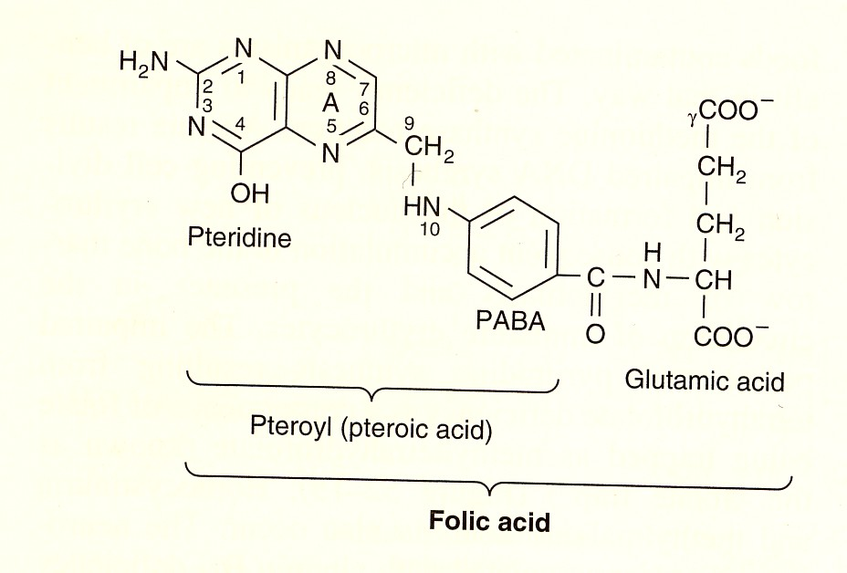

Folat coenzymes ( Folic acid, Folasin, vitamin B9 coenzymes):

Tetrahydrofolic acid, is the coenzyme of enzymes transferring one carbon groups as metil (−CH3) and hydroymethyl (−CH2−OH) from one molecule to the other. Coenzymes are:

* Tetrahydropholic acid (FH4)
* N5, N10 methylene tetrahydropholic acid ,
* N5, N10 methenyl tetrahydropholate,
* N10 formil tetrahydropholate
* N5 metil tetrahydropholate

FH4 and other derivatives

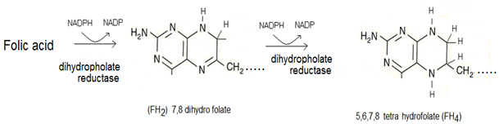

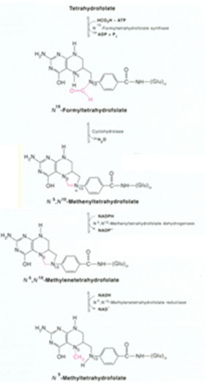

Folate [coenzymes](http://lpi.oregonstate.edu/mic/glossary) in the body appears to be in mediating the transfer of [one-carbon units](http://lpi.oregonstate.edu/mic/glossary).   
N10 formil tetrahydropholate and ve N5, N10 methenyl tetrahydropholate are 1 C donors of transformilase enzymes. They provide 2. and 8. C of purin rings during nucleic acid synthesis. (The [synthesis](http://lpi.oregonstate.edu/mic/glossary) of DNA from its [precursors](http://lpi.oregonstate.edu/mic/glossary) (thymidine and purines) is dependent on folate coenzymes).

N5, N10 methylene FH4 s are donor susbtrates of OH methyl group for some enzymes and methyl donor substates for timidilate synthase.

N5 methyl FH4 is a CH3 group donor for methionin synthase:

Homosistein  metiyonin  
  
A folate coenzyme is required for the synthesis of [methionine](http://lpi.oregonstate.edu/mic/glossary) from [homocysteine](http://lpi.oregonstate.edu/mic/glossary) and methionine is required for the synthesis of S-adenosylmethionine (SAM).

SAM is a methyl group (one-carbon unit) donor used in most biological [methylation](http://lpi.oregonstate.edu/mic/glossary) reactions, including the methylation of a number of sites within DNA, [RNA](http://lpi.oregonstate.edu/mic/glossary), [proteins](http://lpi.oregonstate.edu/mic/glossary), and [phospholipids](http://lpi.oregonstate.edu/mic/glossary).   
Folate (and/or vitamin B12) deficiency can result in decreased synthesis of methionine and an accumulation of homocysteine. Elevated blood concentrations of homocysteine have been considered for many years to be a [risk](http://lpi.oregonstate.edu/mic/glossary) factor for some chronic diseases, including [cardiovascular disease](http://lpi.oregonstate.edu/mic/glossary).

.

Deficiency is seen with alcohol, oral contraceptives and anticonvulsants. It is also accompanied with the B12 deficiency. Synthesis of purine and nucleic acid is degeneretad in folic acid deficiency.

Clinical folate deficiency leads to [megaloblastic anemia](http://lpi.oregonstate.edu/mic/glossary), which is reversible with folic acid treatment.

There is also neurologic disorders.

RDA = 400 µg,   
MDR = 50 µg

**B12 (Cobalamin)**

Coenzyme forms

5-Deoxyadenosyl cobalamin is the coenzyme required by methylmalonyl-CoA mutase, while methylcobalamin acts as the methyl-group acceptor and donor during the methionine synthase reaction.  
  
B12 coenzymes have a role in nucleic acid synthesis, red blood cell synthesis. Helps to maintain nerve cells, protects the myeline sheath.

Vitamin B12 is not made in plants; it is only synthesized by microorganism (also by intestinal microorganisms) and found in meat especially liver and kidney, also found in milk, egg, yeast and fish.

It is not found in vegetable sources  
MDR: 0.1µg /day  
RDA: 2-3 µg /day  
  
Deficiency

Absorbtion of the vitamin is impaired in chronic alcoholics. Inadequate IF (intrinsic factor) secretion from the stomach also causes B12 deficiency leading to [megaloblastic anemia](http://lpi.oregonstate.edu/mic/glossary) (pernicious anemia) and [neurologic](http://lpi.oregonstate.edu/mic/glossary) disorders. B9 and Fe deficiencies both  
are usually present.

Diminished activity of methionine synthase in vitamin B12 deficiency inhibits the regeneration of tetrahydrofolate (TH4; THF) and traps [folate](http://lpi.oregonstate.edu/mic/vitamins/folate) in a form that is not usable by the body. Thus, in both folate and vitamin B12 deficiencies, folate is unavailable to participate in [DNA](http://lpi.oregonstate.edu/mic/glossary) [synthesis](http://lpi.oregonstate.edu/mic/glossary) (TH4 can not be formed that is required for purine and primidine synthesis). This impairment of DNA synthesis affects the rapidly dividing cells of the bone marrow earlier than other cells, resulting in the production of large, immature, [hemoglobin](http://lpi.oregonstate.edu/mic/glossary)-poor red blood cells. The resulting [anemia](http://lpi.oregonstate.edu/mic/glossary) is known as [megaloblastic anemia](http://lpi.oregonstate.edu/mic/glossary) and is the symptom for which the disease, [pernicious anemia](http://lpi.oregonstate.edu/mic/glossary), was named.

Methyl malonyl CoA mutase

Methyl malonyl CoA  succinyl CoA   
 5-Deoxyadenosyl (adenosil) cobalamin

This reaction plays a key role in the oxidation of *fatty acids* with even numbers of carbon *chains* and metabolism of branched chain amino acids.  
The deficiency results in neuropathy.

Vitamin C (Ascorbic Acid)

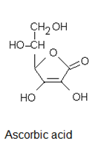

Ascorbic acid is strongly a reductant; antioxidant.  
Vitamin C is necessary for hydroxylase enzymes. Here it has 2 roles;  
1. ascorbate acts as a reducing agent, [donating electrons](https://en.wikipedia.org/wiki/Electron_donor) for reduction of O2 and 2. prevents oxidation; to keep iron and copper atoms in their reduced states

These hydroxylases are [prolyl-4-hydroxylase](https://en.wikipedia.org/wiki/P4HA1), and [lysyl hydroxylase](https://en.wikipedia.org/wiki/Lysyl_hydroxylase) that are required for the [hydroxylation](https://en.wikipedia.org/wiki/Hydroxylation) of [proline](https://en.wikipedia.org/wiki/Proline) and [lysine](https://en.wikipedia.org/wiki/Lysine) in the synthesis of [collagen](https://en.wikipedia.org/wiki/Collagen),  
[dopamine beta hydroxylase](https://en.wikipedia.org/wiki/Dopamine_beta_hydroxylase) participates in the biosynthesis of [norepinephrine](https://en.wikipedia.org/wiki/Norepinephrine) from [dopamine](https://en.wikipedia.org/wiki/Dopamine) .  
Dopamin-β hydroxilase for the synthesis of epinephrine (cathecholamine) from tyrosine.   
Vitamin C also plays a role in carnitine from lysine, in hydroxylation of steroid hormones, aromatic drugs and carcinogens.

Vitamin C is supposed to be a transporter of SO4; taking role in glucosaminoglycan, increases intestinal absorbtion of Fe, important in bone mineralisation due to its chelating with Ca. It also constitutes the phosphate formation for mineralisation

Avitaminosis: scurvy

symptoms appear to be related to the weakening of blood vessels, connective tissue, and bone, which all contain [collagen](http://lpi.oregonstate.edu/mic/glossary).

Vitamin C has less side effects, more than 1 gram a day can cause diarrheae, stomach ache. Because oxalate is a [metabolite](http://lpi.oregonstate.edu/mic/glossary) of vitamin C, there is some concern that high vitamin C intake could increase the [risk](http://lpi.oregonstate.edu/mic/glossary) of calcium oxalate [kidney stones](http://lpi.oregonstate.edu/mic/glossary).

RDA for adults: 60 mg/day  
Vitamin C is used in cancer, catching cold and cardiovasculer diseases.

Tetrahydrobioptherine

Not a vitamine, synthesized in the body  
Coenzyme for NO synthase and for phenylalanine hydroxylase.