**Reversible Reactions**

At equilibrium, the reaction rate of reaction is equal to zero for all species. For the general reaction expresion:



The equilibrium relationship in terms of the equilibrium concentrations are related by the equilibrium constant Kc as following:

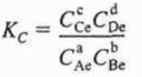

As an example for the reversible gas phase reaction:

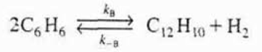

Where kB, and k-B are the forward and reverse specific reaction rate constants. Benzene (B) is consumed by the following forward reaction:



where the decomposition rate of benzene is as following:



Diphenyl (D) and hydrogen (H2) react with the reverse reaction as following:



where the reaction rate of diphenyl with hydrogen gas is as following:



The net rate of formation of benzene is the sum of the rates of formation of the forward reaction and the reverse reaction as shown below:



The given rate law can be written in terms of the equilibrium rate constant

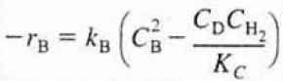

At which the equilibrium rate constant “Kc” is equal to:

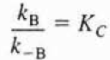

If the forward reaction is exothermic, which means the reaction generates heat during the chemical reaction, then the reverse reaction is endothermic, which means that the reaction absorbs heat when it takes place, by the same degree. Similarly, if the forward reaction is endothermic, then the reverse reaction is exothermic by the same degree.

The equilibrium constant decreases with increasing temperature for exothermic reactions and increases with increasing temperature for endothermic reactions.

At equilibrium, -rB is equal to zero, and the rate law given as following:

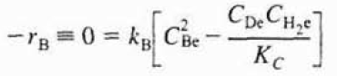

The equilibrium expression can be arranged into the following formin terms of the equilibrium rate constant “Kc”:

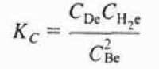

If there is no change in the total number of moles and the heat capacity term “ΔCp” is equal to zero, the temperature dependence of the concentration equilibrium constant is given as following:

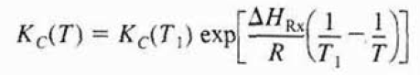

For endothermic reactions, the equilibrium constant, “Kc”, decreases with decreasing the reaction temperature. For exothermic reactions, the equilibrium constant, “Kc”, increases with decreasing the reaction temperature.

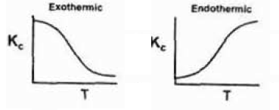

**The Reaction Rate Constant**

The reaction rate constant k is independent of the concentrations of the species involved. The reaction rate constant is strongly dependent on temperature and pressure. Arrhenius suggested the temperature dependence of the specific reaction rate, “kA”, as shown below:



where A is the preexponential factor or frequency factor, E is the activation energy in J/mol or cal/mol, R is the gas constant and T is the absolute temperature in Kelvin. The Arrhenius can be arranged into a useful form as shown below:

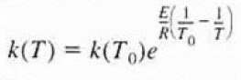

The design equations of the batch reactor, backmix reactor (CSTR) and the tubular reactor (PRF) are given below:

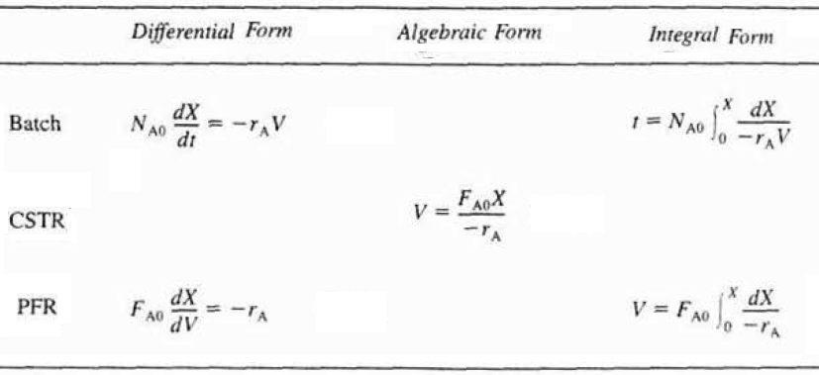

**References:**

* H. Scott Fogler, “Elements of Chemical Reaction Engineering”, Prentice Hall Professional Technical Reference, Fourth Edition.