**III. REFRACTIVE INDEX AND ITS MEASUREMENT**

**A. *Refractive index***

The refractive index (n) is a physical property of a mineral mathematically defined as:

**n** =  **v v**

**vm** [1]

where,

n = refractive index of mineral

* vv = velocity of light in a vacuum

vm = velocity of light in the mineral

There are three important points gained from an examination of Equation

1. (1) The refractive index of a vacuum is 1.0.

(2) Refractive index is a unitless number.

(3) Because the velocity of light cannot exceed that in a vacuum (3x108 m/s), the refractive index of any material is greater than

1. In routine work the velocity of light in air is substituted for the velocity of light in a vacuum in Equation 1. This only amounts to a small error because the refractive index of air is approximately 1.0003.

Refractive index usually increases when matter changes from a gas to a liquid to a solid. The quantum theory of light is used to explain changes in refractive index. The refractive index is greater than one because as photons enter a mineral they are slowed by interaction with electrons. The more photons are slowed while travelling through a material, the greater the material's refractive index. Generally, any mechanism that increases electron density in a material also increases refractive index. For instance, increasing the density of a material usually increases the refractive index. However, refractive index is also closely related to bonding. In general, ionic compounds having lower values of n than covalent ones. In covalent boning more electrons are being shared by the ions than in ionic bonding; thus, more electrons are distributed through the structure and interact with the incident photons slowing them. Thus, changes in refractive index are related, albeit in a very complicated, as yet not fully understood, manner to the interaction of the incident light's photons and the material's bonding electrons.

**B. *Light refraction***

Geometrically, light travels through a crystal with the incident and transmitting rays following Snell's Law, mathematically written:

**ni sin**( **i**) = **nt sin**( **t** ) [2]

where,

ni = refractive index of incident media

nt = refractive index of transmitting media

i = angle of incidence

t = angle of transmission or refraction

Much of the science of physical optics and ray tracing is based on this formula. By analyzing Equation 2 the following are noted. (1) Any ray at normal incidence onto a material of different refractive index will be transmitted without any deviation (ray 1, Figure 4). (2) When both the incident and transmitting medias have the same refractive index, the incident and transmitting angles are equal. (3) For the general case, when the angle of incident is not 0 and the refractive indices for the two materials are unequal, the ray is refracted and the angle of refraction can be found from Equation 2 (ray 2, Figure 4). (4) There is some angle at which an incident ray is refracted at 90 ; this is termed total refraction and used in refractometery to determine the refractive index of an unknown (ray 3, Figure 4 and Figure 5). The angle at which total refraction occurs is called the critical angle.

Every incident ray, before the critical angle is reached, has a reflected as well as a transmitted portion. For the reflected component, the angle of reflection is equal to the angle of incidence. For both rays

the intensities and polarization properties can also be calculated (Gunter,

1989). Snell's Law is obeyed by all isotropic materials; however, it is not obeyed for random orientations in anisotropic materials.

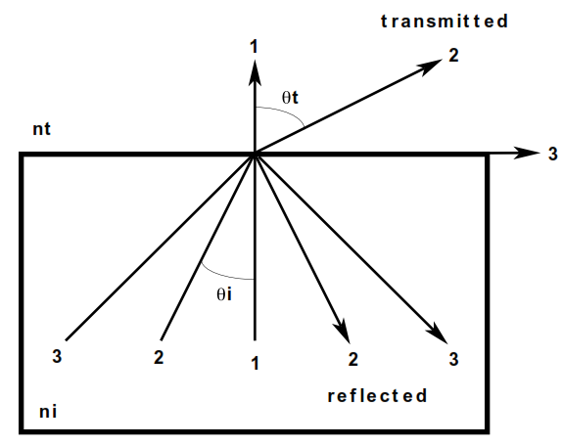

Figure 4. Ray paths illustrating reflection and refraction. Rays 1, 2, 3 are incident from the lower left and each ray has a reflected and refracted portion. The angle of reflection is equal to the angle of incidence ( i). The angle of refraction, or transmittance (t), can be found by application of Snell's Law. Ray 3 shows the case of total internal reflection when t = 900 .

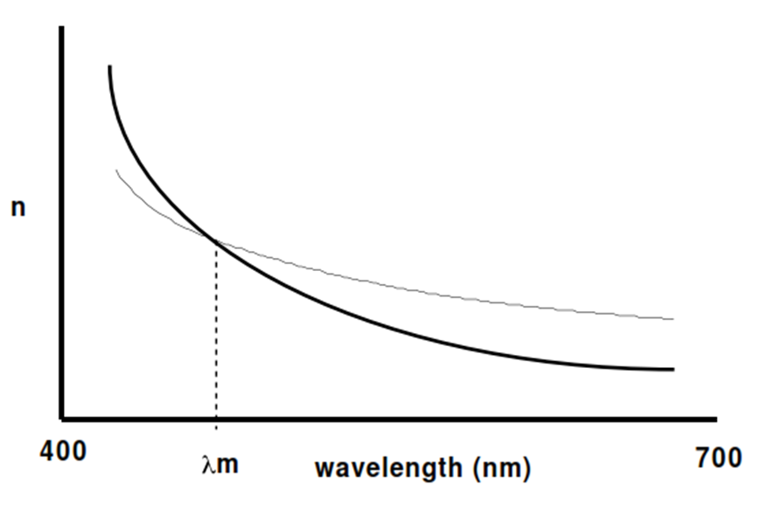

Figure 5. Dispersion curves for two materials. Dispersion curves in the visible have this distinctive concave upward shape. The bolder curve has a higher dispersion than the lighter curve. The refractive index of the two materials are equal at m, the wavelength of match.

**C. *Dispersion***

The refractive index of a material depends upon the wavelength of light and the wavelength change in refractive index is called dispersion and is graphically shown in Figure 5. The bolder curve has a steeper slope and exhibits a greater dispersion than the lighter curve. In general, the dispersion of a liquid is greater than that of a solid. Also, in general, the higher the refractive index of a material the higher the dispersion.

The rainbow, created from drops of rain, or a glass prism are familiar examples of dispersion. The refractive index of water, or glass, decreases with wavelength (like the curves in Figure 5). White light is composed of the different wavelengths of light, and each wavelength possesses a different refractive index. Application of Snell's Law (Equation 2) shows that a different angle of refraction occurs for different colors of light. Thus, because of dispersion and geometrical optics from Snell's Law, the colors of the rainbow are easily understood. Red light, with the lowest refractive index, is refracted the least and occurs on the outside of the rainbow. Violet light, with the highest refractive index, is refracted the most and occurs on the inside of the rainbow.

**D. *Measurement of refractive index***

There are two general methods to measure the refractive index of transparent compounds: (1) a direct measurement of the angle of refraction as found in Snell's Law or (2) a comparison of the unknown material's refractive index to a known. The former method is routinely used to determine the refractive index of liquids and larger solid samples (greater than 1 mm) and was discussed above, with details below, on its application to anisotropic samples. While the latter method is more normally used to determine the refractive indices of smaller samples

(less than 1 mm). The comparison method was developed early in this century and has become known as the immersion method. In this method a solid sample of unknown refractive index is placed into a liquid of known refractive index. By microscopic observations, explained later, the liquid is "adjusted" until its refractive index matches that of the solid, thus determining the refractive index of the unknown.

The immersion methods works on the basis of refraction of light rays as defined in Snell's Law. When the refractive index of the liquid (nl) and solid (ns) are the same, there is no refraction of the light rays, basically making the samples invisible. When there is a large difference between the refractive index of the sample and liquid, light is refracted when entering and leaving the solid. The refraction of these waves make the sample visible. The word "relief" is used to semi-quantitatively denote the difference between the refractive index of the solid and that of the liquid. Samples at or near a match are have low relief, while those farther from match have high relief. When nl < ns the sample has positive relief; when nl > ns the sample has negative relief.

The mineral's relief is observed in thin section mineral identification. The epoxy holding the thin section to the slide has a refractive index of approximately 1.55. Minerals in thin section with a refractive index of within +/- 0.04 will have low positive/negative relief. Minerals with a refractive index within the range of +/- 0.04 to 0.12 will have moderate positive/negative relief, while those with refractive indices above +/- 0.12 will have high positive/negative relief.

**BECKE LINE**

The Becke line method is the most commonly used technique to determine a match between nl and ns in the immersion method. A crystal is immersed in liquid between a glass slide and a coverslip. After obtaining a focused view of the crystal under the microscope in polychromatic light, the microscope is slightly de-focused by racking the stage down. Two lines, one light and one dark, appear around the grain boundaries. The light Becke line moves into the material which has the larger refractive index. Basically, the grain is functioning as a lens in the liquid. When nl < ns, the grain acts as a convex lens, refracting the light into the grain's center - the light Becke moving into the grain. When nl >ns, the grain acts as a diverging lens, sending the bright Becke line into the liquid. Another liquid is selected based upon the findings of the previous observation, and the process of bracketing the solid with the liquid continues until the Becke lines become colored, at which time another strategy is used.

The Becke lines become colored when the dispersion curves for the liquid and solid intersect in the visible. The intersection point marking the precise wavelength of match were the refractive index of the liquid and solid are equal. An entire progression of colors occur, depending upon the point of intersection of the two curves (Figure 6 and 7).

[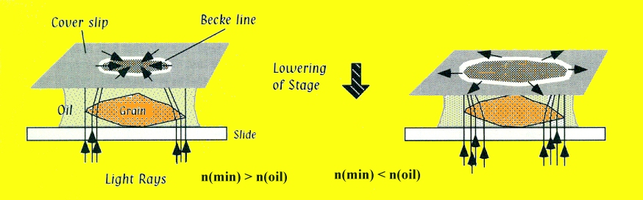](http://www.google.com.tr/url?sa=i&rct=j&q=becke+line&source=images&cd=&cad=rja&docid=Mc3NPFZB3WF20M&tbnid=X36IcUdodF7lOM:&ved=0CAUQjRw&url=http%3A%2F%2Fwww.mineralatlas.com%2FOptical%2520crystallography%2Frefractive%2520index.htm&ei=EJBQUe7HB8y_PM3XgJgF&bvm=bv.44158598,d.Yms&psig=AFQjCNFPOrLOInuR3wmOT3IAgth-FyG6pw&ust=1364320613111545)

Figure 6. Formation of Becke line during the moving the microscopic stage.

**Becke Lines** - Are defined as the broad, dark or bright lines (due to refraction and/or diffraction) formed in the image at the boundary between media of different optical path lengths. They move in the direction of the longer optical path when the distance between the objective and the object is increased. The Becke line disappears in the region of the object that lies in exact focus

[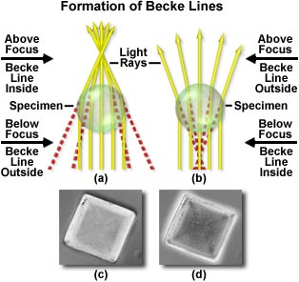](http://www.google.com.tr/url?sa=i&rct=j&q=becke+line&source=images&cd=&cad=rja&docid=5253XalGaklSPM&tbnid=jLsql4oQxITpuM:&ved=0CAUQjRw&url=http%3A%2F%2Fmicro.magnet.fsu.edu%2Foptics%2Ftimeline%2Fpeople%2Fbecke.html&ei=rpBQUfunJYHYPOysgegP&bvm=bv.44158598,d.Yms&psig=AFQjCNFPOrLOInuR3wmOT3IAgth-FyG6pw&ust=1364320613111545)

Figure 7. Formation of Becke lines (a) the transparent specimen has a higher refractive index than the surrounding medium. When the objective is raised above focus a bright Becke line appears inside the specimen, but the Becke line appears to enlarge and surrounds the specimen when the objective is moved below the focus point. If the specimen has a lower refractive index than that of the medium (b), the situation is reversed and raising the objective above focus produces a bright Becke line surrounding the specimen.

The double-variation method is a refinement on the above technique. With it, and careful observations, refractive indices can be obtained with an accuracy and precision of +/- 0.0001. The "double" originates from the microscopist's control over both wavelength of light and temperature of the liquid. As shown in Figure 4, refractive index decreases with wavelength. In this method a monochrometer is used and the precise wavelength at which a Becke line disappears can be

found. Also, refractive index decreases with increasing temperature. For a material this change is mathematically written as dn/dt. The dn/dt for liquids is several orders of magnitude greater than that of solids. By raising the temperature of the liquid a few degrees centigrade, a large change occurs in its refractive index, while the crystal's refractive index does not significantly change. By making several wavelength matches at different temperature, the precision of the refractive index determination

is increased. This is the chosen method, coupled with use of the spindle stage (discussed below), to obtain accurate and precise optical data on single crystals.

***Plecochroism, Absorption, and Color***

*Pleochroism*, absorption, and color are helpful aids in mineral identification and useful in fully understanding the crystal structure of a mineral. These three phenomena are closely related. *Pleochroism is the change in color of an anisotropic sample as a function of the vibration*

*direction.* Absorption occurs when light is absorbed in the crystal, which results in a decrease in light transmission. Pleochroism and absorption manifest themselves on the PLM in plane polarizer light by a change in color and light transmission upon stage rotation.

Many minerals are colored, and many colored minerals exhibit both pleochroism and absorption. The causes of these phenomena are well beyond the scope of this article. The interested reader should consult Nassau (1978) for an excellent discussion of color in minerals.