**Packed-Bed Reactor**

The main difference between the reactor design procedure with homogeneous reactions and with fluid-solid heterogeneous reactions is that the fluid-solid heterogeneous reaction occurs on the surface of the catalyst. A catalyst is a substance that can be added to a reaction to increase the reaction rate without getting consumed in the process. Catalysts typically speed up a reaction by reducing the activation energy or changing the reaction mechanism.

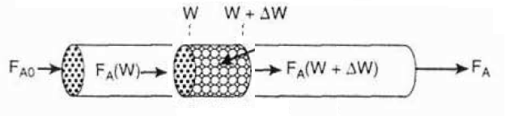

Figure 1. Configuration of the packed-bed catalytic reactor (PBR)

For the fluid-solid heterogeneous reaction systems, the reaction rate of a substance A is defined as:



The derivation of the design equation for a packed-bed catalytic reactor (PBR) will be carried out in a manner analogous to the development of the tubular design equation.

In the packed-bed catalytic reactor, the reactants are continually consumed as they pass through the reactor. The concentration varies only in the axial direction not in the radial direction. Thus, the reaction rate varies also axially as within the PFR.

The general mole balance can be modified for the packed-bed catalytic reactor (PBR) as given below:

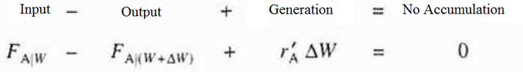

The differential form of the mole balance equation for a packed-bed reactor (PBR) is shown as followings:

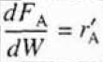

**Definition of Conversion**

If we develop the stoichiometric relationships and design equations for the following reaction:



If we take species A as our basis of calculation, we need to divide the reaction expression by the stoichiometric coefficient of species A. The arranged form of the stoichiometric relationships given below:

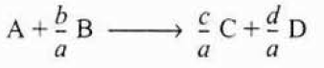

The conversion shown with the notation “XA” is the number of moles of A, which is reacted per mole of A fed to the reactor:

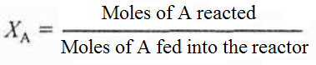

**Batch Reactor Design Equations With Conversion**

In batch reactor systems, the conversion X is a function of the reaction time. The total number of moles of A that have reacted after a time t can be expressed as:

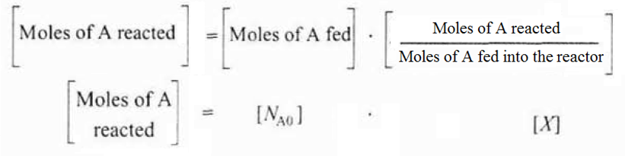

The total number of moles of A that remain in the reactor after a time t is:

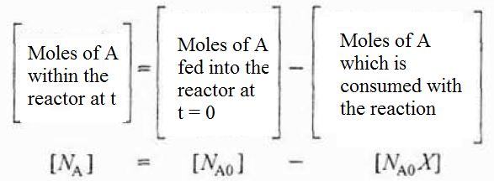

The total number of moles of A within the reactor after a conversion X can also be expressed as shown below:



If there is no spatial variations in reaction rate, then the mole balance on species A for a batch reactor system can be expressed as followings:

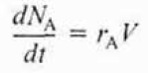

The given design equation for the batch reactor can be turn into a form in terms of the conversion:

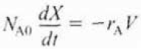

For the gas-phase reaction and the liquid-phase reaction, batch reactors are preferred in industry. For the constant-volume batch reactor, the design equation can be arranged into the following form:



The time “t” necessary to achieve a specific conversion “X” within the batch reactor can be calculated using the following equation:

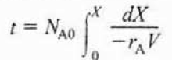

**Design Equations for Flow Reactors With Conversion**

In flow reactors, the conversion “X” is a function of the reactor volume V. The molar rate at which species A is reacting within the reactor will be:

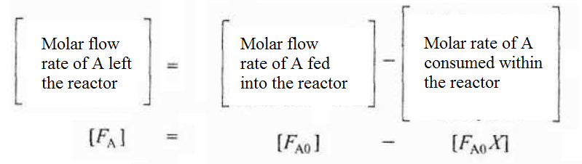

After arranging the given equation as shown below:



The entering molar flow rate of species A can also be expressed as the product of the entering concentration “CAo” and the entering volumetric flow.



**References:**

* H. Scott Fogler, “Elements of Chemical Reaction Engineering”, Prentice Hall Professional Technical Reference, Fourth Edition.