# 5. PROJECTS IN FIBER OPTICS (NEWPORT CORPORATION)

Projects in Fiber Optics (Newport Model #**FKP-STD**) is a set of laboratory equipment containing the hardware needed to complete a series of projects which will provide students, engineers and scientists with an introduction to the hands-on experience needed to master the basic concepts and laboratory techniques of optical fiber technology.

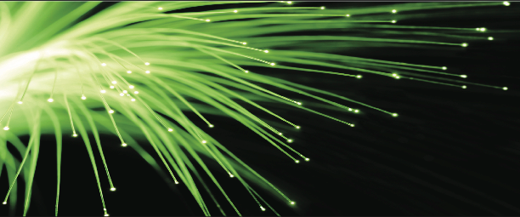

The following projects are going to be performed with this experimental set:

**Project 5.1** Handling Fibers, Numerical Aperture

**Project 5.2** Fiber Attenuation

**Project 5.3** Coupling Fibers to Semiconductor Sources

**PRIMER IN FIBER OPTICS**

**HISTORY OF FIBER OPTICS**

The concept of optical communications goes far back into history. The sending of messages by light is certainly as old as the first signal fires or smoke signals, and has continued, in more recent history, in the use of signal lamps for communication between ships at sea. However, the first patents for an optical communications system were filed in 1880. At that time, Alexander Graham Bell obtained patents on the photophone and demonstrated communication on a beam of light at a distance of 200 meters. The photophone, shown in **Fig. 5.l**, used a photosensitive selenium cell to detect variations in the intensity of a beam of light. However, all of these methods mentioned here depend on the atmosphere as the transmission medium, and anyone who has ever driven on a foggy day knows how unreliable that is.

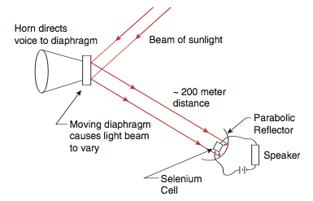

**Figure 5.1. Schematic diagram of Alexander Graham Bell's photophone**

A waveguide made of a non-conducting material, which transmits light (a dielectric), such as glass or plastic, would provide a much more reliable transmission medium, because it is not subject to the variations of the atmosphere. The guiding of light by a dielectric medium is also not a new idea. In 1870, John Tyndall showed that light could be guided within a stream of water. Tyndall's experiment is illustrated in **Fig. 5.2**. By 1910, Hondros and Debye had developed a theory of dielectric waveguides.

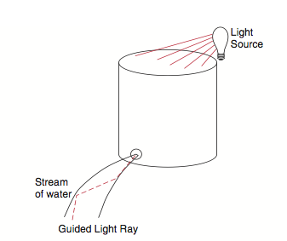

**Figure 5.2:** Tyndall's experiment showing that a stream of water will guide a beam of light.

The breakthrough, which has made the optical fiber waveguide the leading contender as the transmission medium of choice for current and future communications systems, was triggered by two events. The first was the demonstration of the first operating laser in 1960. The second was a calculation, in 1966, by a pair of scientists, Charles Kao and George A. Hockham, speculating that optical fiber waveguides could compete with the existing coaxial cables used for communications if fibers could be made that would transmit 1% of the light in them over a distance of 1 kilometer (km). It is important to note that at that time the light energy which was transmitted would be down to 1% of its initial value after only 20 meters in the best existing fibers and that no materials expert was on record predicting that the required high-quality transmission could be achieved.

Many research groups began to actively pursue this possibility, however. In 1970, Corning Glass Works investigated high-silica glasses for fibers and was the first to report a transmission greater than 1% over a distance of 1 km. This group later increased the transmission to greater than 40% over 1 km. Today, transmissions in the range of 95- 96% over 1 km are easily achieved. For comparison, if ocean water had an optical transmission of 79% through each km of depth, one could see to the bottom of the world's deepest oceans with the naked eye. The progress in high- transmission fibers is traced in **Fig. 5.3**.

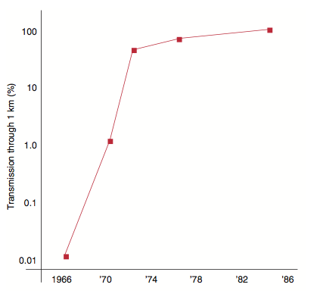

**Figure 5.3.** Progress in optical fiber transmission. The last two data points represent results near the theoretical limits at 0.85 and 1.55 μm.

The achievement of low-loss transmission, along with the additional advantages of large information carrying capacity, immunity from electromagnetic interference, and small size and weight, has created a new technology. Optical fiber has become the medium of choice for communications applications, and is rapidly taking over the use of wire based communications systems.

Optical fiber is also used in sensor applications, where the high sensitivity, low loss, and electromagnetic interference immunity of the fibers can be exploited. Optical fibers are versatile and sensors can be designed to detect many physical parameters, such as temperature, pressure, strain, and electrical and magnetic fields, using either the power transmission properties of multimode fibers or the phase sensitive properties of single-mode fibers. Another application of optical fiber is beam delivery for medical uses. Lasers are now being investigated for use in surgery and diagnostics and optical fiber is being used to deliver beams to sites within the human body.

**GEOMETRICAL OPTICS AND FIBER OPTICS**

To understand what is occurring in these projects in fiber optics, it is necessary to understand some basic concepts of optics and physics. This section is intended to introduce these ideas for those who may not have studied the field and to review these ideas for those who have.

**LIGHT AS AN ELECTROMAGNETIC FIELD**

The light by which we see the world around us is a part of the range, or spectrum, of electromagnetic waves that extends from radio frequencies to high power gamma radiation (**Fig. 5.4**).

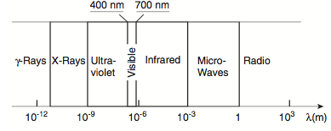

**Figure 5.4:** The electromagnetic energy spectrum

These waves, a combination of electric and magnetic fields, which can propagate through a vacuum, have as their most distinguishing features their wavelength and frequency of oscillation. The range of wavelengths for visible light is from about 400 nanometers (nm) to about 700 nm. (A nanometer is one billionth of a meter.) In most of the work done in the field of fiber optics, the most useful sources of electromagnetic radiation emit just outside the visible in the near infrared with wavelengths in the vicinity of 800 to 1500 nm.

It can be difficult to follow what happens in an optical fiber system if the progress of light through the system is depicted in terms of the wave motion of the light. For the simplest cases it is easier to think of light traveling as a series of rays propagating through space. The experience of seeing the sun's rays streaming through the clouds on a partially cloudy day provides a familiar example of light as a collection of rays.

In a vacuum, light travels at approximately 3 x 108 meters per second. In material media, such as air or water or glass, the speed is reduced. For air, the reduction is very small; for water, the reduction is about 25%; in glass, the reduction can vary from 30% to nearly 50%.

**LIGHT IN MATERIALS**

In most cases, the results of the interaction of an electromagnetic wave with a material medium can be expressed in terms of a single number, the index of refraction of the medium. The **refractive index** is the ratio of the speed of light in a vacuum, *c*, to the speed of light in the medium, *v*,

*n = c/v*

Since the speed of light in a medium is always less than it is in a vacuum, the refractive index is always greater than one. In air, the value is very close to one; in water, it is about *4/3* (*n = 1.33*); in glasses, it varies from about *1.44* to about *1.9*.

There are some qualifications to the simple picture presented here. First, the refractive index varies with the wavelength of the light. This is called **wavelength dispersion**. Second, not only can the medium slow down the light, but it can also absorb some of the light as it passes through.

In a homogeneous medium, that is, one in which the refractive index is constant in space, light travels in a straight line. Only when the light meets a variation or a discontinuity in the refractive index will the light rays be bent from their initial direction.

In the case of a variation in the refractive index within a material, the behavior of the light is governed by the way in which the index changes in space. For example, the air just above a road heated by the sun will be less dense than the air further from the road. Since the refractive index increases with density, the refractive index of the air increases with height. This is called a **refractive index gradient** and is, in this case, equivalent to having an extended prism above the road with its vertex pointing downward (see **Fig. 5.5**). Light coming from an object down the road will not only travel directly to the observer's eye, but some of the light from the object that would normally be absorbed by the road is bent toward the observer. The result is that someone looking down the road will see a reflection, called a mirage, of a distant object on the road, as if it were reflected in a pool of water. This gradual bending of light by a refractive index gradient is used in fiber optics to increase the information carrying capacity of fibers and to provide a very compact lens for fiber optic systems.

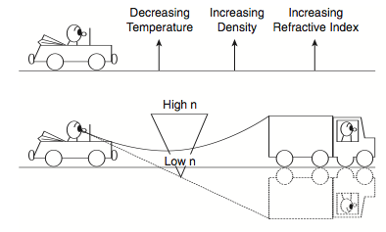

**Figure 5.5:** Bending of light rays by a refractive index gradient, using the mirage on a heated road as an example.

If the change in refractive index is not gradual, as in the case of the refractive index gradient, but is instead, an abrupt change like that between glass and air, the direction of light is governed by the Laws of Geometrical Optics. If the angle of incidence, *i*, of a ray is the angle between an incident ray and a line perpendicular to the interface at the point where the light ray strikes the interface (**Fig. 5.6**), then:

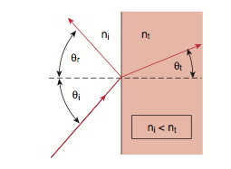

**Figure 5.6.** Geometry of reflection and refraction.

1. The angle of reflection, *r*, also measured with respect to the same perpendicular, is equal to the angle of incidence:

*r = i*

2. The angle of the transmitted light is given by the relation:

*nt sin t = ni sin i*

The first of these relations is known as the **Law of Reflection**, and the second is the **Law of Refraction** or **Snell's Law**.

It is useful to refer to a material whose refractive index is greater than another as being optically denser and one whose refractive index is less as being rarer. Thus, light traveling into an optically denser medium would be bent toward the normal, while light entering an optically rarer medium would be bent away from the normal. In **Fig. 5.7**, a series of rays in a dense medium are incident on an interface at different angles of incidence. Ray #1 is refracted at the interface to a rarer medium according to Snell's Law. Ray #2 is incident at an angle such that the refracted angle is 90°, Ray #3 is incident at an even larger angle. If the angle of incidence of Ray #3 in inserted into Snell's Law, the sine of the angle of transmission will be found to be greater than one! This cannot happen. Instead, all of the light is reflected back into the incident medium. There is no light transmitted into the second medium. The light is said to be **totally internally reflected**. For all angles of incidence greater than a **critical angle**, total internal reflection will occur. This critical angle occurs at the angle of incidence at which the transmitted ray is refracted along the surface of the interface (the case illustrated by Ray #2). Setting the angle of transmission equal to 90°, the critical angle, *θ crit* is found to be:

*sin θ crit = nt/ni*

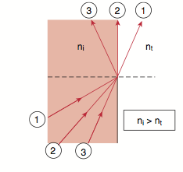

**Figure 5.7.** Geometry of total internal reflection. Ray #1 is at less than the critical angle. Ray #2 is at the critical angle. Ray #3 is totally internally reflected.

In the ray picture, the concept of total internal reflection makes the interface look like a perfect mirror. If this process is examined in terms of wave propagation, theory predicts and experiment confirms that a weak electromagnetic field exists in the rarer medium, but it decays rapidly with distance from the interface and no light energy is transmitted to the rarer medium. This field is called an **evanescent field**. However, if another optically dense material were located very close to the material in which the total internal reflection were occurring (within a wavelength or so) some of the light energy could be coupled out of the first medium across the small gap and into the second dense medium. This process is called **frustrated total internal reflection** since the usual reflection is frustrated by the location of the material next to the interface. Frustrated total internal reflection is responsible for the operation of a component in fiber optic systems called a bidirectional coupler.

**LIGHT IN OPTICAL FIBERS**

Once you understand total internal reflection, you understand the illuminated stream shown in **Fig. 5.2**. Light traveling through the water is reflected off of the surface of the water-air interface and trapped inside the stream. The same thing will happen to a glass rod or thread. Optical fibers are a little more complicated than this, however.

If one were to use a fiber consisting of only a single strand of glass or plastic, light could be lost at any point where the fiber touched a surface for support. Thus, the amount of light that could be transmitted would be dependent on the methods used for holding the fiber. Any movement of the fiber would also affect the output of the fiber during its use. To eliminate these problems, the central light-carrying portion of the fiber, called the **core**, is surrounded by a cylindrical region, called the **cladding** (**Fig. 5.8**). The cladding is then covered with a protective plastic jacket.

By putting a cladding around the core of the fiber, the light is more likely to stay within the core. Since the refractive index difference between the core and the cladding is less than in the case of a core in air, the critical angle is much bigger for the clad fiber. The index of the cladding, *ncl*, must still be less than the index of the core, *ncore*, because total internal reflection will occur only when

*ncore > ncl.*

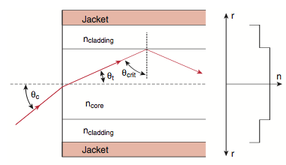

**Figure 5.8:** Step-index fiber. The refractive index profile is shown at the right. The geometry for derivation of the numerical aperture is given.

Looking at a cross-section of the fiber in **Fig. 5.8**, one sees that the cone of rays that will be accepted by the fiber is determined by the difference between the refractive indices of the core and cladding. The **fractional refractive index difference** is given by

*Δ  = (ncore –ncl)/ncore*

Because the refractive index of the core is a constant and the index changes abruptly at the core-cladding interface, the type of fiber in **Fig. 5.8** is called a **step-index fiber**.

The definition of the critical angle can be used to find the size of the cone of light that will be accepted by an optical fiber with a fractional index difference, *Δ*. In **Fig. 5.8** a ray is drawn that is incident on the core-cladding interface at the critical angle. If the cone angle is *c*, then by Snell's Law,

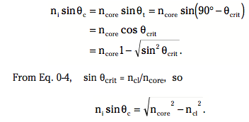



The **numerical aperture**, NA, is a measure of how much light can be collected by an optical system, whether it is an optical fiber or a microscope objective lens or a photographic lens. It is the product of the refractive index of the incident medium and the sine of the maximum ray angle.

NA = ni sin max.

In most cases, the light is incident from air and *ni = 1*. In this case, the numerical aperture of a step-index fiber is, from the equations above, 

**

When *Δ «1*, this equation can be approximated by

*.*

The condition in which *«1* is referred to as the **weakly-guiding approximation**. The NA of a fiber will be measured in **Experiment 5.1**.

In **Fig. 5.9**, two rays are shown. One, the **axial ray**, travels along the axis of the fiber; the other, the **marginal ray**, travels along a path near the critical angle for the core-cladding interface and is the highest-angle ray which will be propagated by the fiber. At the point where the marginal ray hits the interface, the ray has traveled a distance L2, while the axial ray has traveled a distance L1. From the geometry, it can be seen that

sin  = ncl/ncore = L1/L2.

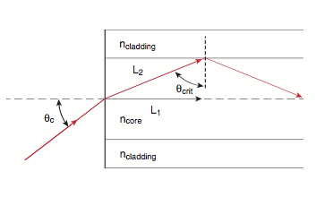

**Figure 5.9:** The geometry for derivation of the differential delay of a step-index fiber.

The length *L2* is a factor *ncl/ncore* larger than *L1* in the case shown in the figure. For any length of fiber L the additional distance traveled by a marginal ray is

L = (ncore – ncl)L/ ncl.

This equation can be simplified to *L = L .* The additional time it takes light to travel along this marginal ray is

t = L/v = L  ncore/c.

Therefore, a pulse with a length *t* representing one bit of information will be lengthened to *t + t*. This **differential time** between axial and marginal rays will cause a pulse to smear and thereby limit the number of pulses per second that could be sent through a fiber and distinguished at the far end. In such a case, the system may be limited not by how fast the source can be turned on and off or by the speed of response of the detector, but by the differential time delay of the fiber. This smearing of pulses can be remedied through the use of graded-index or single-mode fibers.

Earlier, it was noted that light rays could be deflected by variations in the refractive index of a medium as well as by encountering an abrupt interface between two indices. There are a number of methods of creating controlled index gradients. Some involve introducing impurities into thin layers of glass as they are laid down on a substrate. This is not a continuous process since the refractive index within each layer is nearly constant. The resulting variation of refractive index in a fiber resembles that of a series of concentric tree rings rather than a smooth change in the index. Other techniques involve the removal of material from the base glass by some type of chemical method. Fibers whose cores have such an index gradient are called **graded-index fibers**. In our discussion, we will not make a distinction between these processes, but instead assume that the graded-index profiles are smooth and exactly conform to theory. In real graded-index optical fibers this may not be correct and such departures from the ideal gradient will affect their performance.

Once the refractive index gradient can be controlled through manufacturing processes, it is up to the designer of optical fibers to determine the most useful **refractive index profiles**, *n(r)*, the variation of index with radial distance in the core. This usually fits a power law profile given by

n2(r) = n20 [1 –2  (r/a) α]

Where *n0* is the index of refraction at the center of the core, and *∆*  is the fractional index difference defined earlier, but with *n0* now substituting for *ncore*. The parameter, **, is the exponent of the power law and determines the shape of the graded-index profile. When * = ∞*, the profile is that of a step-index fiber. For * = 2*, the profile is parabolic (**Fig. 5.10**). This is the profile found in most telecommunications graded-index fibers because this profile eliminates the differential time delay between axial and marginal rays. The numerical aperture of a graded- index fiber is the same as that of a step-index fiber only for rays entering on the fiber axis. For rays entering at other points on the core, the local numerical aperture is less because the local index, *n(r),* must be used in *NA* equation. In the case of the parabolic graded-index fiber, the total amount of light which can be collected is one half of that which can be collected by a step-index fiber with the same*Δ*.

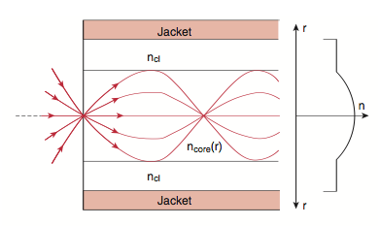

**Figure 5.10:** Graded-index fiber. The refractive index profile is shown at the right. Diverging rays are refocused at a point further down the fiber.

Without plunging into the mathematics needed to prove that graded-index fibers with a parabolic profile remove differential delay, it is possible to get a qualitative feel of why the smearing of light pulses in such a fiber would be reduced. Instead of the rays bouncing off of the core-cladding interface as in step-index fibers, rays follow a gently curving path in graded-index fibers. In those with a parabolic profile, this path is sinusoidal. That is, the path can be described as a sine function in space. It would seem that light paths, which have large radial amplitude, are still longer than the direct light path down the axis of the fiber. But because of the refractive index gradient, the velocity of the light at the center of the fiber is smaller than the velocity of the light near the edge of the core. Although the light that travels near the edge of the fiber has to go farther, it travels faster and arrives at the end of the fiber at the same time as the light traveling down the center of the fiber. If the length of the fiber is *L* and the speed of light down the center of the fiber is *v= c/n0*, then the time for a pulse to travel to the end of the fiber is *t = L/v = n0L/c*. For light traveling a sinusoidal path, the length traveled will be *L"* and the time to travel to the end of the fiber is *t = n(r,z)L"/c*. The product of the actual geometrical path and the refractive index is called the **optical path length**. If the optical path length, *n(r)L*, is the same for all paths, there will be no differential delay in the time the rays take to travel through a fiber. For all optical path lengths to be equal, the profile must be parabolic (* = 2*)

**GRADED-INDEX LENSES**

One thing to note in **Fig. 5.10** is that a fan of rays injected at a point in a graded-index fiber spreads out and then recrosses the axis at a common point just as rays from a small object are reimaged by a lens. The distance it takes for a ray to traverse one full sine path is called the pitch of the fiber. The length of the pitch is determined by *∆*, the fractional index difference.

If a parabolic graded-index fiber is cut to a length of one quarter of the pitch of the fiber, it can serve as an extremely compact lens (called a **GRIN lens**, for GRaded- INdex) for fiber applications (**Fig. 5.11**). By positioning the output of a fiber at the face of the short fiber length, light from the lens will be collimated, just as diverging light at the focal point of a lens is collimated. Because the lens’ s focusing properties are set by its length, this graded-index lens is referred to as a **quarter-pitch** or **0.25 pitch lens**.

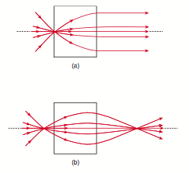

**Figure 5.11.** Graded-index (GRIN) lens. (a) 0.25 pitch lens. (b) 0.29 pitch lens.

In some cases it is not collimation of light which is required, but focusing of the fiber output onto a small detector or focusing of the output of a source onto the core of a fiber. The easiest way of accomplishing this is to increase the length of the GRIN lens slightly to 0.29 of a pitch (**Fig. 5.11**). This enables the fiber optic system designer to move the source back from the lens and have the transmitted light refocus at some point beyond the lens. This is particularly useful for coupling sources to fibers and fibers to detectors. The pitch of the lens can be described as the focusing power of the lens. Both 0.25 and 0.29 pitch GRIN lenses will be used in **Experient 5.3**.

**TRANSMITTING POWER THROUGH OPTICAL FIBERS**

**LOSSES IN FIBERS**

In all of the above discussion, it has been assumed that the light travels down the fiber without any losses beyond those from radiation and leaky modes and some higher-order modes that are coupled out into the cladding.

When light is transmitted through an absorbing medium, the irradiance falls exponentially with the distance of transmission. This relation, called **Beer’s Law**, can be expressed as

I(z) = I(0) exp(–Γz)

where *I(z)* is the irradiance at a distance z from a point

*z = 0*, and *Γ* is the attenuation coefficient, expressed in units reciprocal to the units of z. In some fields of physics and chemistry, where absorption by a material has been carefully measured, the amount of absorption at a particular wavelength for a specific path length, such as 1 cm, can be used to measure the concentration of the absorbing material in a solution.

Although the absorption coefficient can be expressed in units of reciprocal length for exponential decay, in the field of fiber optics, as well as in most of the communications field, the absorption is expressed in units of dB/km (dB stand for decibels, tenths of a logarithmic unit). In this case, exponential decay is expressed using the base 10 instead of the base e (= 2.7182818...) as

I(z) = I (0) 10–(Γz /10),

where z is in kilometers and Γ is now expressed in decibels per kilometer (dB/km). Thus, a fiber of one kilometer length with an absorption coefficient of 10 dB/km permits *I(z)/I(0) = 10–(10*1/10) = 0.10* or *10%* of the input power to be transmitted through the fiber. Experiment 5.2 involves the measurement of the attenuation in an optical fiber.

The losses in fibers are wavelength dependent. That is, light of different wavelengths introduced into the same fiber will suffer different amounts of loss. Fig. 5.12 shows the attenuation in *dB/km* of a typical optical fiber as a function of wavelength.

Although the exponential dependence was described for absorption losses, the same mathematics can be used for other sources of losses in fibers. Optical transmission losses in fibers are due to several mechanisms. First, optical fibers are limited in the short wavelength region (toward the visible and ultraviolet) by absorption bands of the material and by scattering from inhomogeneities in the refractive index of the fiber. These inhomogeneities are due to thermal fluctuations when the fiber is in the molten state. As the fiber solidifies, these fluctuations cause refractive index variations on a scale smaller than the parabolic variation that is imposed upon graded-index fibers. Scattering off of the inhomogeneities is known as Rayleigh scattering and is proportional to λ–4, where λ is the wavelength of the light. (This same phenomenon is responsible for the color of the sky. The stronger scattering of light at shorter wavelengths gives the sky its blue color.)

In the long wavelength region, infrared absorption bands of the material limit the long wavelength end of the radiation spectrum to about 1600 nm. These two mechanisms are the ultimate limit for fiber losses. The highest quality fibers are sometimes characterized by how closely they approach the Rayleigh scattering limit, which is about 0.17 dB/km at 1550 nm.

At one time metal ions were the major source of absorption by impurities in optical fibers. It was the elimination of these ions that produced low-loss optical fibers. Today, the only impurity of consequence in optical fibers is water in the form of the hydroxyl ion (OH–), whose absorption bands at 950, 1250, and 1380 nm dominate the excess loss in today's fibers. They are evident in the absorption spectrum shown in Fig. 5.12.

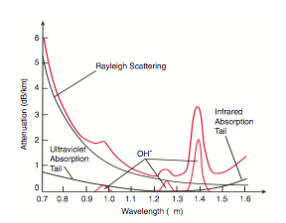

**Figure 5.12:** Attenuation of an optical fiber as a function of wavelength.

## EXPERIMENT 5.1 HANDLING FIBERS, NUMERICAL APERTURE

In this first project, the student will learn how to prepare a bare fiber for use in the laboratory. Observations will be made of a fiber's geometry, and a measurement of the numerical aperture (NA) of a telecommunications-grade fiber will be performed. The method presented for determining the NA of a fiber especially illustrates the concept to be learned.

**FIBER GEOMETRY**

An optical fiber, which is illustrated in Fig. 5.13, consists of a core with a circularly-symmetric cross section, a radius of a (diameter 2a), a cladding of diameter d, and a jacket. The refractive indices of the core and cladding are ncore and ncl, respectively. Typical core diameters range from 4-8 μm (1 μm = 1 micrometer = 10–6 m) for single-mode fibers, to 50-100 μm for multimode fibers used for communications, to 200-1000 μm for largecore fibers used in power trans-mission applications. Communication-grade fibers will have d in the range of 125-140 μm, with some single-mode fibers as small as 80 μm. In high-quality communications fibers, both the core and the cladding are made of silica glass, with small amounts of impurities added to the core to slightly raise the index of refraction. There are also lower-quality fibers available which have a glass core surrounded by a plastic cladding, as well as some all-plastic fibers. The latter have very high attenuation coefficients and are used only in applications requiring short lengths of fiber. Surrounding the fiber will generally be a protective jacket. This jacket may be made from plastic and have an outside diameter of 500-1000 μm. However, the jacket may also be a very thin layer (~250 μm outer diameter) of acrylate material.

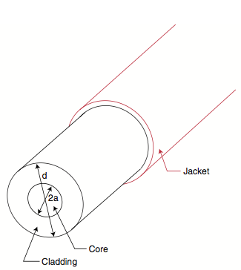

**Figure 5.13:** Geometry of an optical fiber, showing core, cladding, and jacket.

**FIBER MECHANICAL PROPERTIES**

Before measuring the NA of a fiber, it will be necessary to prepare the ends of the fiber so that light can be efficiently coupled in and out of the fiber. This is done by using a scribe-and-break technique to cleave the fiber. A carbide or diamond blade is used to start a small crack in the fiber, as illustrated in **Fig. 5.14**. Evenly applied stress, applied by pulling the fiber, causes the crack to propagate through the fiber and cleave it across a flat cross section of the fiber perpendicular to the fiber axis.

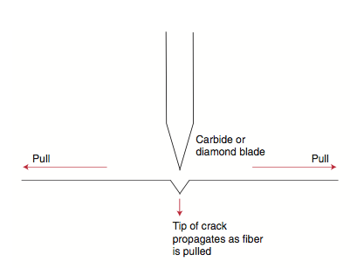

**Figure 5.14:** Scribe-and-break technique of fiber cleaving. A carbide blade makes a small scribe, or nick, in the fiber. The fiber is pulled to propagate the scribe through the fiber.

In theory, the breaking strength of glass fibers can be very large, up to about 725 kpsi (where 1 kpsi = 1000 pounds/sq. inch) or 5 GPa (where 1 Pa = 1 Newton/sq. meter and 1 GPa = 109 Pa). However, because of inhomogeneities and flaws, fibers do not exhibit strengths anywhere near this value.

Before being wound on a spool, a fiber is stretched over a pair of pulleys, which apply a fixed amount of strain (stretching per unit length). This process is called proof-testing. Typical commercial fibers may be proof-tested to about 50 kpsi (345 MPa), which is equivalent to about a one pound load on a 125 μm OD fiber. When a crack is introduced, this is reduced even further in the neighborhood of the crack. Fracture occurs when the stress at the tip of the crack equals the theoretical breaking strength, even while the average stress in the body of the fiber is still very low.1 The crack causes sequential fracturing of the atomic bonds only at the tip of the crack. This is the reason that a straight crack will yield a flat, cleaved, fiber face.

Optical fibers are required to have high strength while maintaining flexibility. Fiber fracture usually occurs at points of high strain when the fiber is bent. For a fiber of radius d/2, bent to a radius of curvature R, as shown in Fig. 5.15, the surface strain on the fiber is the elongation of the fiber surface, (R + d/2)θ - Rθ, divided by the length of the arc, Rθ. The strain is, then, d/2R. Although silica fibers have been prepared which can withstand strains of several percent, an upper strain limit of a fraction of 1% has been found to be necessary to guarantee fiber survival in a cable installed in the field.2 If a strain limit of 0.5% is used as a reasonably conservative value, a 125 μm diameter fiber will be able to survive a bend radius of 1.25 cm.

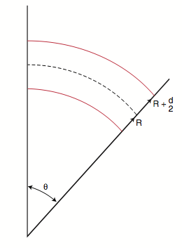

**Figure 5.15:** Strain of a bent fiber.

**MEASURING NUMERICAL APERTURE**

A detailed derivation of the expression for the NA of a fiber was given at the beginning of this section. Recalling the NA of a fiber, in the weakly-guiding approximation, was found to be

NA = ncore (2∆)1/2

where ncore is the refractive index of the core of a step-index fiber or the refractive index at the center of the core of a graded-index fiber, and ∆ is the fractional index difference, ∆ = (ncore–ncl)/ncore.

As an example, a typical multimode communications fiber may have ∆≅ 0.01, in which case the weakly-guiding approximation, which assumes ∆<<1, is certainly justified.

For silica-based fibers, ncore will be approximately 1.46. Using NA equation, these values of ∆ and ncore give NA = 0.2. This gives a value of 11.5° for the maximum incident angle in Fig. 5.8 and a total cone angle of 23°. Values of NA range from about 0.1 for single-mode fibers to 0.2–0.3 for multimode communications fibers up to about 0.5 for large-core fibers.

The way in which light is launched into the fiber in the method used here to measure the fiber NA is shown in Fig. 5.16. The light from the laser represents a wave front propagating in the z-direction. The width of the laser beam, ~1 mm, is much larger than the diameter of the fiber core, 100 μm in this case. In the neighborhood of the fiber core, the wavefront of the laser light takes on the same value at all points having the same z, so we say that we have a plane wave propagating parallel to the z-axis. When a plane wave is incident on the end face of a fiber, then we can be sure that all of the light launched into the fiber has the same incident angle, θc in Fig. 5.16.

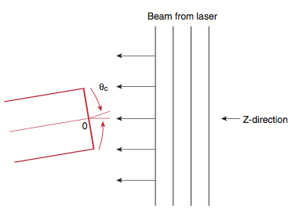

**Figure 5.16.** Geometry of a plane-wave launch of a laser beam into an optical fiber.

If the fiber end face is then rotated about the point O in Fig. 5.16, we can then measure the amount of light accepted by the fiber as a function of the incident angle, θc.

Fig. 5.17 shows the light accepted by a Newport F-MLD fiber as a function of acceptance angle using the method just described. The point where the accepted radiation has fallen to a specified value is then used to define the maximum incident angle for the acceptance cone. The Electronic Industries Association uses the angle at which the accepted power has fallen to 5% of the peak accepted power as the definition of the experimentally determined NA.3 The 5% intensity points are chosen as a compromise to reduce requirements on the power level which has to be distinguished from background noise.

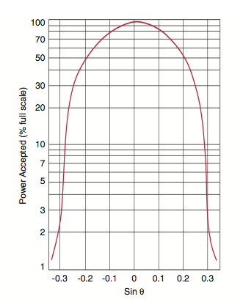

**Figure 5.17** Plot of the data taken in the measurement of the NA of the Newport F-MLD fiber.

Note that in **Fig. 5.17**, the radiation levels were measured for both positive and negative rotations of the fiber and the NA was determined using one half of the full angle between the two 5%-intensity points. This eliminates any small errors resulting from not perfectly aligning θc = 0° to the plane wave laser beam. The NA obtained in this test case was 0.29, which compares well with the manufacturer’s specification of NA = 0.30.

**PARTS LIST**

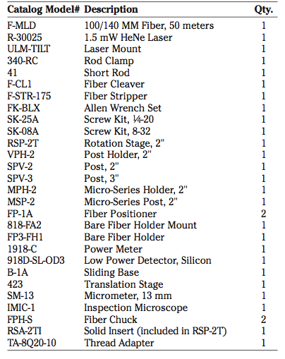

**INSTRUCTION SET**

**PREPARING FIBER ENDS**

1. Remove 1.5" of fiber coating (or jacket) from a ∼2 meter segment of F-MLD Fiber, using the F-STR-175 Fiber Stripper.
2. Use the F-CL1 Fiber Cleaver to cleave the stripped end of the fiber. The cleaver should be placed on the top of the table with the blade pointing up. Draw the fiber over the blade with a light motion. Be sure that the fiber is normal to the blade. Do not attempt to cut the fiber with the cleaver. Only start a small nick, which will propagate through the fiber when pulled. Gently, but firmly, pull the fiber to cleave it.

**NOTE:** The F-CLl Fiber Cleaver is much more dependent on operator skill than is the F-BK3 which may be chosen as an option to use in place of the F-CLl. In this case, follow the directions that are included with the F-BK3 Fiber Breaker and cleave the ends of the fiber.

1. Check the quality of the cleave by examining it with the IMIC-1 Fiber Inspection Microscope. Carefully examine the end face of the fiber. The end face should appear flat and should be free of defects, as in **Fig. 5.18a**. Chips or cracks which appear near the periphery of the fiber are acceptable if they do not extend into the central region of the fiber. Some poorly cleaved fiber ends are illustrated in **Fig. 5.18b** and **c**. The problems associated with the poor cleaves are discussed in Step 4.

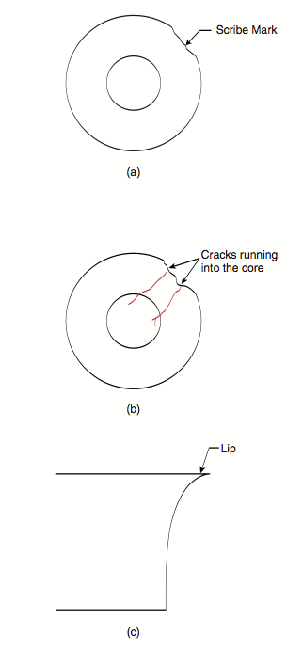

**Figure 5.18:** Cleaved fiber ends. (a) good cleave. (b) cracked fiber. (c) Side view of a lip on the end of a fiber.

1. If the inspection of the fiber end face in Step 3 does not show that the end face has been properly cleaved, two sources of error should be considered: 1) a poor scribe or 2) a non-uniform pull of the fiber.

A scribe that is too deep may cause an irregular cleave and may cause multiple cracks to propagate through the fiber (**Fig. 15.18b**). A scribe that is too shallow will be the same as no scribe at all and the fiber will break randomly.

If the pull, which propagates the crack through the fiber is not uniform, and especially if it includes twisting of the fiber, irregularities may show up on the fiber end face or a lip may be formed on the end of the fiber, as in **Fig. 5.18c**.

If the fiber end is cleaved at an angle, the fiber was probably scribed at an angle other than 90° across the fiber axis, although this, too, can be caused by a non- uniform pull of the fiber. (This will not be a problem if the F-BK3 Fiber Breaker has been chosen as an option, but will have to be considered if the F-CL1 Fiber Cleaver is being used.)

1. Once the fiber segment has been prepared with two well-cleaved ends, the geometry of the fiber may be examined as was described in the introduction. View a fiber end as in Step 3. Use an incandescent lamp to illuminate the far end of the fiber. The light shining through the central portion of the fiber should be visible. This is the fiber core. The region surrounding the core is the fiber cladding. The fiber coating will not be visible, because it has been stripped away from the end of the fiber.

**MEASURING NUMERICAL APERTURE**

1. Attach the Model ULM-TILT Laser Mount to the Model 340-RC Rod Clamp, using 1/4-20 screws from the SK- 25A Screw Kit. Place the 340-RC Rod Clamp on the Model 41 Short Rod. Mount the 41 Short Rod to the 423 Translation Stage and mount the 423 Translation Stage to a Breadboard. Place the HeNe Laser into the ULM-TILT Laser Mount. Tighten the set screw. Do not over tighten as this will damage the laser. Plug the laser power supply into a 110V (or possibly 220V if using outside the U.S.) wall outlet. Plug the cord from the laser head into the power supply. Note that the plug from the laser head to its power supply can only be inserted one way. The laser is turned on at the key switch on the front of the power supply. **NOTE: The laser should be turned on and left on for ~30 minutes before taking any measurements to ensure proper stability.** The combination of the ULM-TILT Mount and the 340-RC Rod Clamp should align the laser parallel to a line of bolt holes on the table.
2. Position the beam from the HeNe Laser so that it passes over the center hole of the RSP-2T Rotation Stage. This can be done by means of the 423 Translation Stage mounted under the 41 Short Rod. Mount the MPH-2 Micro- Series Post Holder on the RSP-2T Rotation Stage using the TA-8Q20-10. Place the MSP-2 Micro-Series Post in the MPH-2, as shown in **Fig. 5.18.**
3. Prepare a fiber segment, ~2 meters long, with a good cleave at each end face. (The fiber prepared in the previous section may be used.) Insert one end of the fiber into an FPH-S Fiber Holder (At least 3" of the jacket should be stripped from the fiber in order to do this and the following step) and place this holder into its FP-l Fiber Positioner, which has been post-mounted on the RSP-2T Rotation Stage, using the MPH-2 Post Holder and the MSP-2 Post.

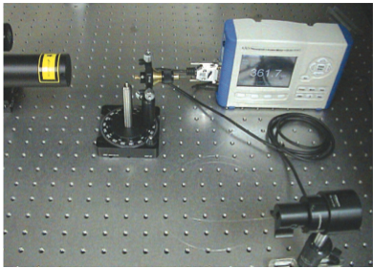

**Figure 5.18:** Laboratory set-up for determination of fiber NA.

1. Extend the tip of the fiber and orient the FP-1A positioner so that the fiber tip is at the center of rotation of the stage. This is a critical step if an accurate value for the fiber NA is to be obtained. (To help align the fiber tip, mount an SPV-3 Post in the center hole of the RSP-2T Rotation Stage with the 8-32 stud pointing up toward the fiber. Then align the fiber end over this 8-32 stud.)
2. Re-check the alignment of the light-launching system by making sure that the tip of the fiber remains at the center of the laser beam as the stage is rotated. This setup achieves plane-wave launching into the end of the fiber.
3. Mount the far end of the fiber in an FPH-S Fiber Holder, which is mounted in the FP-lA, mounted on the SPV-2, VPH-2 and B-1A. A quick approximation of the fiber's NA may be made with a 3 x 5 card placed a distance, L, away from the laser in a darkened room, as shown in **Fig. 5.19**. Measure the width, W, on the card of the spot out of the fiber and the distance, L, from the fiber to the card. The NA of the fiber is approximately sin–1[(1/2)(W/L)] This is a quick method, which is used when only an approximate measurement of a fiber's NA is needed.

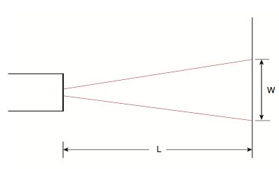

**Figure 5.19:** Approximate measure of the NA of a fiber.

1. For a direct reading, remove the FP-1A Fiber Positioner from the SPV-2 Post and replace it with the 918D-SL-OD3. Remove the fiber from the FPH-S Fiber Holder and place it in the FP3-FH1 Bare Fiber Holder. Screw the 818-FA2 Bare Fiber Mount Holder onto the face of the 918D-SL-OD3. Then, snap the FP3-FH1, with the fiber in it, into the 818-FA2, so the output beam from the fiber is incident on the detector head. Block the laser beam and zero the power meter before taking a reading.
2. Measure the power accepted by the fiber as a function of the incident angle of the plane-wave laser beam. For the best continuity, begin taking measurements at the minimum power on one side and continue through the maximum to the minimum power on the other side. (An angle of about 30° should be traversed.) Measurements may be taken in 1-2 degree increments.
3. Plot the power received by the detector as a function of the sine of the acceptance angle. Use the semi- log paper in the back of the manual. Measure the full width of the curve at the points where the received power is at 5% of the maximum intensity. The half-width at this intensity is the experimentally determined numerical aperture of the fiber. Compare your results with the results of **Step 6** and **Fig. 5.17**.

## EXPEIMENT 5.2 FIBER ATTENUATION

In this exercise, one of the most important fiber parameters will be measured: attenuation per unit length of a multimode communications-grade optical fiber. Also discussed will be the way that the conditions under which light is launched into the fiber can affect this measurement. Finally, a brief introduction to mode scrambling will be made, and the student will be shown how to generate a desirable distribution of light in the fiber.

**EASUREMENT OF OPTICAL FIBER ATTENUATION**

An expression for the amount of optical power which still remains in a fiber after it has propagated a distance, z, is given as

I(z) = I(0) 10–(Γz/ 10).

The length of the fiber, z, is given in kilometers, and the attenuation coefficient, Γ, is given in decibels per kilometer (dB/km).

Because the designers of fiber optic systems need to know how much light will remain in a fiber after propagating a given distance, one of the most important specifications of an optical fiber is the fiber's attenuation. In principle, fiber attenuation is the easiest of all fiber measurements to make. The method which is generally used is called the “cutback method.”1 The general procedure to follow is a) launch light into a long length of fiber, b) measure the power at the far end of the fiber, c) cut off most of the fiber, leaving a short length at the input, and d) measure the power transmitted by the shorter length. The reason for leaving a short length of fiber at the input end of the system is to make sure that the loss that is measured is due solely to the loss of the fiber and not to the loss that occurs when the light source is coupled to the fiber. Fig. 5.20 shows a schematic illustration of the measurement system. (The mode scrambler shown in the figure was discussed in the primer section.)

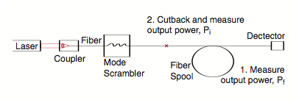

**Figure 5.20:** Schematic of laboratory set-up for cutback method of determining fiber attenuation.

The transmission through the fiber is written as

T=Pf /Pi,

where, we have substituted Pi (initial power) and Pf (final power) for I(0) and I(z), respectively. A logarithmic result for the loss in decibels (dB), is given by

L (dB) = –10 log (Pf / Pi).

The minus sign causes the loss to be expressed as a positive number. This allows losses to be summed and then subtracted from an initial power when it is also expressed logarithmically. [In working with fiber optics, you will often find powers expressed in dBm, which means “dB with respect to 1 mW of optical power.” Thus, e.g., 0 dBm = 1 mW, 3 dBm = 2 mW, and –10 dBm = 100 μW. Note that when losses in dB are subtracted from powers in dBm, the result is in dBm. For example, an initial power of +3 dBm minus a loss of 3 dB results in a final power of 0 dBm. This is a shorthand way of saying “An initial power of 2 mW with 50% loss results in a final power of 1 mW.”]

The attenuation coefficient, Γ, in dB/km is found by dividing the loss, L, by the length of the fiber, z. The attenuation coefficient is then given by

Γ(dB/km) = (l / z) [–10 log (Pf / Pi)].

The total attenuation can then be found by multiplying the attenuation coefficient by the fiber length, giving a logarithmic result, in decibels (dB), for the fiber loss.

**PRACTICAL PROBLEMS**

he cutback method works well for high-loss fibers, with Γ on the order of 10 to 100 dB/km. However, meaningful measurements on low-loss fibers are more difficult. The highest quality fibers will have losses which are on the order of 1 dB/km or less, so that cutting a full 1 km from the fiber will result in a transmitted power decrease of less that 20%, putting greater demand on the measurement system's resolution and accuracy.

There is also an uncertainty due to the fact that the measured loss will depend on the characteristics of the way in which light is launched into the fiber. The launch conditions, which result in an overfilled or underfilled fiber, were discussed in at the beginning of this section. When a fiber is overfilled, many high-order and radiation modes are launched. These modes are more highly attenuated than are low-order modes. When a fiber is underfilled, mostly low-order modes are launched and lower losses occur.

The solution to this problem is to attempt to generate what is known as the stable mode distribution as quickly as possible after launching. **Fig. 5.21** compares the transmission characteristics of the stable distribution with those of the overfilled and underfilled launch conditions. The stable mode distribution may be achieved, even in a short length of fiber, by using mode scrambling to induce coupling between the modes shortly after the light is launched.

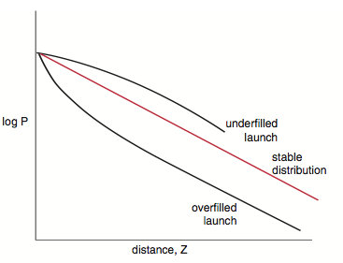

**Figure 5.21:** Comparison of attenuation characteristics of various launch conditions.

Mode scrambling generates an approximation of a stable distribution immediately after launch and allows repeatable measurements (which approximate those that would be found in the field) to be made in the laboratory. **Fig. 5.21** compares the optical power in a fiber as a function of propagation distance for the three types of launch conditions: overfilled, underfilled, and stable distribution. The slope of the curve at large distances is equal to the attenuation coefficient.

It is the fact that the mode scrambling generates a stable distribution immediately after the source that allows a short cutback length to be used in the cutback method of measuring attenuation.

**PARTS LIST**

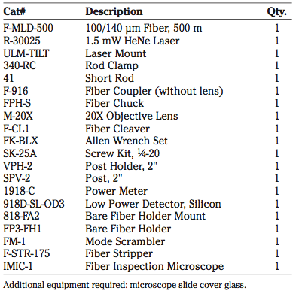

**INSTRUCTION SET**

1. Prepare both ends of the 500 meter fiber spool which has been provided, as you learned to do in **EXPERİMENT 5.1** (**Steps 1-3**). This fiber is the Newport F- MLD fiber with a 100 μm core and a 140 μm OD. You may have to use some care in freeing the end of the fiber, which was the start of the winding onto the spool. (This end will be referred to as the far end of the fiber.)
2. Thread the 818-FA2 onto the 918D-SL-OD3 Detector head and mount on a post. Place the cleaved far end of the fiber in the FP3-FH1 fiber holder so that 1 or 2 mm of fiber is sticking out the end, then insert the FP3-FH1 into the 818-FA2. There is no need to align the fiber to the detector since the FP3-FH1 and the 818-FA2 automatically align the fiber to the active area of the detector. The laboratory set-up for this project is shown in **Fig. 5.22**.

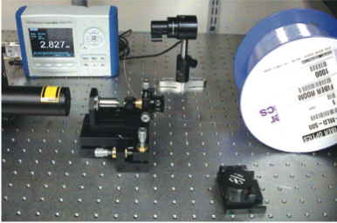

**Figure 5.22:** Laboratory set-up for determining fiber attenuation using the cutback method.

1. The use of the F-916 Fiber Coupler to couple light from a HeNe laser into a fiber is illustrated in **Fig. 5.23**. Align the coupler and the HeNe laser so that the laser beam is directed along the axis of the F-916 Fiber Coupler. Mount the M-20X microscope objective in the F-916. Place the cleaved front end of the fiber into the FPH-S and insert this into the coupler. Carefully align the fiber to maximize the light launched into the fiber, using the power meter to monitor the launched power. Place a microscope slide cover glass at 45° in the path of the laser beam to look at the Fresnel reflection from the fiber end face. Project the Fresnel reflection from the fiber end face onto a white screen. Focus the Fresnel reflected beam by adjusting the z component of the fiber position, as defined in **Fig. 5.23**; this is done by turning the z adjustment knob on the fiber positioner. When this reflection is focused, the fiber end face is in the focal plane of the coupler's microscope objective lens.

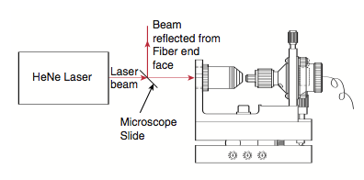

**Figure 5.23:** Coupling of HeNe laser light into a fiber using the F-916 Fiber Coupler.

1. Position the FM-l Mode Scrambler at a convenient place near the launch end of the fiber, as shown in **Fig. 5.22**.
2. Rotate the knob of the FM-l counter-clockwise to fully separate the two corrugated surfaces. The FM-l Mode Scrambler is illustrated in **Fig. 5.24**. Place the fiber between the two corrugated surfaces of the Mode Scrambler. Leave the fiber jacket on to protect the fragile glass fiber. Rotate the knob clockwise until the corrugated surfaces just contact the fiber. Examine the far-field distribution of the output of the fiber. Rotate the knob further clockwise and notice the changes in the distribution as the amount of bending of the fiber is changed. Since a narrow, collimated HeNe beam is being used to launch light into the fiber, the original launched distribution will be underfilled. When the distribution of the output just fills the NA of the fiber, an approximation of the stable distribution has been achieved. This can be determined by projecting the output of the fiber onto a white screen. The diameter of the output distribution will change as the knob of the FM-1 is rotated clockwise and counterclockwise. The knob should be rotated to a position such that the diameter of the output distribution is just about to increase. (Obviously this will involve observing the diameter increasing, and then reversing the direction of the knob slightly.) An approximation of a stable distribution has now been achieved. It is important that no more bending be added than is necessary to accomplish this, as this will result in excess loss. This launching and mode-scrambling set-up should not be changed again during the remainder of the exercise.
3. Measure the power out of the far end of the fiber. Note the exact length of the fiber. It will be part of the information on the label of the spool.

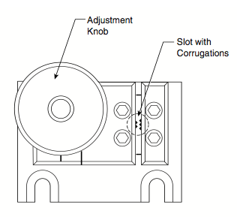

**Figure 5.24:** Model FM-1 Mode Scrambler.

1. Break off the fiber ∼2 meters after the mode scrambler (see **Fig. 5.20**) from the launching set-up. (Be sure to note on the spool how much fiber you have removed, so that other people using the same spool in the future will be able to obtain accurate results.) Cleave the broken end of the fiber and measure the output from the cutback segment.
2. Calculate the fiber attenuation, using

Γ(dB/km) = (l / z) [–10 log (Pf / Pi)]

and compare this with the attenuation written in the fiber specification on the spool. Your value is probably somewhat higher than the specification. Why? (**HINT:** Go back and look at **Fig. 5.12**.)

## EXPERIMENT 5.3 COUPLING FIBERS TO SEMICONDUCTOR SOURCES

**LIGHT SOURCES FOR OPTICAL FIBERS**

Although light of many wavelengths and degrees of coherence may be transmitted by an optical fiber, there are a number of sources that are fairly convenient and efficient in coupling light into a fiber.

The small red indicator lights that we see in smoke detectors and electronic panel lights are **light emitting diodes** (LED's). The name is quite descriptive, since these devices are nothing more than special semiconductor diodes that emit light. They are made of semiconductors, such as gallium arsenide, to which small amounts of atomic impurities have been added to raise the conductivity. The carrier of electrical current is either an electron or a hole (the absence of an electron). The material in which electrons are the major carrier of current is called n-type material and the material in which holes are the major carrier is called p-type. A diode is created when pieces of n-type and p-type material are constructed next to one another, as in **Fig. 5.25**. The interface plane between them is called the junction. When a voltage is applied across the diode junction so that the diode conducts, it emits light, which is radiation resulting from the recombination of electrons and holes. This radiation is called, appropriately, **recombination radiation**. The amount of light output is proportional to the number of electron-hole pairs that recombine in the diode and this is proportional to the diode current. Therefore, the optical power-current curve of an LED will be a straight line. The wavelength of the emitted radiation in an LED depends on the differences between the energies of the electrons in the n-type material and holes in the p-type material. The bandwidth of the radiation is broad compared to that of laser sources.

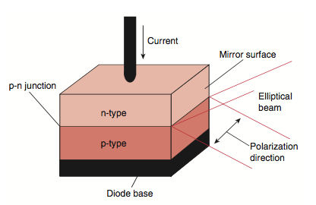

**Figure 5.25:** Construction of a simple semiconductor diode. Light emitting diodes and injection laser diodes have a similar basic construction, although the actual structure of the laser device is considerably more complicated.

Although the construction of **current injection laser diodes** (LD's) is much more elaborate than LED's the two are shown in **Fig. 5.25** as being similar. Both in the simplest illustration and in the basic principles of operation, these two devices are similar. Current is injected into the diode by applying a voltage across the diode. However, the current densities are considerably greater in a laser diode than those in an LED. Instead of electron-hole pairs recombining spontaneously as in an LED, in a laser diode this enormous current flow stimulates the pairs to emit coherently, creating a more powerful output with a narrower bandwidth. This process is called **stimulated emission**.

The optical power-current curve of the LD is different from that of the LED in that the current must reach a threshold value before lasing can occur. The output then increases rapidly in proportion to the current in excess of the threshold current. The stimulated process just described is enhanced by the surfaces of the semiconductor crystal that serve as partially reflecting mirrors to redirect part of the laser output back into the junction region. These mirrors also cause the output of the LD to be partially collimated, although diffraction of the light by the edges of the junction region causes the light to be directed into a fan-shaped beam with a divergence typically about 15° by 30°. The larger divergence angle is in the direction perpendicular to the junction plane, as shown in **Fig. 5.25**.

In contrast to the solid state semiconductor medium of the LD, the lasing medium of the helium-neon (HeNe) laser is a mixture of helium and neon gases which is excited by an electrical current, creating a light-emitting discharge similar to those seen in neon signs. The difference between the neon sign and the HeNe laser is the proportions of the gas mixture, a narrow discharge path in the glass tube, and reflecting end mirrors, as shown in **Fig. 5.26**. The output wavelength of the HeNe laser is usually in the red at 633 nm, although outputs at other wavelengths in the visible and infrared can be obtained by using different sorts of mirrors with higher reflectivities at the allowed wavelengths. The output is more highly collimated than the output of the LD. For a typical HeNe laser, the beam divergence is about 1 milliradian (mrad) or 0.06°.

The polarization of radiation in a fiber optics system depends on the type of source that is used. Some HeNe lasers possess a high degree of linear polarization; others are randomly polarized. Their polarization is usually determined by the details of the laser construction. The output of an LED is randomly polarized, while that of an LD is polarized parallel to the plane of the p-n junction. The polarization of a source can be checked by observing the variation in power on a detector as a polarizer is rotated in front of the source. A linearly polarized source will show large variations in the transmitted power as the polarizer is rotated, while randomly polarized or circularly polarized light will show little or no variation. Separating circularly from randomly polarized light requires the use of an optical component known as a waveplate.

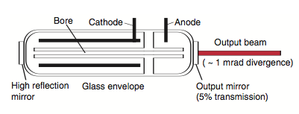

**Figure 5.26:** Construction of a Helium-Neon laser tube.

There are other sources that might be considered for use in fiber optics systems: the sun, tungsten lamps, fluorescent light neon lamps, electric arcs, etc. However, most of these sources are extended sources. That is, they have a large emission area compared to the sources already discussed. To introduce light from these sources into a fiber requires that some optical system be constructed to refocus the source onto the fiber end. The larger and more divergent the source, the more difficult it is to couple light into the system.

**COUPLING SOURCES TO FIBERS**

One objective in any fiber optics system is to insert as much power into the system with as little loss as possible. This allows the use of lower power sources in a system, reducing the cost and enhancing the reliability, since the source does not have to be operated near its maximum rated power. Attention paid to coupling a source to a fiber or a fiber to other components will be repaid in a more reliable and cheaper system.

The direction of the radiation that is emitted from a source must be considered in the field of fiber optics, since that radiation has to be collected and focused onto a fiber end. Sources can range from isotropic (emitting in all directions) to collimated (emitting in only one direction). In general, the angular distribution of the source can be expressed as

B(θ) = B0 (cos θ)m, θ < θmax,

where θmax is the maximum angle from the normal at which the light is emitted and is determined by the geometry of the source. If m = 1, the source is called a Lambertian source. Many non-laser sources closely approximate Lambertian sources. For a collimated source, m is very large. For intermediate cases, the source may be considered to be a partially collimated source.

The ability of a fiber to accept radiation can be characterized by its NA. We can describe the range of angles into which a source emits by a similar NA. The definition of the maximum angle of the source is not as easily determined as the maximum angle of a fiber with its critical angle, since the light may be emitted into a distribution of angles that does not have a precisely defined cut off.

In some cases, the light from the source is so divergent and the source is so large that the source must be reimaged on the fiber end face by a short focal length lens. For such a source, the lens is overfilled and the marginal rays, those at the edge of the cone of light, are determined by the size of the lens that is used. In that case, the NA of the source is give by

NAextended = n sin θ,

Where θ=tan–1 r/d, with r=radius of the lens and d= image distance, as shown in Fig. 5.27.

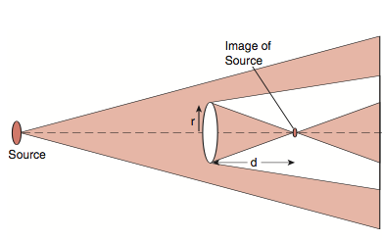

**Figure 5.27:** Calculation of the NA of an extended source.

For collimated laser sources, the lens is usually under- filled if it is placed close to the source. The light comes to a focus at the focal point of the lens. The beam then has a divergence half-angle that is approximately equal to the ratio of the beam waist radius before the lens, r0, to the focal length of the lens. Thus, the NA of the beam is given by

NAbeam = n sin (r0/f).

There are four parameters which affect the efficiency of source-fiber coupling: the NA of the source, NA of the fiber, the dimensions of the source and the fiber core itself. It is possible to show that the product of the source diameter and the NA of the source is a constant no matter what the focal length of the imaging lens may be. By comparing this value to the product of the fiber core diameter times the fiber NA, it is possible to determine whether a lens may be chosen that can image the source onto the fiber core without overfilling the fiber. Overfilling is marked by a source NA that is larger than the fiber NA. If the diameter-NA product of the source is larger than that of its fiber counterpart, reducing a source NA to fit a fiber NA will not increase the coupling, since that action enlarges the diameter of the source image on the fiber face. Thus, a careful consideration of the diameter-NA products will keep someone from trying to do the impossible. This same approach can be applied also to coupling between fibers of different sizes and NA's.

**APPLICATIONS**

Most of the applications of fiber optics systems fall into one of three categories: communications, sensors, and power distribution. In this section, each will be described briefly.

By far the most extensive use of fiber optics is in the field of communications. It encompasses short links between computers and telecommunications devices, the local area networks (LAN's) and longer distance connections that include those between the metropolitan areas of the Northeastern United States and those between America and the European continent.

When information is sent through a fiber optics system, it is encoded on the light wave by changing the light irradiance as a function of time. This process of varying the light level with time is called modulation. There are two types of modulation: analog and digital. Analog modulation consists of changing the light level in a continuous manner, while with digital modulation, the information is encoded through a series of pulses separated by spaces, as shown in **Fig. 5.28**. The absence or presence of a pulse at some point on the stream of pulses represents one element, or bit, of information.

The performance of a system using analog modulation is determined by how faithfully it reproduces the signal and by the smallest signal that can be transmitted, which is limited by random or extraneous noise in the system. Part of this is due to the type of detector that is used to convert the modulated light signal back into an electrical signal and part is due to the system itself. The ratio of the detected signal to the smallest signal, which can be distinguished from the noise, is called the **signal-to-noise ratio** (SNR). In the case of digital systems, the faithful reproduction of signal level is not required, which makes such systems superior in the presence of noise sources. All that is required is that pulses be transmitted with sufficient power for the detector and electronics to determine the presence or absence of the pulse. Performance in digital systems is given in terms of the **bit error rate** (BER), the fraction of bits sent that are determined to be in error when compared with the original digital information. BER's of less than 10–9 are generally required for a fiber optic digital communication link to be considered a good quality system.

Another application involves the use of optical fiber sensors to measure physical parameters. Because of their small diameter, sensors made of optical fibers can be fit into tight geometries where conventional sensors would be too large. Also, because the fiber medium is non- conducting, fiber sensors can be used in dangerous circumstances, such as explosive atmospheres. Sensors can be used to measure physical parameters such as temperature and pressure and engineering information such as liquid levels and distances.

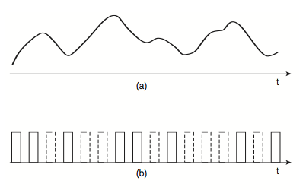

**Figure 5.28:** Two types of signal modulation. (a) analog. (b) digital.

Persons who have not studied fiber optics tend to think of them as optical water hoses. But as we have seen, the launching conditions, the fiber NA, the mode distribution in the fiber, and the fiber absorption and scattering losses all can contribute to reducing the usefulness of a fiber as a conductor of optical power. There are, however, certain fields where the transmission of optical power by optical fibers has proved useful.

In the field of medicine, the ability to insert optical fibers inside small hollow tubes that are pushed through small incisions in the body has provided a number of successful surgical procedures that do not call for massive cutting of tissues and yet still provide treatment for diseased parts of the body from the output of the optical fiber. Parallel to the power carrying optical fiber there is usually a second tube with many strands of optical fiber arranged in a precise manner that conduct illuminating light to the location of the treatment and carry an image of the treatment site back to the surgeon. Many of the treatments are still in the experimental phase. One of the most sought after products is an optical fiber that would carry large amounts of long wavelength infrared radiation from a carbon dioxide laser. The focused output of this laser makes an ideal surgical scalpel, but in the near term there are no fibers of sufficient flexibility, low cost, and low absorption at the CO2 laser wavelength that this specific application will become widespread.

There are a number of applications in the field of material processing where the delivery of laser power to a location would be an ideal method of operation. In dusty, dirty or difficult environments, the replacement of multiple lens-based optical power delivery systems with fiber-based systems is useful because of the reduction in down time and maintenance. Usually, the divergent output of the fiber must be refocused by a lens to produce the required irradiance to heat treat, melt, or vaporize an area of the material being processed. Depending on the wavelength of the radiation being used and the type of fiber employed, there are maximum values of power that can be delivered by such systems.

This project is an exercise in coupling semiconductor sources, i.e., laser diodes and light-emitting diodes (LED's), to optical fibers. Laser diodes and LED's are the sources generally used with optical fibers in communications and sensor applications. Also presented is a procedure to experimentally determine the electrical and optical characteristics of these sources.

The coupling will be achieved using a 0.29-pitch graded-index (GRIN) rod lens. GRIN-rod lenses have become widely accepted for use in fiber optic applications because of their small size, convenient focal lengths and working distances, and high-quality images with low distortions.

The sources which will be used are infrared devices, with the laser diode emitting at approximately 780 nm and the LED centered at about 830 nm. Since these devices emit invisible radiation, proper safeguards must be used to ensure that the possibility of injury is eliminated. Never look directly into a laser beam or its reflection.

**TYPES OF SOURCES**

Two types of semiconductor light sources are used in fiber optic systems. These are light-emitting diodes (LED's) and Laser diodes. In this project, we will be concerned with the coupling of these devices to optical fibers.

A light source may be characterized by the distribution of power emitted from its surface among all of the possible ray directions. Sources are generally divided into two types, depending on the radiation distribution. These two types are Lambertian sources and collimated sources. A Lambertian source is one which emits light in all directions from each differential source element. A surface emitting LED closely approximates a Lambertian source. A source which emits light only into a very narrow range of angles about the normal to its surface produces a collimated beam. The output of a HeNe laser approximates a collimated beam.

In general, the angular distribution of the source brightness can be expressed as

B(θ) = B0 (cos θ)m, θ < θmax,

where θmax is the maximum angle from the normal at which light is emitted and is determined by the geometry of the source. For a diffuse source, m = 1. For a collimated source, m is large. For intermediate cases, the source may be called a partially collimated source. The laser diode is a special case. The far-field distribution of the radiation from a laser diode diverges in a fan-shaped pattern with angles which are typically on the order of 15° × 30°. This is because the small emittance area of these devices (on the order of 1 μm on a side) causes the collimation of the far- field distribution of the radiation to be limited by diffraction at the output.

**Fig. 5.29** shows the output radiation characteristics, in polar coordinates, for two sources, one with m = 1 (typical of an LED) and one with m = 20 (typical of a laser diode).

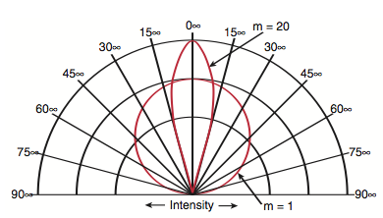

**Figure 5.29:** Polar plot of radiation patterns from typical laser diode and LED sources.

There are other properties which distinguish light- emitting diodes from laser diodes. These include the optical power-current curves, which are characteristic of the devices and the polarization of the output beam.

**COUPLING EFFICIENCY**

The amount of light energy which can be coupled into a fiber is dependent on the NA of the fiber. Since a fiber will accept only those light rays which are contained within a cone defined by the fiber's NA and core diameter, coupling loss will occur for sources which have an angular emission cone larger than the acceptance cone of the fiber's NA.

In some cases the fiber will be butt-coupled to the source. **Butt-coupling** is defined as coupling by placing the flat fiber end directly against the source, without the aid of any lens system. Butt-coupling cannot be achieved when the source is mounted in a package with a covering window glass. If the fiber is directly butt-coupled to the light source, the ratio of the power accepted by the fiber to the power emitted by the source can be shown to be

Pf /Ps = 0.5(m + 1)[α/(α + 2)] NA2,

where α is the index profile of the fiber. (A parabolic graded index would accept only one half as much light as a step index fiber. The factor α/(α + 2) is a mathematical expression of this fact.) The coupling efficiency to either a graded-index (α = 2) or a step index (α = ∞) fiber is proportional to the square of the numerical aperture and increases with increasing directionality (increasing m) of the source. The coupling loss in dB will be –10 log10 (Pf/Ps). **Fig. 5.30** shows the theoretical coupling loss as a function of fiber NA for some values of m.

For optimum coupling efficiency, one needs to match the source diameter-NA product to the fiber core diameter- NA product.

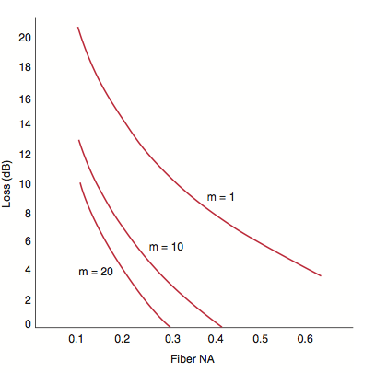

**Figure 5.30:** Plot of coupling loss as a function of fiber NA for various values of m, using Equation Pf /Ps.

**LENS COUPLING USING A GRIN ROD LENS**

This project uses a graded-index (GRIN)-rod lens to facilitate source-to-fiber coupling. Most optical devices used in fiber-optic systems employ lenses, and for most of these devices, GRIN-rod lenses have advantages over conventional lenses.

The GRIN-rod lens, is a glass rod, 1.0 to 3.0 mm in diameter, with a radially dependent index of refraction. This index of refraction is a maximum on the axis of the rod lens, and can be expressed as

n(r) = n0 (1 - Ar2/2),

where n0 is the index of refraction at the lens axis and A is referred to as the quadratic gradient constant. (This is really a restatement of n2(r) = n02 [1 –2∆ (r/a)α], with A=2∆/a2.)

By far the most popular choice of GRIN-rod lens length is one-quarter pitch. This is because a beam travels exactly one quarter of a sinusoidal period in that distance. Therefore, a collimated beam incident on one end of the lens will be focused to a point on the opposite end of the lens. Conversely, any point source at the surface of a quarter-pitch lens will become a collimated beam at the far end, as was seen in **Fig. 5.11a**.

Also widely used is the 0.29-pitch lens (which was illustrated in Fig. 5.11b), which is provided for use in this project. This lens is used to couple a laser diode to a fiber or a fiber to a detector. The lens which you will be using has no = 1.599 and √A = 0.332 mm–1. Since the length of this lens is slightly more than one quarter pitch, the light from a point source will be converted to a converging beam, rather than a collimated beam.

**Table 5.1** gives examples of the relationships between the working distances, 11 and 12, and the beam magnification, M, for the 0.29-pitch lens at a wavelength of 0.83 μm. l1 is the working distance from the source to the lens, while 12 is the working distance from the lens to the receiving fiber. The table may be used to optimize laser and fiber working distances. For example, a typical laser diode output may have a beam divergence cone with half-angle of about 15° at the half-power points in the direction perpendicular to the diode junction. Therefore, the e–2 power point for the Gaussian output beam will be at sin θ ∼0.4. Since the numerical aperture of a typical multimode communications fiber is ∼0.2, a magnification of about 2 will optimize the laser-fiber coupling. If the physical dimensions of the device permit, l1 and 12 can now be adjusted to fit the required magnification. Note that the magnification in the table is the image size magnification; the beam divergence will be reduced by the same factor. The laser diode provided for use in this project has a diode-to-window distance of approximately 2.0 mm. Because of this, achieving a magnification of 2.0 will not be possible. The result is that the coupling loss will be about 4 dB when the laser-fiber coupling is optimized using the 0.29-pitch GRIN-rod lens.

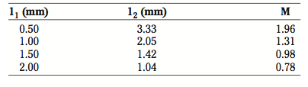

**Table 5.1**: Working distances and magnification of the 0.29-pitch grin-rod lens

**PARTS LIST**

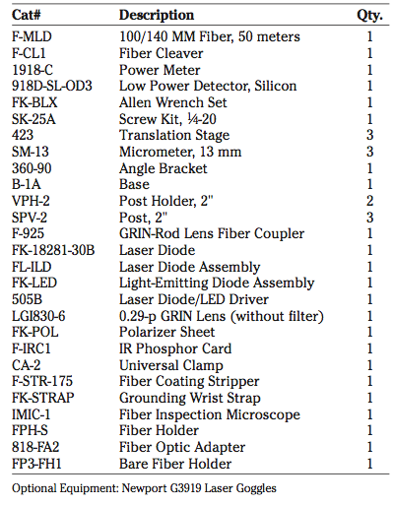

**INSTRUCTION SET**

**CAUTION: READ THESE WARNINGS BEFORE PROCEEDING WITH THIS PROJECT.**

The LED and laser diode devices provided for use in this project are infrared devices which emit radiation which can damage the human eye even though it is invisible. Proper precautions must be taken to ensure that the beams cannot enter the eye. This means knowing exactly what the beam path is at all times, including the possibility of specular reflections.

**CAUTION:** Use of controls or adjustments or performance of procedures other than those specified herein may result in hazardous radiation exposure.

**CAUTION:** The use of optical instruments (e.g. a lens, which can focus the light) with this product will increase eye hazard.

Also, it is important to remember that semiconductor infrared sources are highly sensitive devices. Wear the grounding wrist strap at all times when working with the laser diodes or LED's. When going through the instruction set, check and double-check to be sure that all connections have been properly made, and carefully follow all directions for device operation. A wrong connection can cause the catastrophic failure of either the laser diode or the LED. Before each use visually inspect the laser diode in the FL-ILD assembly to check for damage to the diode.

**LASER DIODE**

1. Install SM-13 micrometers onto each of the three 423 translation stages. Mount one stage to the table and use the other two stages along with the 360-90 angle bracket to construct an xyz configuration.

2. The FL-ILD Laser Diode mounting assembly is pre- mounted in an MH-2PM optics holder. Put the FK-STRAP grounding wrist strap on and connect it to the grounding post on the back of the 505B laser diode driver. Remove the cover plate on the laser diode mount, which is held on by (2) small button head hex screws. Removing this plate will expose the 3- pin socket. Remove the laser diode from the box and orient the pins correctly to match the socket in the mounting assembly. Install the laser diode into the socket, pushing gently to avoid damaging the pins. Reinstall the cover plate and post mount this assembly using two SPV-2 Posts and the CA-2 Universal Clamp. Mount this on the Z axis of the 423 stage system from **Step 1**.

**IT IS VERY EASY TO BLOW OUT A LASER DIODE BY EXCEEDING CURRENT SPECIFICATIONS OR BY STATIC DISCHARGE FROM YOUR BODY. A GROUNDING WRIST STRAP SHOULD BE WORN BY EACH PERSON WHO WILL BE HANDLING THE LASER DIODE AND THE LED. MAKE THE FOLLOWING CONNECTIONS ONLY WHEN THE DIODE POWER SUPPLY IS OFF. PLUG THE GROUNDING WRISTBAND INTO THE GROUNDING POST ON THE REAR OF THE MODEL 505B LASER DIODE DRIVER. ALWAYS WEAR THE WRISTBAND WHEN HANDLING THE LASER DIODE OR LED.**

3. Connect the laser diode to the model 505B driver circuit.

4. Place the 918D-SL-OD3 detector head directly in front of the laser window. Increase the diode current to the operating current listed for the device. Monitor the output power as the current is increased. Make note of the power obtained when the listed optimum operating current (Iop) is reached.

5. Reduce the current through the laser to zero. Now, slowly increase the current, recording the coupled output power as a function of diode current. Record data for current values from 0 to Iop.

6. Plot the results. Draw a line along the rise in power above the onset of lasing. Extend this line down through the current axis. Compare the current at this point with the listed threshold current. This is one of the techniques used to determine the laser's threshold current.

7. The F-IRC1 IR Phosphor Card may be used to view the laser output. Place the phosphor card in the path of the beam at a convenient viewing distance. Measure the width of the beam parallel and perpendicular to the width of the diode junction. Using this and the distance from the device, calculate the divergence of the beam. The manufacturer specifies a divergence of about 15° × 30° for this laser diode.

8. Place the FK-POL Polarizing Sheet with a known polarization axis in the laser beam and determine the plane of polarization of the laser output.

9. Place the LGI830-6 0.29-pitch GRIN-Rod Lens into the groove of the F-925 coupler, as shown in **Fig. 5.31**. The lens should extend out of the coupler ~1 mm toward the laser diode. Insert a cleaved segment of F-MLD fiber into the FP-l of the coupler using the FPH-S holder and couple the laser output into the fiber through the GRIN-rod lens. The proper setup is shown in Fig. 5.32.

10. Optimize the coupling and determine the coupling loss, using the power coupled into the fiber and the power out of the laser diode which you measured in **Step 5**. The best coupling will be attained with the laser window as close to the lens as possible. With the laser diode which is used here, and the F-MLD fiber, a coupling loss of about 4 dB should be obtained.

11. Turn the 505B Laser Driver output off. Disconnect the 9-pin laser diode connector from the Model 505B.

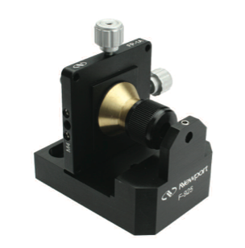

**Figure 5.31:** Placing a 0.29-pitch GRIN-rod lens in the V-groove of the Model F-925 GRIN-Rod Lens Coupler.

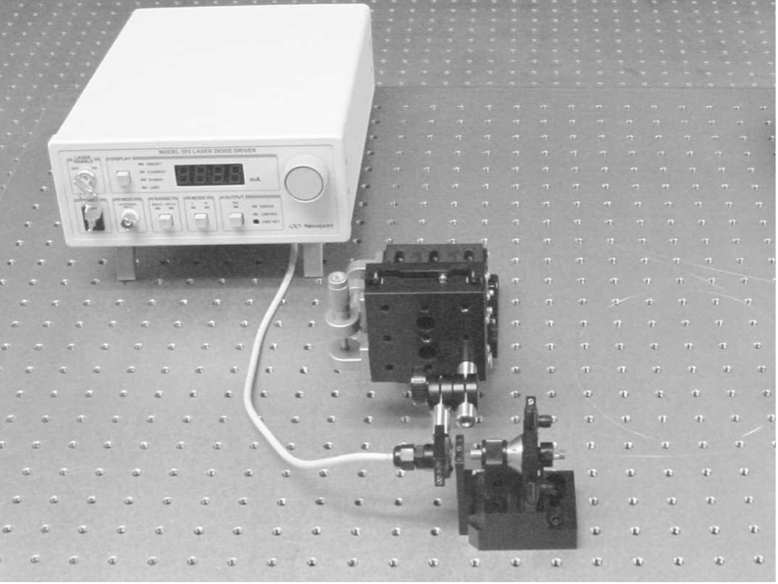

**Figure 5.32:** Laboratory set-up for coupling semiconductor sources to optical fibers. Use CA-2 Universal Clamp on the stage assembly if matching the optical axis of the laser diode and that of the fiber coupler is difficult.

**LIGHT EMITTING DIODE**

1. Post mount the FK-LED Light-Emitting Diode Assembly in the same way as the laser diode. (See **Fig. 5.4**) 2. Connect the LED to the model 505B driver unit. Turn

the current up to 100 mA and record the power out of the device.

3. Reduce the LED current to zero. Record the power out of the coupled LED as a function of current from zero to approximately 110 mA (or 10% over the specified operating current). The data should provide a good fit to a straight line, a characteristic typical of LED's.

4. Place the F-IRCl IR Phosphor Card in the path of the LED output. The LED has a microlens over the semiconductor chip; all of the output power will not be accepted by the lens, and the output will appear to be better collimated than might be expected from the discussion of **Section 5.1**. However, you will still see a marked contrast to the output of the laser diode.

5. Place the polarizer used previously in the LED output beam. Confirm that the LED output is unpolarized.

6. Couple the LED to the fiber using the F-925 GRIN lens coupler as you did in **Steps 9** and **10** of the previous section. Calculate the coupling loss using the power coupled into the fiber and the power out of the LED which you measured in **Step 3**.