**Cogeneration**

The internal combustion engine can manage to convert only a moderate fraction (typically on the average around 1/3) of the chemical energy of its fuel released through combustion into useful mechanical work or electrical work.

The bulk of the energy is dissipated in the form of environmental thermal pollution via the high energy exhaust gases discharged.

So cogeneration is the simultaneous production of electricity and setam from a single fuel source, delivering energy efficiency of up to 86%.



How to utilize rejected heat energy?

Rejected heat is used to produce hot water, low temperature steam or hot air.

For which part does the cogeneration work in automobiles?

Interior heating by using the thermal energy rejected by the engine.

**Fuel consumption**

It is becoming increasingly essential to reduce the fuel consumption of energy devices in general and internal combustion engine. This is not necessray for economical considerations but also for environmental reasons.

Below are the general practices that are applied to reduce the fuel consumption for vehicles:

* Reduction of the air conditioner load.
* Designing Windows that are capable of minimizing heat gain in the summer and heat loss in the winter.
* Reduction of the frictional losses via using lubricants for the operation of pumps and fans.
* Operating the vehicles at the right cranckshaft rotational velocity.
* Using lightweight and strong material for the design such as carbon fiber bicycles.
* Hybrid operations.

**HYBRID VEHICLES**

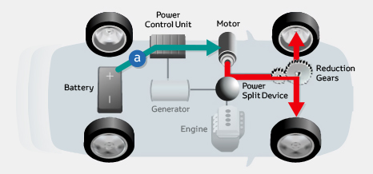

(http://www.toyota-global.com/innovation/environmental_technology/hybrid/images/sec1_img_01.jpg)

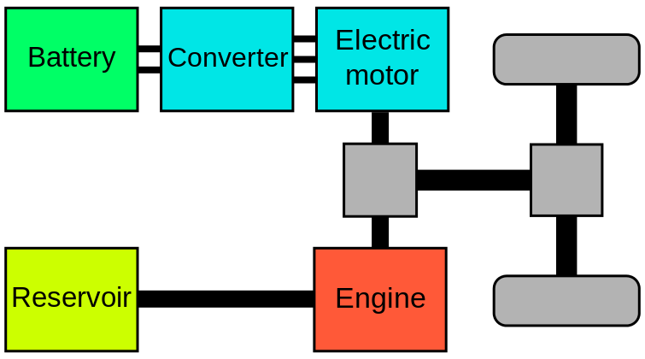

(https://upload.wikimedia.org/wikipedia/commons/thumb/5/5b/Hybridpar.svg/220px-Hybridpar.svg.png)

Hybrid vehicle operation relates an engine that is linked to an electric motor-generator-storage system that provides controllable power to the wheels.

**Exhaust emissions from the combustion of fuels**

Normally, the mixing of air in excess proportions with a hydrocarbon fuel should result after the combustion, in all C in the appearing as CO2 , as H appearing as H2O, unutilized O2 and unchanged N2.

**Incomplete combustion vs complete combustion**



Reference: Ghazi A. Karim, Fuels, Energy and the Environment, 1st Edition, CRCPress.