**IV. OPTICAL CLASSES - INDICATRIX THEORY**

**A. *Optical classes: isotropic vs anisotropic minerals***

Minerals are divided into one of six crystallographic systems based upon their symmetry: cubic, hexagonal, tetragonal, orthorhombic, monoclinic, or triclinic (For an excellent presentation of crystal symmetry.) Minerals are also divided into classes based upon their optical behavior. There are two broad optical classes: isotropic and anisotropic. Anisotropic minerals are further subdivided into uniaxial and biaxial classes. Unpolarized light remains unpolarized after passage through an isotropic sample but will be linearly polarized into two mutually perpendicular planes after passing through an anisotropic mineral.

There is a direct relationship between the crystallographic and the optical class (i.e., there is a relationship between crystal structure and

light interaction). Isotropic materials belong to the cubic crystal system (some isotropic materials are amorphous). Uniaxial minerals belong to either the hexagonal or tetragonal crystal systems. Biaxial minerals belong to either the orthorhombic, monoclinic, or triclinic systems.

In isotropic minerals, the refractive index is the same in all directions, and Snell's Law always applies. For certain orientations in anisotropic minerals Snell's Law does not apply. In these orientation two separate ray paths occur, because the refractive index differs has a function of orientation. Also, in anisotropic minerals the ray path is no longer perpendicular to the vibration direction (Figure 1). These complexities make it very difficult to construct ray paths in anisotropic samples. The interested reader is referred to Bloss (1961) for a detailed discussion.

The refractive index a mineral exhibits is more directly to the vibration direction than to the ray path. The observable refractive index is parallel to the vibration direction for special directions in anisotropic and all directions in isotropic crystals it is perpendicular to the ray path. To understand how light interacts with minerals, especially anisotropic minerals, it is necessary to think in terms of how the vibration direction of linearly polarized light moves through the crystal with regard to the crystal's structure.

The optical indicatrix is a geometrical solid relating the refractive index of a mineral to the mineral's structure. The surface of the indicatrix represents the different refractive indices in the crystal. These different refractive indices are related to the different vibration directions that linearly polarized light can vibrates parallel to while in the mineral.

**B. *Isotropic indicatrix***

Isotropic minerals belong to the cubic crystal system and possess only one refractive index, usually labelled as n. The isotropic indicatrix is a sphere with radius proportional to the n of the mineral (Figure 8). Each vector drawn in Figure 8 can be thought of as a vibration direction. Light

vibrating parallel to that vector would exhibit the refractive n of the mineral. For isotropic minerals all the vectors are the same length, so the refractive index does not vary with differing vibration directions.

**C. *Uniaxial indicatrix***

Uniaxial minerals belong to either the hexagonal or tetragonal crystal systems and possess two mutually perpendicular refractive indices, and , which are called the principal refractive indices. Intermediate values occur and are called “ a non-principal refractive index”. The uniaxial indicatrix is an ellipsoid, either prolate ( > ), termed positive, or oblate ( < ), termed negative (Figure 9). In either case, coincides to the single optic axis of the crystal, yielding the name "uniaxial." The optic axis also coincides with the axis of highest

symmetry of the crystal, either the 4-fold for tetragonal minerals or the 3- or 6-fold of the hexagonal class.

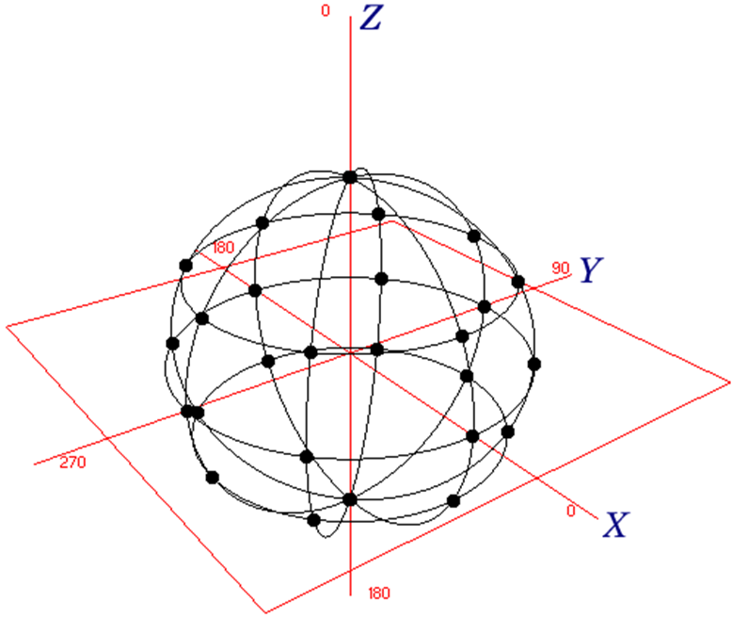

Figure 8 isotropic distribution of the minerals, Optical indicatrix for isotropic minerals. A series of vectors, whose length is proportional to n, is constructed from a common origin. The surface the tips of these vectors describe, in this case a sphere, is the optical indicatrix

Because of the symmetry imposed by the 3-, 4-, or 6-fold axis, the indicatrix contains a circle of radius perpendicular to (perpendicular to the optic axis). Light vibrating parallel to any of the vectors labelled

in Figure 6 would exhibit the refractive . Light vibrating parallel to the optic axis would exhibit . Light that does not vibrate parallel to one of these special directions within the uniaxial indicatrix would exhibit a refractive index intermediate option.

As previously stated, the ray path and vibration direction for isotropic minerals are perpendicular. This is not always the case in anisotropic minerals. For the case when linearly polarized light is vibrating parallel to either of the principal refractive indices the ray path and vibration direction will be perpendicular. Thus, in Figure 6 light whose ray path is parallel to the optic axis would be vibrating in the direction. Likewise, any light whose ray path was perpendicular to the optic axis that is travelling within the circular section, would have its vibration direction parallel to the optic axis and exhibit. For light not travelling along one of these two special directions, the ray path and vibration direction would not be perpendicular and would be exhibited.

The indicatrix provides the framework for understanding optical measurements on crystals. To determine the principal refractive indices for uniaxial minerals, linearly polarized light must be forced to vibrate parallel to them. This can be accomplished with the aid of the PLM (Figure 2). A crystal can be oriented on the microscope stage so that, for instance, the optic axis is parallel to the microscope stage. Then a rotation of the microscope stage is made so the E-W lower polarizer is made parallel to the optic axis. This done, can be determined as later discussed.

**D. *Biaxial indicatrix***

Biaxial minerals belong to either the orthorhombic, monoclinic, or triclinic crystal systems and possess three mutually perpendicular refractive indices which are the principal refractive indices. Intermediate values also occur and are labelled. The three principal refractive indices coincide with three mutually perpendicular directions, X, Y, and Z, which form the framework for the biaxial indicatrix (Figure 9). The point group symmetry of the biaxial indicatrix is 2/m 2/m 2/m. In orthorhombic minerals the X, Y, Z axes coincide with either the 2- fold axes or normals to mirror planes. In monoclinic minerals, either X, Y, or Z coincide with the single symmetry element. In triclinic minerals, no symmetry elements necessarily coincide with the axes of the indicatrix.

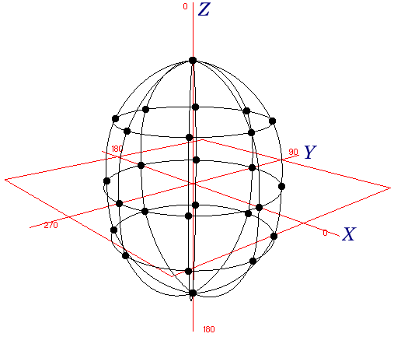

Figure 9. Optical indicatrix for uniaxial minerals. When > the mineral is positive; when < it is negative. These indicatrices were formed in a similar manner to the isotopic indicatrix. However, because the refractive indices differ, depending upon the vibration direction, they are no longer spheres.

Also shown in Figure 9 are the two optical axis, labelled OA1 and OA2, which is how this class derives its name. The optic axes are perpendicular to circular sections, having radii that can be inscribed inside the indicatrix. The optic axes lie in the XZ plane of the biaxial indicatrix. The acute angle between the optic axes is defined as 2V, sometimes labelled has 2Vz or 2Vx. 2Vz and 2Vx are supplementary angles. When 2Vz is acute the mineral is termed biaxial positive, and when 2Vx is acute the mineral is biaxial negative.

For light vibrating parallel to either X, Y, or Z, the principal refractive indices or respectively results. Also, for these three directions, the ray path would be perpendicular to the vibration direction. For any other vibration direction within the crystal non- principal refractive index would result and the ray path and vibration direction would not be perpendicular.

The three optical indicatrices progress from high - isotropic to lower symmetry - uniaxial and then biaxial as the crystal structure of the minerals decrease in symmetry from cubic to hexagonal or tetragonal and finally to orthorhombic, monoclinic, or triclinic. The biaxial indicatrix will become uniaxial when, for instance, and become equal. Also,

when this happens the two circular sections in the biaxial indicatrix would rotate into coincidence with each other and become the single circular

section, with radius of the uniaxial indicatrix. The two optic axes would rotate into coincidence and become the single optic axis of the uniaxial indicatrix. In the previous example a positive biaxial mineral would become a positive uniaxial mineral. If and were to become equal, a

negative biaxial mineral would become a negative uniaxial mineral.

Because the optical indicatrix is related to the crystal system, optics play an important role in crystal structure determination. Certain minerals, for instance some garnets, appear anisotropic while they are supposed to belong to the cubic crystal system, and most structure determinations place them there. However, optics is more sensitive to slight structural changes than x-ray diffraction and when used in combination with it can help avoid incorrect crystal system assignments.

**Optical Birefringence**

The term "birefringence" describes the optical phenomenon of [double refraction](http://www.allaboutgemstones.com/gemstone_refractive_index.html) as a single beam of light travels through a transparent, molecularly ordered material, and is split into two separate beams. The amount of birefringence in a given material is directly linked to the orientation-dependent differences in its dual refractive indices. The term "intrinsic birefringence" is used to describe any naturally occurring mineral's asymmetry with respect to its refractive indices which are inherently direction-dependent.

The optical characteristics of a given transparent material is categorized as being either *anisotropic* or *isotropic*. Most transparent minerals are optically isotropic, meaning that their index of refraction is equal in all directions throughout their [crystalline lattice](http://www.allaboutgemstones.com/crystalline_structures.html) structure. The mineral calcite (above, left) has two different refractive indices of 1.490 and 1.660 exhibiting strong double refraction and therefore, birefringence. Calcite's rhombohedral cleavage block produces two distinct images (double vision) when it is placed over an object.

This splitting of light gives a double-vision effect. Anisotropic crystals such as calcite, [alexandrite](http://www.allaboutgemstones.com/gemstones_alexandrite.html), [amethyst](http://www.allaboutgemstones.com/gemstones_amethyst.html) (quartz) or [tourmaline](http://www.allaboutgemstones.com/gemstones_tourmaline.html) have crystallographically distinct axes, and interacting with the light traveling through them by a mechanism which is dependent upon the orientation of their crystalline lattice with respect to the angle of incident light.

When a beam of incident light enters the "optical axis" of these anisotropic crystals, it behaves in a manner similar to the interaction with isotropic crystals, and passes through at a single velocity.

[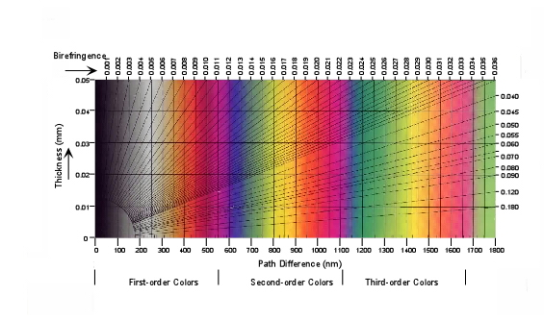](http://www.google.com.tr/url?sa=i&rct=j&q=birefrenges+of+the+minerals&source=images&cd=&cad=rja&docid=MlyPeYVM1BrtcM&tbnid=HCy4CaAMUkVXbM:&ved=0CAUQjRw&url=http%3A%2F%2Fwww.geo2all.com%2Fvb%2Fshowthread.php%3Fp%3D13382&ei=b6FQUcD4O8nPObmqgagK&bvm=bv.44158598,d.Yms&psig=AFQjCNGUYVMH-BVnlYIAwH1ambIGhgm8ng&ust=1364325067767194)

|  |  |  |
| --- | --- | --- |
|  |  |  |

But when the beam of light enters a "non-equivalent" axis, it is refracted (split) into two separate rays, each polarized with their vibration directions oriented at right angles to one another (mutually perpendicular), exhibiting birefringence. Each separate beam is now traveling at different velocities (speeds), and therefore, their frequencies (colors) are also now different.

**Interference Colors in Anisotropic Minerals**

When the "ordinary" and "extraordinary" rays emerge from a birefringent crystal (above, left), they are still vibrating at right angles with respect to one another. Because one wave is retarded (delayed) with respect to the other, interference (either constructive or destructive) occurs between the waves as they pass through the crystal, the result being that some birefringent crystal acquires a spectrum of color when observed in white light. Such "interference color" effects are often mistakenly referred to as a "rainbow" or solar "spectral colors," and are commonly seen in soap bubbles, or in oil slicks on the surface of water.

**E. *Retardation and Birefringence***

Anisotropic minerals possess different values of refractive index depending upon the vibration direction. The mathematical difference between two vibration directions is termed the crystal's birefringence. For example, the birefringence of a uniaxial positive crystal would be. If the precise vibration directions are not known in the crystal, another nomenclature is used: N (referred to as "big N") is used to signify the larger refractive index and n (referred to as "little n") is used to signify the smaller refractive index.

**F. *Interference***

Light can interact with itself to produce many different colors. Interference of light occurs when two light rays travelling in the same direction, but having different intensities or wavelengths, interact with one another to form a single light ray. . The interference of the colures can be described as three ordered of the colures (Figure 10.)

[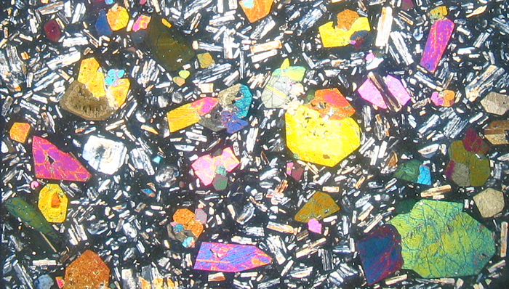](http://www.google.com.tr/url?sa=i&rct=j&q=birefrenges+of+the+minerals&source=images&cd=&docid=QOybV2E-D5K0FM&tbnid=JKM9_gakpbq7QM:&ved=0CAUQjRw&url=http://www.geosecslides.co.uk/index.php?s=Viewing&ei=ap9QUZ6WF4G0O4jAgNgK&bvm=bv.44158598,d.Yms&psig=AFQjCNEq3JUojsDebVfgmtgLHtyhsb8hnA&ust=1364324195754547)



Figure 10 Color chart of the minerals

This is the phenomenon that produces color in such things as oil slicks and hummingbird feathers. The interaction of light in a crystal produces interference which is a function of the wavelength of light used and the optical characteristics of the crystal, namely the birefringence.

For instance, if a uniaxial mineral is illuminated with unpolarized light whose ray path is normal to the optic axis, the crystal will constrain the light to vibrate parallel to and . Because, by definition, the light travels at different velocities along these two vibration directions, it will not be in phase upon exit from the crystal. However, after exit the two

rays will combine - interfere - with each other and produce a single beam of light. This interference results in two distinct differences for the final ray: (1) it will, in general, be linearly polarized with its plane of polarization not parallel to the upper or lower polar and (2) the crystal will appear colored when viewed between crossed-polars - the resulting

color is termed as an interference color.

Interference colors of minerals are directly correlated to the mineral's retardation. In thin sections the thickness is known, so the birefringence is easily calculated. The index of refrection with their birefringence is given in Table- 1. The birefringence, along with determination of the optical class and approximate refractive index, is usually all that is required to identify most minerals in thin section.

Table-1 Index and birefringence of the minerals

|  |  |  |  |  |
| --- | --- | --- | --- | --- |
| **Index of Refraction** | | **Birefringence** | | |
| **Descriptive Term** | **Range of Values** | **Descriptive Term** | **Range of Values** | **Interference Color** |
| Very low | Below 1.51 | Very low | Less than .006 | 1 Black to Gray |
| Low | 1.51 - 1.571 | Low | .006 - 014 | 1 White-Yellow |
| Moderate | 1.571 - 1,620 | Moderate | .014 - .020 | 1 Red - 2 Blue |
| Moderately high | 1.621 - 1.650 | Moderately high | .021 - .025 | 2 Green - Yellow |
| High | 1.653 - 1.73 | High | .025 - .045 | 2 Orange - 3 Green |
| Very high | l.731 - 1.90 | Very high | .045 - .060 | 3 Green - 4 Green |
| Extremely high | Above 1.90 | Extremely high | .06 or higher | 4 Green and |

Reference books on mineral identification (Nesse, 1986; Fleischer, et al.

1984) commonly list these optical properties.

The accessory shown in Figure 2 of the PLM is a retardation plate. Retardation plates are used to determine optic sign of minerals by determining the orientation of N and n of the crystal. They are also used to determine retardation, both qualitatively and quantitatively. These plates have a metal holder with an anisotropic crystal that can be

inserted into the optic path of the microscope. Retardation plates are manufactured based upon two criteria. First, the crystal's orientation must be known and marked on the plate (usually the N direction will be labeled). Second, the thickness of the crystal must be controlled so the amount of retardation it produces is known.

There are three types of retardations. Plates cut to a single thickness that produce 1 or 1/4 retardation, plates cut into the form of a wedge that produce a range of retardations, say from 0 - 4 , and tilting compensators, in which a flat plate rotates, thus changing its thickness and retardation value. The tilting compensators are used for precise measurement of retardation.