**Incomplete combustion vs complete combustion**

C4H10 + 13/2 O2 = 4CO2 + 5H2O …. 2877 kJ/mol energy released

C4H10 + 9/2 O2 = 4CO + 5H2O ….. 1745 kJ/mol energy released

According to the above equations, 1132 /mol energy lost in the presence of incomplete combustion.

CO is emitted from the combsution of fuels as a result of incomplete combustion resulting either from

-oxygen deficiency

-quenching of combustion processes due to contact with cold surfaces, rapid expansion or a relatively excessive air supply.

How can you prevent CO emissions ?

-Removal from exhaust gases

-Complete combustion – successful oxidation with suitable catalysts

**Formation of NOx**

Where does NOx come from?

Reaction of oxygen with some N2 in the air or that may be present in the fuel at high T.

NOx are NO, NO2, N2O, N2O2, N2O3, N2O4, N2O5. But NO is the primary form.

NO is generated with the reaction of N2 with O2 at elevated temperatures, above 1300°C.

In transport engine applications, the degree of exhaust gas emissions basically depend on the followings:

-Type of fuel

-Engine type

-Operational conditions

-Exhaust gas treatment

In reality, in addition to the incomplete combustion products, there would be other products due to:

-Inhomogeneous mixing of the fuel and the air

-Insufficient time given to complete combustion

-Excessive heat loss

-Dissociation of nitrogen

-Poor flame propagation

**Equivalence ratio** is an important parameter which indicates the way the combustion reaction will proceed: complete or incomplete combustion.

It is the ratio defined as the ratio of the actual air/fuel ratio to the stoichiometric fuel/air ratio:

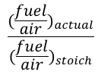

Stoichiometric combustion occurs when all O2 is consumed in the reaction and there is no molecular O2 in the products.

If equivalence ratio <1 - air fed in excess – complete combustion

If equivalence ratio >1 – air fed less than the stoichiometric amount

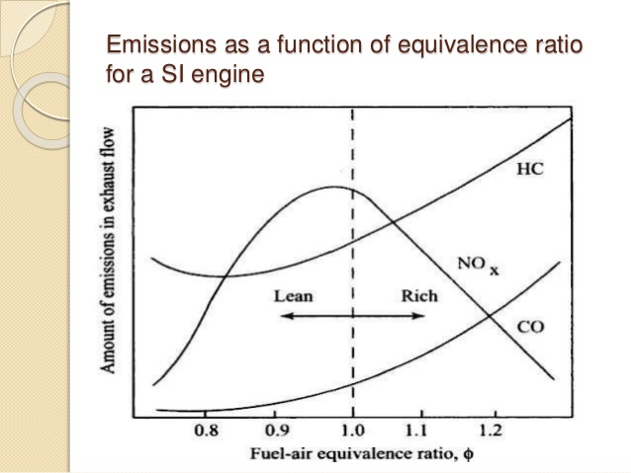

(https://image.slidesharecdn.com/pptonice-141209051543-conversion-gate01/95/ic-engines-emission-and-its-control-3-638.jpg?cb=1418102344)

**Air pollution due to the combustion**

Smog is derived from the words smoke and fog, it is a type of air pollutant and its composition is variable.



Soot is impure carbon particles resulting from the incomplete combustion.

Reference: Ghazi A. Karim, Fuels, Energy and the Environment, 1st Edition, CRCPress.