**POWER CYCLES**

In power cycles or heat engines, there are various ways to define the performance of a heat engine. But, the below definition of heat efficiency is universal



When the efficiency is defined in terms of combustion enthalpy or heating value of a chemical fuel:



Be careful! - When expressing geating value of a fuel, either HHV or LHV is used.

HHV-Higher heating value is the gross calorific value is the amount of heat released by a definite amount of fuel following its combustion and later, returning its temperature to 25°C. So it accounts the latent heat of vaporization of H2O as a product of combsution reaction.

LHV- Lower heating value- Net calorific value is amount of heat released by a definite amount of fuel following its combustion in which the latent heat of vaporization of H2O is not taken into account.

HHV is determined via Calorimeter Bomb. Since T of the products were brough to 25°C.

Bomb calorimeter is a large container filled with water, in which is placed a small comtainer - bomb , the and a metal crucible which holds the sample. Oxygen is supplied and combustion is initiated with an ignition source. The temperature change of the sample is monitored thorughout the reaction. By this way, calorific value of the solid and liquid fuels can be found.

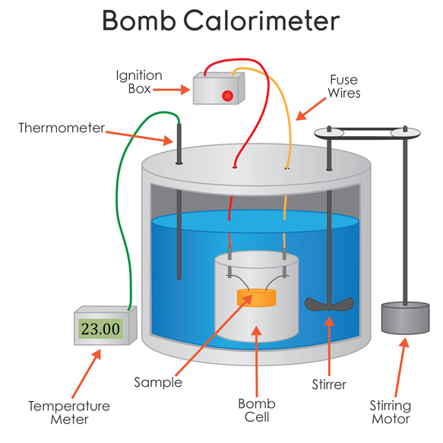

(Taken from https://www.learner.org/courses/chemistry/images/text_img/BombCalorimeter.jpg)

**Stages of Carnot Cycle**



P-V diagram of Carnot cycle

1. During reversible isothermal gas expansion process, the ideal gas absorbs *some* heat from a heat source expands and does work on surroundings.
2. During a reversible isentropic gas expansion process, the system is insulated. The gas continues to expand and do work on surroundings, which causes the system to cool.
3. During isothermal gas compression surroundings do work on the gas and results in a heat loss.
4. During isentropic gas compression process, the system is insulated. Surroundings do work on the gas, which causes temperature rise.

In reality, power cycles do not yield the expected performance due to following reasons:

* Heat losses to the surroundings.
* Frictional losses during fluid flow.
* Fluid expansion or contraction when passing through nozzles or valves.
* Mixing of different components.

References:

Jefferson W. Tester and Michael Modell, “Thermodynamics and Its Applications”, 1996, Prentice Hall.

D. Winterbone and A. Turan , "Advanced Thermodynamics for Engineers", 1996, Butterworth-Heinemann.