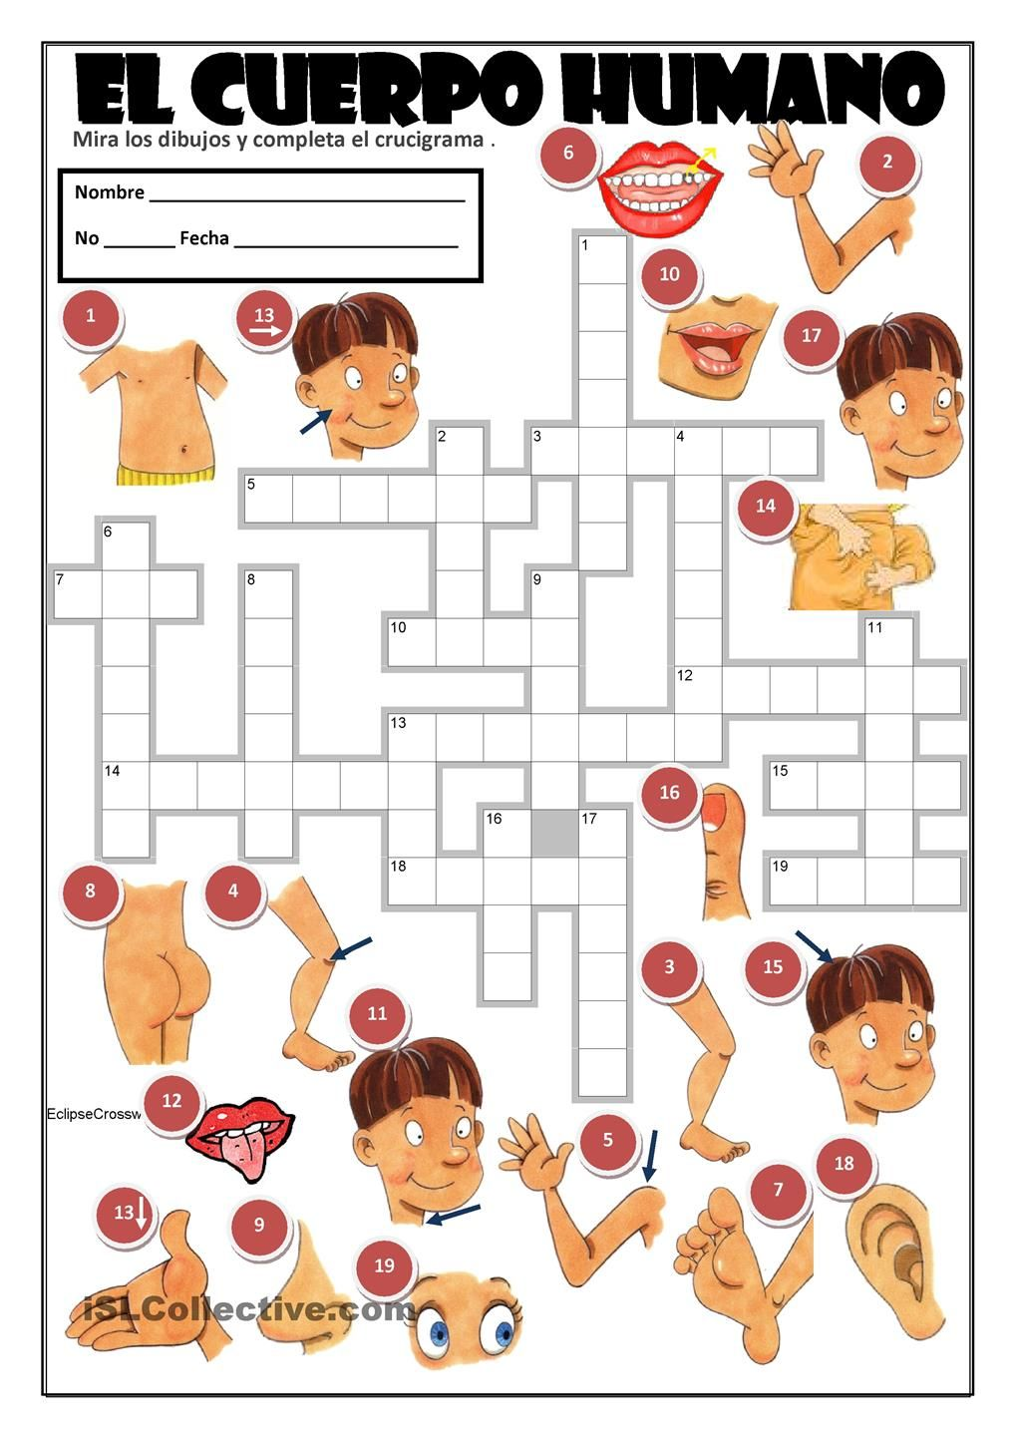

<https://images.app.goo.gl/pzw6wZW688c88s38A>

iSLCollective.com