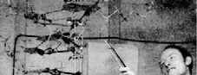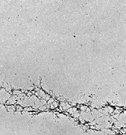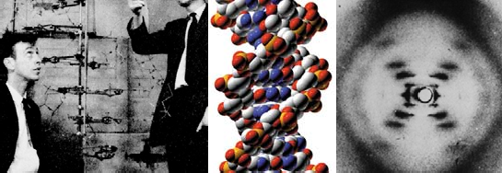

Molecular Genetics I DNA

Deoxyribonucleic acid is the molecule that encodes the characteristics of living things. It is the molecule that is passed from a mother cell to daughter cells, and the molecule that is passed from parents to offspring. 1

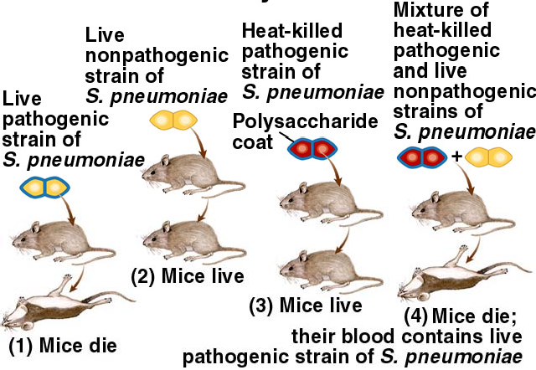

**History of discovery of DNA**

1869 - Miescher isolated phosphorus rich compound from the nucleus of cells. He called it “nuclein.” Because nuclein was slightly acidic it was later named **nucleic acid**.

1928 - Griffith demonstrated transformation in bacteria

2

1944 - Avery, McCleod and McCarty showed that DNA was the likely agent of transformation

Experiments:

1. Heat-killed S + live R  live R and live S
2. Heat-killed S treated with protease + live R  live R and live S
3. Heat-killed S treated with DNAse + live R  only live R

Conclusions:

1. Protease has no effect on transformation - protein is not responsible for transformation
2. DNAse stops transformation - DNA is the probable agent of transformation

3

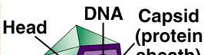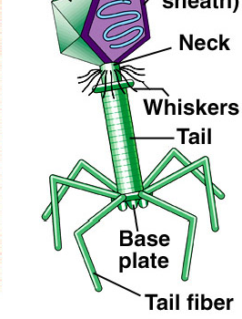

1952 - Hershey and Chase - worked with bacterial viruses (**bacteriophages**)

Biology of viruses: Viruses have a protein coat and a nucleic acid core. Many reproduce by attaching to cells and injecting nucleic acid into the cell. The injected genes commandeer the cell and use the cell’s machinery (proteins) to make copies of the viral nucleic acid and coat proteins.

The nucleic acid is packed into the protein coats and the cell is lysed, releasing the virus particles that can attach to other cells.

4

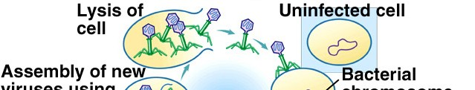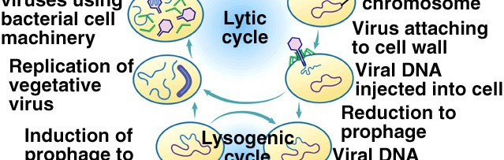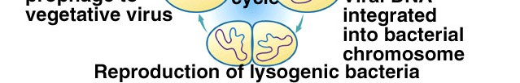

5

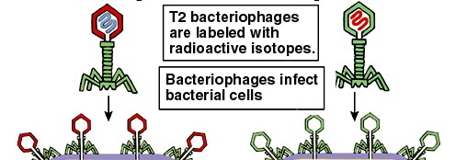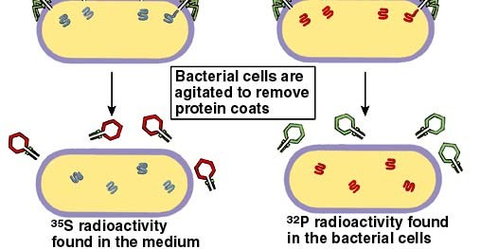

6

virus particles from the cell membranes

Hershey and Chase labeled the viruses with radioactive isotopes.

They used 35S to label protein and 32P to label the DNA of bacteriophage T2. S is found in protein but not in DNA. P is found in DNA not in protein. (The common nonradioactive isotope of sulfur is 32S. The common nonradioactive isotope of phosphorus is 31P.).

They then allowed the viruses to infect bacterial cells and early in the infection process, agitated the cells (in a blender) to remove the

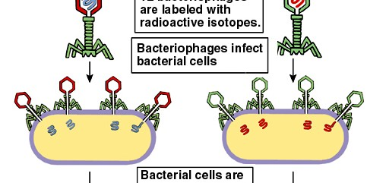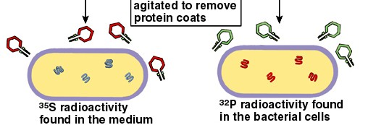

They used centrifugation to separate the cells from the viral coats. The coats were light and stayed in the supernatant and the cells settled out in the pellet. The 35S was found in the in supernatant and the 32P was found in the pellet.

They concluded DNA (containing P) is injected into the cells and protein (containing S) remains on the outside.

When the viruses were allowed to complete their life cycle, no 35S was found in the new particles but some 32P was.

7

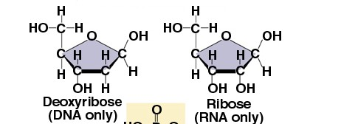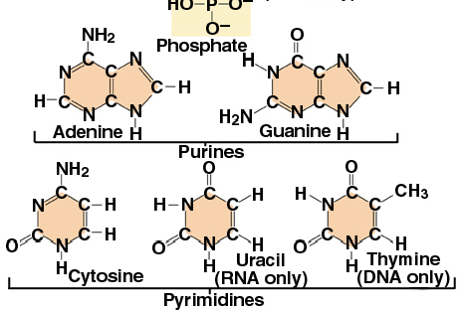

1922 - Levene analyzed nucleic acids and found they contained phosphates, and sugars (deoxyribose in DNA and ribose in RNA) and each contained 4 nitrogenous containing bases. DNA’s bases consisted of two purines, **A**denine and **G**uanine, and two pyrimidines, **C**ytosine and **T**hymine. RNA used the same two purines, and the pyrimidine cytosine, but instead of thymine had the pyrimidine **U**racil.

8

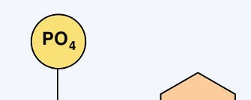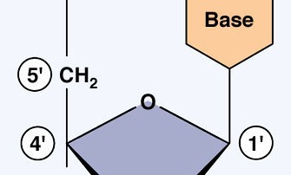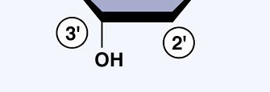

Levene also determined the structure of nucleotides. The base is attached to the #1 carbon of the sugar and the phosphate attached to the #5 carbon.

9

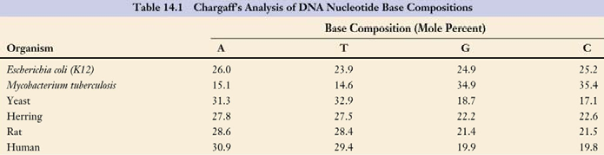

1947 - Chargaff analyzed the nucleotide composition of the DNA of many organisms. He determined the %A, %T, %C, %G.

He found that although the percentage of each nucleotide varied among different types of organisms the %A and %T were always almost equal, and the %C and %G were always almost equal.

The equality of composition of bases in DNA (%A=%T and

%C=%G) is known as **Chargaff’s Rule**

10

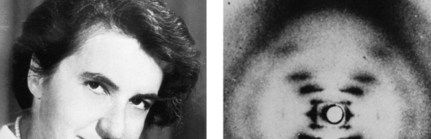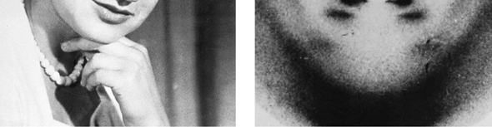

1952 - Rosalind Franklin analyzed DNA fibers using X-ray diffraction. She concluded that DNA is a helix and has one complete turn every 3.4 nm.

11

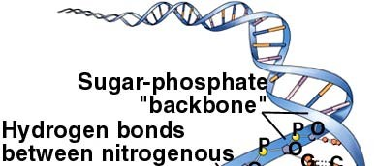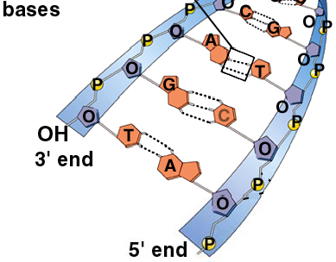

12

1953 - Watson and Crick, using Franklin’s results (before they were published) and using a little- known, but correct, structure for guanine, were able to develop a molecular model for DNA. They suggested DNA is a **double helix** with **anti-parallel** strands (oriented in opposite directions), held together by H-bonding between the bases of the two strands (A-T, C-G). They also suggested DNA could be replicated by allowing the molecule to unzip with each single strand serving as the model for a new complementary strand.

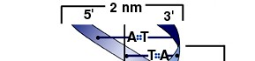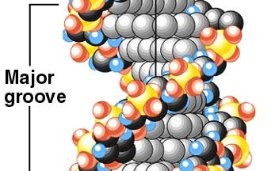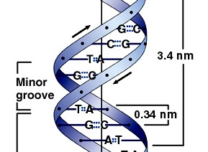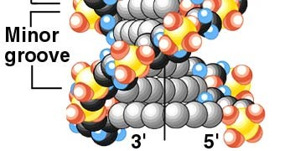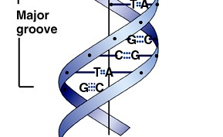

Their model explained Chargaff’s rule and fit with Franklin’s conclusions.

13

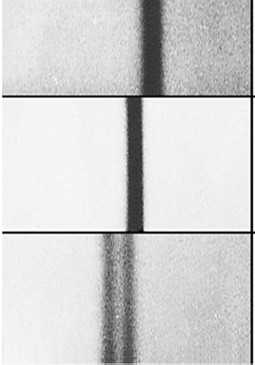

1958 - Meselsohn and Stahl showed that DNA replication is **semiconservative** (new DNA molecules consist of one original strand and one new strand). density

1. They allowed bacteria to replicate for

many generations in a medium containing only heavy N (15N). They centrifuged the DNA using density-gradient centrifugation and found all heavy DNA (15N/ 15N)

1. They allowed 15N cells to replicate their DNA once in an 14N medium, centrifuged the DNA, and found DNA of intermediate density (14N/ 15N)
2. They allowed 15N cells to replicate DNA twice in an 14N medium and found the DNA be both of intermediate density (14N/ 15N)

and light density (14N/ 14N) 14

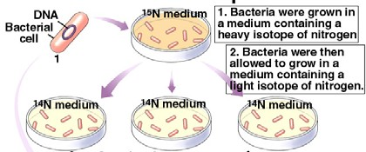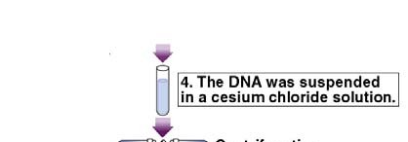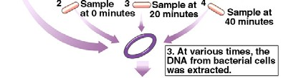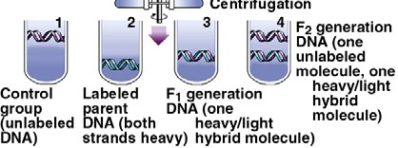

15

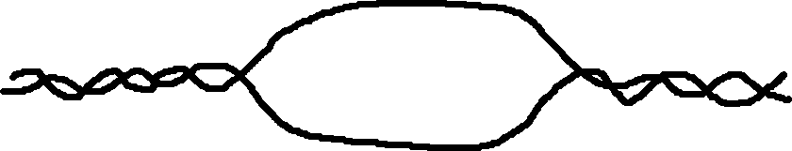

**DNA Replication**

For DNA replication to begin, the two strands of the DNA molecule must separate and unwind. This forms a replication “eye.”

Opening and unwinding is accomplished by at least 4 proteins

**Initiator proteins** recognize the replication origin

**Helicase** unwinds the strands

**Single strand binding proteins** stabilize the single stranded DNA

**Gyrase** (topoisomerase) relieves torque by cutting and resplicing 16

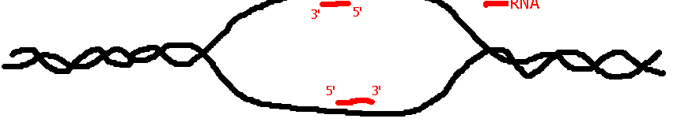

The primary enzyme for DNA synthesis is DNA polymerase III To accomplish DNA synthesis, DNA polymerase III requires

A single stranded **DNA template**

**Triphosphate nucleotides** (ATP, TTP, CTP, GTP)

A nucleotide with a **3’-OH** where DNA synthesis is to begin

DNA polymerase can’t synthesize new DNA from a naked DNA strand. A **primer** must be in place for it to begin. The primer is an RNA sequence that is synthesized by **Primase** (RNA polymerase).

17

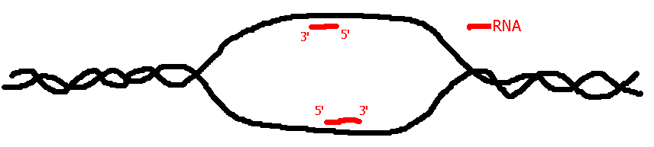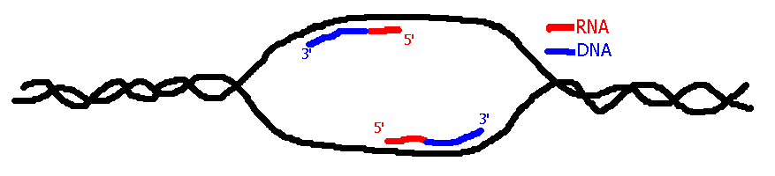

Primase recognizes the replication origin and synthesizes a **primer** - a short strand of RNA, using the DNA as a template. The primer provides a 3’-OH for DNA polymerase III to use to begin DNA synthesis.

18

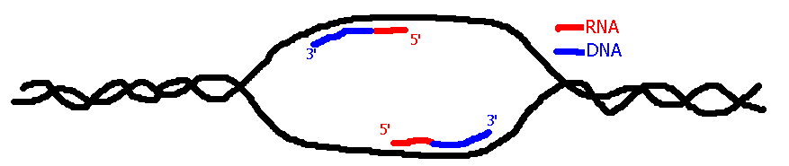

DNA polymerase III can only synthesize DNA in a 5’ to 3’ direction. It continously works off the 3’ end that it leaves for itself as it adds new nucleotides.

How does replication happen on the other side of the “eye?”

19

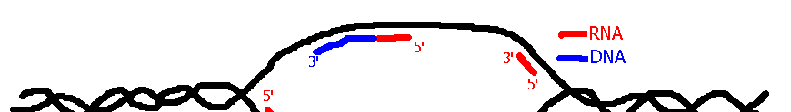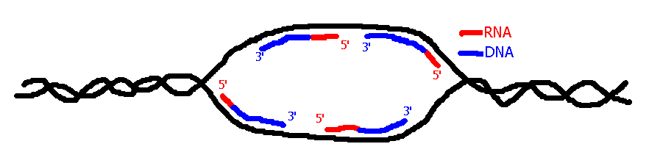

As the DNA unwinds, new primer initiation points are exposed. Primase synthesizes new primers as these points are exposed.

The new primers provide new points for DNA polymerase III to begin DNA synthesis.

20

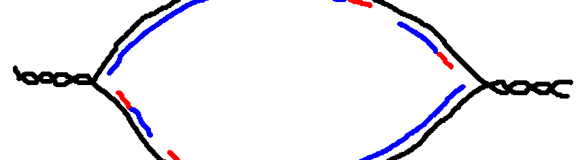

The DNA strand continues to unwind. DNA polymerase III continues synthesis off the original primer toward both **replication forks**.

New primer sites are exposed and primers are synthesized.

21



22

DNA synthesis is “**semi-discontinuous**.”

discontinuous

continuous

discontinuous

continuous

DNA synthesis goes on continuously on one side of the replication fork and discontinuously on the other side.

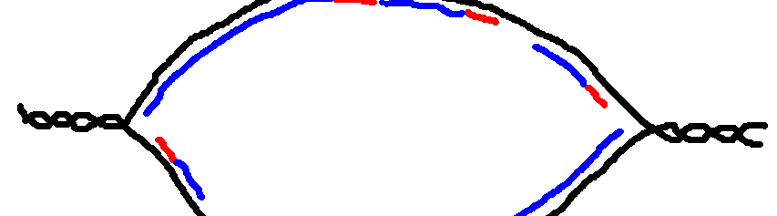

23

strand are called “**Okazaki fragments**.”

The small segments of DNA that are synthesized on the lagging

discontinuous

continuous

Okazaki fragments

lagging

leading

discontinuous

continuous

The side of the DNA strand that is synthesized continuously is called the “**leading strand**.” The discontinuous side is called the “**lagging strand**.”



24

DNA polymerase III stops synthesis and leaves.

discontinuous

continuous

discontinuous

continuous

DNA polymerase III continues DNA synthesis on the lagging strand until it encounters the 5’ end of an RNA primer.

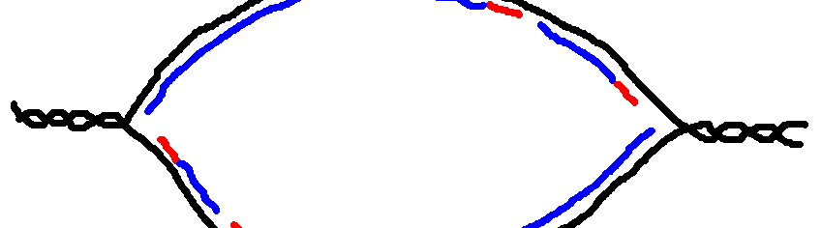

Another DNA polymerase, **DNA polymerase I**, removes the RNA primer from the 5’ end and fills in new DNA at the 3’ end of the DNA molecule.

25

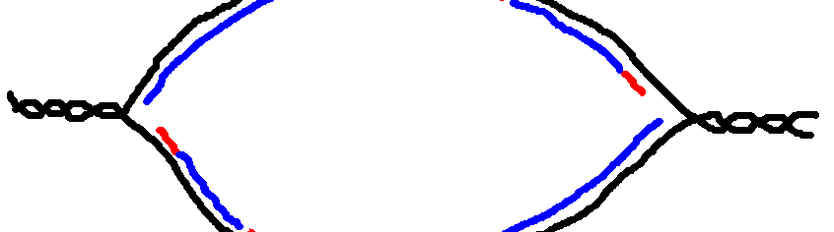

When DNA polymerase I is finished removing the RNA primer and replacing it with DNA, a gap remains in the DNA.

26

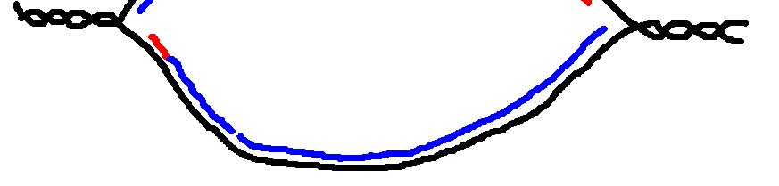

Another enzyme, **DNA ligase**, joins the pieces of DNA together.

The DNA continues to unwind, continuous DNA synthesis proceeds on the leading strand, new primers are laid down for new Okazaki fragments on the lagging strand, DNA polymerase III works off the primers for discontinuous synthesis, DNA polymerase I removes primers, and ligase fills the gaps as needed.

27

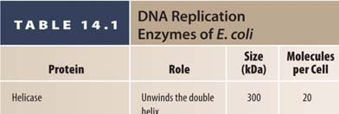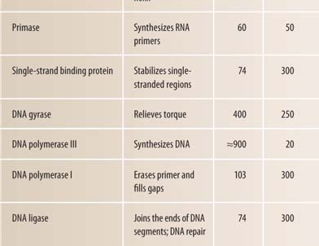

28

29

29

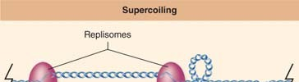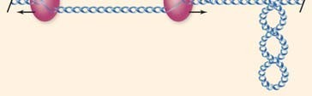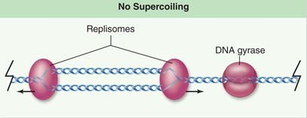

Without DNA Gyrase

With DNA Gyrase

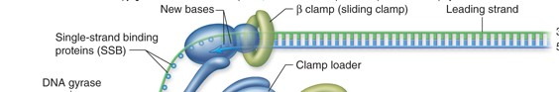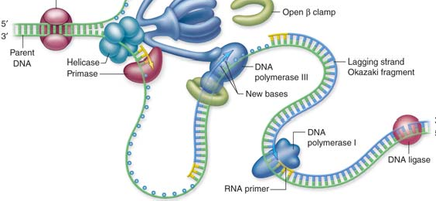

DNA Replication Complex at one replication fork

30

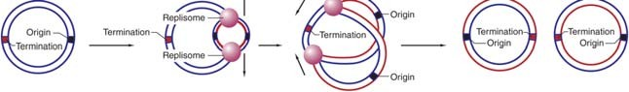

In prokaryotes, there is a single origin of replication for the entire DNA molecule.

Replication proceeds from the origin all the way around the molecule semidiscontinuously.

31

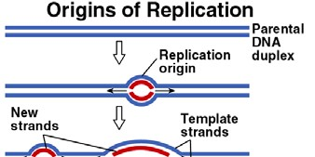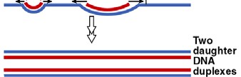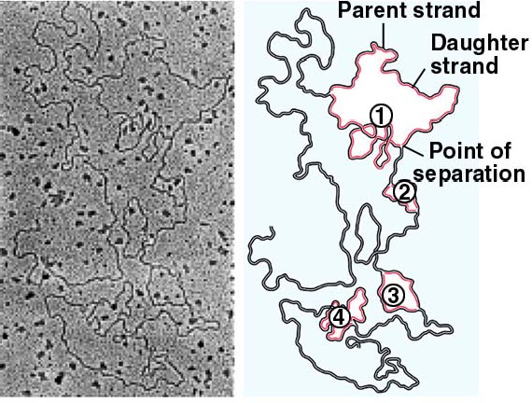

Eukaryotic chromosomes have multiple origins of replication. When DNA synthesis from different origins meet, they are united using the same processes that unite Okazaki fragments.

32

Reference: <https://www.nicholls.edu/biol-ds/biol155/Lectures/DNA.pdf>