HEAT TRANSFER COEFFICIENT

- Convection Heat Transfer Coefficient
If we suspend a flat plate in a uniform stream of velocity v, and temperature T, as shown in Figure 1, and if the temperature at the surface of the plate is kept constant at Tw, the total rate of heat transfer from the plate to the flowing stream can be calculated by integrating the total energy flux at the wall over the surface area.
The total energy flux at the wall is:
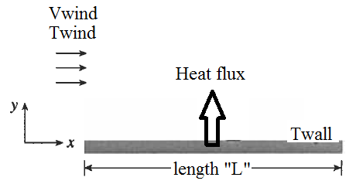
Figure 1. Wind flow over a flat plate at Twall
The flux expression can be expressed by usig the following equation, consists of molecular and convective flux terms.
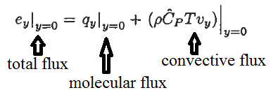
where the convective energy flux at the wall is equal to since Vy is equal to zero. This condition is known as no slip boundary condition. Hence, total flux is equal to molecular flux, only. The total heat transfer can be calculated by integrating the molecular energy flux at the wall over the surface area.
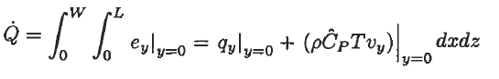
Evaluation of the expresion requires the determination of the temperature profile at the interface of the Wall. The temperature profile is not easy to be determined. Hence, the molecular flux at the interface can be expressed in terms of the convection heat transfer weficient, h, by using the following expression, kown as Newton's law of cooling.
Where “h” is the heat transfer coefficient, in units of W/m².K. The heat transfer coefficient depends on the fluid flow mechanism and te following fluid properties:
- Density
- Viscosity
- Thermal conductivity
- Heat capacity
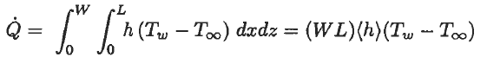
where (h) is the average heat transfer coefficient and WL is the heat transfer area.

- Physical interpretation of heat transfer coefficient
The Fourier's law of heat conduction, which is the molecular energy flux at the Wall, is expressed as following:
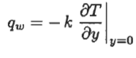
If we equate the Newton’s law of cooling to the given expression above:
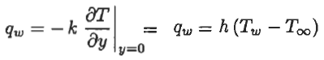
The heat transfer coefficient can be expressed as given below:
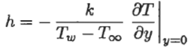
The heat transfer coefficient can be ontained if the temperature profile at the wall inteface is known. Since the temperature profile at the wall interface is not easy to be determined, the actual temperature profile is idealized as shown in Figure 2.
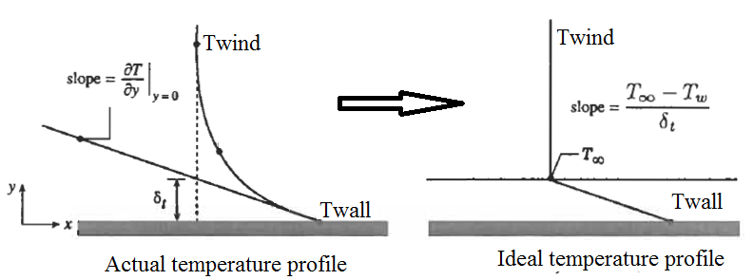
Figure 2. The film model for actual ad ideal energy transfer from the Wall surface

The entire heat resistance from the Wall to the air is assumed to be due to a thin stagnant film
in the fluid next to the Wall surface. The thickness of the thin film provides the same resistance to heat transfer as the resistance that exists for the actual condition.

Then the convective heat transfer coefficient can be expressed as a fuction the film thickness and the thermal conductivity:
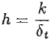
Equation given above indicates that the thickness of the stagnant film determines the value of the convective heat transfer coefficient “h”. That is why the term “h” is frequently referred to as the film heat transfer coefficient.

References:
İ. Tosun, “MODELLING IN TRANSPORT PHENOMENA A Conceptual Approach”, Elsevier, 2002.

