MATHEMATICAL FORMULATION OF THE BASIC IDEAS AND CONCEPTS

- Inlet and Outlet Terms
A quantity may enter / leave a system by two means:
- by inlet and/or outlet streams,
- by exchange of a specific quantity between the system and its surrounding through the system boundaries
In either case, the rate of input and/or output of a quantity is described using the flux of this particular quantity. The flux of a quantity might be either constant or dependent on position.
Thus, the rate of a quantity can be determined as given below:
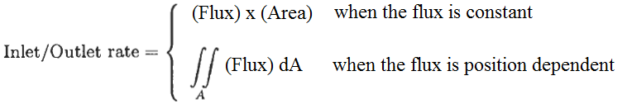
At which A is the area perpendicular to the direction of the flux.

- Rate of Generation/Depletion Term
The generation rate or depletion rate per unit volume is denoted by “R” and it may be either constant or dependent on position. Thus, the generation rate or depletion rate is described as given below:
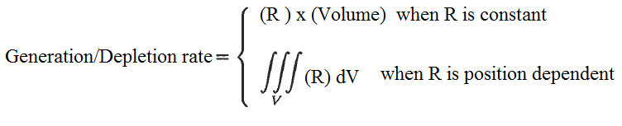
At which V is the volume of the system. In the case of depletion, the plus sign in front of the generation term must be replaced by the minus sign.

- Rate of Accumulation Term
The rate of accumulation of any quantity “ϴ” is the time rate of change of that particular quantity within the volume of the system. The total quantity of “ϴ” can be expressed as given below:
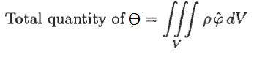
At which “ρ” is the density and “φ” is the quantity per unit mass. The rate of accumulation can be expressed by:
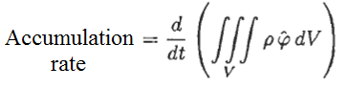
If term “φ” is independent of position, then the given equation can be simplified to the following equation:
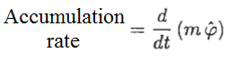
At which the term “m” is total mass within the system.

- Steady-State Transport Without Generation
For this condition, the general equation reduces to the fllowing relation:
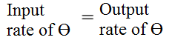
The given relation can also be expressed in terms of flux as given below:
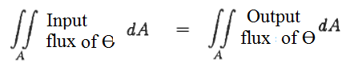
If the inlet / outlet flux terms are constant, then the given relation reduces to the following form:
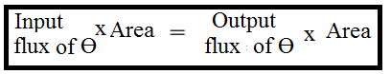
If the inlet / outlet flux areas are equal, then the given relation reduces to the following form:
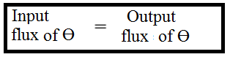
- Steady-State Transport With Generation
For this condition, the general equation reduces to the fllowing relation:
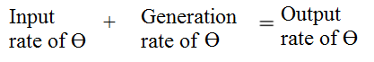
The given relation can also be expressed in terms of flux as given below:
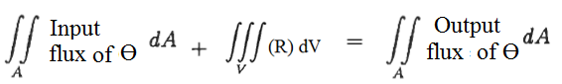
At which R is generation of depletion per unit volüme. If the inlet / outlet flux terms are constant and R is constant, then the given relation reduces to the following form:
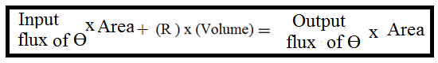

Example: An exothermic chemical reaction takes place in a 100 cm thick slab and the energy depletion rate per unit volume is 1 x l0⁶ W/m³. The steady-state heat transfer rate into the slab at the right-hand side of the slab is equal to 300 W. Calculate the heat transfer rate to the surroundings from the left-hand side of the slab. The surface area of each face is 1 cm².

Solution: At steady-state, the accumulation rate of energy is equal to zero and we can use the folowing form of the equation “conservation of energy”
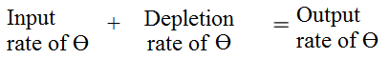
V_{slab} = 1 m x 1 x 10⁻⁴ = 1 x 10⁻⁴ m³

Output rate of heat transfer = 300 W - (1 x l0⁶ W/m³) x (1 x 10⁻⁴ m³) = 200 W

The depletion rate of heat transfer was subtracted from the inlet heat transfer rate since there is no generation term.

References:
İ. Tosun, “MODELLING IN TRANSPORT PHENOMENA A Conceptual Approach”, Elsevier, 2002.

