Continuous-Flow Reactors
Continuous flow reactors operate at steady state conditions. There are three types continuous reactors:
- the continuous stirred tank reactor (CSTR),
- the plug flow reactor (PFR),
- the packed bed reactor (PBR)
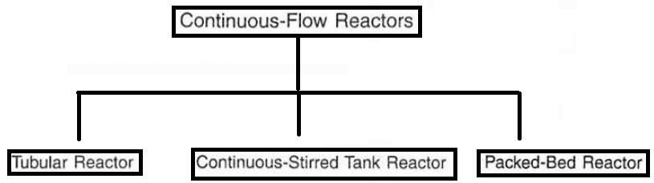

Continuous-Stirred Tank Reactor
It is assumed to be perfectly mixed, which means that there is no time dependence or position dependence of the temperature. The concentration is the same at every point inside the reactor. In addition, the reaction is the same at every point inside the reactor at any time. The temperature and concentration are assumed to be the same as in the exit stream. There should be efficient mixing, provided with a stirrer.
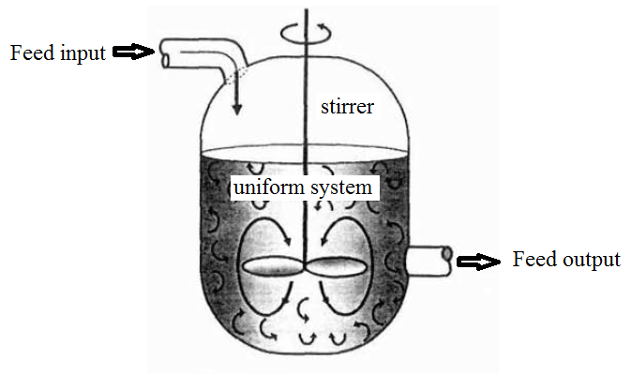
Figure 2. Configuration the Continuous-Stirred Tank Reactor

The general mole balance can be modified for continuous-stirred tank reactor as shown below:
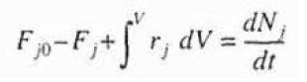
As stated before continuous flow reactors operate at steady state conditions, which means that the stated condition does not change with time.
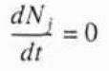
If there is no spatial variations in the rate of reaction, which means that there is perfect mixing condition
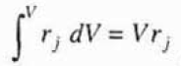
If we insert the given form of the eqution into the general mole balance equation, we will obtain the design equation for the continuous-stirred tank reactor (CSTR) as shown below:
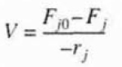
The molar flow rate can be written as the product of the concentration of any kinds of species j and the volumetric flow rate as illustrated below:
Tubular Reactors
Besides to the CSTR and batch reactors, another kind of reactors commonly used in industry is the tubular reactor. In this type of the reactor, the reactants are continually consumed as they pass through the reactor. As an assumption, the concentration varies only in the axial direction not in the radial direction. Hence, the reaction rate varies also axially. In addition, the flow field within the reactor was assumed to adjust the flug-flow model. Hence, this type of the reactor is also known as the plug-flow reactor (PFR).
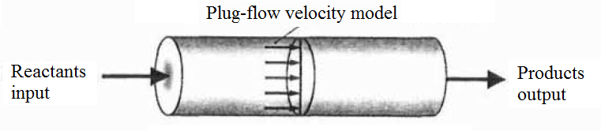
Figure 3. Configuration of the plug-flow reactor
The general mole balance can be modified for the plug-flow reactor (PFR) as shown below:
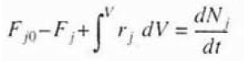
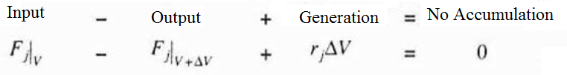
If we divide the general mole balance equation for a specific volume by ΔV and if we arrange the given equation:
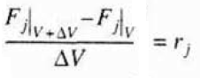
If we take the limit as ΔV goes to zero, the given equation can be arranged into the following form:
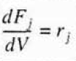
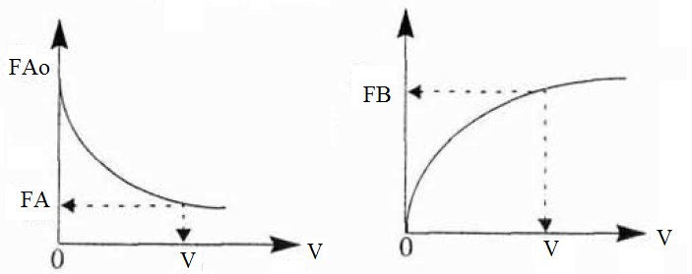
For a given reaction (A → B). As the reactants goes down through the reactor. A is consumed by the given chemical reaction and B, which is the product, is produced. Thus, the molar rate of A decreases and the molar rate of B increases.

References:
- H. Scott Fogler, “Elements of Chemical Reaction Engineering”, Prentice Hall Professional Technical Reference, Fourth Edition.

