STOICHIOMETRY
In order to calculate the concentration and the reaction rate law as a function of conversion for the following expression:
For the batch reactors, the reactor is opened at the start of the reaction and the reactants A, B and C are placed into the reactor. The number of moles of A remaining in the reactor after a conversion X has been achieved is:
In order to determine the number of moles of reactant B remaining at time t, for every mole of A that consumed, b/a moles of B must consumed; therefore, the number of moles of B that consumed is:
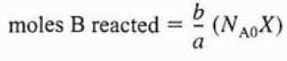
The number of moles of B remaining in the system at time t can be expressed as show below:
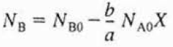
The expression in parentheses (c/a – b/a - 1) represent the increase in the total number of moles per mole of A reacted. This expression is shown with the symbol “δ”:
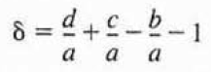
The total number of moles can now be calculated by using the given notation “δ” with the following equation:
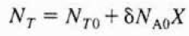
In order to calculate the reaction rate as a function of conversion X, the concentrations of the reacting species need to be known as a function of conversion. The concentration of the reactants, A, B and C, are the number of moles of the reactants per unit volume as shown below:
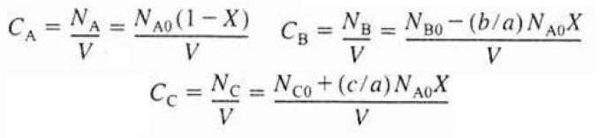
The concentration expressions for B and C can be simplified by defining a new parameter as shown below:
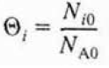
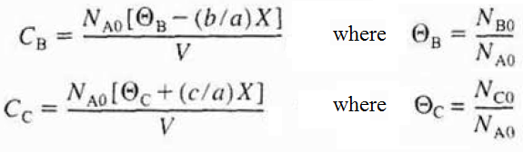
For the constant-volume systems (V=Vo), the concentration expressions for A, B and C can be rearranged as shown below:
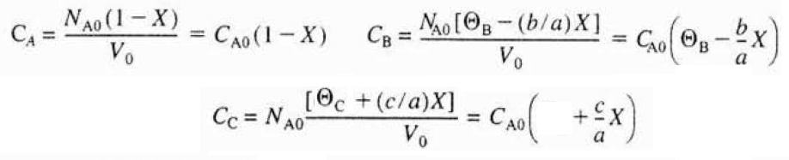
Table 1. Stoichiometry Table for the batch reaction system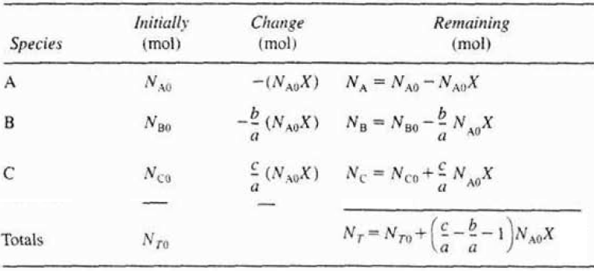
The stoichiometric table for a continuous-flow system of the following reaction expression can prepared as shown below:
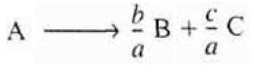
Table 2. Stoichiometry Table for a flow reaction system
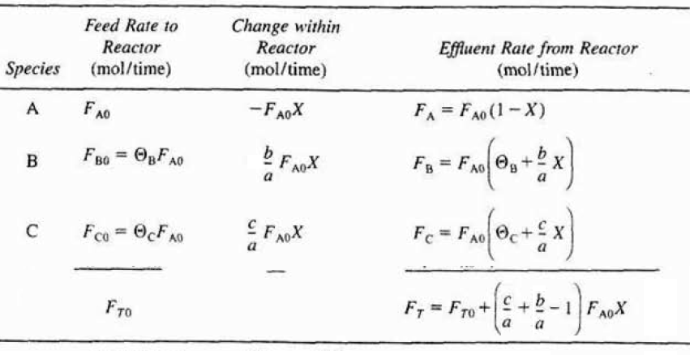
For a flow system, the concentrations C_{A}, C_{B} and C_{C}, at a given point can be determined from the molar flow rate F_{A}, F_{B} and F_{C} and the volumetric flow rate v at that point. In order to calculate the concentration as a function of conversion X:
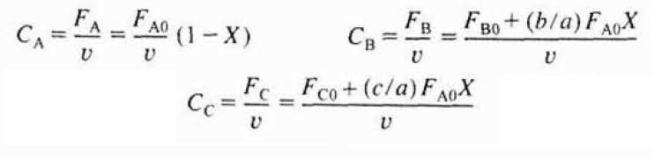
For liquid phase reactions, the volume change with reaction is negligible when no phase variation takes place.
References:
- H. Scott Fogler, “Elements of Chemical Reaction Engineering”, Prentice Hall Professional Technical Reference, Fourth Edition.

