Faktör Analizi

Faktör analizi için yapılması gereken işlemler

- Analyze > Dimension reduction > Factor
- İncelenecek tüm değişkenler Variables kutusuna taşınmalı.
- Desriptives butonuna tıklayın.
- Statistics bölümünde Initial Solutions’ın tıklandığından emin olun.
- Correlatoin Matrix olarak ifade edilen bölümde Coefficients ve KMO and Bartlett’s test of sphericity’I seçin.
- Extraction butonuna basin.
- Display bölümünde Screeplot’I seçin.
- Extract bölümünde Based on Eigenvalue’u seçin. Faktörleştirme için sabit birsayıyı tercih edecekseniz Fixed number of factors’I seçerek istediğiniz değeri girin.
- Rotation’a tıklayın ve Direct Oblimin’I seçin.
- Continue > OK

Verilerin Yorumlanması

- Betimsel istatistik tablosu örneklem büyüklüğü, minimum ve maksimum değerler, ortalama ve standart sapma hakkında bilgiler içerir.

Descriptive Statistics
 | N | Minimum | Maximum | Mean | Std. Deviation
Justifiable: Claiming government benefits to which you are not entitled | 82711 | 1 | 10 | 2.80 | 2.536
Justifiable: Avoiding a fare on public transport | 83375 | 1 | 10 | 2.65 | 2.392
Justifiable: Stealing property | 83763 | 1 | 10 | 1.80 | 1.769
Justifiable: Cheating on taxes if you have a chance | 78750 | 1 | 10 | 2.26 | 2.131
Justifiable: Someone accepting a bribe in the course of their duties | 83456 | 1 | 10 | 1.95 | 1.880
Justifiable: Homosexuality | 78241 | 1 | 10 | 3.35 | 3.052
Justifiable: Prostitution | 59073 | 1 | 10 | 2.85 | 2.524
Justifiable: Abortion | 80687 | 1 | 10 | 3.29 | 2.771
Justifiable: Divorce | 82514 | 1 | 10 | 4.63 | 3.079
Justifiable: Sex before marriage | 71790 | 1 | 10 | 4.69 | 3.349
Justifiable: Suicide | 82492 | 1 | 10 | 2.30 | 2.252
Justifiable: Euthanasia | 40904 | 1 | 10 | 3.37 | 2.988
Justifiable: For a man to beat his wife | 83683 | 1 | 10 | 2.08 | 2.032
Justifiable: Parents beating children | 83688 | 1 | 10 | 2.91 | 2.575
Justifiable: Violence against other people | 83652 | 1 | 10 | 1.99 | 1.912
Valid N (listwise) | 28759

2) Veri setinin faktörleştirilebilir olup olmadığının belirlenebilmesi için Kaiser-Meyer-Olkin ölçütünün (KMO) 0.6 ya da daha fazla olması beklenir. Bartlett testinin de 0.05 düzeyinde anlamlılığa sahip olması kontrol edilmelidir.

KMO and Bartlett's Test
Kaiser-Meyer-Olkin Measure of Sampling Adequacy. |  | .908
Bartlett's Test of Sphericity | Approx. Chi-Square | 223306.332
 | df | 105
 | Sig. | .000

- İkinci adımda, kaç faktörün olluştuğunun tespiti için, Total Variance Explained sütunundaki özdeğerlerin kaç tanesinin 1 ya da daha fazla olduğuna bakılmalıdır. Aynı tabloda, bu faktör sayısıyla toplam varyansın ne kadarının açıklanabildiği de görülür.

Total Variance Explained
Component | Initial Eigenvalues |  |  | Extraction Sums of Squared Loadings
 | Total | % of Variance | Cumulative % | Total | % of Variance | Cumulative %
1 | 5.806 | 38.709 | 38.709 | 5.806 | 38.709 | 38.709
2 | 2.702 | 18.012 | 56.721 | 2.702 | 18.012 | 56.721
3 | 1.206 | 8.043 | 64.764 | 1.206 | 8.043 | 64.764
4 | .732 | 4.879 | 69.643
5 | .637 | 4.247 | 73.890
6 | .529 | 3.527 | 77.417
7 | .466 | 3.108 | 80.525
8 | .459 | 3.063 | 83.588
9 | .419 | 2.794 | 86.382
10 | .404 | 2.691 | 89.073
11 | .377 | 2.512 | 91.585
12 | .338 | 2.254 | 93.840
13 | .315 | 2.100 | 95.940
14 | .313 | 2.085 | 98.025
15 | .296 | 1.975 | 100.000
Extraction Method: Principal Component Analysis.

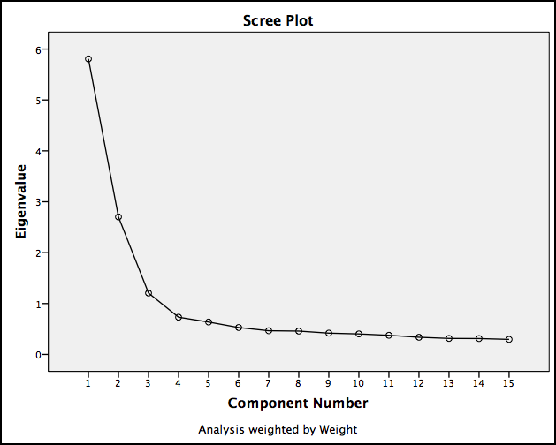

- Üçüncü adımda da, Pattern Matrix’te görülen değişkenlerin hangi faktör içerisine yerleştiği incelenir. Birden fazla faktöre yüklenen değişkenler söz konusuysa, yük miktarının 0.3’ten fazla olduğu değişkenler tercih edilebilir. Her bir bileşenin üç ya da daha fazla değişken tarafından yüklenmiş olmasına dikkat edilmelidir.

Component Matrixª
 | Component
 | 1 | 2 | 3
Justifiable: Suicide | .715
Justifiable: Prostitution | .713 | -.304
Justifiable: Someone accepting a bribe in the course of their duties | .694 | .409
Justifiable: Stealing property | .686 | .432
Justifiable: Violence against other people | .682 | .369
Justifiable: Cheating on taxes if you have a chance | .664 | .375
Justifiable: Abortion | .663 | -.486
Justifiable: Euthanasia | .647 | -.383
Justifiable: Homosexuality | .611 | -.543
Justifiable: For a man to beat his wife | .603 | .440 | .432
Justifiable: Avoiding a fare on public transport | .568 | .322 | -.456
Justifiable: Claiming government benefits to which you are not entitled | .471 | .355 | -.464
Justifiable: Sex before marriage | .556 | -.605
Justifiable: Divorce | .552 | -.583
Justifiable: Parents beating children | .418 | .397 | .592
Extraction Method: Principal Component Analysis.
a. 3 components extracted.

Pattern Matrixª
 | Component
 | 1 | 2 | 3
Justifiable: Avoiding a fare on public transport | .826
Justifiable: Claiming government benefits to which you are not entitled | .809
Justifiable: Cheating on taxes if you have a chance | .708
Justifiable: Stealing property | .684
Justifiable: Someone accepting a bribe in the course of their duties | .650
Justifiable: Sex before marriage |  | -.851
Justifiable: Divorce |  | -.834
Justifiable: Homosexuality |  | -.828
Justifiable: Abortion |  | -.817
Justifiable: Euthanasia |  | -.725
Justifiable: Prostitution |  | -.687
Justifiable: Suicide |  | -.540 | .335
Justifiable: Parents beating children |  |  | .875
Justifiable: For a man to beat his wife |  |  | .800
Justifiable: Violence against other people |  |  | .664
Extraction Method: Principal Component Analysis.
Rotation Method: Oblimin with Kaiser Normalization.
a. Rotation converged in 8 iterations.

ÖRNEK 2

Descriptive Statistics
 | N | Minimum | Maximum | Mean | Std. Deviation
Confidence: The Churches | 82229 | 1 | 4 | 2.16 | 1.017
Confidence: The armed forces | 79760 | 1 | 4 | 2.17 | .918
Confidence: The press | 82681 | 1 | 4 | 2.61 | .867
Confidence: Television | 83379 | 1 | 4 | 2.50 | .877
Confidence: Labour Unions | 73565 | 1 | 4 | 2.72 | .891
Confidence: The police | 83234 | 1 | 4 | 2.38 | .937
Confidence: The courts | 82098 | 1 | 4 | 2.41 | .940
Confidence: The government (in your nation’s capital) | 82355 | 1 | 4 | 2.56 | .956
Confidence: Political Parties | 77983 | 1 | 4 | 2.92 | .883
Confidence: Parliament | 81167 | 1 | 4 | 2.72 | .937
Confidence: The Civil service | 80140 | 1 | 4 | 2.57 | .890
Confidence: Universities | 80440 | 1 | 4 | 2.14 | .853
Confidence: Major Companies | 79470 | 1 | 4 | 2.49 | .871
Confidence: Banks | 81455 | 1 | 4 | 2.42 | .928
Confidence: Environmental organizations | 78383 | 1 | 4 | 2.38 | .876
Confidence: Women's organizations | 76570 | 1 | 4 | 2.39 | .896
Confidence: Charitable or humanitarian organizations | 79044 | 1 | 4 | 2.32 | .892
Confidence: The European Union | 15126 | 1 | 4 | 2.68 | .814
Valid N (listwise) | 11721

KMO and Bartlett's Test
Kaiser-Meyer-Olkin Measure of Sampling Adequacy. |  | .926
Bartlett's Test of Sphericity | Approx. Chi-Square | 108866.770
 | df | 153
 | Sig. | .000

Total Variance Explained
Component | Initial Eigenvalues |  |  | Extraction Sums of Squared Loadings
 | Total | % of Variance | Cumulative % | Total | % of Variance | Cumulative %
1 | 7.251 | 40.282 | 40.282 | 7.251 | 40.282 | 40.282
2 | 1.582 | 8.789 | 49.071 | 1.582 | 8.789 | 49.071
3 | 1.086 | 6.031 | 55.102 | 1.086 | 6.031 | 55.102
4 | .999 | 5.549 | 60.650
5 | .888 | 4.932 | 65.583
6 | .854 | 4.742 | 70.325
7 | .726 | 4.032 | 74.356
8 | .607 | 3.374 | 77.731
9 | .583 | 3.237 | 80.968
10 | .558 | 3.098 | 84.066
11 | .459 | 2.551 | 86.617
12 | .419 | 2.326 | 88.943
13 | .399 | 2.216 | 91.159
14 | .355 | 1.972 | 93.131
15 | .331 | 1.840 | 94.971
16 | .330 | 1.833 | 96.804
17 | .299 | 1.661 | 98.464
18 | .276 | 1.536 | 100.000
Extraction Method: Principal Component Analysis.

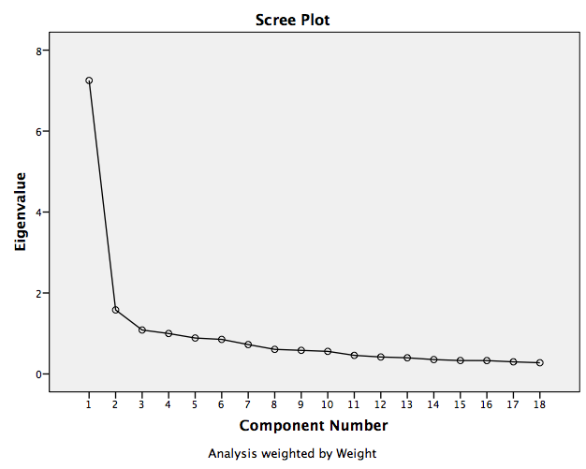

Rotated Component Matrixª
 | Component
 | 1 | 2 | 3
Confidence: The Churches |  |  | .562
Confidence: The armed forces | .345 |  | .526
Confidence: The press | .312 |  | .740
Confidence: Television | .303 |  | .747
Confidence: Labour Unions | .424 |  | .430
Confidence: The police | .614 |  | .301
Confidence: The courts | .676
Confidence: The government (in your nation’s capital) | .778
Confidence: Political Parties | .758
Confidence: Parliament | .800
Confidence: The Civil service | .638 | .371
Confidence: Universities |  | .586
Confidence: Major Companies |  | .576
Confidence: Banks |  | .534
Confidence: Environmental organizations |  | .787
Confidence: Women's organizations |  | .784
Confidence: Charitable or humanitarian organizations |  | .771
Confidence: The European Union |  | .501
Extraction Method: Principal Component Analysis.
Rotation Method: Varimax with Kaiser Normalization.
a. Rotation converged in 5 iterations.

Pattern Matrixª
 | Component
 | 1 | 2 | 3
Confidence: The Churches |  |  | .603
Confidence: The armed forces |  |  | .501
Confidence: The press |  |  | .750
Confidence: Television |  |  | .764
Confidence: Labour Unions | .330 |  | .355
Confidence: The police | .601
Confidence: The courts | .670
Confidence: The government (in your nation’s capital) | .812
Confidence: Political Parties | .798
Confidence: Parliament | .831
Confidence: The Civil service | .606
Confidence: Universities |  | .572
Confidence: Major Companies |  | .544
Confidence: Banks |  | .495
Confidence: Environmental organizations |  | .842
Confidence: Women's organizations |  | .845
Confidence: Charitable or humanitarian organizations |  | .834
Confidence: The European Union |  | .497
Extraction Method: Principal Component Analysis.
Rotation Method: Oblimin with Kaiser Normalization.
a. Rotation converged in 6 iterations.

