Microscopy
(Adapted from http://www.biologycorner.com/)

Introduction
A microscope is an instrument that magnifies an object so that it may be seen by the observer. Because cells are usually too small to see with the naked eye, a microscope is an essential tool in the field of biology. In addition to magnification, microscopes also provide resolution, which is the ability to distinguish two nearby objects as separate. A combination of magnification and resolution is necessary to clearly view specimens under the microscope. The light microscope bends a beam of light at the specimen using a series of lenses to provide a clear image of the specimen to the observer.
In this lab, parts of the microscope will be reviewed. Students will learn proper use and care of the microscope and observe samples from pond water.

Parts of the microscope

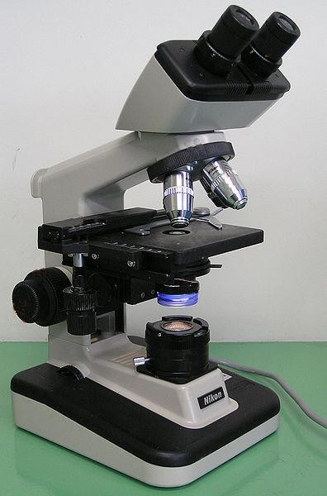Nose piece Objectives

Course focus knob Fine focus knob

Ocular

Mechanical Stage

Iris Diaphragm

Condenser

Illuminator

Magnification

Your microscope has 4 objective lenses: Scanning (4x), Low (10x), High (40x), and Oil Immersion (100x). In this lab you will not use the oil immersion lens; it is for viewing microorganisms and requires technical instructions not covered in this procedure.

In addition to the objective lenses, the ocular lens (eyepiece) has a magnification. The total magnification is determined by multiplying the magnification of the ocular and objective lenses.

 | Magnification | Ocular lens | Total Magnification
Scanning | 4x | 10x | 40x
Low Power | 10x | 10x | 100x
High Power | 40x | 10x | 400x
Oil Immersion | 100x | 10x | 1000x

General Procedures
- Make sure all backpacks, purses, etc. are off the benchtop.
- Carry microscope by the base and arm with both hands.
- Store with cord wrapped around microscope and the scanning objective clicked into place.

Focusing Specimens
- Plug your microscope in to power supply and switch on illuminator.
- Always start with the stage as low as possible and using scanning objective (4x). Odds are, you will be able to see something on this setting (sometimes it’s only a color). Use the coarse knob to focus: the image may be small at this magnification, but you won't be able to find it on the higher powers without this first step. Move the mechanical stage until your focused image is also centered.
- Once you've focused using the scanning objective, switch to the low power objective (10x). Use the coarse knob to refocus and move the mechanical stage to re-center your image. Again, if you haven't focused on this level, you will not be able to move to the next level.
- Now switch to the high power objective (40x). At this point, ONLY use the fine adjustment knob to focus specimens.
- If the specimen is too light or too dark, try adjusting the diaphragm.

Cleanup
- Store microscope with the scanning objective in place and the stage in its lowest position.
- Wrap cords around microscope.
- Replace slides to original slide tray.

Troubleshooting
Occasionally you may have trouble with working your microscope. Here are some common problems and solutions.
- Image is too dark!
  - Adjust the diaphragm, make sure your light is on.
- There's a spot in my viewing field- even when I move the slide the spot stays in the same place!
  - Your lens is dirty. Use lens paper, and only lens paper to carefully clean the objective and ocular lens. The ocular lens can be removed to clean the inside.
- I can't see anything under high power!
  - Remember the steps, if you can't focus under scanning and then low power, you won't be able to focus anything under high power.
- Only half of my viewing field is lit, it looks like there's a half-moon in there!
  - You probably don't have your objective fully clicked into place.
- I see my eyelashes!
  - You’re too close to the objectives. Move your head back a little.
- This is giving me a headache!
  - Relax. Try adjusting the ocular distance, check that the intensity of your light isn’t too high or too low. Take breaks if needed!

BE PATIENT AND KEEP TRYING. USING A MICROSCOPE TAKES PRACTICE!!

Part 1: Orientation of Images in the Microscope

A large part of the learning process of microscopy is getting used to the orientation of images viewed through the oculars as opposed to with the naked eye. A common mistake is moving the mechanical stage the wrong way to find the specimen. This procedure is merely practice designed to make new users more comfortable with using the microscope.

Materials
  - Compound microscope
  - Microscope slide with the letter “e”

Procedure
- Place the letter “e” slide onto the mechanical stage. Be sure to note the orientation of the letter “e” as it appears to your naked eye.

- Use the SCANNING (4x) objective and course focus adjustment to focus, then move the mechanical stage around to find the letter “e”. Note the orientation when viewed through the oculars.

Does the lens of the microscope reverse the image? Does it flip the image? (upside down)

Part 2: Practice with Depth of Field in the Microscope

This portion of the procedure is another practice to demonstrate depth perception. Many new microscope users find it difficult to conceive that the specimen on the slide is in three dimensions. As the stage is moved up and down, different threads will be in focus.

Materials
  - Compound microscope
  - Microscope slide with 3 threads

Procedure
- Place the thread slide onto the mechanical stage.

- Use the SCANNING (4x) objective and course focus adjustment to focus, then move the mechanical stage around to find the threads.

- If needed, switch to the low power (10x) objective and refocus.

- Determine which thread is on the bottom, middle, and top of the slide.

TOP | MIDDLE | BOTTOM

Part 3: Investigation of Pond Water & Microorganisms

Materials
  - Compound microscope
  - Microscope slide
  - Coverslip
  - Transfer pipette
  - Pond water sample

Procedure
- Using the transfer pipette, transfer a drop of pond water onto a microscope slide. The best specimens usually come from the bottom and probably will contain chunks of algae or other debris that you can see with your naked eye.

- Place coverslip onto the slide.

- Use the SCANNING (4x) objective to focus, then move the mechanical stage around to scan the slide for live microorganisms. You are looking for tiny swimming beings- they may look green or clear and might be very small. Choose one to focus on and center it in your visual field.

You may wish to use the ProtoSlo to keep your organisms from swimming to quickly!

- Switch to low power (10x). This may be sufficient to view your chosen organism. Try to note how it moves and do your best to draw it as you see it, unless you need more magnification.

- Once you have centered and focused the image, switch to high power (40x) and refocus. Note movements and draw the organism as you see it.

Remember, do NOT use the coarse adjustment knob at this point!

Pond water organism 1 Pond water organism 2

Questions:
- Why is it important to begin focusing with the scanning objective?

- If you’re using the 40X objective and you know your ocular is 10X, what is the total magnification?

- If you bump your microscope and lose focus, what do you do to refocus your specimen?

- Why must you center your image before switching to a higher objective

