Cell Respiration and Photosynthesis

Part 1: Photosynthesis and Floating Leaf Disks

(Adapted from Biology Corner)

Introduction

Photosynthesis fuels ecosystems and replenishes the Earth's atmosphere with oxygen. Like all enzyme- driven reactions, the rate of photosynthesis can be measured by either the disappearance of substrate, or the accumulation of products. The equation for photosynthesis is:

6CO2 + 6H2O ------light > C6H12O6 + 6O2 + H20

In this investigation, you will use a system that measures the accumulation of oxygen in the leaf. Consider the anatomy of the leaf as shown below.
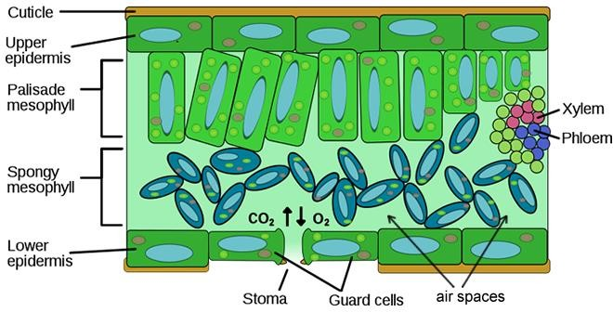

The leaf is composed of layers of cells. The spongy mesophyll layer is normally infused with gases (oxygen and carbon dioxide). Leaves will normally float in water because of these gases. If you draw the gases out from the spaces, then the leaves will sink because they become denser than water. If this leaf disk is placed in a solution with an alternate source of carbon dioxide in the form of bicarbonate ions, then photosynthesis can occur in a sunken leaf disk. As photosynthesis proceeds, oxygen accumulates in the air spaces of the spongy mesophyll and the leaf becomes buoyant and floats. Oxygen and carbon dioxide are exchanged through openings in the leaf called stoma.
While this is going on, the leaf is also carrying out cellular respiration. This respiration will consume the oxygen that has accumulated and possibly cause the plant disks to sink. The measurement tool that can be used to observe these counteracting processes is the floating (or sinking) of the plant disks. In other words, the buoyancy of the leaf disks is actually an indirect measurement of the net rate of photosynthesis occurring in the leaf tissue.

Materials:
  - Syringe
  - Desk lamp
  - Hole punch
  - Petri dishes (4 per group)
  - Detergent and baking soda solution
  - Detergent solution
  - Fresh spinach leaves
  - Forceps

Procedure:
- Test the syringes by sealing the tip and pulling back on the plunger. When released, the plunger should snap back, indicating a good vacuum. Remove the plunger from a syringe.
- Use a hole punch to punch out 40 disks from the leaves. The disks should be as uniform in size and mass as possible. Avoid the larger veins of the leaves. As you punch out the leaf disks, put them into the syringe. Continue until you have at least 40 disks.
- Tap the side of the syringe so that the disks are at the bottom, and then reinsert the plunger— being careful not to crush the leaf disks.
- Insert the tip of the syringe into the beaker and draw a small amount of the detergent solution into the syringe. Tap the syringe to dislodge disks that are stuck to the sides. There may be a couple of disks that you simply cannot dislodge.
- Hold the syringe vertically, with the tip pointed upwards, and push in the plunger to expel the trapped air.
- Close the tip of the syringe with your finger and pull on the plunger to create a vacuum. The vacuum removes gas from the leaf tissues. Hold the plunger in place for 10 seconds and release it. When you release the plunger, liquid infiltrates the tissue. Repeat this 3 times. As liquid infiltrates the leaf tissues, the density of the disks increases, and they begin to sink.
- Use tweezers to transfer 10 disks to each petri dish and add enough solution to cover the disks; set up according to the table below:

 | Dish A | Dish B | Dish C | Dish D
Solution | Baking soda | Baking soda | Baking soda | Detergent only
Placement | Directly under lamp | On benchtop | On benchtop, covered | Directly under lamp

** Make sure to fully submerge the leaf discs in solution before beginning the assay**

- Turn on the light and begin recording the time. As oxygen is produced by photosynthesis, it comes out of solution and infiltrates the leaf tissue, replacing some of the water. This decreases the density of the disks, and they begin to float.
- Record the number of floating disks in 5 minute intervals, continuing the experiment until all disks are floating. Record your data in the table on the following page.

 | Number of Disks floating
Time (min) | Dish A | Dish B | Dish C | Dish D
5
10
15
20
25
30

Analyzing Data
To make comparisons between experiments, a standard point of reference is needed. Repeated testing of this procedure has shown that the point at which 50% of the disks are floating (ET50) is a reliable and repeatable point of reference. In this case, the disks floating are counted at the end of each time interval.

Graph your data for each experimental group. Determine the ET50 for your data. Did your outcome match your expectation?
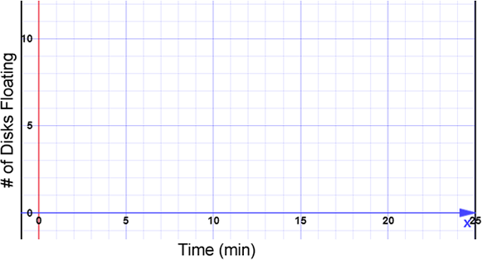

Questions:
- A mutation is capable of reducing the amount of chlorophyll in the leaf. Would this also reduce the rate of photosynthesis?

- What about a plant that exhibits variegation… Do areas of the leaf with chlorophyll outperform areas that lack chlorophyll? Could you design an experiment to test this?

- In this experiment, the amount of oxygen produced was observed to measure the rate of photosynthesis. What else could you measure to determine the rate of photosynthesis?

- List any factors that you think may affect the rate of photosynthesis. Consider environmental factors that you could manipulate during the lab.

Part 2: Chicago Cyanide Murders- A Case Study in Cellular Respiration

(Adapted from http://www.biologycorner.com/worksheets/case_study_cellular_respiration.html)

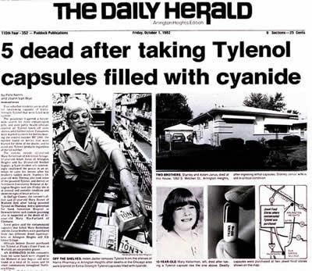
Background
In September of 1982, Mary Kellerman gave her 12 year old daughter a painkiller when she awoke during the night complaining of a sore throat. At 7 am the next morning, her daughter was found collapsed on the bathroom floor, and later pronounced dead.

Adam Janus, a postal worker in another Chicago suburb also died unexpectedly, though originally it was thought he had suffered from a heart attack. While his family gathered to mourn their loss, his brother and sister became ill and later died.

In the days that followed, three more unexplained deaths occurred in nearby Chicago suburbs. Investigators found that all of the victims had taken an extra strength tylenol hours before their death. They suspected that someone had tampered with the medication.

Symptoms exhibited by each of the victims included:
  - weakness, dizziness, sleepiness
  - flushed, bright red, skin tone
  - headache
  - shortness of breath and rapid breathing
  - vomiting
  - confusion and disorientation

- In your opinion, are the seven deaths connected? What additional information would you need to determine if they are connected?

- If poison is suspected in the deaths, how would you proceed with the investigation?

Autopsy report
The medical examiner concluded that each of the victims had died of hypoxia. Hypoxia means that the person suffered from a lack of oxygen, or they were suffocated. The reason for the hypoxia is not always clear at the first examination.
The medical examiner also showed the tissue samples from the heart, lungs, and liver showed massive cell death. On further investigation, it was shown that the tissues had major mitochondrial damage.
Even though the victims died of hypoxia, their level of oxygen in their blood was approximately 110 mm Hg. The normal range is 75-100 mm Hg.

- Recall your knowledge of the function of organelles. What function of the cells was interrupted in these patients?

- While poison is the main suspect in the case, what are other ways a person could die of hypoxia?

- Analyze the oxygen levels of the victims. Were the levels higher or lower than normal? How can you reconcile this observation with the cause of death being hypoxia?

Toxicology reports show that the victims had been poisoned with cyanide. The poison was traced back to extra strength tylenol where the murderer had opened the capsules and replaced
acetaminophen (a pain killer) with cyanide. Cyanide acts very quickly, often killing within minutes of ingestion and authorities were slow to identify the cause of the deaths. Once the cause as identified, stores removed tylenol and other drugs from shelves. While there were many suspects, no one was ever charged with the crime and it is still an ongoing investigation. Since the Chicago Tylenol murders, drug companies have drastically changed how medicines are packaged.

Why is cyanide such an effective poison? You might be surprised to learn that it directly interferes with cellular respiration that occurs in the mitochondria.

- Recall that the mitochondrion is sometimes called the "powerhouse" of the cell. What does this mean? Why is the mitochondrion important?

Why Do We Need Oxygen?
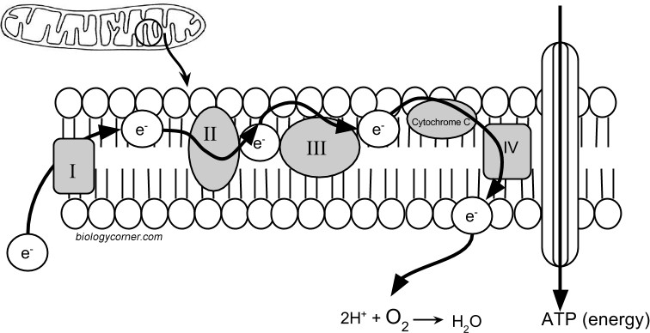
It seems like a simple question, everyone knows you need to breathe to live. Have you ever thought about why oxygen is so important? The victims of the cyanide poisoning all had high levels of oxygen in their blood, but the poison was interfering with how the cells use that oxygen. To understand, we need to take a very close look at the structure of the mitochondrion.

Inside the mitochondrion, there are several layers of membranes. In fact, these membranes resemble the membrane that surrounds the cell. It has a bilayer of phospholipids and embedded proteins. On the diagram above, the proteins are labeled I, II, III, IV, and cytochrome C.
The proteins in the membrane pass electrons from one to the other; this is known as the electron transport chain. The passing of these electrons allows ATP (adenosine triphosphate) to be generated. At the end of the electron transport chain, cytochrome C passes the electron to Complex IV and then to its final acceptor, oxygen. Oxygen then binds with proteins to create water. This process is continuous in cells, with ATP constantly being generated and oxygen being used as the final electron acceptor.
Cyanide inhibits cytochrome C, preventing the last protein from doing its job. The electron stops at the end of the chain and cannot be passed to oxygen. The whole chain grinds to a halt and no ATP can be made.

- On the model of the mitchondrion, highlight the area that is the ELECTRON TRANSPORT CHAIN. Place an X over the protein that is inhibited by cyanide.

What is the relationship between the ETC and oxygen?

- Cyanide is an extremely fast acting poison. In fact, it was developed as a suicide pill (called L- pill) during World War II so that British and American spies could avoid being captured alive.

Given what you know about ATP and cellular respiration, explain why cyanide is so fast acting.

- Given what you know about cyanide poisoning, do you think that giving a person oxygen would be an effective treatment? Why or why not?

