Biotechnology Lab
Dr. Leah Howell, Dalton State College Introduction
(Adapted from The Biology Place. Pearson Molecular Biology Lab Bench.)

Gel electrophoresis is a procedure that separates molecules on the basis of their rate of movement through a gel under the influence of an electrical field. The direction of movement is affected by the charge of the molecules, and the rate of movement is affected by their size. Positively charged molecules will move through the gel toward the negative electrode (black), and negatively charged molecules will move toward the positive electrode (red). Large molecules move slower than small molecules.

DNA is a negatively charged molecule, so DNA molecules will move toward the positive electrode side of the gel when a current is applied. Often times, before DNA is run on a gel, it has first been cut with restriction enzymes. These are enzymes that cut DNA at specific nucleotide sequences. When DNA has been cut by restriction enzymes, the different-sized fragments will migrate at different rates through the gel. DNA that has been exposed to restriction enzymes and then run on a gel will produce multiple bands on the gel. Each band contains DNA of a specific base pair size.

When forensic scientists try to determine the source of DNA found at a crime scene, they can cut the crime scene DNA and DNA from any suspects with the same restriction enzyme. These DNA samples can then be run side by side on a gel and compared to determine if the banding patterns are the same- this is commonly referred to as DNA fingerprinting. Today’s lab illustrates the process of gel electrophoresis with dyes instead of with DNA. Molecules of different dyes are different sizes and charges, so they should move different directions and at different rates.

Exercise 1: Gel electrophoresis Materials
- Gel chamber
- Power supply
- Dyes
- Pre-poured agarose gel
- Pipetman
- Disposable tips
- Running buffer

Procedure:
- Gently remove the comb and the end caps from the gel. Be careful to avoid damaging the wells.
- Using the pipetman, add 10 µL of each dye sample to each corresponding lane as listed below. Use a new tip for each sample.
Lane 1 | Bromophenol blue
Lane 2 | Xylene cyanol
Lane 3 | Methyl orange
Lane 4 | Ponceau G
Lane 5 | Explorer I
Lane 6 | Explorer II

- Place the gel in the center of the gel chamber
- Add buffer to one end of the chamber until the liquid is almost even with the top of the gel.
- Add buffer to the other side of the chamber. Keep filling until gel is completely submerged.
  - Be careful to avoid washing the samples out of the wells.
- Put lid on chamber. Be sure outside surface is dry.
- Plug cords into power supply. Be sure that red goes to red, and black to black.
  - Check with me before turning on power supply.
- Turn on power supply.
  - Look for tiny bubbles coming off the electrodes.
- Notice how the dye migrates as the current runs through the gel.
- Run until the first dye nears the bottom of the gel, then turn off the power supply and disconnect the cords.
- Examine the results to answer the questions.

Questions:
- What is the purpose of electrophoresis?

- What purpose does the buffer serve?

- Why do dye molecules migrate toward the anode (positive electrode)?

- Why do smaller molecules migrate faster than larger molecules?

Draw your finished gel in the space below. Be sure to label which band is which dye on you figure.
+
-

- Which dye molecule is the smallest? Which is the largest? List dyes by name, not appearance.

- Which dyes are in the Explorer I mix? List dyes by name, not appearance.

- Which dyes are in the Explorer II mix? List dyes by name, not appearance.

Exercise 2: Who Ate the Cheese?!

(Adapted from: http://www.biologycorner.com/worksheets/who_ate_the_cheese.html)

Objectives: In this simulation you will examine crime scene evidence to determine who is responsible for eating the Queen's special imported Lindbergher Cheese. You will model the process of electrophoresis and DNA fingerprinting.

ROYAL GUARD INCIDENT REPORT
Incident Data

Incident Type: Theft Complaint Status Pending DNA results Processed by: Chief Wiggam Other Officers: Officer Li Gase

Property

Property Code: Rare cheese Owner's Name Queen Elizabeth
Name: Lindbergher Value: $12,000

Burglary Data

Method of Entry: Unknown, no evidence of force on doors or windows.

Narrative: The cheese was allegedly stolen from the Queen's sitting room the night before the grand ball. The cheese was listed as a gift from the Manchurian diplomat. Officer Li Gase dusted for fingerprints and found none on the table or doors, the maid claimed that they had been wiped clean earlier. The wheel of cheese was on a platform in the sitting room, and half of it had been eaten. We took pictures of the half eaten cheese and sent it to the lab for further tests. Edna N. Zime, the lab technician said that saliva samples could be taken from the teeth imprints of the cheese that was left behind.

Suspect Data

Suspect Number: 1
Name: Princess Dubbah Elix
Description of Suspicion: The princess was seen entering the sitting room earlier in the evening. She is well known for her love of cheese.

Suspect Number 2 Name: Electra Foresis
Description of Suspicion: Electra was recently involved in a relationship with the Manchurian diplomat that sources say ended badly. Her motive may have been to sabotage the diplomat's gift to the Queen.

Suspect Number 3 Name: Ada Nine
Description of Suspicion: Ada was the maid in charge of cleaning the sitting room. She had access to the cheese. Suspect Number 4

Name: Gene Tics Description of Suspicion: Ge have cheese from anywhere  Crime Lab Data  Crime Lab Investigator | ne is the leader of the local Ch but his own guild.  R. Renee | eese-Makers Guild, he may  Lab Technician | not have wished for Queen Eliz  Edna N. Zime
List of Evidence Received  Narrative: After receiving th so small, the DNA was ampli them to the crime scene DN  Results: See attached DNA R | Plastic bag with cheese crumbs  e package with the plastic bag fied using the polymerase cha A using DNA restriction analys  esults | List of Procedures Used  marked Crime Scene, the D in reaction. We isolated the is. | DNA extraction Polymerase Chain Reaction DNA restriction Analysis  NA was extracted. Because the DNA from the four suspects an
abeth to
sample was
d compared

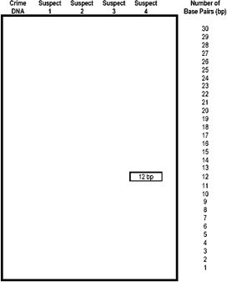
DNA Evidence Evaluation

- On the following page you will find several DNA sequences. Cut each out and turn the resulting strips right side up. The restriction enzyme cuts at every point it finds C C G G, always cutting between the C and the G. Use scissors to cut the DNA sequence at the C C G G points. Label the back of the slips with the suspect number so that you don't get them confused after cutting.

- Count the number of base pairs (bp) in each piece of DNA that you created. Record the base pair number on the back side of the DNA fragment.

- Make an enlarged chart like the one shown at left. Use a ruler to ensure that the lengths are uniform.

- Tape your DNA fragments to the chart, using the
base pair numbers as a guideline for fragment placement.

- Compare the crime scene DNA to the suspects and indicate on your chart which suspect is guilty of eating the cheese.

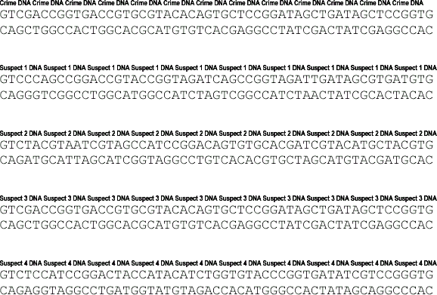

- For each of the following tasks performed in the activity, describe what they are actually simulating.

Cutting the DNA into fragments: Taping the DNA onto the large paper:

- Describe how each technique below relates to DNA Fingerprinting:

Polymerase Chain Reaction Gel Electrophoresis Restriction Enzyme

