Biology
Laboratory Manual to accompany Concepts in Biology 13th Edition

Enger−Ross

McGraw -Hill

McGraw−Hill Primis

ISBN−10: 0−39−092262−5
ISBN−13: 978−0−39−092262−5

Text:

Laboratory Manual to accompany Concepts in Biology, 13th Edition
Enger−Ross

Enger−Ross: Laboratory | 28. Frog Dissection | Text |  | © The McGraw−Hill

271

Manual to accompany
Concepts in Biology, 13th Edition

L A B O R A T O R Y

Frog Dissection
Companies, 2009

28

✚ Safety Box
- Ether is highly explosive; keep it away from flames and do not agitate the container. Be sure to keep the container closed and refrigerated when not in use.
- Dissection tools are, of necessity, sharp. You must use them carefully to prevent cutting yourself and to maintain them in proper condition. When finished with a set of dissection tools, carefully clean, dry, and return them to their proper place.
- You will use a living organism for this exercise; therefore, treat it with the respect due any life-form.
- Make sure that the animal is anesthetized or pithed before cutting it. When you are finished with the dissection, make sure the organism does not come out of the anesthesia and feel pain. Therefore, you need to decapitate it and dispose of the remains as indicated by your instructor.

Objectives
Be able to do the following:
dorsal
parasite
ventral
posterior
Ringer’s solution
anterior
isosmotic
1. Define these terms in writing.
- Locate these structures in a frog:
  - External—anus, tympanum, nares, eyes, and pectoral and pelvic girdles
  - Internal—liver, gallbladder, lungs, stomach, small intestine, large intestine, spleen, ovaries or testes, kidneys, adrenal glands, fat bodies, nerves, urinary bladder, heart, atrium and ventricle, and oviduct
- Describe a function of each of the structures named in objective 2.

Introduction
A living animal is a much more interesting organism to study than a dead, preserved one. It is possible to show many types of phenomena with living animals that are just not possible in nonliving organisms. For this reason, we use an anesthetized frog for this exercise.
It is important in any study of living animals that the organism not be subjected to unusual pain or cruel treat- ment. Anesthetizing the frog effectively prohibits any feeling on the part of the frog while still allowing the internal or- gans to function normally. Alternatively, pithing is a technique that destroys the nervous tissue of the brain, so the frog feels no pain. Your instructor will provide pithed frogs if this technique is used.

272
Enger−Ross: Laboratory | 28. Frog Dissection | Text |  | © The McGraw−Hill

Manual to accompany
Concepts in Biology, 13th Edition
Companies, 2009

When you are working with living tissue, it is important that the cells be bathed in a solution that is isosmotic to the cells. Why?

The solution we use is called Ringer’s solution, which contains sodium and potassium salts in a 0.7% solution. During this exercise, moisten the tissues frequently with Ringer’s solution.

Preview
During this exercise, you will work with a live frog. Because it is a living organism, treat it with respect.
During this lab exercise, work in groups of 2–4 people. You will
- obtain a frog.
- examine the frog’s external structures.
- anesthetize or pith your frog by closely following the instructor’s directions.
- study circulation in tongue or toe.
- dissect your frog.
- manipulate the frog’s body temperature and count its heartbeats.
- examine the frog’s internal structures.
- examine organs for parasites.
- complete a quiz.
- clean up your materials.

Procedure
Anesthetizing
Place some crumpled paper towels or cloth in a jar (with a tight-fitting lid) large enough to hold this material and a frog. Pour a few milliliters of ether into the jar, place the live frog into the jar, and close the lid. When the frog becomes very limp, it can be removed and your observations can begin. Be aware that occasionally a frog may show signs of reawakening during the observation. At the first sign of movement, return the frog to the jar until it is once more quite limp; then the observation can proceed.
Pithing
If the frog is to be pithed rather than anesthetized, watch your instructor carefully as this process is demonstrated. Re- member, the object of pithing, as with anesthetizing, is to prevent unnecessary pain.
External Anatomy
The frog’s basic body consists of the (1) head, (2) trunk, (3) pectoral girdle (the front legs and associated structures), and (4) pelvic girdle (hind legs and associated structures). Identify these structures on your frog. Also identify the dorsal (back), ventral (belly), anterior (head end), and posterior (tail end) surfaces of your frog. Locate these struc- tures: the anus on the dorsoposterior surface between the hind legs; the tympanum, a circular area found posterior and lateral to the eyes; and the external nares, small, pitlike openings on the anterior of the head.
Studies of Circulation
You can observe the capillaries either in the frog’s tongue or in the webbing between the toes. Place the anesthetized frog on its belly on a frog board and stretch the tongue or toes over the opening in the edge of the frog board. Secure the tongue or toes in place with pins and observe with low power through the compound microscope. You will be able to see three different kinds of blood vessels with blood flowing through them: arteries, capillaries, and veins. The ar- teries branch into smaller and smaller blood vessels until eventually the blood vessels are about the same diameter as the red blood cells. These smallest blood vessels are capillaries. These capillaries combine into larger and larger blood vessels called veins. The red blood cells are oval in outline and flow from the arteries through the capillaries to the

Enger−Ross: Laboratory | 28. Frog Dissection | Text |  | © The McGraw−Hill

273

Manual to accompany
Concepts in Biology, 13th Edition
Companies, 2009

veins. Usually, the blood flowing in the arteries flows in pulses, and the blood in the veins flows at a continuous pace. Compare the rate of blood flow in these three blood vessels.
After you have studied the circulation in the tongue or toes of the frog, open the body cavity of the frog and study the action of the heart. Place the frog on its back in a dissecting tray and use a pair of scissors to cut through the skin from a point where the hind legs join to the point of the chin. Make cuts to the side at the level of the shoulder and hip so that the skin can be peeled back on either side, as indicated in figure 28.1.

Figure 28.1 Frog dissection: cut on dotted lines.
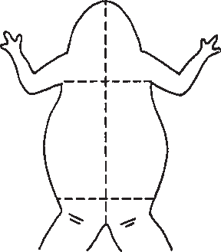

Notice the large number of blood vessels inside the skin. The skin is the major organ of gas exchange (oxygen and carbon dioxide). The whitish-colored, thin layer remaining over the belly of the animal is the belly musculature. Make a similar pattern of cuts through this muscle, but cut to either the right or left of the midline to prevent cutting the ventral abdominal blood vessel. When you get to the region of the arms, it is necessary to cut through the bones of the shoulder girdle. Immediately under these bones is the heart. It still should be beating. You will be able to see two major portions of the heart. The ventricle is the triangular-shaped structure beating. There are two smaller chambers at the an- terior end of the heart called the atria. The atria are anterior to the ventricle and beat slightly before the ventricle. Lo- cate and distinguish the atria and ventricle of the heart. Determine the heart rate in beats per minute and record. After a few minutes, place some cool Ringer’s solution (10°C) on the heart and record the heart rate. Use several milliliters of Ringer’s solution, not just a few drops. Repeat a few minutes later with warm Ringer’s solution (30°C).
  - Warm: beats per minute
  - Room-temperature: beats per minute
  - Cold: beats per minute What effect does temperature have on heart rate? Why?

Internal Anatomy
After your experiments on the heart, locate the following structures and compare them with figure 28.2:
- The liver, a large, reddish-brown organ located posterior to the heart, stores food and releases it as needed. The liver produces compounds that aid in the digestion of fats and assist in the coagulation of blood. It also interconverts carbohydrates, fats, and proteins and destroys toxins.
- The gallbladder: Lift the lobes of the liver until you locate a bluish-green sac. This sac stores bile, which contains compounds that aid in fat digestion. If you have ever removed the internal organs of a game animal, you may have been warned not to break the gallbladder to avoid spilling this bitter fluid on the meat.
- The two lungs are located on each side of the heart and should be seen protruding from under the liver. These are thin sacs, usually speckled with black. Some exchange of gases between the atmosphere and the blood takes place in the lungs. Remember that the skin is the primary organ of gas exchange.

274
Enger−Ross: Laboratory | 28. Frog Dissection | Text |  | © The McGraw−Hill

Manual to accompany
Concepts in Biology, 13th Edition
Companies, 2009

- The stomach, small intestine, and large intestine take up most of the abdominal cavity. The huge, J-shaped structure is the stomach. This can be seen at the frog’s left side and just below the liver. Digestion starts in the stomach of the frog, rather than in the mouth, as in humans. The long, slender middle portion, extending from the stomach, is the small intestine. This is called the small intestine because of its small diameter, even though it is several inches long. Digestion is completed here. The small intestine empties into an abruptly expanded portion at the base of the abdominal cavity, which is the large intestine. Undigested food is held in the large intestine until the animal defecates.
- The spleen is a small, reddish structure found near the small intestine. It is sometimes difficult to locate. The spleen stores and cleans the blood.
- The two kidneys, located on opposite sides of the backbone, are about 2 centimeters long and are reddish in color. There may be a thin membrane separating the kidneys from the rest of the abdominal cavity; if present, remove it. The kidneys serve the important job of removing cell wastes from the blood.
- The yellowish stripe on the surface of the kidney is the adrenal gland. This complicated organ furnishes the hormone epinephrine, which helps the organism respond to emergencies.
- a. The presence of testes is the easiest way to verify that your frog is a male. These are the two white, bean-shaped structures located at the anterior end of the kidneys. As in humans, they produce the male sex cells.
b. If you have a female frog with mature eggs, you see the enlarged, saclike ovaries, which contain the eggs. You may want to remove these to see the remaining parts.
- On the right and left sides, you should see two coiled tubes. They will be very large in females with eggs. Females without eggs will have smaller oviducts. These oviducts conduct eggs from the ovary to the outside. In males, they are present but are much smaller and nonfunctional.
- Fat bodies are irregularly shaped, yellowish-white masses of stored food. They may be found attached at the anterior end of the kidney. Their size varies greatly, depending on how well the frog has eaten.
- The white threads that run from the backbone are nerves. Pinch some of them and see what happens. Nerves are most easily seen on each side of the backbone, running to the legs.
- The urinary bladder is attached to the large intestine very near the point where the legs join the body. It is very thin and is easily damaged during dissection. It is usually empty and will look like a small, irregular mass of membrane. Its function is to hold the “urine.”
Parasites
Most living organisms have parasites that live inside some of the organs of the body, and the frog is no exception. Sur- vey the following organs for parasites. Be sure to wash your hands thoroughly when finished.
- Remove a lung and place it in a dish of Ringer’s solution. Using two needles, pull the lung apart and examine under the dissecting microscope for parasites. You might find a brownish-black lung fluke with whitish blotches and long, thin roundworms flexing about.
- Open the large intestine and examine some of the contents for parasites. Some very small ones are common here, so examine with both the dissecting and compound microscopes.
- Similarly, examine the
  - small intestine.
  - urinary bladder.
  - gallbladder.
- How many different kinds of parasites did you find?

Clean up all utensils and your work area. Your instructor will tell you how to dispose of your frog. Wash your hands before you leave the laboratory.

Enger−Ross: Laboratory | 28. Frog Dissection | Text |  | © The McGraw−Hill

275

Manual to accompany
Concepts in Biology, 13th Edition
Companies, 2009

Figure 28.2 Internal organs of the frog.

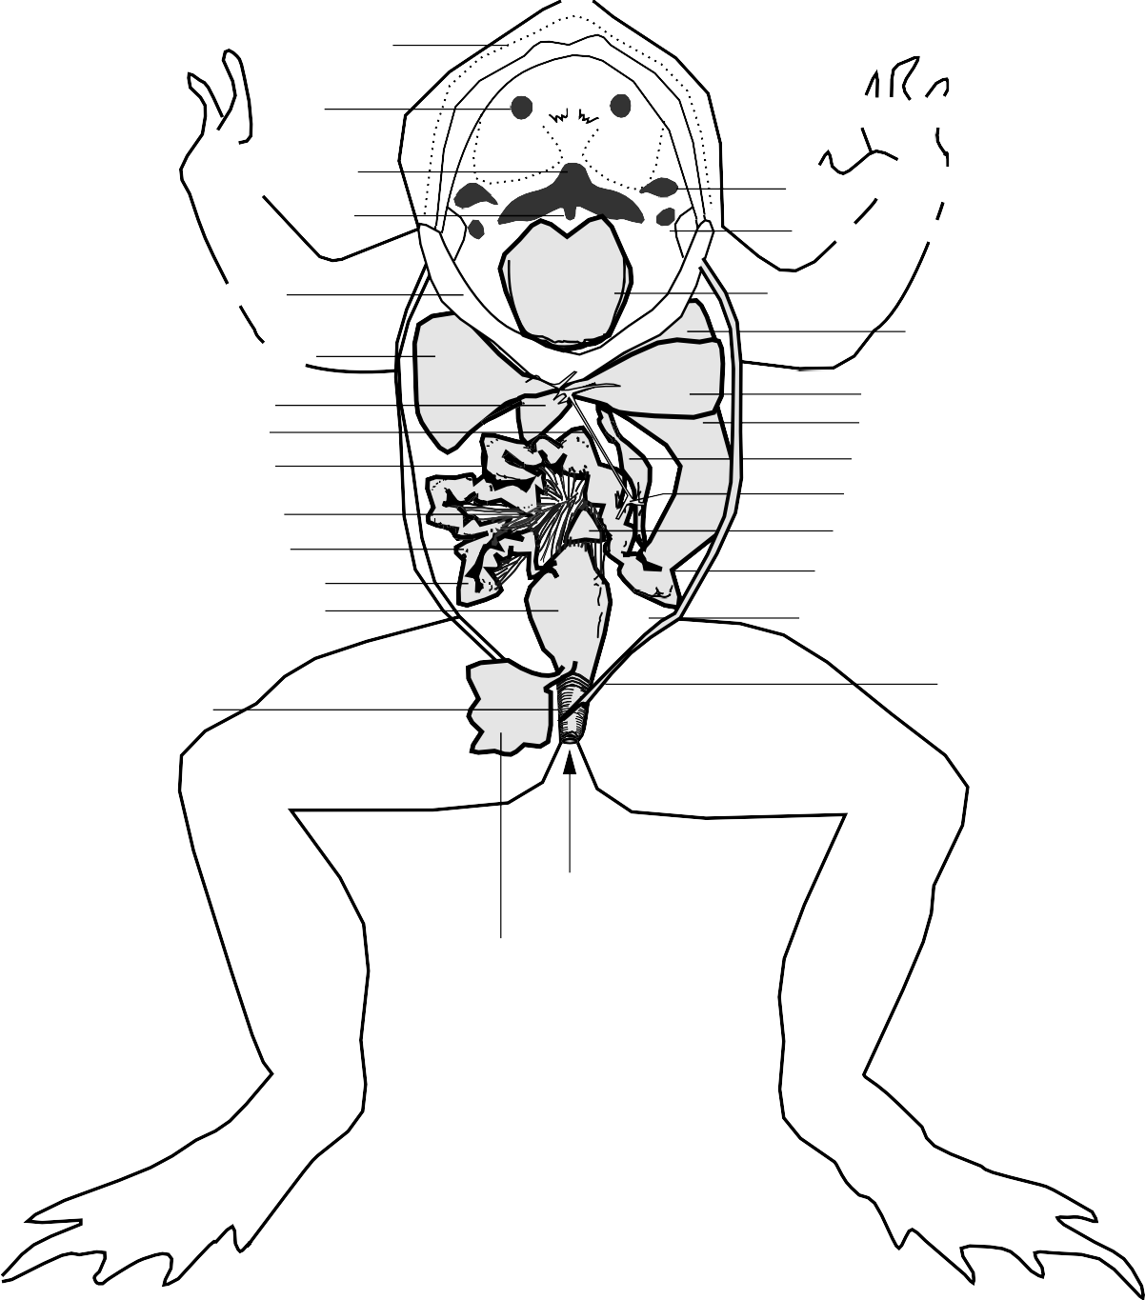
Maxillary teeth

Internal Vomerine teeth nares

Esophagus

Glottis
Eustachian aperture
Vocal sac aperture (in males)

Lower jaw
Right lobe of liver Gallbladder
Bile duct Duodenum
Mesentery
Tongue

Median lobe of liver

Left lobe of liver Stomach
Pancreas Pancreatic duct

Ileum
Small intestine
Large intestine
Spleen Pyloric sphincter
Coelom

Cloaca

Urogenital openings into cloaca

Urinary

