Robert Frost (1874- 1963 ) Briefly
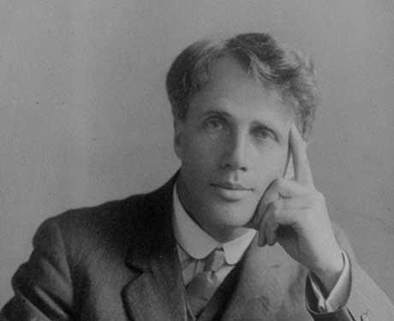

- Robert Frost is probably the most well-known and most anthologized poet of the first half of the century.
- His poems were particularly popular among university students in his life time; they are constantly included in highschool coursebooks. This must be interpreted as a sign of not being “avant-garde” enough.
- His life is full of artistic susccesses, reawrds and appreciation of different sorts.
- He employs the voice of a rural wise old New England farmer but actually he spent only a small part of his early life on his uncle’s farm.
- He might be considered an individualist though not in the sense of the Transcendentalists. He is at times very critical of people for lacking curiosity, individuality and insight.
- His biography displays a life full of pain, lack of self-confidence, depression, self-doubt and pain although his popular image is one of success and prosperity.

