Anne Sexton Briefly
(1928-1974)

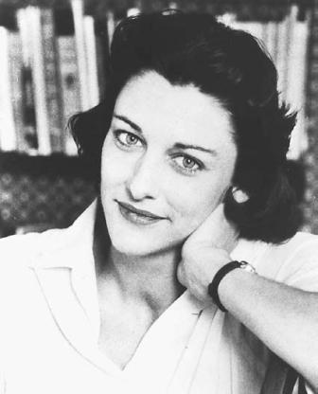

Diane Hume George: “Anne Sexton’s poetry tells stories that are immensely significant to mid-twentieth-century artistic and psychic life. Sexton understood her culture’s malaise through her own, and her skill enabled her to deploy metaphorical structures at once synthetic and analytic … Sexton explored the myths by and through which our culture lives and dies: the archetypal relationships among mothers and daughters, fathers and daughters, mothers and sons, gods and humans, men and women. She perceived, and consistently patterned in the images of her art, the paradoxes deeply rooted in human behavior and motivation. Her poetry presents multiplicity and simplicity, duality and unity, the sacred and the profane, in ways that insist on their similarities—even, at times, their identity. In less abstract terms, Sexton made explicit the intimacy of forces persistently treated as opposites by the society she lived in.”

For the rest of the article https://www.poetryfoundation.org/poets/anne-sexton

