Theodore Roethke Briefly
(1908-1963)

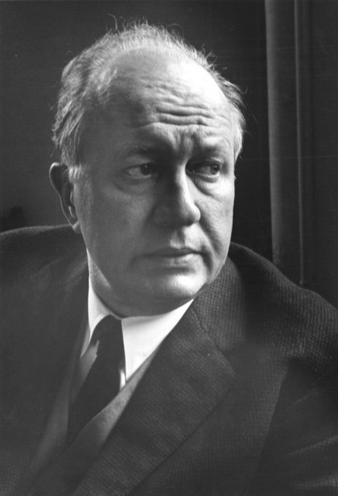

Theodore Roethke hardly fits anyone’s image of the stereotypical high-minded poet-intellectual of the 1940s through 1960s.
When he was 14, his father died of cancer and his uncle committed suicide. He attended the University of Michigan, Ann Arbor, where he adopted a tough, bear-like image (weighing over 225 pounds) and even developed a fascination with gangsters.
His difficult childhood, his bouts with bipolar disorder, and his ceaseless search for truth through his poetry writing led to a difficult life, but also helped to produce a remarkable body of work that would influence future generations of American poets to pursue the mysteries of one’s inner self.

Poet and writer James Dickey once named Roethke the greatest of all American poets: “I don't see anyone else that has the kind of deep, gut vitality that Roethke's got. Whitman was a great poet, but he's no competition for Roethke.”

For more https://www.poetryfoundation.org/poets/theodore-roethke

