PROJECTS IN OPTICS (NEWPORT CORPORATION)

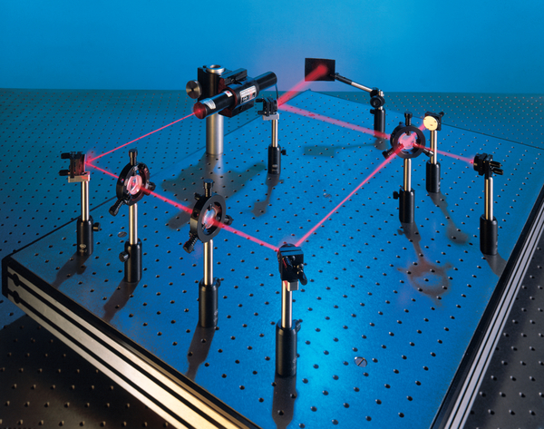

The following experiments are going to be performed with this experiment kit

Experiment 2.1: Diffraction of Circular Apertures, Single Slit Diffraction and Double Slit Interference
Experiment 2.2: The Michelson Interferometer
Experiment 2.3: Analyzing Polarization Status of Light Beam

Preface

The ‘Projects in Optics Kit’ is a set of laboratory equipment containing all of the optics and optomechanical components needed to complete a series of experiments that will provide students with a basic background in optics and practical hands on experience in laboratory techniques. The projects cover a wide range of topics from basic lens theory through interferometry and the theory of imaging.

Theory:

Diffraction
￼Threating light as rays propagating in straight lines, does not fully describe the range of optical phenomena that can be investigated within the experiments in Projects in Optics. There are a number of additional concepts that are needed to explain certain limitations of ray optics and to describe some of the techniques that allow us to analyze images and control the amplitude and direction of light. This section is a brief review of two important phenomena in physical optics, interference and diffraction.

Huygen’s Principle

Light is an electromagnetic wave made up of many different wavelengths. Since light from any source (even a laser!) consists of fields of different wavelength, it would seem that it would be difficult to analyze their resultant effect. But the effects of light made up of many colors can be understood by determining what happens for a monochromatic wave (one of a single wavelength) then adding the fields of all the colors present. Thus by analysis of these effects for monochromatic light, we are able to calculate what would happen in non- monochromatic cases. Although it is possible to express an electromagnetic wave mathematically, we will describe light waves graphically and then use these graphic depictions to provide insight to several optical phenomena. In many cases it is all that is needed to get going.

An electromagnetic field can be pictured as a combination of electric (E) and magnetic (H) fields whose directions are perpendicular to the direction of propagation of the wave (k), as shown in Fig. 2.1. Because the electric and magnetic fields are proportional to each other, only one of the fields need to be described to understand what is happening in a light wave. In most cases, a light wave is described in terms of the electric field. The diagram in Fig 2.1 represents the field at one point in space and time. It is the arrangement of the electric and magnetic fields in space that determines how the light field progresses.
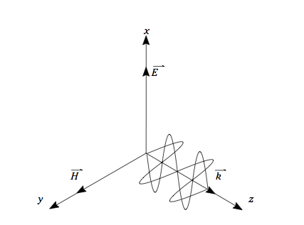
Figure 2.1: Monochromatic plane wave propagating along the z-axis. For a plane wave, the electric field is constant in an x-y plane. The vector k is in the direction of propagation.
One way of thinking about light fields is to use the concept of wavefront. If we plot the electric fields as a function of time along the direction of propagation, there are places on the wave where the field is a maximum in one direction and other places where it is zero, and other places where the field is a maximum in the opposite direction, as shown in Fig. 2.2. These represent different phases of the wave. Of course, the phase of the wave changes continuously along the direction of propagation. To follow the progress of a wave, however, we will concentrate on one particular point on the phase, usually at a point where the electric field amplitude is a maximum. If all the points in the neighborhood have this same amplitude, they form a surface of constant phase, or wavefront. In general, the wavefronts from a light source can have any shape, but some of the simpler wavefront shapes are of use in describing a number of optical phenomena.
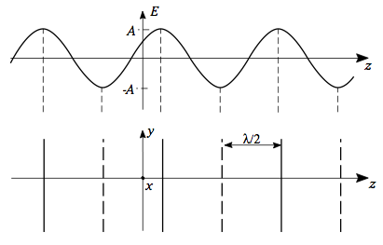
Figure 2.2: Monochromatic plane wave propagat- ing along the z-axis. For a plane wave, the electric field is constant in an x-y plane. The solid lines and dashed lines indicate maximum positive and negative field amplitudes.
A plane wave is a light field made up of plane surfaces of constant phase perpendicular to the direction of propagation. In the direction of propagation, the electric field varies sinusoidally such that it repeats every wavelength. To represent this wave, we have drawn the planes of maximum electric field strength, as shown in Fig. 2.2, where the solid lines represent planes in which the electric field vector is pointing in the positive y- direction and the dashed lines represent plane in which the electric field vector is pointing in the negative y- direction. The solid planes are separated by one wavelength, as are the dashed planes.
Another useful waveform for the analysis of light waves is the spherical wave. A point source, a fictitious source of infinitely small dimensions, emits a wavefront that travels outward in all directions producing wavefronts consisting of spherical shells centered about the point source. These spherical waves propagate outward from the point source with radii equal to the distance be- tween the wavefront and the point source, as shown schematically in Fig. 2.3. Far away from the point source, the radius of the wavefront is so large that the wavefronts approximate plane waves. Another way to create spherical waves is to focus a plane wave. Figure 2.4 shows the spherical waves collapsing to a point and then expanding. The waves never collapse to a true point because of diffraction. There are many other possible forms of wave fields, but these two are all that is needed for our discussion of interference.
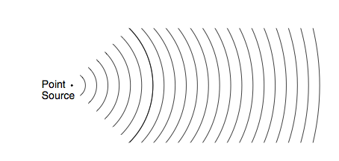
Figure 2.3: Spherical waves propagating outward from the point source. Far from the point source, the radius of the wavefront is large and the wavefronts approximate plane waves.
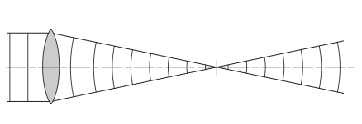
Figure 2.4: Generation of spherical waves by focusing plane waves to a point. Diffraction prevents the waves from focusing to a point.

What we have described is a single wavefront. What happens when two or more wavefronts are present in the same region? Electromagnetic theory shows that we can apply the principle of superposition: where waves overlap in the same region of space, the resultant field at that point in space and time is found by adding the electric fields of the individual waves at a point. For the present we are assuming that the electric fields of all the waves have the same polarization (direction of the electric field) and they can be added as scalars. If the directions of the fields are not the same, then the fields must be added as vectors. Neither our eyes nor any light detector “sees” the electric field of a light wave. All detectors measure the square of the time-averaged electric field over some area. This is the irradiance of the light given in terms of watts/square meter (w/m2 ) or similar units of power per unit area.
Given some resultant wavefront in space, how do we predict its behavior as it propagates? This is done by invoking Huygen’s Principle. Or, in terms of the graphical descriptions we have just defined, Huygen’s Construction (see Fig. 2.5): Given a wavefront of arbitrary shape, locate an array of point sources on the wavefront, so that the strength of each point source is proportional to the amplitude of the wave at that point. Allow the point sources to propagate for a time t, so that their radii are equal to ct (c is the speed of light) and add the resulting sources. The resultant envelope of the point sources is the wavefront at a time t after the initial wavefront. This principle can be used to analyze wave phenomena of considerable complexity.
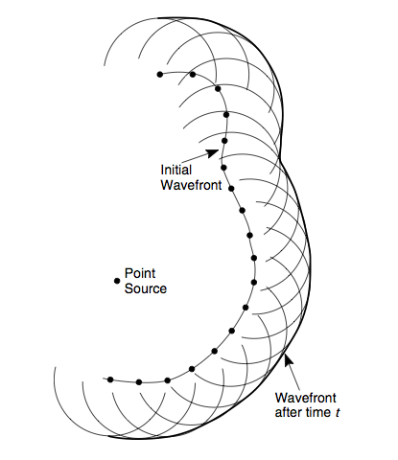

Figure. 2.5: Huygen’s Construction of a propagating wavefront of arbitrary shape.

experiment 2.1: Diffraction of Circular Apertures, Single Slit Diffraction and Double Slit Interference

Diffraction of Circular Apertures:

Most of the optical systems that you will work with are made up of components whose apertures are circular. They can be mirrors, lenses, or holes in the structures that contain the components. While they do permit light to be transmitted, they also restrict the amount of light in an optical system and cause a basic limitation to the resolution of the optical system.

In this experiment you will measure the diffraction effects of circular apertures (Fig. 2.6). The diffraction associated with the size of the aperture determines the resolving power of all optical instruments from the electron microscope to the giant radiotelescope dishes. In addition, you will discover that a solid object not only casts a shadow but that it is possible for a bright spot to appear in the center of the shadow!

The diffraction patterns you will examine are located both close to the diffraction aperture and far away. The first is called Fresnel (Freh - NEL) diffraction; the second is Fraunhofer (FRAWN - hoffer) diffraction.

WARNING.
To be able to see some of the diffraction patterns, this experiment will be performed in a darkened room. Extreme care should be taken concerning the He-Ne laser beam. Your pupils will be expanded and will let in 60 times more light than in a lighted room. DO NOT LOOK AT A DIRECT SPECULAR REFLECTION OR THE DIRECT LASER BEAM. BE AWARE OF YOUR SURROUNDINGS AND FELLOW CO- WORKERS.

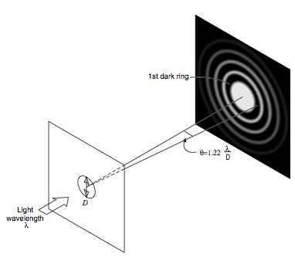

Figure 2.6: Diffraction from a circular aperture.

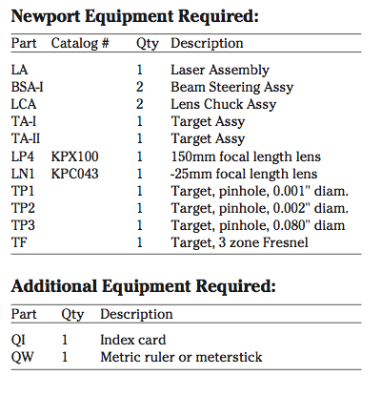

Table 2.1: Required Equipment

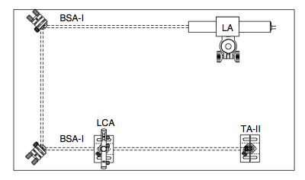
Figure 2.7: Schematic view of Fraunhofer diffraction experiments using TP1.

Experimental Set Up:

- Mount a laser assembly (LA) at the rear of the breadboard. Adjust the position of the laser such that the beam is parallel to the edge and on top of a line of tapped holes in the breadboard. Tape an index card with a small (about 2 mm) hole in it to the front of the laser, so that the laser beam can pass through it. This card will be used as a screen to monitor the reflections from the components as they are inserted in the beam.

- Mount a beam steering assembly (BSA-I) approximately 4 inches in from the far corner of the breadboard (Fig. 2.7). Adjust the height of the mirror mount until the beam intersects the center of the mirror. Then rotate the post in the post holder until the laser beam is parallel to the left edge and the surface of the optical breadboard.

- Place a second beam steering assembly (BSA-I) in line with the laser beam at the lower left corner of the optical breadboard, (Fig. 2.7). Rotate and adjust the mirror mount until the laser beam is parallel to the front edge and the surface of the optical breadboard.

- Place an index card in a modified target holder assembly (TA-II) and set it at the end of the breadboard so that the beam hits the center of the card.

- Mount a lens chuck assembly (LCA) five inches to the right of the last beam steering mirror and directly in line with the laser beam. This will be the aperture holder.

Fraunhofer Diffraction of a Circular Mask

- Carefully place the pinhole target (TP1) into the LCA. Adjust the mount such that the laser beam strikes the target approximately in the center.
WARNING — The target will reflect a large percentage of the beam.

- Adjust the last beam steering mirror such that the laser beam fills the pinhole. This can best be accomplished by viewing the back-side of the target (beyond the laser) from 45° and looking for a bright red glow. This will occur when the laser beam (or part of the laser beam) is illuminating the aperture.

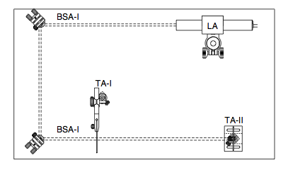
Figure 2.8: Schematic view of Fraunhofer diffraction experiments using TP2.

- Watch the white card. Carefully adjust the last beam steering mirror to produce the brightest image. You should see a bright central circle surrounded by dark and light circular bands. This is the Airy disc pattern. Measure the distance from TP1 to the index card in TA-II. Mark and then measure the diameter of the first dark circular band around the bright central circle. This is a measure of the amount of diffraction caused by the pinhole.

- As was pointed out in the Primer, the angular subtense of the dark band is related to the wavelength and diameter of the pinhole by sinθ = 1.22 λ /D where D is the diameter and λ is the wavelength. Since the diffraction angle is small, the sine and the tangent of the angle are equal. The tangent is found from dividing the radius of the dark band by the distance from the pinhole to the index card that was recorded in step #8. Inserting the wavelength of the He-Ne laser (λ = 633 nm) into the equation, calculate the diameter of the pinhole.

- All circular apertures will exhibit an Airy pattern. Replace the TP1 with TP2. You will need to use a target holder mount (TA-I) approximately four inches in from the breadboard edge and in line with the position of the lens chuck assembly. Measure the diameter of the first dark band and the distance between the pinhole and the index card. Calculate the pinhole diameter based on this data. This series of rings from a circular aperture causes objects that are close together to overlap at the focal plane of the observing instrument and will limit the resolving power of large aperture telescopes.

- Assemble a 6:1 beam expander, between the first and second beam steering mounts (BSA-I) as shown in Fig. 2.9. Replace TP2 with TP3. Because the aperature is so large, replace the card mount TAII with a third BSA-I and direct the beam to a wall more than 10 feet (305 cm) away. Measure the diameter of the first dark band and estimate the distance between the pinhole and the wall. Calculate the pinhole diameter.

At far field the Fraunhofer diffraction pattern does not change in shape, but only in size. Using the index card, look at the diffraction pattern starting at the pinhole and moving away toward the wall. At a distance of about 2 feet (61 cm) from the pinhole you will see the center bright spot become a small dark spot. Depending on how well the beam expander is set, this small dark spot may be difficult to resolve. However, the center spot changing from bright to dark and then to bright again is Fresnel diffraction.
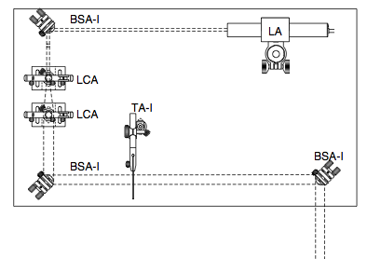
Figure 2.9: Schematic view of Fresnel diffraction experiment.

Fresnel Diffraction of Circular Mask
- Replace TP3 with the Fresnel target (TF). Look at the diffraction pattern on the target screen. Note that the center of the image has several bright and dark rings. This is also Fresnel diffraction. Depending on the distance of TA-II from TF, the center of the pattern may be bright or dark. Although the Fresnel target (TF) has a central absorbing circle, note there is still light at the center of the pattern. The bright spot at the center is sometimes called the Poisson spot or the spot of Arago.

- Examine the shadows of other objects put in the expanded laser beam. Pencil points, wires, and small beads on a string are good objects that give interesting Fresnel patterns. Note how the patterns change as you move the objects along the beam direction. Sketch some of the more interesting patterns in your notebook.

Single Slit Diffraction and Double Slit Interference:

Diffraction of light occurs whenever light illuminates an aperture that has dimensions that are on the order of the wavelength of light being used. In the case of a slit, which has a narrow opening that is “infinitely” tall, the diffraction takes place in the direction perpendicular to the small dimension.

In addition light from one slit will interfere with the light from a second nearby slit to produce an interference pattern that combines the interference properties of the single slit with the interference pattern of two nearby sources. (Fig. 2.10)

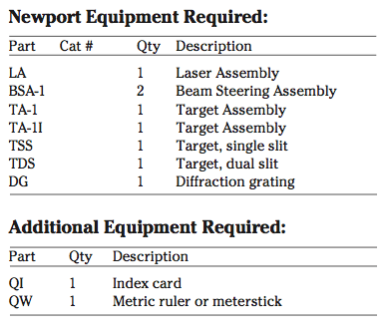

Table 2.2: Required Equipment

Experimental Set Up:

- Mount a laser assembly (LA) to the rear of the breadboard (Fig 2.11). Adjust the position of the laser such that the beam is parallel to the edge and on top of a line of tapped holes in the bread- board top. Tape an index card with a small (about 2 mm) hole in it to the front of the laser, so that the laser beam can pass through it. This card will be used as a screen to monitor the reflections from the components as they are inserted in the beam.

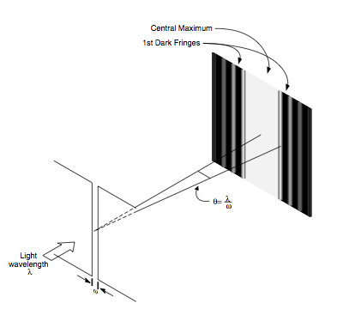
Figure 2.10: Diffraction from a single slit.

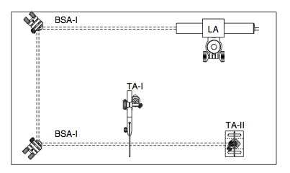
Figure 2.11: Schematic view of diffraction experiments.

- Mount a beam steering assembly (BSA-I) approximately 4 inches (10 cm) in from the far corner of the breadboard (Fig. 2.11). Adjust the height of the mirror mount until the beam intersects the center of the mirror. Then rotate the post in the post holder until the laser beam is parallel to the left edge and the surface of the optical breadboard.
- Place a second beam steering assembly (BSA-I) in line with the laser beam at the lower left corner of the optical breadboard, (Fig. 2.11). Rotate and adjust the mirror mount until the laser beam is parallel to the front edge and the surface of the optical breadboard.
- Place an index card in a modified target holder assembly (TA-II) and mount it at the end of the breadboard so that the beam hits the center of the card.
- Mount a TA-I five inches (13 cm) to the right of the last beam steering mirror and four inches in from the laser beam. This will be the holder for parts TSS and TDS.
- Carefully place the TSS (single slit – 0.002 in. wide) into the TA-I. Adjust the mount such that the laser beam strikes the target approximately in the center.
WARNING: The target will reflect a large percentage of the beam.
- Adjust the last beam steering mirror such that the laser beam fills the slit. This can best be accomplished by viewing the backside of the target from 45° and looking for a bright red glow. This will occur when the laser beam is illuminat- ing the slit.
- Watch the white card. Carefully adjust the last beam steering mirror to produce the brightest image. You should see a bright central band with several dimmer bands on each side. This is the single slit diffraction pattern. Mark on the index card the locations of as many dark bands as you can easily see. Note that the central band is larger than the sidebands. Measure the distance between the center of the dark bands on both sides of the central band and the distance from the slit to the index card. Calculate the angle at the slit between the central peak and the first dark band. Remember the distance between the first dark bands is twice the distance between the central part and the first dark band. Based on expressions given in the Primer, the angular subtense of the center band from central peak to first dark band is given by
Sinθ = mλ/ω
If the wavelength of the He-Ne laser is 633 nm, determine the width of the slit from your calculations.
Young’s Double Slit Experiment

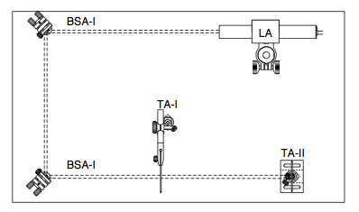

Figure 2.12: Schematic view of Young’s double slit experiment.

- A second and related experiment can be performed with the previous setup. Replace the TSS with a TDS (dual slit – 0.002 in. wide with 0.008 in spacing) target and the index card used as the observation screen. Measure the slit to index card distance R.

- The pattern will now have a series of maxima and minima spaced within the envelope of the original single slit pattern. These fringes are the interference pattern of the double slit. Mark the locations of the minima x₁,x₂. . . of these closely spaced fringes. Calculate the average separations ∆x=x₁- x₂. Also mark the location of the minimum of the large band (the position where the interference fringes disappear).

- Calculate the fringe separation from

∆θ=∆x/R

and record it in your notebook. From this value of ∆θ and the wavelength of the laser (λ=633nm) you can calculate the slit separation using the following formula:

- Take a card or the edge of a ruler and carefully insert it in front of one of the two slits. This takes a little practice. If you do it right you will see the interference pattern disappear and a single slit diffraction pattern remain. Note that when you take away the item blocking the light from any of the slits, you introduce dark fringes. Of course the light at the bright fringes is brighter. You are using light to push light around!

Additional experiments:

The Diffraction Grating
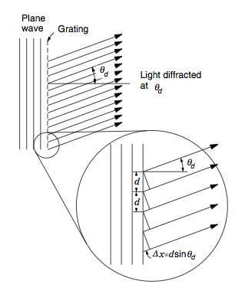
Figure 2.13: Diffraction of light by a diffraction grating.
It is a somewhat confusing use of the term to call the item under discussion a diffraction grating. Although diffraction does indeed create the spreading of light from a regular array of closely spaced narrow slits, it is the combined interference of multiple beams that permits a diffraction grating to deflect and separate the light. In Fig. 2.13 a series of narrow slits, each separated from its neighboring slits by distance d, are illuminated by a plane wave. Each slit is then a point (actually a line) source in phase with all other slits. At some angle θ_{d} to the grating normal, the path-length difference between neighboring slits will be (see inset to Fig. 2.13)
∆x = d sin(θ_{d}),
Constructive interference will occur at that angle if the path-length difference ∆x is equal to an integral number of wavelengths:
m λ = d sin(θ_{d}) (m = an integer).
This equation, called the grating equation, holds for any wavelength. Since any grating has a constant slit separation d, light of different wavelengths will be diffracted at different angles. This is why a diffraction grating can be used in place of a prism to separate light into its colors. Because a number of integers can satisfy the grating equation, there are a number of angles into which monochromatic light will be diffracted. Therefore, when a grating is illuminated with white light, the light will be dispersed into a number of spectra corresponding to the integers m = . . ., ±1, ±2, . . ., as illustrated in Fig. 2.14(a). By inserting a lens after the grating, the spectra can be displayed on a screen one focal length from the lens, Fig. 2.14(b). These are called the orders of the grating and are labeled by the value of m.
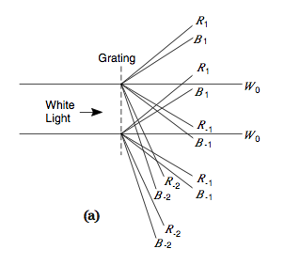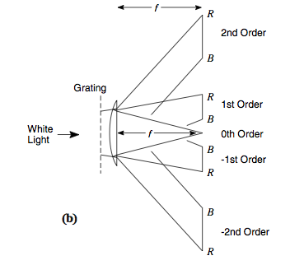
Figure 2.14. Orders of diffraction from a grating illuminated by white light. (a) Rays denoting the upper and lower bounds of diffracted beams for the red (R) and blue (B) ends of the spectrum; (b) spectra produced by focusing each collimated beam of wavelengths to a point in the focal plane.

Higher order diffraction patterns exist for 3,4,5 ... equally spaced slits. Eventually, the number of slits becomes very large and the result approaches the diffraction grating. Most highresolution instruments for determining the transmission or reflection characteristics of optical materials and coatings use some form of a grating.

Experimental Set Up:

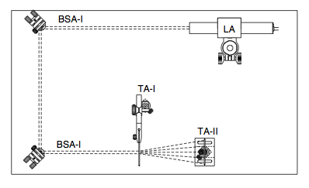
Figure 2.15: Schematic view of diffraction grating experiment.

- Mount a diffraction grating (DG) in the TA-1 and illuminate it with the laser beam. Mount a new index card in the TA-II and locate it behind DG, so that a number of diffraction orders can be seen.

- Move the TA-II away from DG until only a few dots remain on the screen and their separations are easily measured. Mark the locations of the diffraction orders on the card and label each with the order (0 for the undiffracted beam). Measure the distance from DG to the screen.
- Calculate the diffraction angles from the measurements. Note the angles are large enough that you cannot use any small angle approximation. You must use the inverse tangent to arrive at the angle.
- The groove separation, or grating constant, for this grating is found by taking the reciprocal of the grating frequency, which is 13,400 grooves per inch. From the groove separation and the angular measurements for several orders, determine the wavelength of the helium-neon laser. Compare it to 633 nm.
The spectra of other sources can be studied using this diffraction grating, but additional components are required. Since most will not be lasers with sharply defined beams, the sources illuminate a slit. The light from the slit is then collimated to provide a constant angle of incidence to the grating. The diffracted beams are then refocused to a series of slit images that are separated into the colors in the spectrum of the source located in the focal plane of the focus lens. See any of the major optics references for description of a simple transmission grating spectrometer.

In most commercial spectrometers, the diffraction grating is a reflection, rather than a transmission type. This is because the instrument is more compact and the gratings tend to be more efficient in this mode.

experiment 2.2: MICHELSON INTERFERROMETER

In this experiment you will build a Michelson interferometer and use it as a means to observe small displacements and refractive index changes. When this arrangement of components is used to test optical components in monochromatic light it is called a Twyman-Green interferometer. The Twyman-Green interferometer is widely used for testing optics and optical systems, and provides a means for measuring the amount of aberra- tions present in these optical systems. Rather than make such a distinction here, the device will be referred to as a Michelson interferometer throughout this manual.

Theory of the Experiment:
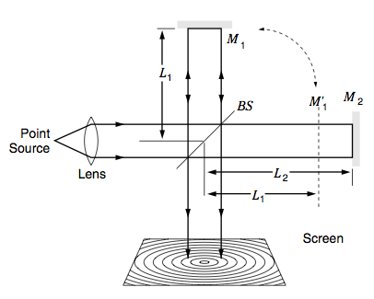

Figure 2.16: Michelson interferometer (M₁, M₂: amirrors, BS: beam splitter, path difference between M₁ and M₂ :2(L₂-L₁))

This is a Michelson interferometer, which is constructed from a beamsplitter and two mirrors. The beamsplitter is a partially reflecting mirror that separates the light incident upon it into two beams of equal strength. After reflecting off the mirrors, the two beams are recombined so that they both travel in the same direction when they reach the screen. If the two mirrors are the same distance (Ll = L2 in Fig. 2.16) from the beamsplitter, then the two beams are always in phase once they are recombined, just as is the case along the line of constructive interference in Young’s experiment. Now the condition of constructive and destructive interference depends on the difference between the paths traveled by the two beams. Since each beam must travel the distance from the beamsplitter to its respective mirror and back, the distance traveled by the beam is 2L. If the path-length difference, 2L1 - 2L2, is equal to an integral number of wavelengths, mλ, where m is an integer, then the two waves are in phase and the interference at the screen will be constructive.
L₁ -L₂ =mλ/2 (m=...,-1,0,1,2,...).
If the path-length difference is an integral number of wavelengths plus a half wavelength, the interference on the screen will be destructive. This can be expressed as
L₁ - L₂ = m λ /4 (m = odd integers).
In most cases the wavefronts of the two beams when they are recombined are not planar, but are spherical wavefronts with long radii of curvature. The interference pattern for two wavefronts of different curvature is a series of bright and dark rings. However, the above discussion still holds for any point on the screen. Usually, however, the center of the pattern is the point used for calculations.
In the above discussion, it was assumed that the medium between the beamsplitter and the mirrors is undisturbed air. If, however, we allow for the possibility that the refractive index in those regions could be different, then the equation for the bright fringes should be written as
n₁L₁ -n₂L₂ =mλ/2 (m=...-1,0,1,2,...).
Thus, any change in the refractive index in the regions can also contribute to the interference pattern.
In optical system design, interferometers such as the Michelson interferometer can be used to measure very small distances. For example, a movement of one of the mirrors by only one quarter wavelength (corresponding to a path-length change of one half wavelength) changes the detected irradiance at the screen from a maximum to a minimum. Thus, devices containing interferometers can be used to measure movements of a fraction of a wavelength. One application of interference that has developed since the invention of the laser is holography. This fascinating subject is explored in a separate set of experiment in this laboratory.

Experimental Set Up:

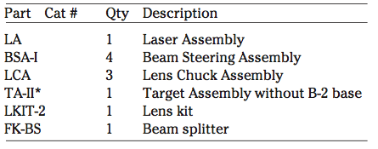

Table 2.3: Required Equipment

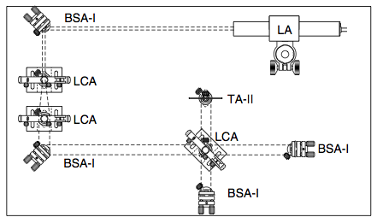
Figure 2.17: Schematic view of Michelson Interferometer experiment.

- Mount a laser assembly (LA) to the rear of the breadboard (Fig 2.17). Adjust the position of the laser such that the beam is parallel to the edge and on top of a line of tapped holes in the bread- board top. Tape an index card with a small (about 2 mm) hole in it to the front of the laser, so that the laser beam can pass through it. This card will be used as a screen to monitor the reflections from the components as they are inserted in the beam.
- Mount a beam steering assembly (BSA-I) approxi- mately 4 inches in from the far corner of the breadboard (Fig. 2.17). Adjust the height of the mirror mount until the beam intersects the center of the mirror. Then rotate the post in the post holder until the laser beam is parallel to the left edge and the surface of the breadboard.
- Place a second beam steering assembly (BSA-I) in line with the laser beam at the lower left corner of the breadboard, (Fig. 2.17).
- Set up a beam expander between the first two BSA-I’s. This beam expander generates an expanded plane wave that is needed to build the interferometer.
- Place a lens chuck assembly (LCA) approximately five inches to the right of the last BSA-I mount. Mount a 50/50 beam splitter in the LCA and rotate the assembly 45 degrees to the optical path. The beam reflected off of the first surface should be perpendicular to and going in the direction of the front edge of the breadboard. The beamsplitter divides the incoming laser beam into two equal components for the two arms of the interferom- eter.
- Place a BSA-I with its mirror centered about the path of the reflected beam and about five inches from the beamsplitter such that the beam is retro-reflected back onto the index card taped to the laser. This mirror will be called the reference mirror.
- Place a second BSA-I with its mirror centered about the path of the transmitted beam five inches beyond the beam splitter to intercept the transmitted beam (Fig. 2.17). Adjust the mirror until its beam is directed back to the index card taped to the laser. This mirror will be called the test mirror.
- Use a TA-II* (no base) with an index card (QI) as an observation screen on the other side of the beamsplitter from the reference mirror (See Step 6). Adjust the mirrors in the two arms of the interferometer until the two beams overlap on the screen. There should be combined reflections at the observation screen and on the card at the front of the laser. Aligning the two beams on the card at the front of the laser is good for a quick rough alignment.
- As the two beams are brought into coincidence, a series of bright and dark fringes should appear representing the interference pattern between the two wavefronts. The orientation and separa- tion of the fringes can be controlled by adjusting the reference and test mirrors. Usually it is best to use one mirror for adjustment. Adjust the mirror so that approximately five fringes appear across the beam on the card. The number of fringes can be varied in a particular direction by tilting the reference mirror in a direction perpen- dicular to the direction of the fringes. Your Michelson interferometer is now completed.
- Any curvature present in the fringes represent phase differences between the waves that have traversed the two arms of the interferometer, i.e. the reference mirror arm and the test mirror arm. If the reference mirror is assumed to be perfectly lat, then the curvature in the fringes may be due to the fact that the mirror under test is not flat, but has a long radius of curvature or aberrations. These aberrations cause the plane wave, gener- ated by the beam expander, in the test arm to depart from a plane wave. The interference of the plane wave reference wavefront with the test mirror wavefront will create a pattern of curved fringes with varying separation. The amount of the departure of a curved fringe from a straight line, represents the phase shift introduced by the component under test. This departure, measured in number of fringes, gives twice the departure of the test wavefront from the reference wavefront in wavelength of laser light. The amount of test mirror aberration (W ) may be calculated as follows:

W = (fringe shift)/2
where W is expressed in units of the wavelength of the laser used (in this case the laser wave- length is 633 nm), and fringe shift is the height of the fringe expressed in units of the average fringe separation distance in the interference pattern. The factor of two arises from the fact that reflection doubles the amount of aberration.
- Move the second lens of the beam expander slowly toward the first. The expanded beam now diverges, causing the wavefront to be spherical instead of planar. The fringes will become circular and if you further adjust the beam coincidence, a bull’s-eye pattern can be seen.
- Turn the soldering iron (QS) on, and after it warms up place it in the path of the light in the test arm. Observe the changes in the fringes around the tip of the soldering iron. The shift in the fringes is due to the extra phase shift intro- duced by the hot air surrounding the iron tip. Hot air has a different density and refractive index than cold air and consequently the two arms have a different optical path-lengths.
- Insert your finger partway into one of the arms of the interferometer, so that its shadow can be seen on the screen. Notice the variations in the fringes just due to the heat of your finger. Also hold your hand palm up just below one of the interferometer arms.
- Push on the test mirror and note that very little force leads to tiny deflections of the test mirror. These deflections are measurable as indicated by the shift in the fringes. For each fringe that moves past a point in the center of the pattern the mirror has moved one half wavelength along the beam direction. Try to devise a means of slowly moving one mirror. If the motion is slow enough you can count the number of fringes and determine the amount of mirror displacement.
- Another means of changing the optical path inside the interferometer is to insert a transpar- ent material, such as a microscope slide or other flat material, in one of the arms. The departure of the fringe pattern from the undisturbed system is a measure of the refractive index and thickness variation in the material.

Additional experiments: Distance measurement.
Time dependence of the fringes
1. After setting up the Michelson interferometer, monitor the change in the fringe pattern as a function of time. Usually thermal changes will cause small expansion and contractions in the component distances and this will result in a shift of the fringes with time.
Vibration dependence of the fringes
2. Tap on the surface of the table and monitor the changes in the fringes. How long does it take the vibration to damp out? Do you detect any vibrational motion when you slam a door, walk across the room, or jump up and down? Some tables have air cushions or springs to isolate an optical system such as a Michelson Interferometer from the vibrations of the outside world.
Motion detector
3. This is a somewhat more elaborate experiment and requires a light detector such as a photocell or phototransistor. *Replace the observation screen with the detector and a large pinhole that allows only one fringe to pass. When the fringe pattern moves the light on detector will create alternately strong and weak signals. If the detec- tor is hooked up to an audio amplifier and speaker, the alternating signal will provide an audible sound. The frequency of the sound will depend upon the number of fringes per second that sweep past the pinhole. Since each fringe represents one half wavelength mirror move- ment, the pitch of the sound wave represents the speed of motion of the mirror.

EXPERIMENT 2.3: ANALYZING POLARIZATION STATUS OF LIGHT BEAM

Preface

While the idea of polarization is fairly simple, it remains somewhat abstract until you can work with light and its various forms of polarization. The object of this project is to give you some experience in the orientation and generation of polar- ized light.

Theory of the Experiment:

Since electric and magnetic fields are vector quantities, both their magnitude and direction must be specified. But, because these two field directions are always perpendicular to one another in nonabsorbing media, the direction of the electric field of a light wave is used to specify the direction of polarization of the light. The kind and amount of polarization can be determined and modified to other types of polarization. If you understand the polarization properties of light, you can control the amount and direction of light through the use of its polarization properties.

Types of Polarization

The form of polarization of light can be quite complex. However, for most design situations there are a limited number of types that are needed to describe the polarization of light in an optical system. Fig. 2.18 shows the path traced by the electric field during one full cycle of oscillation of the wave (T = 1/ν) for a number of different types of polarization, where ν is the frequency of the light. Fig. 2.18(a) shows linear polarization, where orientation of the electric field vector of the wave does not change with time as the field amplitude oscillates from a maximum value in one direction to a maximum value in the opposite direction. The orientation of the electric field is referenced to some axis perpendicular to the direction of propagation. In some cases, it may be a direction in the laboratory or optical system, and it is specified as horizontally or vertically polarized or polarized at some angle to a coordinate axis.

Because the electric field is a vector quantity, electricfields add as vectors. For example, two fields, E_{x} and E_{y}, linearly polarized at right angles to each other and oscillating in phase (maxima for both waves occur at the same time), will combine to give another linearly polarized wave, shown in Fig. 2.18(b), whose direction (tanθ = E_{y} /E_{x}) and amplitude () are found by addition of the two components. If these fields are 90° out of phase (the maximum in one field occurs when the other field is zero), the electric field of the combined fields traces out an ellipse during one cycle, as shown in Fig.2.18(c). The result is called elliptically polarized light. The eccentricity of the ellipse is the ratio of the amplitudes of the two components. If the two components are equal, the trace is a circle. This polarization is called circularly polarized. Since the direction of rotation of the vector depends on the relative phases of the two components, this type of polarization has a handedness to be specified. If the electric field coming from a source toward the observer rotates counterclockwise, the polarization is said to be left-handed. Right-handed polarization has the opposite sense, clockwise. This nomenclature applies to elliptical as well as circular polarization. Light whose direction of polarization does not follow a simple pattern such as the ones described here is sometimes eferred to as unpolarized light. This can be somewhat misleading because the field has an instantaneous direction of polarization at all times, but it may not be easy to discover what the pattern is. A more descriptive term is randomly polarized light.
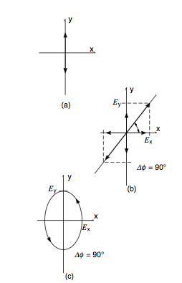
Figure 2.18: Three special polarization orientations: (a) linear, along a coordinate axis; (b) linear, components along coordinate axes are in phase (∆Φ = 0) and thus produce linear polarization; (c) same components, 90° out of phase, produce elliptical polariza tion.

Light from most natural sources tends to be randomly polarized. While there are a number of methods of converting it to linear polarization, only those that are commonly used in optical design will be covered. One method is reflection, since the amount of light reflected off a tilted surface is dependent on the orientation of the incident polarization and the normal to the surface. A geometry of particular interest is one in which the propagation direction of reflected and refracted rays at an interface are perpendicular to each other, as shown in Fig. 2.19. In this orientation the component of light polarized parallel to the plane of incidence (the plane containing the incident propagation vector and the surface normal, i.e., the plane of the page for Fig. 2.19) is 100% transmitted. There is no reflection for this polarization in this geometry. For the component of light perpendicular to the plane of incidence, there is some light reflected and the rest is transmitted. The angle of incidence at which this occurs is called Brewster’s angle, θ_{B}, and is given by:

tanθ_{B} = n_{trans}/n_{incident}

As an example, for a crown glass, n = 1.523, and the Brewster angle is 56.7°.

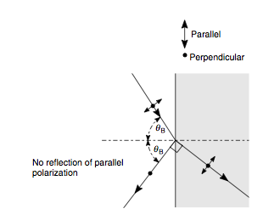

Figure 2.19: Geometry for the Brewster angle.

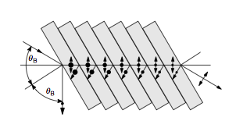

Figure 2.20: A “Pile of Plates” polarizer. This device working at Brewster angle, reflects some portion of the perpendicular polarization (here depicted as a dot, indicating an electric field vector perpendicular to the page) and transmits all parallel polarization. After a number of transmissions most of the perpen- dicular polarization has been reflected away leaving a highly polarized parallel component.

Sometimes only a small amount of polarized light is needed, and the light reflected off of a single surface tilted at Brewster’s angle may be enough to do the job. If nearly complete polarization of a beam is needed, one can construct a linear polarizer by stacking a number of glass slides (e.g., clean microscope slides) at Brewster’s angle to the beam direction. As indicated in Fig. 2.20, each interface rejects a small amount of light polarized perpendicular to the plane of incidence.

The “pile of plates” polarizer just described is somewhat bulky and tends to get dirty, reducing its efficiency. Plastic polarizing films are easier to use and mount. These films selectively absorb more of one polarization component and transmit more of the other. The source of this polarization selection is the aligned linear chains of a polymer to which lightabsorbing iodine molecules are attached. Light that is polarized parallel to the chains is easily absorbed; whereas light polarized perpendicular to the chains is mostly transmitted. The sheet polarizers made by Polaroid Corporation are labeled by their type and transmission. Three common linear polarizers are HN-22, HN-32, and HN- 38, where the number following the HN indicates the percentage of incident unpolarized light that is transmitted through the polarizer as polarized light.
When you look through a crystal of calcite (calcium carbonate) at some writing on a page, you see a double image. If you rotate the calcite, keeping its surface on the page, one of the images rotates with the crystal while the other remains fixed. This phenomenon is known as double refraction. (Doubly refracting is the English equivalent for the Latin birefringent.) If we examine these images through a sheet polarizer, we find that each image has a definite polarization, and these polarizations are perpendicular to each other.

Calcite crystal is one of a whole class of birefringent crystals that exhibit double refraction. The physical basis for this phenomenon is described in detail in most optics texts. For our purposes it is sufficient to know that the crystal has a refractive index that varies with the direction of propagation in the crystal and the direction of polarization. The optic axis of the crystal (no connection to the optical axis of a lens or a system) is a direction in the crystal to which all other directions are referenced. Light whose component of the polarization is perpendicular to the optic axis travels through the crystal as if it were an ordinary piece of glass with a single refraction index, n₀. Light of this polarization is called an ordinary ray. Light polarized parallel to a plane containing the optic axis has a refractive index that varies between n₀ and a different value, n_{e}. The material exhibits a refractive index n_{e} where the field component is parallel to the optic axis and the direction of light propagation is perpendicular to the optic axis. Light of this polarization is called an extraordinary ray. The action of the crystal upon light of these two orthogonal polarization components provides the double images and the polarization of light by transmission through the crystals. If one of these components could be blocked or diverted while the other component is transmitted by the crystal, a high degree of polarization can be achieved.

In many cases polarizers are used to provide information about a material that produces, in some manner, a change in the form of polarized light passing through it. The standard configuration, shown in Fig. 0.24, consists of a light source S, a polarizer P, the material M, another polarizer, called an analyzer A, and a detector D. Usually the polarizer is a linear polarizer, as is the analyzer. Sometimes, however, polarizers that produce other types of polarization are used.

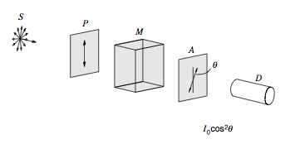

Figure 2.21: Analysis of polarized light. Randomly polarized light from source S is linearly polarized after passage through the polarizer P with irradiance I₀. After passage through optically active material M, the polarization vector has been rotated through an angle θ. (The dashed line of both polarizers A and P denote the transmission axes; the arrow indicates the polarization of the light.) The light is analyzed by polarizer A, transmitting an amount I₀cos2θ that is detected by detector D. The amount of light transmitted by a polarizer depends on the polarization of the incident beam and the quality of the polarizer. Let us take, for example, a perfect polarizer — one that transmits all of the light for one polarization and rejects (by absorption or reflection) all of the light of the other polarization. The direction of polarization of the transmitted light is the polarization axis, or simply the axis of the polarizer. Since randomly polarized light has no preferred polarization, there would be equal amounts of incident light for two orthogonal polarization directions. Thus, a perfect linear polarizer would have a Polaroid designation of HN-50, since it would pass half of the incident radiation and absorb the other half. The source in Fig. 2.21 is randomly polarized, and the polarizer passes linearly polarized light of irradiance Io. If the material M changes the incident polarization by rotating it through an angle θ, what is the amount of light transmitted through an analyzer whose transmission axis is oriented parallel to the axis of the first polarizer? Since the electric field is a vector, we can decompose it into two components, one parallel to the axis of the analyzer, the other perpendicular to this axis. That is

(Note that the parallel and perpendicular components here refer to their orientation with respect to the axis of the analyzer and not to the plane of incidence as in the case of the Brewster angle.) The transmitted field is the parallel component, and the transmitted irradiance Itrans is the time average square of the electric field
or
I_{trans} = I₀ cos²θ

This equation, which relates the irradiance of polarized light transmitted through a perfect polarizer to the irradiance of incident polarized light, is called the Law of Malus, after its discoverer, Etienne Malus, an engineer in the French army. For a nonperfect polarizer, I₀ must be replaced by αI₀, where α is the fraction of the preferred polarization transmitted by the polarizer.

Polarization Modifiers

Besides serving as linear polarizers, birefringent crystals can be used to change the type of polarization of a light beam. We shall describe the effect that these polarization modifiers have on the beam and leave the explanation of their operation to a physical optics text.

In a birefringent crystal, light whose polarization is parallel to the optic axis travels at a speed of c /n||; for a polarization perpendicular to that, the speed is c/n⊥. In calcite n⊥ > n||, and therefore the speed of light polarized parallel to the optic axis, v||, is greater than v⊥. Thus, for calcite, the optic axis is called the fast axis and a perpendicular axis is the slow axis. (In other crystals n|| may be greater than n⊥ and the fast-slow designation would have to be reversed.)
The first device to be described is a quarter-wave plate. The plate consists of a birefringent crystal of a specific thickness d, cut so that the optic axis is parallel to the plane of the plate and perpendicular to the edge, as shown in Fig. 2.22. The plate is oriented so that its plane is perpendicular to the beam direction and its fast and slow axes are at 45° to the polarized direction of the incident linearly polarized light. Because of this 45° geometry, the incident light is split into slow and fast components of equal amplitude traveling through the crystal. The plate is cut so that the components, which were in phase at the entrance to the crystal, travel at different speeds through it and exit at the point when they are 90°, or a quarter wave, out of phase. This output of equal amplitude components, 90° out of phase, is then circularly polarized. It can be shown that when circularly polarized light is passed through the same plate, linearly polarized light results. Also, it should be noted that if the 45° input geometry is not maintained, the output is elliptically polarized. The angle between the input polarization direction and the E optic axis determines the eccentricity of the ellipse.

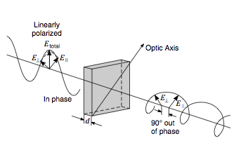

Figure 2.22: Quarter-wave plate. Incident linearly polarized light is oriented at 45 ° object axis so that equal E|| and E⊥ components are produced. The thickness of the plate is designed to produce a phase retardation of 90° of one component relative to the other. This produces circularly polarized light. At any other orientation elliptically polarized light is produced.

If a crystal is cut that has twice the thickness of the quarter-wave plate, one has a half-wave plate. In this case, linearly polarized light at any angle θ with respect to the optic axis provides two perpendicular components which end up 180° out of phase upon passage through the crystal. This means that relative to one of the polarizations, the other polarization is 180° from its original direction. These components can be combined, as shown in Fig. 2.23, to give a resultant whose direction has been rotated 2θ from the original polarization. Sometimes a half wave plate is called a polarization rotator. It also changes the “handedness” of circular polarization from left to right or the reverse. This discussion of wave plates assumes that the crystal thickness d is correct only for the wavelength of the incident radiation. In practice, there is a range of wavelengths about the correct value for which these polarization modifiers work fairly well.

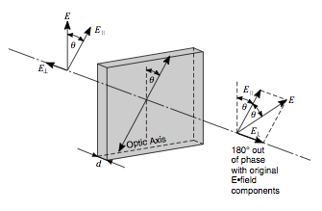

Figure 2.23: Half-wave plate. The plate produces a 180° phase lag between the E|| and E⊥ components of the incident linearly polarized light. If the original polarization direction is at an angle θ to the optic axis, the transmitted polarization is rotated through 2θ from the original.

Waveplates provide good examples of the use of polarization to control light. One specific demonstration concerns reflection reduction. Randomly polarized light is sent through a polarizer and then through a quarter wave plate to create circularly polarized light, as noted above. When circularly polarized light is reflected off a surface, its handedness is reversed (right to left or left to right). When the light passes through the quarter wave plate a second time, the circularly polarized light of the opposite handedness is turned into linearly polarized light, but rotated 90° with respect to the incident polarization. Upon passage through the linear polarizer a second time, the light is absorbed. However, light emanating from behind a reflective surface (computer monitor, for example) will not be subject to this absorption and a large portion will be transmitted by the polarizer. A computer antireflection screen is an application of these devices. Light from the room must undergo passage through the polarizer-waveplate combination twice and is, therefore suppressed, whereas light from the computer screen is transmitted through the combination but once and is only reduced in brightness. Thus, the contrast of the image on the computer screen is enhanced significantly using this polarization technique.

The output of the laser used in the Project in Optics Kit has three modes with two of the modes polarized orthogonally to the third mode. Because the laser has no special stabilization circuitry, the modes of the laser will tend to drift in frequency, so that one of the modes of one polarization may drop out and a mode of the orthogonal polarization pop in. So what had been the single mode polarization becomes the two mode polarization and vice versa! This phe- nomenon is referred to as mode sweeping. Its effect on these experiments is that the output of the laser in a particular polarization will change slowly over time.

So, as you take measurements during this experiment, be aware that some of the power variation may not be due to your efforts to change a variable, but may caused by mode sweeping effects. Two ways to minimize these effects are; (1) to let the laser warm up by turning it on as soon as you enter the lab and (2) take the data series more than once to account for any source variation. If there is time, you may want to monitor and record the power output of the laser for some period of time when you are not performing the experiments. These “baseline” measurements are useful to assess this power variation phenomenon.

NOTE: Part of this experiment requires a measurement of optical power levels. It is not possible for you to rely on your eye to perform this task. Its very construction with a diaphragm that closes down when the light gets too bright makes it a great image detector but a poor power meter. Therefore, some sort of optical detector must be used or constructed. If you do not have a Newport 615 or equivalent Optical Detector, you will need to obtain a standard laboratory voltmeter and construct a fairly simple detector. While there are a number of devices that will do the job, the instructions at the end of this Project should be sufficient to construct a simple photodetector circuit.

Experimental Set Up:

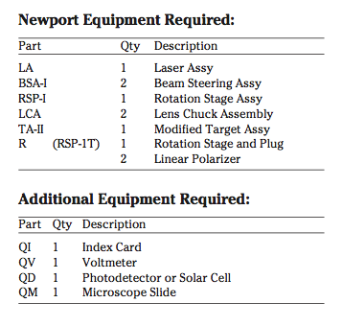

Table 2.4: Equipment Required

- Mount a laser assembly (LA) to the rear of the breadboard. Adjust the position of the laser such that the beam is parallel to the edge and on to of a line of tapped holes in the breadboard top. Tape an index card with a small (about 2 mm) hole in it to the front of the laser, so that the laser beam can pass through it. This card will be used as a screen to monitor the reflections from the components as they are inserted in the beam.

- Mount a beam steering assembly (BSA-I) approxi- mately 4 inches in from the far corner of the breadboard (Fig. 8-2). Adjust the height of the mirror mount until the beam intersects the center of the mirror. Then rotate the post in the post holder until the laser beam is parallel to the left edge and the surface of the optical breadboard.

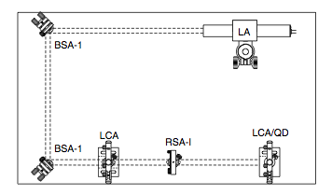
Figure 2.24: Schematic view of polarization of light experiment.

- Place a second beam steering assembly (BSA-I) in line with the laser beam at the lower left corner of the optical breadboard, (Fig. 2.24). Rotate and adjust the mirror mount until the laser beam is parallel to the front edge and the surface of the optical breadboard.
- Place the detector in a lens chuck assembly (LCA) and mount it well beyond the second BSA-I so that the beam hits the center of the detector.
- Mount a polarizer in an LCA assembly with the notch in the disk facing up. Tape a second polarizer by the edges to a rotation stage assembly (RSA-I) such that the notch is vertical when the rotation stage is set at 360°. Place both of these assemblies directly in line with the laser beam between the second BSA-I and the detector. The output of the device will be proportional to the irradiance of the light (Watts/m2). This quantity is proportional to the square of the amplitude of the electric field. Rotate the second polarizer by 10° increments between 0° and 180°, recording the angle and the output of the detector as measured by the voltmeter.
- Plot the results of your measurements and compare them to the Law of Malus.
I_{trans} = I₀ cos²θ

You will have to scale your comparison plot to the I₀, which is the maximum value recorded. Also, you may have missed the orientation of one of the polarizers by some amount and therefore the two curves may be shifted along the angle axis. You may have to adjust your plots to make the comparison, but you should justify any adjustment in your notebook.
- Remove the RSA-I from the bench and demount the Rotation Stage. Remove the polarizer and insert a plug in the 1 inch hole. Mount a Lens Chuck Assembly (LCA) without a base onto this stage by using the hole in the center of the plug. The Rotation Stage (R) is then attached to the table with 1/4-20 screws. Place the LCA such that the laser beam passes through the center of the lens holder. Tape a microscope slide (QM) to the lens holder so that the slide is held firmly in place and the beam does not pass through the tape (Fig. 2.25).

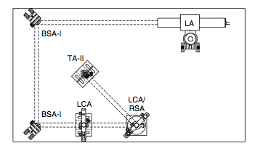

Figure 2.25: Schematic view of Brewster angle experiment.

- Set the Rotation Stage to 0°. Rotate the lens chuck in its holder so that the beam reflected from the slide is sent back along the input beam. You may want to use the index card with the hole in it to set the beam. Tighten the screw on the post, so that the lens chuck is fixed in the holder.
- Rotate the polarizer so that the transmission direction is horizontal to the table (notch upward). This means that the polarization vector is now horizontal and in a plane formed by the laser beam direction and the normal to the surface of the microscope slide. The plane defined by these two directions is called the plane of incidence.
- Replace the detector in the LCA with a modified target assembly (TA-II) since you are going to have to follow the beam on the table.
- Rotate the Rotation Stage (R) away from 0° and observe the reflection from the slide on the index card mounted in TA-II. At some point in this process the reflection from the slide will become very dim. Scan past the point of minimum reflection and observe that the reflected beam irradiance increases. By successive approximations, bring the stage to produce the minimum reflection. (You may find that you can improve the minimum by slightly tweaking the input polarization angle by a small amount.) Record the angle of the Rotation Stage and determine the angle between the beam and the normal to the surface. Compare this angle to that of Brewster’s angle discussed at the beginning of this section above, and the value given there.
- Rotate the input polarization of the beam to the orthogonal polarization and observe that no such reduction in the reflected beam irradiance occurs at any angle.

