9.Hafta 21’-24’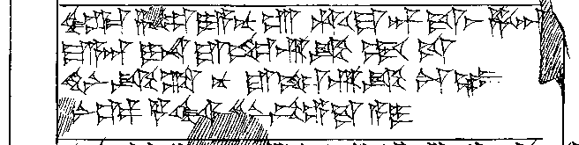
21’ ^{ḪUR.SAG}za-⌈li⌉-ya-nu-ú ḫu-u-ma-an-da-aš ḫa-a[n-te-ez-zi-iš?]
22’ ma-a-an I-NA ^{URU}ne-ri-ik ḫé-u-uš
23’ ḫi-ni-ik-ta nu ^{URU}ne-ri-ik-ka₄-az
24’ [L]Ú ^{GIŠ}GIDRU ^{NINDA}ḫar-ši-⌈in⌉ pé-e-da-a-i

