11.Hafta 4’-8’

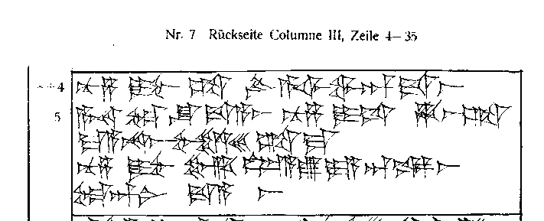

4’ [*nu-za*](http://www.hethport.uni-wuerzburg.de/txhet_myth/q.php?q=Hit|nu-za)[*DUMU.MUNUS*](http://www.hethport.uni-wuerzburg.de/txhet_myth/q.php?q=Hit|%EF%BC%9C%EF%BC%A1%EF%BC%AF%EF%BC%9A%EF%BC%B3%EF%BD%95%EF%BD%8D%EF%BD%85%EF%BD%92%EF%BD%89%EF%BD%81%EF%BD%8E%EF%BC%9EDUMU.MUNUS%EF%BC%9C%EF%BC%8F%EF%BC%9E)[*ŠA*](http://www.hethport.uni-wuerzburg.de/txhet_myth/q.php?q=Hit|%EF%BC%9C%EF%BC%A1%EF%BC%AF%EF%BC%9A%EF%BC%A1%EF%BD%8B%EF%BD%8B%EF%BC%A7%EF%BC%B2%EF%BC%A1%EF%BC%AD%EF%BC%9E%C5%A0A%EF%BC%9C%EF%BC%8F%EF%BC%9E)[LÚ*a-ši-wa-an-da-aš*](http://www.hethport.uni-wuerzburg.de/txhet_myth/q.php?q=Hit|%EF%BC%9C%EF%BC%A1%EF%BC%AF%EF%BC%9A%EF%BC%A4%EF%BD%85%EF%BD%94%EF%BD%85%EF%BD%92%EF%BD%8D%EF%BC%9EL%C3%9A%EF%BC%9C%EF%BC%8F%EF%BC%9Ea-%C5%A1i-wa-an-da-a%C5%A1)

5’ [*A-NA*](http://www.hethport.uni-wuerzburg.de/txhet_myth/q.php?q=Hit|%EF%BC%9C%EF%BC%A1%EF%BC%AF%EF%BC%9A%EF%BC%A1%EF%BD%8B%EF%BD%8B%EF%BC%A7%EF%BC%B2%EF%BC%A1%EF%BC%AD%EF%BC%9EA-NA%EF%BC%9C%EF%BC%8F%EF%BC%9E)[DAM*-ŠU*](http://www.hethport.uni-wuerzburg.de/txhet_myth/q.php?q=Hit|%EF%BC%9C%EF%BC%A1%EF%BC%AF%EF%BC%9A%EF%BC%B3%EF%BD%95%EF%BD%8D%EF%BC%A7%EF%BC%B2%EF%BC%A1%EF%BC%AD%EF%BC%9EDAM%EF%BC%9C%EF%BC%8F%EF%BC%9E-%EF%BC%9C%EF%BC%A1%EF%BC%AF%EF%BC%9A%EF%BC%A1%EF%BD%8B%EF%BD%8B%EF%BC%A7%EF%BC%B2%EF%BC%A1%EF%BC%AD%EF%BC%9E%C5%A0U%EF%BC%9C%EF%BC%8F%EF%BC%9E)[*da-a-aš*](http://www.hethport.uni-wuerzburg.de/txhet_myth/q.php?q=Hit|da-a-a%C5%A1)[*nu-za*](http://www.hethport.uni-wuerzburg.de/txhet_myth/q.php?q=Hit|nu-za)[DUMU.NITA](http://www.hethport.uni-wuerzburg.de/txhet_myth/q.php?q=Hit|%EF%BC%9C%EF%BC%A1%EF%BC%AF%EF%BC%9A%EF%BC%B3%EF%BD%95%EF%BD%8D%EF%BC%A7%EF%BC%B2%EF%BC%A1%EF%BC%AD%EF%BC%9EDUMU.NITA%EF%BC%9C%EF%BC%8F%EF%BC%9E)[*ḫa-aš-ta*](http://www.hethport.uni-wuerzburg.de/txhet_myth/q.php?q=Hit|%E1%B8%ABa-a%C5%A1-ta)

6’ [*ma-a-na-aš*](http://www.hethport.uni-wuerzburg.de/txhet_myth/q.php?q=Hit|ma-a-na-a%C5%A1)[*šal-le-eš-ta-ma*](http://www.hethport.uni-wuerzburg.de/txhet_myth/q.php?q=Hit|%C5%A1al-le-e%C5%A1-ta-ma)

7’ [*nu-za*](http://www.hethport.uni-wuerzburg.de/txhet_myth/q.php?q=Hit|nu-za)[DUMU.MUNUS](http://www.hethport.uni-wuerzburg.de/txhet_myth/q.php?q=Hit|%EF%BC%9C%EF%BC%A1%EF%BC%AF%EF%BC%9A%EF%BC%B3%EF%BD%95%EF%BD%8D%EF%BC%A7%EF%BC%B2%EF%BC%A1%EF%BC%AD%EF%BC%9EDUMU.MUNUS%EF%BC%9C%EF%BC%8F%EF%BC%9E)[MUŠ*il-lu-ya-an-ka-aš*](http://www.hethport.uni-wuerzburg.de/txhet_myth/q.php?q=Hit|%EF%BC%9C%EF%BC%A1%EF%BC%AF%EF%BC%9A%EF%BC%A4%EF%BD%85%EF%BD%94%EF%BD%85%EF%BD%92%EF%BD%8D%EF%BC%9EMU%C5%A0%EF%BC%9C%EF%BC%8F%EF%BC%9Eil-lu-ya-an-ka-a%C5%A1)

8’ [DAM*-an-ni*](http://www.hethport.uni-wuerzburg.de/txhet_myth/q.php?q=Hit|%EF%BC%9C%EF%BC%A1%EF%BC%AF%EF%BC%9A%EF%BC%B3%EF%BD%95%EF%BD%8D%EF%BC%A7%EF%BC%B2%EF%BC%A1%EF%BC%AD%EF%BC%9EDAM%EF%BC%9C%EF%BC%8F%EF%BC%9E-an-ni)[*da-a-aš*](http://www.hethport.uni-wuerzburg.de/txhet_myth/q.php?q=Hit|da-a-a%C5%A1)