一
yī one; single; a(n) common words
一个 yí ge a(n); one (of something) 一次 yí cì once
一同/一起 yī tóng/yī qǐ together 一月 yí yuè January
十一 shí yī eleven
第一 dì yī first
星期一 xīng qī yī Monday
1 stroke
radical
一
二
èr two (number) common words
二十 èr shí twenty
二妹 èr mèi second younger sister 二月 èr yuè February
二手 èr shǒu second hand
十二 shí èr twelve
第二 dì èr second
星期二 xīng qī èr Tuesday
2 stroke
radical
一
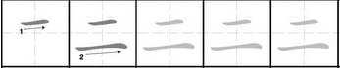
三
sān three common words
三十 sān shí thirty
三月 sān yuè March
三个月 sān ge yuè three months 三明治 sān míng zhì sandwich 十三 shí sān thirteen
第三 dì sān third
星期三 xīng qī sān Wednesday
3 strokes
radical
一
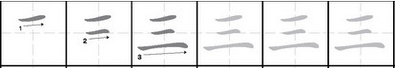
四
sì four
common words
四十 sì shí forty
四百 sì bǎi four hundred 四月 sì yuè April
四处 sì chù everywhere 十四 shí sì fourteen
第四 dì sì fourth
星期四 xīng qī sì Thursday
5 strokes
radical
囗
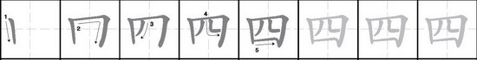
五
wǔ five
common words
五十 wǔ shí fifty
五月 wǔ yuè May
五年 wǔ nián five years 五本 wǔ běn five (books) 十五 shí wǔ fifteen
第五 dì wǔ fifth
星期五 xīng qī wǔ Friday
4 strokes
radical
一

六
liù six
common words
六十三 liù shí sān sixty-three 六月 liù yuè June
六个月 liù ge yuè six months 六天 liù tiān six days
十六 shí liù sixteen
第六 dì liù sixth
星期六 xīng qī liù Saturday
4 strokes
radical
亠

七
qī seven common words
七十七 qī shí qī seventy-seven
七百 qī bǎi seven hundred
七月 qī yuè July
十七 shí qī seventeen
七七八八 qī qī bā bā almost complete 七上八下 qī shàng bā xià worry; anxious 第七 dì qī seventh
2 strokes
radical
一

八
bā eight common words
八十二 bā shí èr eighty-two
八百零五 bā bǎi líng wǔ eight-hundred and five 八月 bā yuè August
八成 bā chéng 80 per cent
八折 bā zhé 20 per cent discount
十八 shí bā eighteen
第八 dì bā eighth
2 strokes
radical
八

九
jiǔ nine common words
九十八 jiǔ shí bā ninety-eight
九百一十 jiǔ bǎi yí shí nine-hundred and ten 九月 jiǔ yuè September
九号 jiǔ hào number/size nine; ninth (of a month) 九分 jiǔ fēn nine points
十九 shí jiǔ nineteen
第九 dì jiǔ ninth
2 strokes
radical
丿

十
shí ten
common words
十千/一万 shí qiān/yí wàn ten thousand 十月 shí yuè October
十一月 shí yī yuè November
十二月 shí èr yuè December
十分 shí fēn 1. ten points 2. very 十全十美 shí quán shí měi perfect; ideal 第十 dì shí tenth
2 strokes
radical
十

你
nǐ you

common words
你好 nǐ hǎo How do you do?
你的 nǐ de your; yours
你们 nǐ men you (plural)
你们的 nǐ men de your; yours (plural)

7 strokes
radical
人(亻)

您
nín you (polite) common words
您好 nín hǎo How do you do? (polite) 您早 nín zǎo Good morning!
您贵姓? nín guì xìng your family name?
11 strokes
radical
心
好
hǎo/hào 1. good 2. alright 3. like common words
好啊! hǎo a Good!; OK!
好看 hǎo kàn 1. good show 2. good looking
好久 hǎo jiǔ a long time
很好 hěn hǎo very good
还好 hái hǎo still alright
那好 nà hǎo alright then ... (agreeing to a suggestion)
6 strokes
radical
女

请
qǐng 1. please 2. to invite common words
请问 qǐng wèn May I ask ...? 请坐 qǐng zuò Please sit down. 请进 qǐng jìn Please come in. 请客 qǐng kè play host; treat 请教 qǐng jiào seek advice 请假 qǐng jià take leave
10 strokes radical
讠
traditional form
請
问
wèn ask common words
问好 wèn hǎo say hello to...
问题 wèn tí question; problem 问答 wèn dá question and answer 学问 xué wèn knowledge
访问 fǎng wèn 1. visit 2. interview
6 strokes radical
门
traditional form
問
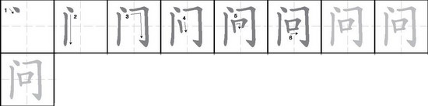
贵
guì 1. honorable 2. expensive; valuable common words
贵姓 guì xìng your honorable surname?
贵人 guì rén respected person
贵客/贵宾 guì kè/guì bīn distinguished guest; VIP 太贵了 tài guì le too expensive
名贵 míng guì valuable 9 strokes
radical
贝
traditional form
貴
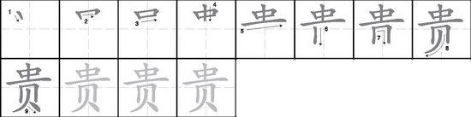
姓
xìng surname common words
姓名 xìng míng full name
同姓 tóng xìng having the same surname 老百姓 lǎo bǎi xìng common people
8 strokes
radical
女
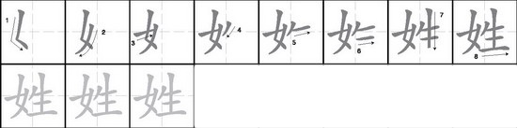
他
tā he
common words
他的 tā de his
他们 tā men they; them (male)
他们的 tā men de their; theirs (male) 他人/其他人 tā rén/qí tā rén other people 其他 qí tā other
5 strokes
radical
人(亻)
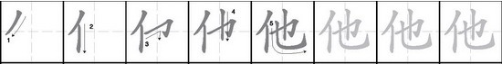
她
tā she
common words
她的 tā de hers
她们 tā men they; them (female) 她们的 tā men de their; theirs (female)
6 strokes
radical
女
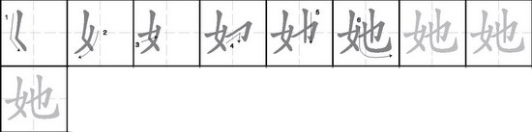
叫
jiào 1. call; be called 2. shout 3. order common words
叫门 jiào mén call at the door 叫好 jiào hǎo cheer
叫喊 jiào hǎn shout; yell 叫做 jiào zuò be called
叫车 jiào chē order a cab 大叫 dà jiào call out loudly
5 strokes
radical
口
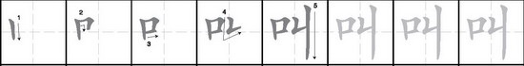
什
shén/shí 1. mixed 2. tenth (mathematics) common words
什么 shén me what
什么的 shén me de etc; so on...
什么时候? shén me shí hòu when?; at what time?
4 strokes
radical
人(亻)
