New Directions in Information Organization, 2013
Library and Information Science Trends and Research: Europe, 2012
Social Information Research, 2012
Web Search Engine Research, 2012
Library and Information Science Trends and Research: Asia-Oceania, 2012
New Directions in Information Behaviour, 2011
Power Laws in the Information Production Process: Lotkaian Informetrics, 2005
Link Analysis: An Information Science Approach, 2004
Understanding Reference Transactions: Transforming an Art into a Science, 2002
Models for Library Management, Decision Making and Planning, 2001
Communicating Research, 1997
Automated Information Retrieval: Theory and Methods, 1997
Information Tasks: Toward a User-centered Approach to Information Systems, 1996
Using Subject Headings for Online Retrieval: Theory, Practice and Potential, 1994
Information Services for Innovative Organizations, 1994
Operations Research for Libraries and Information Agencies: Techniques for the Evaluation of Management Decision Alternatives, 1991
Library Technical Services: Operations and Management, 1991
Developing People’s Information Capabilities, 2013

- Information Literacy Success by Quantum Integrations Staff, Solo... ISBN-13: 9780495913771 ISBN-10: 0495913774 2011 Edition: 2nd
$4.05 $19.99 Own it? Sell it back for $0.25
2.

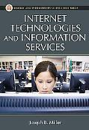

Internet Technologies and Information Services by Miller, Joseph B. ISBN-13: 9781591586258 ISBN-10: 1591586259 Paperback, 2008 List Price: $55.00
$30.67 (Save 44%) $20.98 (Save 61%) Own it? Sell it back for $8.50
3.

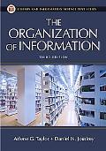

The Organization of Information: Third Edition by Taylor, Arlene G., Joudrey, Dani... ISBN-13: 9781591587002 ISBN-10: 159158700x Paperback, 2008 Edition: 3rd List Price: $50.00

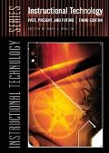

Instructional Technology Past, Present, and Future by Anglin, Gary J., Anglin, Gary J. ISBN-13: 9781563088063 ISBN-10: 1563088061 List Price: $55.00
$43.93 (Save 20%) $28.18 (Save 48%) Own it? Sell it back for $27.00
5.

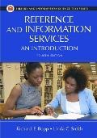

Reference And Information Services An Introduction by Bopp, Richard E., Smith, Linda C. ISBN-13: 9781591583745 ISBN-10: 1591583748 Paperback, 2010 Edition: 4th List Price: $50.00
$40.73 (Save 18%) $24.15 (Save 51%) Own it? Sell it back for $16.93
6.

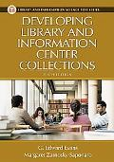

Developing Library And Information Center Collections by Evans, G. Edward, Saponaro, Marg... ISBN-13: 9781591582199 ISBN-10: 1591582199 Paperback, 2005 Edition: 5th List Price: $45.00
$0.49 (Save 98%) $29.73 (Save 33%)
7.

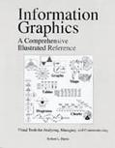

Information Graphics A Comprehensive Illustrated Reference by Harris, Robert L., Jr. ISBN-13: 9780195135329 ISBN-10: 0195135326 List Price: $70.00
$20.59 (Save 70%) $19.00 (Save 72%) Own it? Sell it back for $8.00
8.

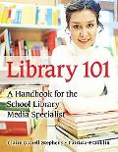

Library 101 A Handbook for the School Library by Stephens, Claire Gatrell, Frankl... ISBN-13: 9781591583240 ISBN-10: 1591583241 Hardcover, 2007 List Price: $35.00
$27.09 (Save 22%) $16.05 (Save 54%) Own it? Sell it back for $14.25
9.

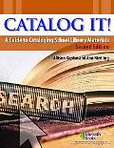

Catalog It! A Guide to Cataloging School Library Materials by Kaplan, Allison G., Riedling, An... ISBN-13: 9781586831974 ISBN-10: 1586831976 Paperback, 2006 Edition: 2nd List Price: $46.95
$25.31 (Save 46%) $19.00 (Save 59%) Own it? Sell it back for $12.53
10.

Children's Literature in Action by Vardell, Sylvia ISBN-13: 9781591585572 ISBN-10: 1591585570 Textbook Paperback, 2008 Edition: 1st List Price: $50.00
$36.11 (Save 27%) $20.98 (Save 58%) Own it? Sell it back for $13.25
11.

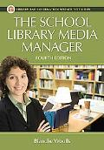

The School Library Media Manager by Woolls, Blanche ISBN-13: 9781591586432 ISBN-10: 1591586437 Paperback, 2008 Edition: 4th List Price: $45.00
$21.42 (Save 52%) $20.98 (Save 53%) Own it? Sell it back for $9.34
12.

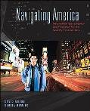

Navigating America: Information Competency and Research for the Twenty-First Century by Moton, David, Dumler, Gloria ISBN-13: 9780073383705 ISBN-10: 0073383708 Hardcover, 2009 List Price: $63.44
$25.62 (Save 59%) $19.00 (Save 70%) Own it? Sell it back for $18.50
13.

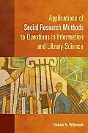

Applications of Social Research Methods to Questions in Information and Library Science by Wildemuth, Barbara M. ISBN-13: 9781591585039 ISBN-10: 1591585031 Paperback, 2009 List Price: $50.00
$29.93 (Save 40%) $22.71 (Save 54%) Own it? Sell it back for $15.96
14.

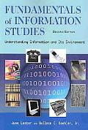

Fundamentals of Information Studies: Understanding Information and Its Environment by Lester, June, Koehler, Wallace C. ISBN-13: 9781555705947 ISBN-10: 1555705944 Textbook Hardcover, 2007 Edition: 2nd List Price: $65.00
$54.40 (Save 16%) $38.15 (Save 41%) Own it? Sell it back for $24.75
15.

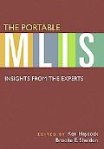

The Portable MLIS: Insights from the Experts by Haycock, Ken, Sheldon, Brooke E. ISBN-13: 9781591585473 ISBN-10: 1591585473 Paperback, 2008 List Price: $50.00
$17.24 (Save 65%) $19.00 (Save 62%) Own it? Sell it back for $10.50
16.

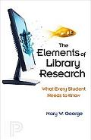

The Elements of Library Research by George, Mary W. ISBN-13: 9780691138572 ISBN-10: 0691138575 Paperback, 2008 List Price: $14.95
$0.01 (Save 99%) $29.84 Own it? Sell it back for $0.23
17.

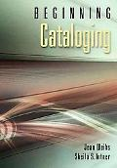

Beginning Cataloging by Intner, Sheila S. ISBN-13: 9781591588399 ISBN-10: 1591588391 Paperback, 2009 Edition: 1st List Price: $40.00
$32.02 (Save 19%) $20.98 (Save 47%) Own it? Sell it back for $14.25
18.

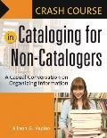

Crash Course in Cataloging for Non-Catalogers: A Casual Conversation on Organizing Information by Kaplan, Allison G. ISBN-13: 9781591584018 ISBN-10: 1591584019 Paperback List Price: $30.00
$31.06 Own it? Sell it back for $12.25
19.

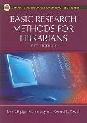

Basic Research Methods for Librarians by Connaway, Lynn Silipigni, Powell... ISBN-13: 9781591588658 ISBN-10: 1591588650 2010 Edition: 5th
$20.67 $19.00 Own it? Sell it back for $10.25
20.

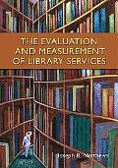

Evaluation and Measurement of Library Services by Matthews, Joseph R. ISBN-13: 9781591585329 ISBN-10: 1591585325 Paperback, 2007 List Price: $50.00
$36.16 (Save 27%) $30.96 (Save 38%) Own it? Sell it back for $12.25
21.

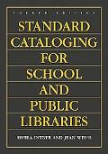

Standard Cataloging for School and Public Libraries by Weihs, Jean, Intner, Sheila S. ISBN-13: 9781591583783 ISBN-10: 1591583780 Paperback, 2007 List Price: $50.00
$19.99 (Save 60%) $15.00 (Save 70%) Own it? Sell it back for $12.53
22.

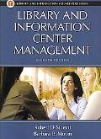

Library and Information Center Management by Stueart, Robert D., Moran, Barba... ISBN-13: 9781591584063 ISBN-10: 159158406X Paperback, 2007 List Price: $50.00
$1.94 (Save 96%) $23.57 (Save 52%)
23.

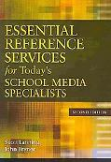

Essential Reference Services for Today's School Media Specialists by Bryner, John, Lanning, Scott ISBN-13: 9781591588832 ISBN-10: 1591588839 Paperback, 2009 Edition: 2nd List Price: $45.00
$19.60 (Save 56%) $15.05 (Save 66%) Own it? Sell it back for $10.25
24.

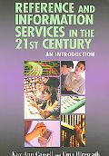

Reference And Information Services in the 21st Century An Introduction by Cassell, Kay Ann, Hiremath, Uma ISBN-13: 9781555705633 ISBN-10: 1555705634 Paperback, 2006 List Price: $65.00
$0.01 (Save 99%)
25.

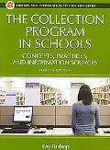

Collection Program in Schools Concepts, Practices, and Information Sources by Bishop, Kay ISBN-13: 9781591583608 ISBN-10: 1591583608 Paperback, 2007 List Price: $50.00
$5.45 (Save 89%) $20.98 (Save 58%) Own it? Sell it back for $0.25
26.

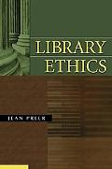

Library Ethics by Preer, Jean L. ISBN-13: 9781591586364 ISBN-10: 1591586364 Paperback, 2008 List Price: $45.00
$20.91 (Save 53%) $73.08 Own it? Sell it back for $8.21
27.

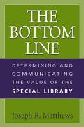

Bottom Line Determining and Communicating the Value of the Special Library by Matthews, Joseph R. ISBN-13: 9781591580041 ISBN-10: 1591580048 2002 List Price: $48.00
$14.05 (Save 70%) Own it? Sell it back for $3.75
28.

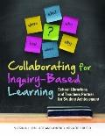

Collaborating for Inquiry-Based Learning : School Librarians and Teachers Partner for Studen... by Wallace, Virginia L., Husid, Whi... ISBN-13: 9781598848502 ISBN-10: 159884850X 2011
$38.51 $31.83 Own it? Sell it back for $15.00
29.

Merchandising Library Materials to Young Adults by Nichols, Mary Anne ISBN-13: 9780313313820 ISBN-10: 0313313822 List Price: $44.00
$6.43 (Save 85%)
30.

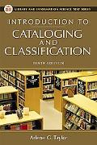

Introduction to Cataloging and Classification by Taylor, Arlene G., Miller, David P. ISBN-13: 9781591582359 ISBN-10: 1591582350 Paperback, 2006 Edition: 10th List Price: $50.00
$7.34 (Save 85%) $19.00 (Save 62%) Own it? Sell it back for $10.50
31.

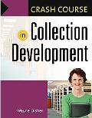

Crash Course in Collection Development by Disher, Wayne ISBN-13: 9781591585596 ISBN-10: 1591585597 Paperback, 2007 List Price: $30.00
$13.93 (Save 53%) $54.40 Own it? Sell it back for $3.25
32.

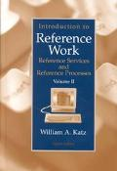

Introduction to Reference Work Reference Services and Reference Processes by Katz, William A. ISBN-13: 9780072441437 ISBN-10: 0072441437 Hardcover, 2001 Edition: 8th List Price: $106.88
$0.01 (Save 99%) $25.67 (Save 75%)
33.

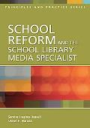

School Reform and the School Library Media Specialist by Hughes-Hassell, Sandra, Harada, ... ISBN-13: 9781591584278 ISBN-10: 1591584272 Paperback, 2007 List Price: $40.00
$3.00 (Save 92%) $33.53 (Save 16%)
34.

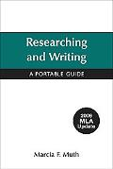

Research and Writing with 2009 by Muth, Marcia F. ISBN-13: 9780312607562 ISBN-10: 0312607563 Paperback, 2009 List Price: $18.75
$6.31 (Save 66%) $20.98 Own it? Sell it back for $3.08
35.

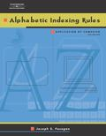

Alphabetic Indexing Rules Application by Computer by Fosegan, Joseph S. ISBN-13: 9780538434720 ISBN-10: 0538434724 Paperback, 2002 Edition: 4th List Price: $76.95
$16.98 (Save 77%) $19.00 (Save 75%) Own it? Sell it back for $9.30
36.

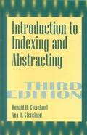

Introduction to Indexing and Abstracting by Cleveland, Donald B., Cleveland,... ISBN-13: 9781563086410 ISBN-10: 1563086417 Hardcover, 2000 Edition: 3rd List Price: $52.00
$10.04 (Save 80%) Own it? Sell it back for $0.25
37.

Alphabetic Indexing Rules Application by Computer by Fosegan, Joseph S. ISBN-13: 9780538970808 ISBN-10: 0538970804 Paperback, 2002 Edition: 4th List Price: $25.95
$15.18 (Save 41%) $20.98 (Save 19%) Own it? Sell it back for $0.25
38.

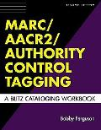

Marc/aacr2/authority Control Tagging A Blitz Cataloging Workbook by Ferguson, Bobby ISBN-13: 9781591582052 ISBN-10: 1591582059 Paperback, 2005 Edition: 2nd List Price: $32.00
$14.94 (Save 53%) Own it? Sell it back for $0.66
39.

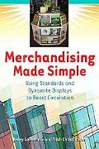

Merchandising Made Simple by LaPerriere, Jenny, Christiansen,... ISBN-13: 9781591585619 ISBN-10: 1591585619 Paperback, 2008
$18.65 Own it? Sell it back for $3.00
40.

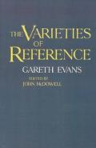

Varieties of Reference by Evans, Gareth, McDowell, John ISBN-13: 9780198246862 ISBN-10: 0198246862 Paperback, 1983 List Price: $99.00
$34.75 (Save 64%) $24.57 (Save 75%) Own it? Sell it back for $18.50
41.

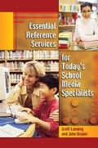

Essential Reference Services for Today's School Media Specialists by Lanning, Scott, Bryner, John ISBN-13: 9781591581376 ISBN-10: 1591581370 Paperback, 2004 List Price: $45.00
$3.40 (Save 92%)
42.

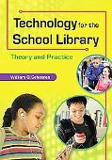

Technology for the School Librarian: Theory and Practice by Scheeren, William O. ISBN-13: 9781591589006 ISBN-10: 1591589002 Paperback, 2010 Edition: 1st List Price: $50.00
$45.34 (Save 9%) $41.28 (Save 17%) Own it? Sell it back for $21.86
43.

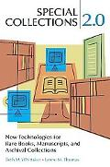

Special Collections 2.0: New Technologies for Rare Books, Manuscripts, and Archival Collections by Thomas, Lynne M., Whittaker, Beth ISBN-13: 9781591587200 ISBN-10: 1591587204 Paperback, 2009 Edition: 1st List Price: $45.00
$37.23 (Save 17%) $26.98 (Save 40%) Own it? Sell it back for $18.00
44.

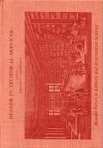

Reader in Technical Services by Applebaum, Edmond L. ISBN-13: 9780313240485 ISBN-10: 0313240485 List Price: $68.95

OUT OF STOCK
See Availability on Amazon
45.

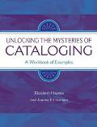

Unlocking the Mysteries of Cataloging A Workbook of Examples by Haynes, Elizabeth, Fountain, Joa... ISBN-13: 9781591580089 ISBN-10: 1591580080 2005 List Price: $38.00
$4.99 (Save 86%)
46.

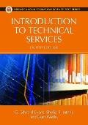

Introduction to Technical Services by Evans, G. Edward, Intner, Sheila... ISBN-13: 9781591588894 ISBN-10: 1591588898 2010 Edition: 8th
$60.51 $55.51 Own it? Sell it back for $13.50
47.

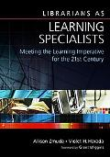

Librarians as Learning Specialists by Zmuda, Allison, Harada, Violet H. ISBN-13: 9781591586791 ISBN-10: 1591586798 Paperback, 2008 List Price: $40.00
$12.94 (Save 67%) $20.98 (Save 47%) Own it? Sell it back for $6.31
48.

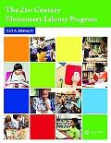

The 21st Century Elementary Library Media Program by Harvey, Carl A., II ISBN-13: 9781586833817 ISBN-10: 1586833812 Paperback, 2009 Edition: 1st List Price: $35.00
$38.70 Own it? Sell it back for $14.25
49.

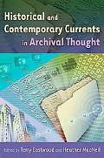

Currents of Archival Thinking by Eastwood, Terry, McNeil, Heather ISBN-13: 9781591586562 ISBN-10: 1591586569 Paperback, 2009 Edition: 1st List Price: $45.00
$49.51 $43.71 (Save 2%) Own it? Sell it back for $14.75
50.

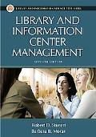

Library and Information Center Management by Stueart, Robert D., Moran, Barba...

