A Short History of Japanese Literature. Part 1
Introduction: Roots of Japanese Literature
Until the 60‘s of the 19th century Japans literature followed a very unique tradition. This is a result of the seclusion from any other country of Japan from 1600 to 1868. Apart from Chinese influences from the 5th to the 9th century Japanese literature is mostly untouched by foreign influences until then. It was meant for Japanese and mainly read by them.
The Japanese language, the Japanese writing system, the cultural background and the traditions were barriers too and made its appeal exotic until the middle of the 20th century.
The early folkloristic themes varied from tales of country, the old folks, climate and nature. The motives of the seasons are to be found in both prose and lyrics.
The special waka or tanka-lyric 和歌 with 31 syllables and the well-known haiku 俳句 with 17 syllables are unique.
Until modern times there is a tradition of „miniature“ literature: not too complicated structures or extraordinary plots, often there are autobiographical stories. Predominant is the literary genre of memoirs, the so-called nikki 日記 (diary) and the essay-writing 随筆 zuihitsu (essay).
In addition to that Japan has brought up many historical stories, which are called rekishi monogatari 歴史物語.
The development of Japanese literature is often divided into the following periods, but the Western classification given in brackets do not match exactly. Japans historical development is different from the Western historical system. Therefore it is only a light orientation:
– Yamato period: from the 6th century to 794 (antiquity)
– Heian period: from 794 to 1185 (classic)
– Kamakura and Muromachi period: from 1185 to 1600 (middle ages)
– Edo period: 1600 to 1868 (pre-modern)
– 1868 until today (modern)
Japanese literature in the Yamato period: from the 6th century to 794 (antiquity)
In the beginning of the 7th century there was a shift from oral tradition to written literature due to the adaption of Chinese characters. The Chinese script was known only to few people like priests and administration officials, and mainly high-class court members.
As Nara became the central capital in 710 a steady cultural development was to be seen.
The oldest historical literary work is the Kojiki 古事記 (Record of Ancient Matters) of 712, this accumulates the story of origins of old Japan, myths, and oral folkloristic tales. The collection was meant to strengthen the reign of the tennô.
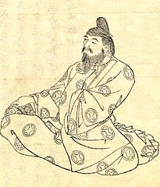
Ono Yasumaro- editor of the Kojiki. Other more folkloristic tales are compiled in so-called fudoki 風土記, which are provincial tales.
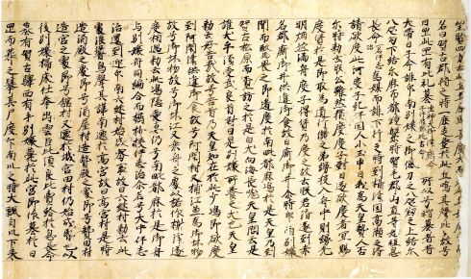
Harima Fudoki. Oldest Fudoki manuscript. The lyrical masterpiece of this period is the famous Man‘yôshû 万葉集, (The Ten Thousand Leaves) a compilation of poems of mainly court-members dealing with love and nature. It is about true-heartedness, pure feeling and romantic that is all defined in the term makoto 誠.

Japanese Literature in the Heian period: from 794 to 1185 (classic)
The development of the Japanese writing system as a mix of Chinese characters (kanji 漢字) and two syllable systems, Hiragana ひらがな and Katakana カタカナ, was essential for a more genuine Japanese literature. Its foundation is to be seen in two streams:
1. At the court in Heiankyô, today Kyôto, the noble court ladies wrote diaries and tales about daily high nobility life with all nuances of romance, behavior and manners. The female authors first used a script called Man‘yogana as a device which helped them to read ideographic Chinese characters. This was the basis of the first Japanese syllable system, the Hiragana, which is an integral part of Japanese today.
It consists of 48 syllables. It is used as an alphabet and you can write Japanese without using the complex Chinese characters (kanji). Here you can see the transformation from a kanji to a Hiragana.
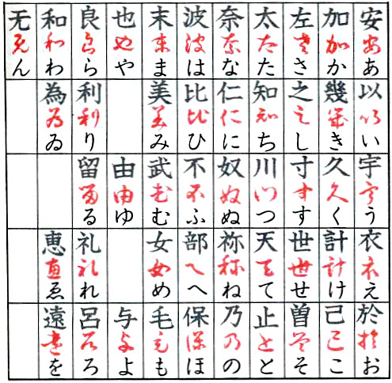
So the court ladies had now an easy tool to write and were eager to record everything which gave Japanese literature at court a boost.
The most important works are:
– The Genji monogatari 源氏物語 (The Tale of Genji) written by Lady Murasaki Shikibu in the early 11th century. A monumental work telling the story of Prince Genji and his adventures, amorous affairs and court intrigues.
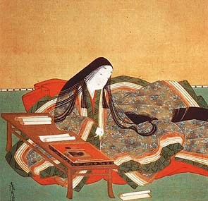
– Makura no sôshi 枕草子 (The Pillow Book) of Sei Shônagon. A diary of a noble court lady full of esprit.
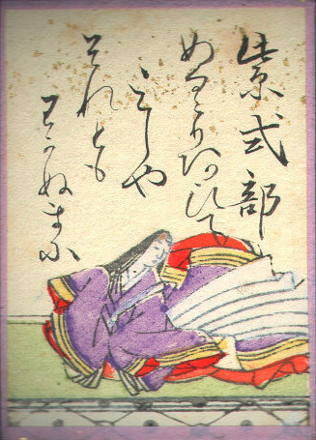
2. Buddhist literature of this time was more open to an overall perspective of Japanese life and even integrated folktales as well, this is the Setsuwa bungaku 説話文学. The priests used the Chinese characters and helped themselves to read a text with another syllable system. This was the origin of the Katakana, still in use today.
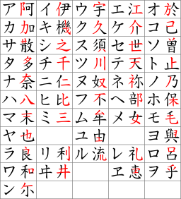
Still Japanese men used Chinese in official documents related to politics and administration and in poetry as well. There was a very lively poetry- scene: Regularly poet contests called uta awase 歌合 were held at the court and was a popular form of entertainment of the nobility.
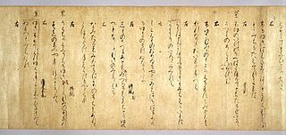
In 905 the most important official anthology of poems of the Heian period was the Kôkin wakashû 古今和歌集 or short Kokinshû 古今集. It was written on behalf of the imperial order of the tennô.
In addition poems were an integral part of Japanese tales, the uta monogatari 歌物語.
Apart from that the Japanese have written many tales monogatari in this period, unfortunately only few are available today, only to mention two of the most famous:
The Taketori monogari 竹取物語 (The Tale of the Bamboo Cutter).
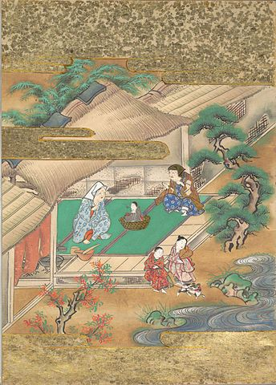
The Ise monogatari 伊勢物語 (Tales of Ise).
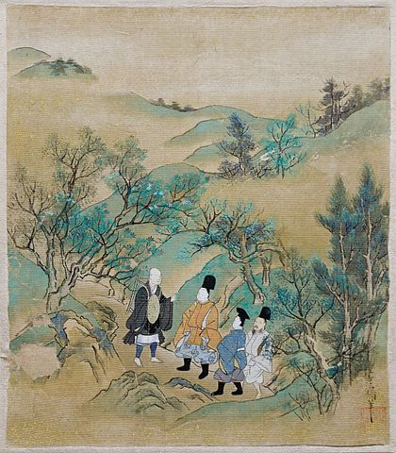
Although there was a strong influence of the Chinese until the 9th century, the Japanese became focussing on Japanese tradition and the development of the above mentioned literary streams.

Japanese Literature in the Kamakura and Muromachi Period: from 1185 to 1600 (Middle Ages)
Political rivalries and upheavals of clans brought great social and political changes to medieval Japan. The tennô and the court nobility lost their ruling power due to clan fightings. A military regime (bakufu 幕府) was established and the shôgun became the de facto ruler of the country. Japan was divided into many feudal territories (han). Kamakura became the capital from 1192 until 1333, far away from the imperial court in Kyôto. The tennô‘s role was now reduced to merely a puppet ruler. There were also harsh rivalries at the tennô-court itself, so that the tennô-family-line was temporarily split into two lines.
Culture and literature nearly limited to the nobility for a long time came under the influence of broader social groups; new themes and motives were invented.
As the court‘s influence in literature had vanished, the military nobility grew more important alongside the buddhist monks, as buddhism became more and more a Japanese religion of the masses.
New cultural developments are to be seen in new literary genres as follows:
The gunki monogatari – Military Tales
The gunki monogatari 軍記物語, were partly told on the streets and marketplaces in front of common people, who couldn‘t read or write. The samurai played an important role in literature, his virtues of power, courage and loyalty were praised.
A common literary motif was the transience and the acrimonious fate. Especially the Heike monogatari 平家物語 (The Tales of the Heike) is an important work of that time.
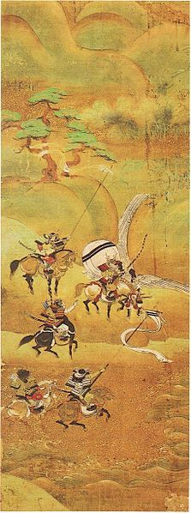
Travel Diaries and Poetry
When Kamakura had been the capital, many people had to travel to and fro Kyôto and Kamakura along the Tôkaidô 東海道.
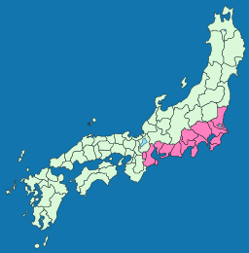
Many places at this route were praised in poems and stories called uta makura. In addition many travel diaries were written.
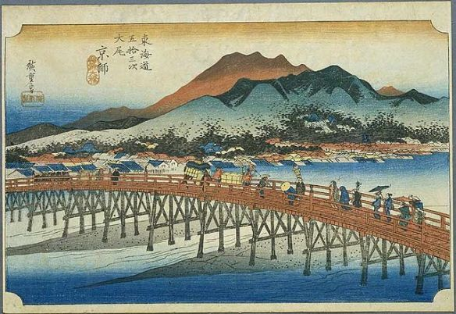
Poetry
A poem anthology, the Shin Kôkinwakashû 新古今和歌集 (New Collection of Poems Ancient and Modern) is to be mentioned as a praiseworthy literary work of this time.
Another outstanding work is the Tsurezuregusa 徒然草 (The Harvest of Leisure) by Yoshida Kenkô, an essay collection with new perspectives of old, mystical and imperfect motifs.
The traditional waka poem vanished slightly and the renga came into fashion due to its entertaining character as renga poems were created together in groups and now even with a broader social audience.
heatre: Nô and Kyôgen
Nô theatre was invented under the influence of Zen Buddhism since the 14th century. A very lyrical performance as an expression of inner emotions rather than complex staging. It is mysterious, religious and symbolic.
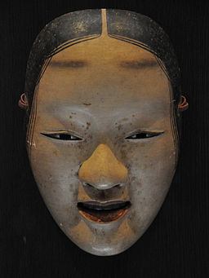
Kyôgen theatre is combined with Nô play and performed in between. It‘s comical character loosens the Nô theatre scenes up. Enjoyment is it‘s aim.
Japanese Literature in the Edo period from 1600 to 1868
Edo, today‘s Tôkyô, became the Japanese capital. There the Tokugawa clan presented the ruler of Japan, the shôgun. Kyôto, the old capital was still the residence of the imperial court and the tennô, who had no political power anymore. The country was held in strictly seclusion from nearly any other country.
Edo flourished as it became the political and economical centre and slightly turned also into the cultural place to be. From the mid-17th century onwards all main cultural activities happened in Edo, now a raising boom town.
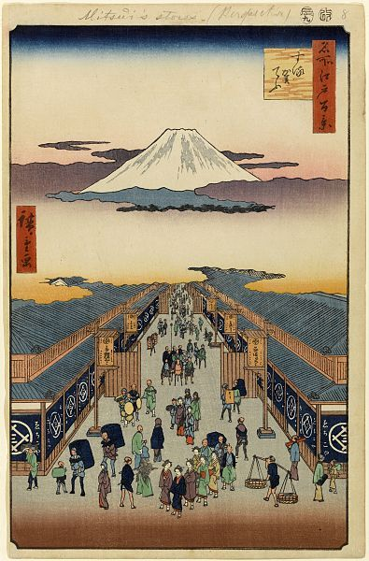
The Japanese society undertook rapid changes during the Edo period. Traditionally the Japanese society was divided into a four class-system, the shinôkôshô 士農工商. The class of the samurai took the first place on top of the peasants, then craftsmen and artisans, who both were named chônin 町人, that is citizens. The Japanese nobility and clergy were located above the four classes. All other people were declared as outcasts, so-called burakumin, like wanderer, prostitutes, people with professions seen as unclean as butchers and grave diggers and the like. There were specific rules and laws for each class regarding every aspect of private and business life.
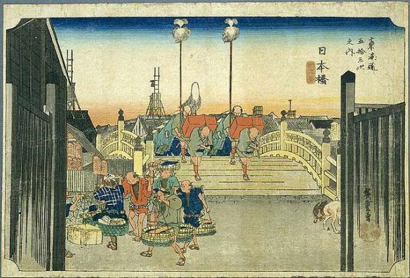
The installation of schools for everyone and the upcoming of the letterpress in the beginning of the 17th century gave a boost to education of the masses. Education now available on a broader scale to all citizens influenced the cultural and societal development. Japan showed a turn from a nobility culture into an urban culture; especially the chônin became more and more independent.

Japanese Fiction
At first Japanese classics were published. Then easy-to-read magazines, so-called kana-zôshi were printed and available for a broader readership.
Very famous is Ihara Saikaku 井原 西鶴 (1642-1693) as an author of this period, inventor of the ukiyo zôshi, magazines about the red-light districts. He is telling stories therein about the life of the chônin with all facets and particularly about Japanese amusement as well as given the reader an overview about morality and customs of traditional Edo-Japan.
Kenji Mizoguchi made a film of his Kôshoku Ichidai Onna 好色一代女 (The Life of an Amorous Woman) in 1952, named The Life of Oharu.
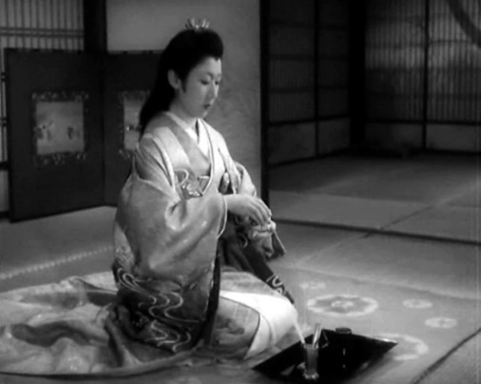
Ueda Akinari 上田 秋成 (1734-1809) wrote his well-known Ugetsu monogatari 雨月物語 (Tales of Moonlight and Rain), which includes fantastic tales and ghost stories. This work is one of the most popular anthology of Japanese literature.
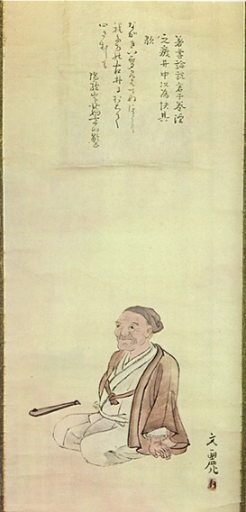
Apart from the above mentioned titles a new literary entertainment genre was invented at the beginning of the 19th century. The yomi-hon, a storybook, became widely in vogue as it provided colloquial speech, popular themes and motifs. Kyokutei Bakin 曲亭馬琴 (1767-1848) was a very famous writer of this popular magazines mainly dealing with historical topics.
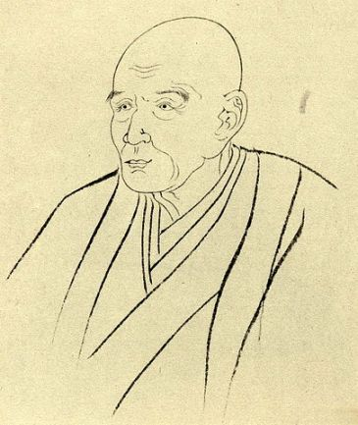
Many people liked to read and the literature targeted to the masses, often in form of
serialized novels. It was the beginning of Japanese fiction writing.
Poetry
Matsuo Bashô 松尾 芭蕉 (1644-1694) was the most famous Japanese poet of his time. He became very popular for his poetry style called haiku 俳句, a short poem consisting of 17 so-called on, a unit in phonology often referred to as syllables, but this is not quite equal because of the specialities of Japanese language.
He was a former samurai who did not like his military life, but choose to study the way of Zen-Buddhism. He lived in a buddhist monastery in Kyôto and near Tôkyô, but little is known of his life until 1676.
He wrote several hundred verses and that makes him popular on a broader scale. Soon he gathered followers around him. They built him a hut of banana leaves which gave him the name bashô 芭蕉. Since 1684 Bashô made many travels through Japan and took up his work of travel diaries mixed with haikus and drawings. These are still popular today. He worked also together with other poets developing haiku no renga, which is a popular variation of collaborative poetry.
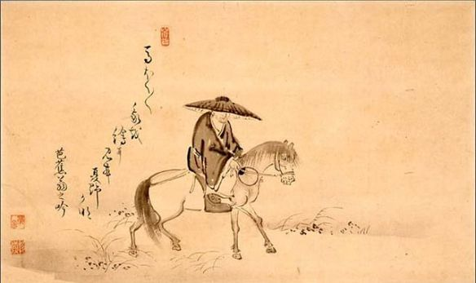
He was a master of poetry during his lifetime, who was respected and worshipped.
His most known poem is The Old Pond
古池や
蛙飛び込む
水の音
furuike ya
kawazu tobikomu
mizu no oto
Ah! The ancient pond
As a frog takes the plunge
Sound of the water
Japanese Literature (translations and fiction) in the Meiji era from 1868 to 1912
The arrival of Commodore Matthew C. Perry of the U.S. Navy in Japan in 1853 is a landmark in Japanese history as the beginning of the opening to the West.
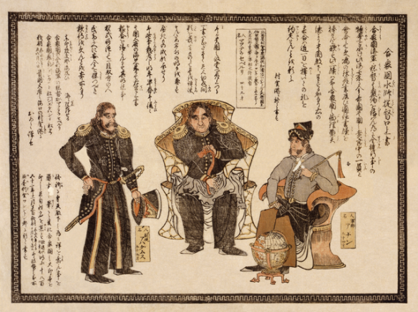
(Photo: Commodore Matthew C. Perry with two American seamen)
The Meiji Restoration in 1868 was a result of it with its effect on political, economical, social and cultural reconstruction and adoptions of Western thoughts. The Japanese- Chinese War in 1894/95 and the Japanese- Russian War in 1904/05 were then further turning points in Japanese history.
The rise of capitalism and industrialism had a strong influence on Japanese economy. The society changed under this influence, in addition Western thoughts of individualism and liberalism were newly adopted. These changes are mirrored by Japanese literature.
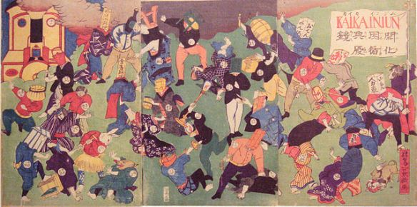
(Photo: The New fighting the Old in early Meiji Japan)
Modern Japanese literature from 1868 to 1912 is called nihon kindai bungaku 日本近代文学 in Japanese. In the first 20 years after the Meiji Restoration the influence of Western literature can be seen as follows: First there came up translations of Western authors of mainly English, American, Russian, French and German origin. The first Japanese translation was made of Self-Help by Samuel Smiles and Ernest Maltravers by Edward Bulwer-Lytton named A Spring Tale of Blossoms and Willows.
Ukigumo 浮雲 Drifting Cloud by Futabatei Shimei 二葉亭 四迷 (1864 – 1909) is referred to as the first Japanese modern novel, published from 1887 to 1889. He criticizes the social changes in Japan by telling a story of a young man, who lost his job. Futabatei is also known as a translator of Russian literature.
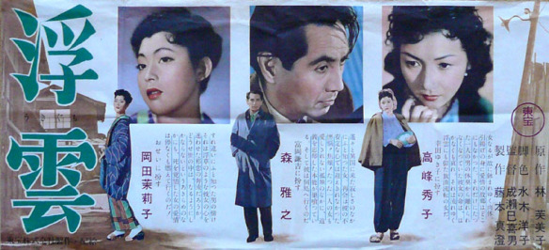
(Photo: Japanese movie poster of Ukigumo in 1955)
Further modern naturalistic literature of influence was written by Shimazaki Tôson 島崎 藤村 (1872-1943). His novel Hakai 破戒 The Broken Commandment of 1906 is a break with Japanese literature traditions. He writes about a so-called burakumin former eta, e.g. people who were seen as outcasts and are discriminated by Japanese society.
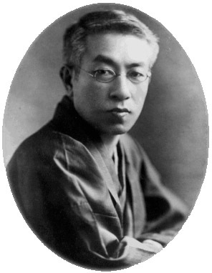(Photo: Shimazaki Tôson)
Another important work of Japanese naturalism of this time is Futon 蒲団 published in 1907 by Tayama Katai 田山 花袋 (1872- 1930). He invented the Japanese I novel, 私小説 shishôsetsu, that is storytelling with autobiographic confessions mainly in the first person, which soon became a genre in Japan.
The most popular and influential authors of the Meiji era are Mori Ôgai and Natsume Sôseki who became popular around the turn of the century.
Mori Ôgai 森 鷗外 (1862- 1922), a physician, writer and translator studied and worked in Germany from 1884 to 1889. Ôgai translated many works of especially German authors. He is a very famous and influential writer and is still respected today. His Wild Geese 雁 Gan of 1911-13 is best known to Western readers. A social novel about unfulfilled love and women in Japanese society.
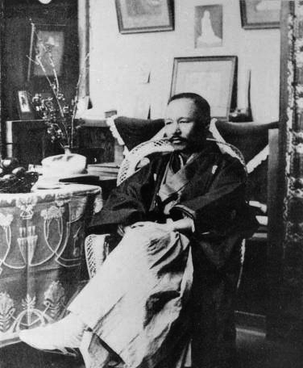
(Photo: Mori Ôgai, 1911)
Natsume Sôseki 夏目 漱石 (1867-1916) is also one of the most famous writer of the Meiji era and still well-known today as a very influential author. He has studied in London as one of the first Japanese abroad from 1900 to 1902. After his return to Japan he became a Professor of English Literature at the Tokyo University. He concentrated on writing novels as his writings were successful after 1907.
His literary works are classics of Japanese literature, here are only mentioned some of his notable works: I am a Cat 吾輩は猫である Wagahai wa neko de aru of 1905, Kokoro こゝろ of 1914, The Gate 門 Mon of 1910 and The Grass Pillow or The Three Cornered World 草枕 Kusa Makura of 1906.
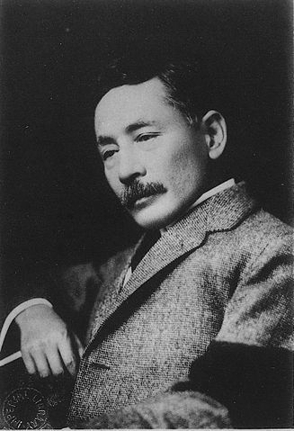
(Photo: Natsume Sôseki)

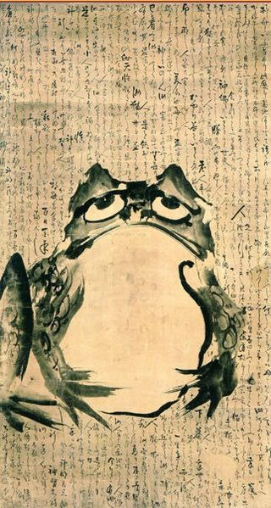

Drama
Chikamatsu Monzaemon 近松 門左衛門 (1653-1725) was a Japanese playwright who wrote more than hundred plays. He is most famous for his Jôruri dramas of puppet theatre. In Japan this genre is regarded as serious literature. Apart from that Chikamatsu wrote several Kabuki plays. Best known is his The Battles of Coxinga 国姓爺合戦 Kokusen’ya Kassen of 1715.
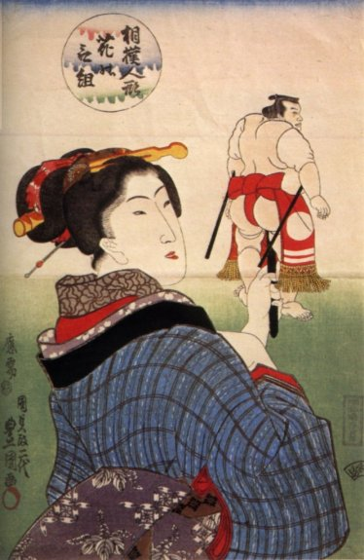
ukiyo, floating world, is a cultural key term of the Edo period for the search of amusement, popular entertainment and development of urban fashion. The rise of the geisha-culture, theatre as Kabuki and Bunraku and the woodblock printing ukiyo-e gave rise to a new urban culture which is still well-known today.
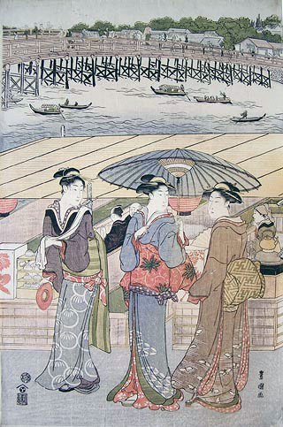

Japanese Literature in the Taishô era (1912-1926) and early Shôwa era – the development of the pre-war novel
Let me begin this post with a quotation, because it cannot be better shortly described:
“Taisho is Japan’s Jazz Age. Can it be summed up in a phrase? It often is: ero-guro-nansensu — eroticism, grotesquerie, nonsense.
All three filled the air. Was Taisho, then, mere frivolity? To cite only the plainest evidence to the contrary: World War I; the 1918 Rice Riots; “Taisho Democracy;” the founding in 1922 of the Japan Communist Party; the Great Kanto Earthquake of 1923; the granting of universal manhood suffrage in 1925; and the repressive Peace Preservation Law passed barely two months later … ” there is much turbulance in the Taishô era and the article of Michael Hoffmann is summing it up very well.
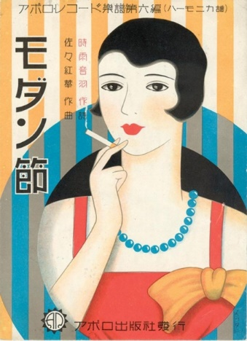
The great earthquake of 1923 in the Kantô region around Tokyo was a disaster: For many month the life of the metropolis was interrupted. The economy crashed and the effect was also felt in the publishing industry. The devastation had an impact on the literary scene as well. Authors moved from Tokyo to other cities and it took some time for new publications.
Literary magazines have been very important for the literary market in Japan. It has been usual that authors publish their works serialized in newspapers or literary magazines. Many of the well-known books were published in this manner. In 1924 some new literary magazines came into life: for example bungei sensen (literary front) by the proletarian literary movement or bungei jidai (literary era) by Kawabata Yasunari and other authors forming the “neo-sensualistic” school.
In the 1920‘s many various literary genre came up. Although it is nearly impossible to use Western categories on Japanese literature one can speak of tendencies: A literary avantgarde arose, presenting a true unique style. Tanizaki Jun‘ichirô, Shiga Naoya and Akutagawa Ryûnosuke, Yasunari Kawabata and Nagai Kafû are to be mentioned as the most prominent representatives of this group. They all have been very influential writers of this time. These authors all have been famous from the very start of their writing career and can be seen as a role model for many Japanese authors.
Women writer
Women cannot be regarded as separated from the literary scene in Japan. They have been important as their male collegues. Tamura Toshiko 田村 俊子 (1884-1945) was a famous female writer, who published her stories in the literary magazine chuô kôron and shinchô regularly. She wrote about daily life, erotic aspects and relationship conflicts. Her novel Akirame (“Resignation”, 1911) won a literary prize early in her career. Nogami Yaeko 野上 弥生子(1885-1985) is more intellectual and individualistic and stands for the liberation of women in the 20’s and 30’s. She won many literary prizes after 1945. Hayashi Fumiko 林 芙美子 (1903-1951) is very famous for her early novel Hôrôki (放浪記 Vagabond’s Diary) with autobiographical background.
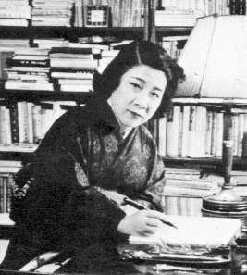
(Photo: Hayashi Fumiko)
Many women writer promoted the women’s liberation movement in Japan and were connected with the proletarian and left-wing movement. In this context one has to mention Sata Ineko 佐多 稲子 (1904- 1998) and Hirabayashi Taiko 平林 たい子 (1905- 1972) as well. Miyamoto Yuriko 宮本 百合子 (1899-1951) was very engaged, she was active even after 1945 in the democratization process of Japan.
All have been praised for their work in and outside of Japan. It is not possible to mention all Japanese authors, but only a selection of the most influential persons can be made in such a short overview. Of course there are many more Japanese authors to be read and write about in the future.
The Avantgarde
Tanizaki Jun‘ichirô 谷崎 潤一郎 (1886-1965) is famous for his works characterized by aestheticism and erotic tales of strong women and sexual obsession. Tanizaki includes Western thoughts and Japanese tradition in his writings.
His career began as he founded the literary magazine Shinshichô (New Currents of Thought) with his co-authors in 1910. Here he published his first short story Shisei (刺靑The Tatooer).
Tanizaki wrote mainly novels. Many of them were translated into other languages as Naomi (Chijin no ai 痴人の愛 , 1924/25), Some Prefer Nettles (Tade kuu mushi 蓼喰う蟲, 1928/29), The Makioka Sisters (Sasameyuki 細雪, 1943-1948) , The Key (Kagi 鍵, 1956) and Diary of a Mad Old Man (Fûten rôjin nikki 瘋癲老人日記, 1960-1962), which are outstanding works.
Tanizaki also wrote an important essay about his aestheticism: In Praise of Shadows (In‘ei raisan 陰翳礼讃 , 1933/34).
From 1935 to 1965 he translated the Genji monogatari into modern Japanese and offered three different versions of it.
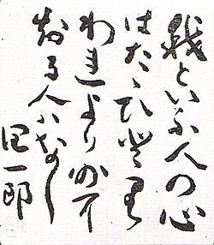
(Illustration: 我といふ人の心はたゝひとり われより外に知る人ハなし 潤一郎. “The heart of mine is only one, it cannot be known by anybody but myself.” Handwritten poem of Tanizaki Jun’ichirô approx. 1963).
Shiga Naoya 志賀 直哉 (1883 – 1971) is a unique Japanese writer, who founded the journal Shirakaba (White Birch). Influenced by Tolstoi he gives his own interpretations of humanism in his psychologically well observed novels of family conflicts, mostly narrated in the first person perspective (shi shôsestu – I novel) and with autobiographical subjects. His most praised novels are Wakai “Reconciliation” of 1917 and A Dark Night’s Passing. (An’ya kôro 1921-19237). He wrote many short stories. A translation of some of them are published in the anthology: The Paper Door And Other Stories.
Akutagawa Ryunosuke 芥川龍之介 (1892-1927)
He was a publisher of the literary magazine Shinshichô (New Currents of Thought) in 1914.
His short story Rashomon 羅生門 which he wrote in his student years is probably still nowadays the most famous of his works. The film of Kurosawa Akira 黒澤 明 is based on this and on Akutagawas “In A Grove” (Yabu no Naka 藪の中) .
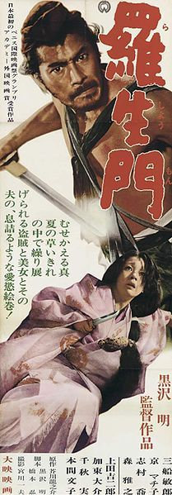
Akutagawa was a follower of the Japanese author Natsume Sôseki. In 1916 he wrote his story “The Nose” (Hana) and became widely recognized for it. Apart from that he worked as an English-teacher and a journalist of the newspaper Ôsaka Manichi Shinbun.
Akutagawa was specialized in writing short stories of historical background giving a modern re-interpretation of for example the Konjaku monogatari. He was a brilliant author of many literary styles: he also wrote many essays and autobiographic notes. In his later life he became mentally ill and committed suicide at the age of 35.
Japanese original works are available on the Internet at aozora.
Rashômon and Seventeen Other Stories is a selection of his stories in English, and provides a good overview of his works.
Kawabata Yasunari 川端 康成 (1899- 1972) re-established the literary magazine Shinshichô (New Currents of Thought) in 1914 and was the co-founder of the magazine bungei jidai (“The Artistic Age”).
Kawabata was the son of a physician, but became unfortunately an orphan early in his life. At the age of 18 he moved to Tokyo, where he studied English and Japanese literature. His writings stand for sensualism, strong lyricism and high aestheticism.
His literary magazine represents a platform of literary experiments for Japanese authors. Kawabata first wrote many short stories which he called Palm-of-the-Hand Stories (tenoshira no shôsetsu 掌の小説). In 1926 he came up with his first novel The Dancing Girl of Izu (Izu no odoriko 伊豆の踊子). His famous novel Snow Country (Yukiguni 雪国) was serialized from 1935 to 1947.
In his later years he worked on The Master of Go (Meijin 名人), Thousand Cranes (Sembazuru 千羽鶴, 1956), The Sound of the Mountain (Yama no oto 山の音, 1969), The House of the Sleeping Beauties (眠れる美女 Nemureru bijo) and many others.
He was president of P.E.N. in Japan from 1948 to 1965. In 1968 he won the Nobel Prize for Literature as the first Japanese author.
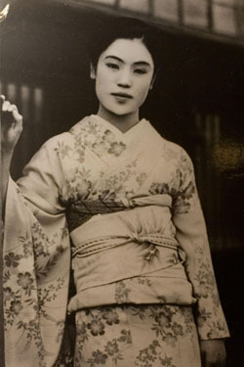
(This picture shows Matsuei of Yuzawa, a geisha. She inspired Kawabata to write his famous novel Snow Country)
Nagai Kafu 永井 荷風 (1879- 1959)
Nagai Kafû was the son of a high official and business man. His first short story was Sudare no tsuki (Moon behind the Bamboo grove) in 1898. His work was highly influenced by Guy de Maupassant and Émile Zola. He spent the year 1903 in the United States and 1907 in France as a student of literature. He became famous of his Amerika monogatari in 1908 and Furansu monogatari in 1909. After his return to Japan he became a professor for literature in Tokyo.
His work is regarded as aesthetic and associated with realism. His most famous novels are Sumida River (Sumidagawa すみだ川) of 1909, Geisha in Rivalry (Udekurabe 腕くらべ 1916/17) and A Strange Tale from East of the River (Bokutô kitan 濹東綺譚 1937).
Until 1932 many authors made experiments with surrealism and expressionism. The rise of nationalism in the 1930‘s, censorship and prosecution as the effect of imperialism and war policy nearly brought the literary scene to become silent. The official policy haunted liberals, democrats, proletarian and left-wing writers, put them into jail or intimidated intellectuals and free thinking minds. It took time until the end of the war after 1945 that there was a new beginning of a rich faceted Japanese literature.
KAYNAK: https://japankaleidoskop.wordpress.com/2013/05/03/a-short-history-of-japanese-literature-part-1/

